Hw 6.1 Compilation:

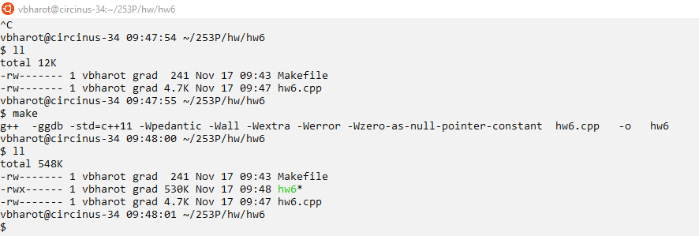

Hw 6.1 Example from assignment:

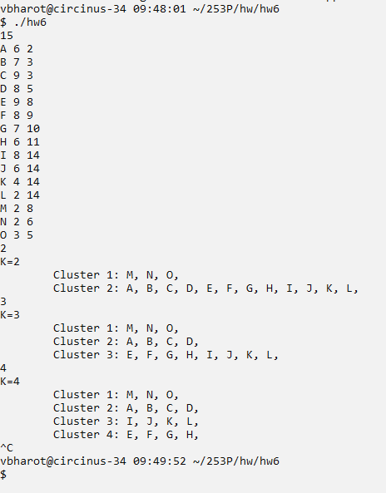

Hw 6.1 Test Input:

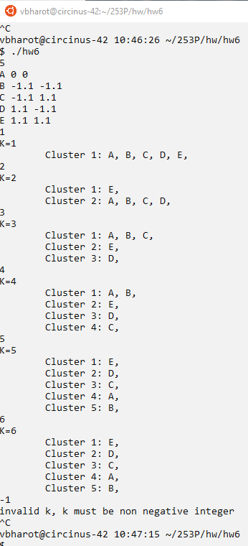

Hw 6.1 Important edge case 1:

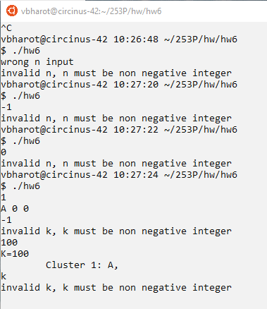

Handling wrong input for n and k is necessary as lack of wrong input handling causes infinite loops and unexpected behavior.

The expected behavior is to notify user of the expected input.

Hw 6.1 Important edge case 2:

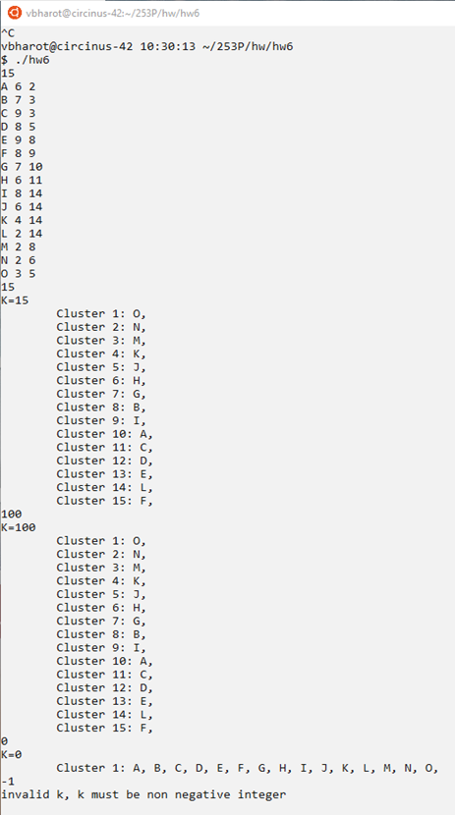 Handling the out of bound inputs are necessary,

For n = number of cities

The expected behavior are as follows:

For k >= n there will be n number of clusters.

For k=0 and 1 there will be 1 cluster

(I am interpreting k=0 saying no quarantine zones required, it’s behavior can easily be adjusted to invalid input prompt according to design interpretation).

For k < 0 there will be invalid input prompt

Hw 6.1 Important edge case 3:

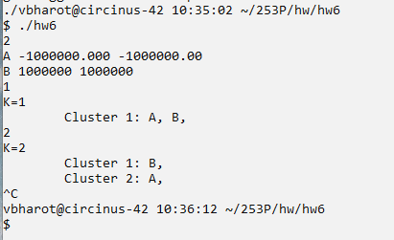

Handling large float value as coordinates of the cities is required.

The expected behavior is that program should be able to handle these inputs without out of bound or buffer overflow errors.

Hw 6.2 Leetcode 1334: Find the City With the Smallest Number of Neighbors at a Threshold Distance.

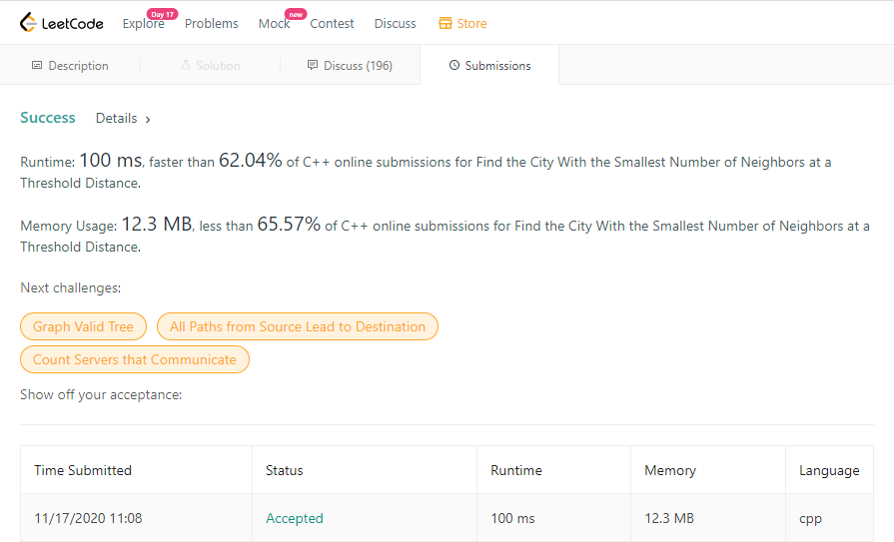

Hw 6.2 Leetcode: 1254: Number of Closed Islands

