HW 7.1 Compilation

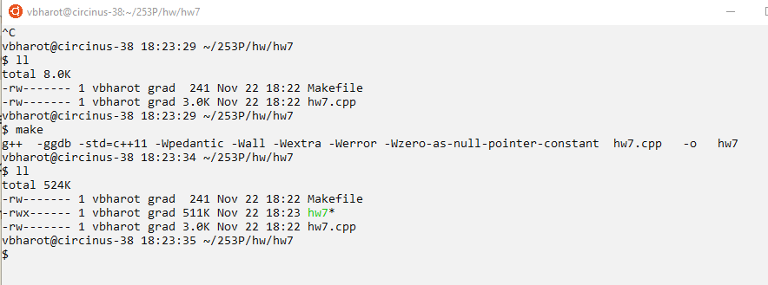

HW 7.1 Example from assignment:

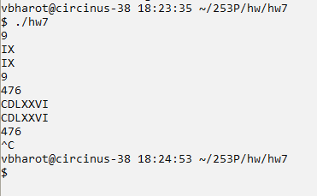

HW 7.1 Test input:

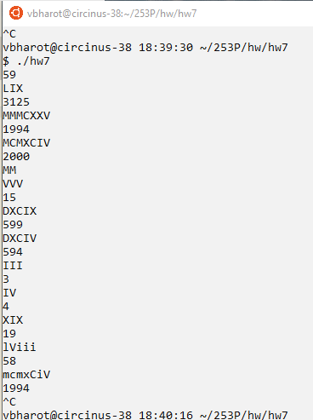

HW 7.1 import edge case 1:

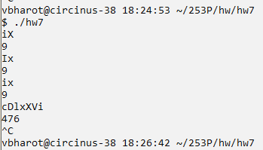

Handle upper-case and lower-case roman numerals and their combinations

HW 7.1 important edge case 2:

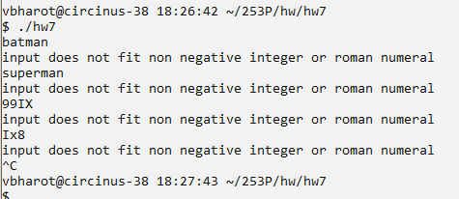

handle invalid inputs

HW 7.1 important edge case 3:

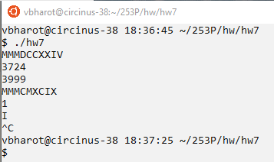

Handling large roman numerals

HW 7.2 Leetcode 42. Trapping Rain Water

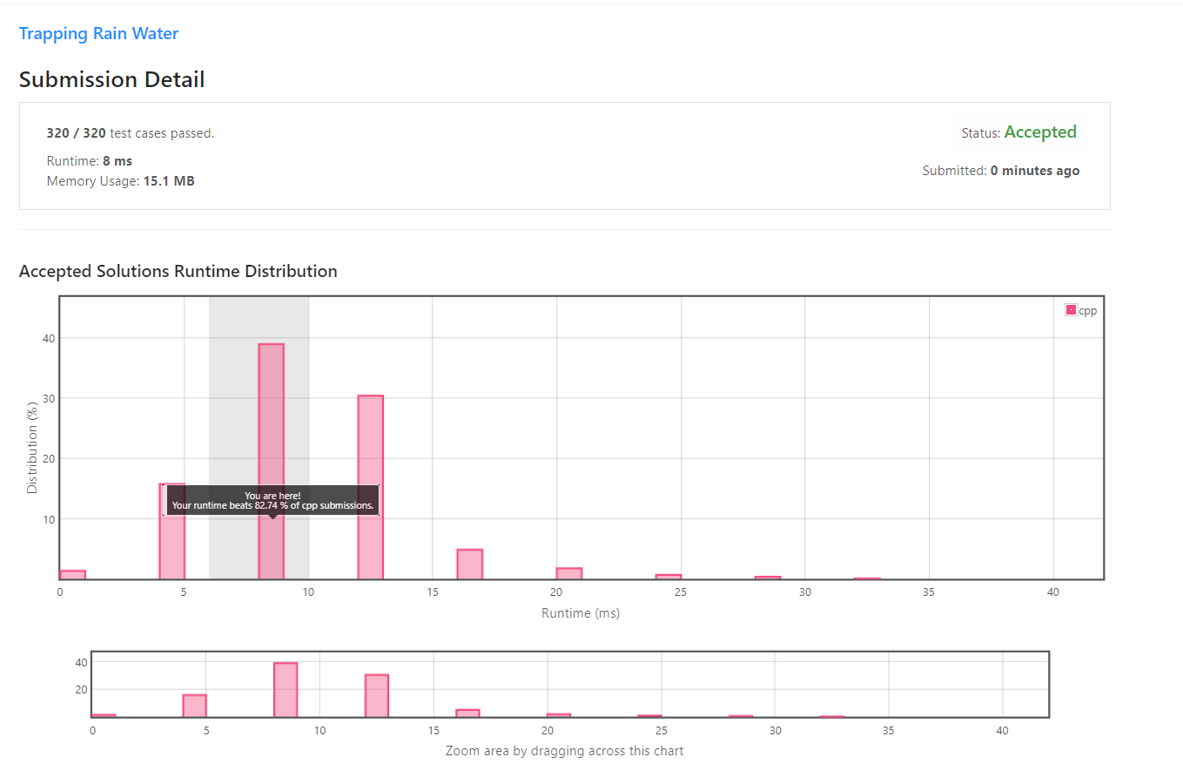

HW 7.3 Leetcode 315: Count of Smaller Numbers After self

