CS 232P: Quiz 2 Labs 0 – 3
Time 1.15h
Feb17th, 2021

Student Name: Vineet Bharot

Student ID: 88649968
Grade: /30

From the .doc or .pdf file “NetworkID” fill in the Network ID assigned to you:
Network ID (.doc or.pdf file): 66.45.0.0
NOTE:
Any quiz submitted with the same Network ID as someone else’s, the student with the wrong Network ID (i.e., using a Network ID other than the one assigned to you in the Excel Sheet), will get “0” points.

- (30pts) You are given the following network setup.
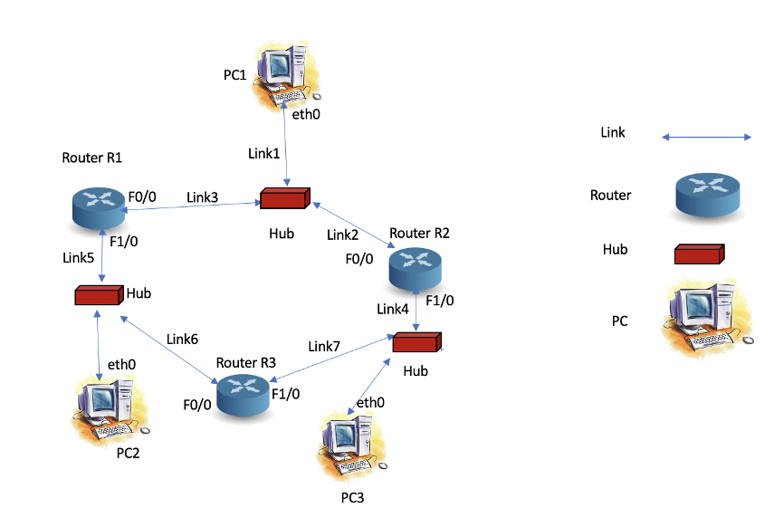
Figure 1
  - Open a GNS3 project and setup a network topology as shown in Figure 1 above.
  - Start Wireshark capture on the following links and set filters to capture ICMP packets:
    - Link1
    - Link4
    - Link5
  - (4.5pts) Use the Network ID assigned to you in the .doc or .pdf file to configure this network with appropriate subnets:
    - (3pts) Configure the 3 routers, R1, R2 and R3, with appropriate IP address/prefix.
      - IP Address/prefix R1 f0/0: 66.45.1.1/24
      - IP Address/prefix R1 f1/0: 66.45.2.1/24
      - IP Address/prefix R2 f0/0 66.45.1.2/24
      - IP Address/prefix R2 f1/0 66.45.3.2/24
      - IP Address/prefix R3 f0/0: 66.45.2.3/24
      - IP Address/prefix R3 f1/0: 66.45.3.3/24
    - (1.5pts) Configure the 3PCs eth0 interface with appropriate IP address/prefix.
      - IP Address/prefix PC1: 66.45.1.11/24
      - IP Address/prefix PC2: 66.45.2.22/24
      - IP Address/prefix PC3: 66.45.3.33/24
  - (4.5pts) Use the annotate feature in GNS3 to include all of your configured IP address/prefix on your project panel. Take a screenshot of your GNS3 project panel and paste it here.
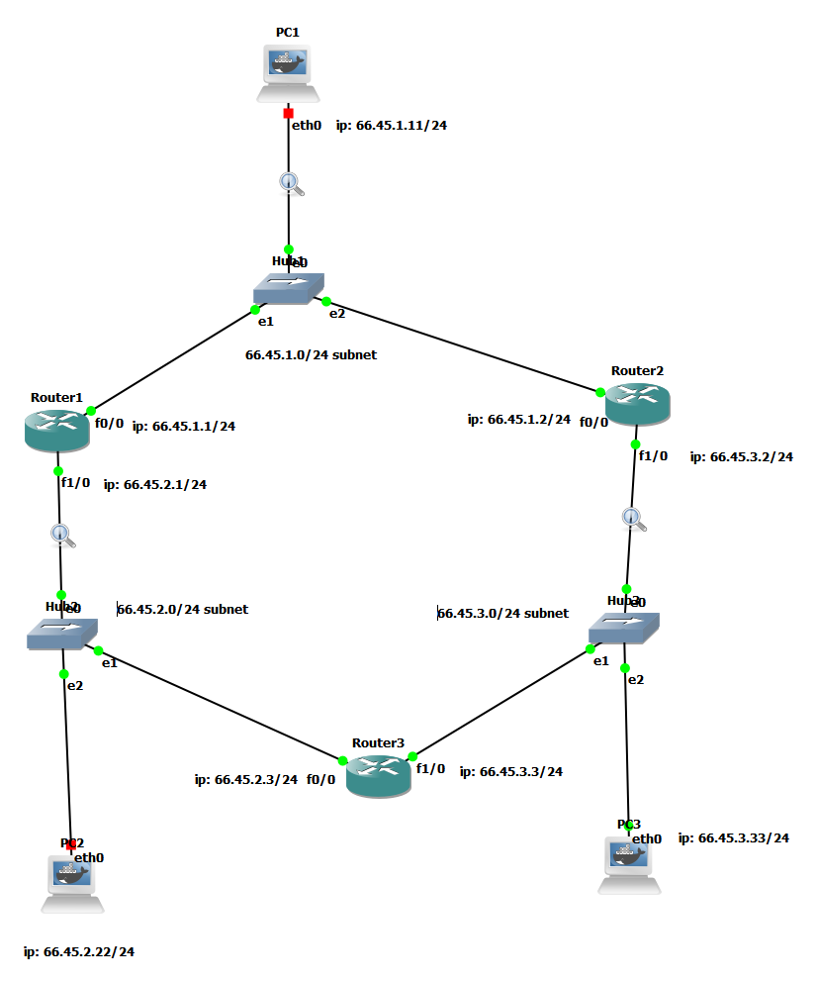
  - (1.5pts) Assign a default route on each PC to enable all hosts to communicate with each other. Take a screenshot of the “netstat -rn” command on each PC to show the routing table. Paste here.
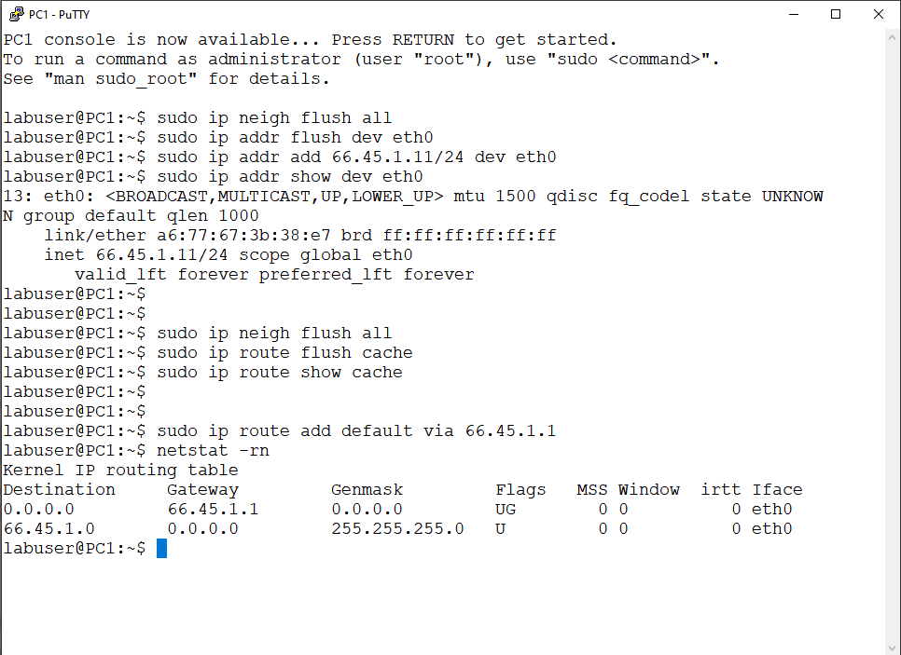
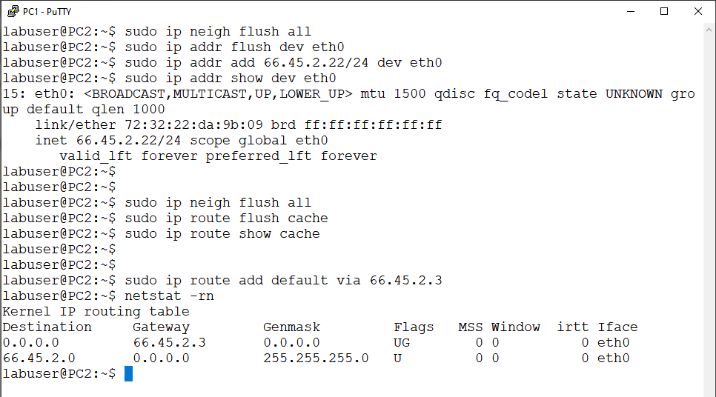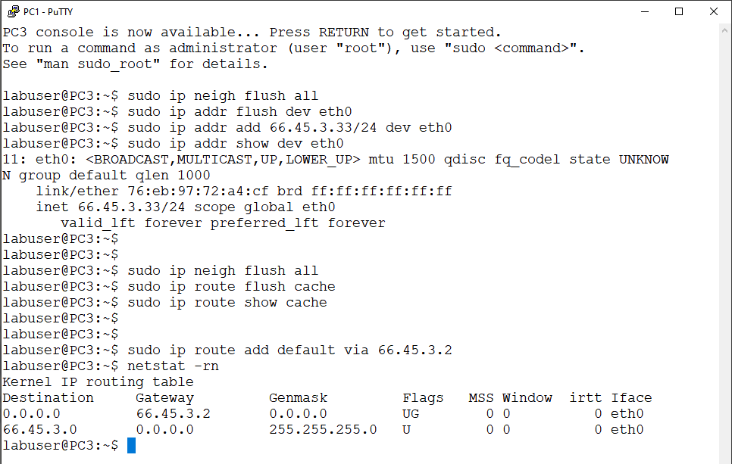
  - (1.5pts) Set up each router’s default route so that all IP devices can communicate on the network. Take a screenshot of the “show ip route” command on each router to show the routing table. Paste here. 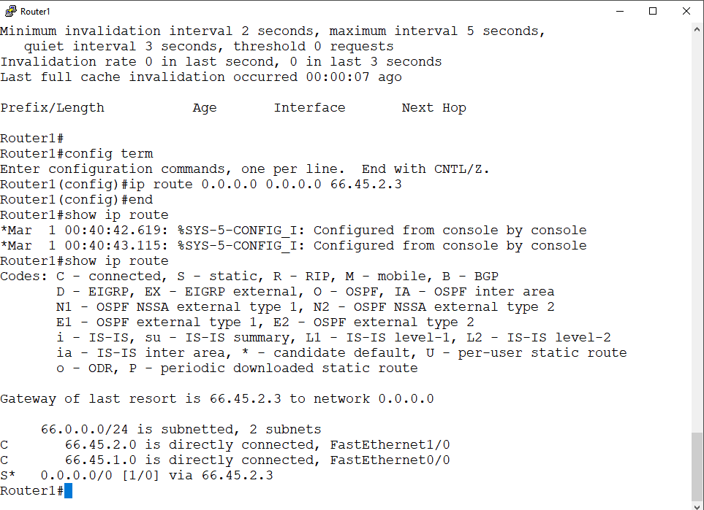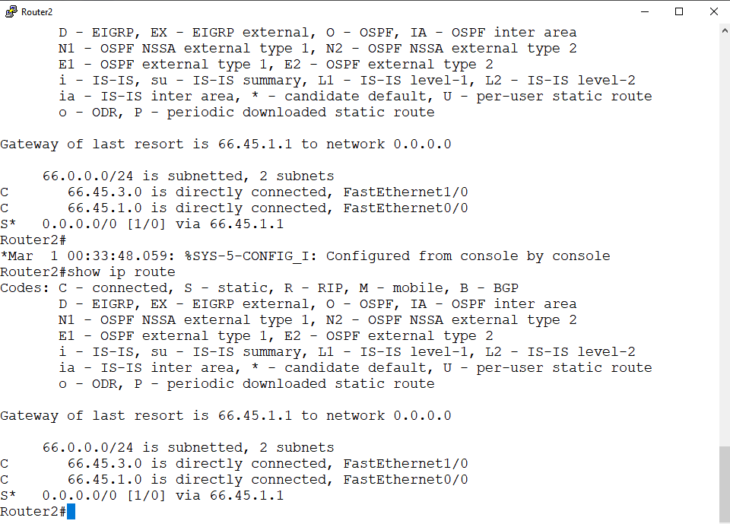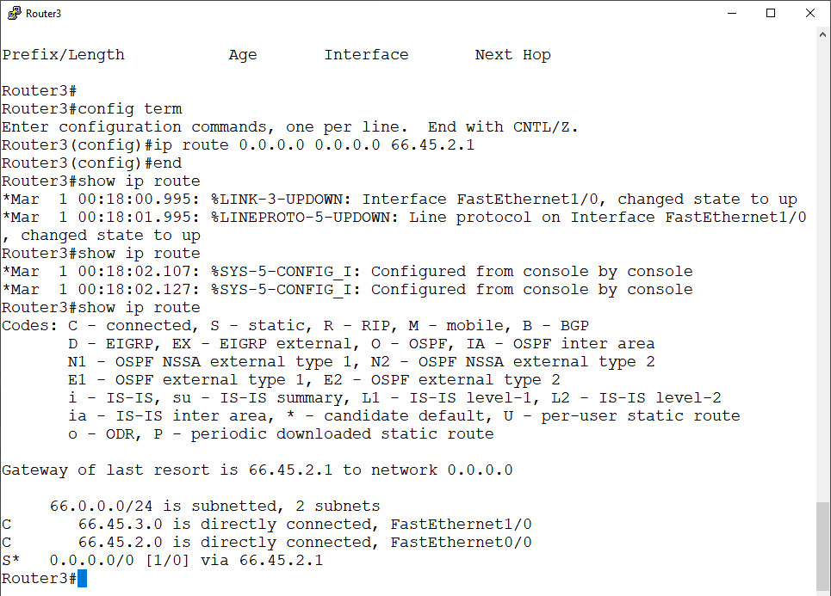
  - (1.5pts) Issue the following pings:
    - PC1% ping PC2 –c 5
    - PC1% ping PC3 -c 5
    - PC2% ping PC3 -c 5
Take a screenshot of the each ping output and paste here.
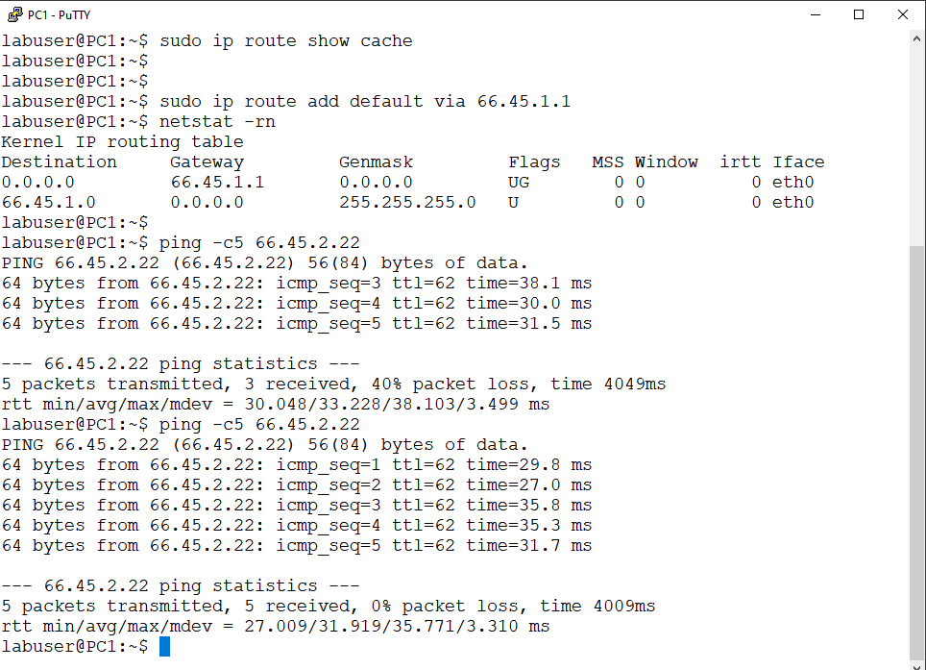
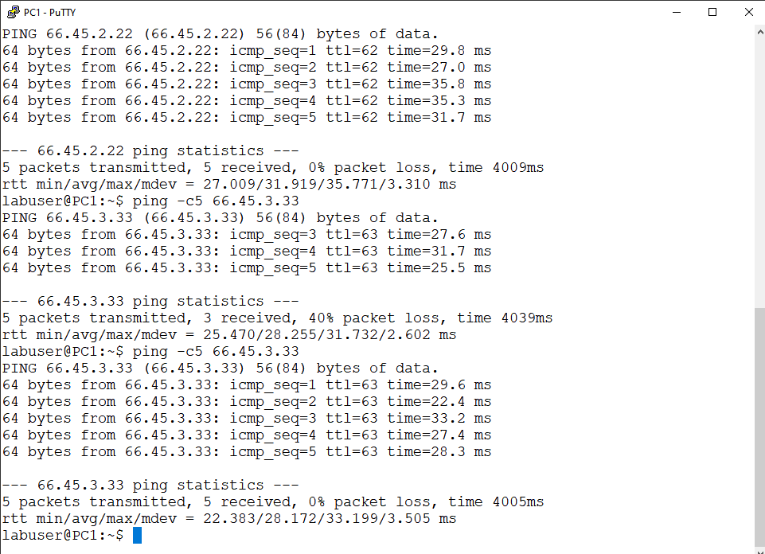
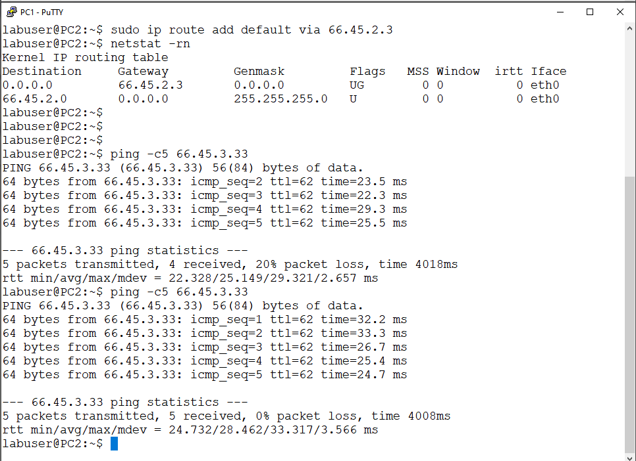
  - (1.5pts) Now issue the following traceroutes – REPEAT TWICE for each traceroute
    - PC1 to PC2
    - PC1 to PC3
    - PC2 to PC3
Take a screenshot of each traceroute output and paste here.
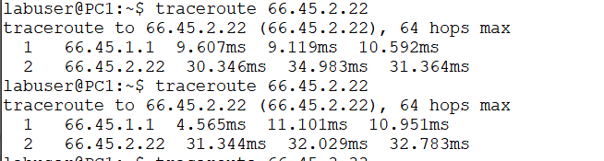
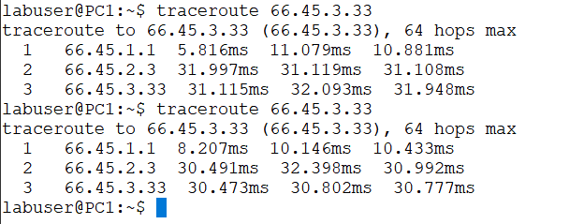
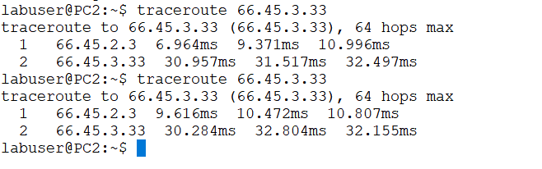
  - Stop Wireshark capture on each link. Save the captured data.
  - (15pts) Answer the following questions using your saved Wireshark output:
  - (6pts) From the Wireshark capture that you saved of the ping outputs in part g., can you explain what you observed. Highlight your observations by detecting the ping traffic packet flow. Take screenshots of the relevant Wireshark packet flows to support your answer. Include the screenshots here.
    - For PC1 ping PC2: observed using link1 and link 5 traffic.
      - PC1 arps for Router 1 to get get mac address.
      - PC1 sends ICMP messages to Router1
      - Router 1 arps for PC2 to get mac of PC2.
      - Router forwards the packets to PC2.
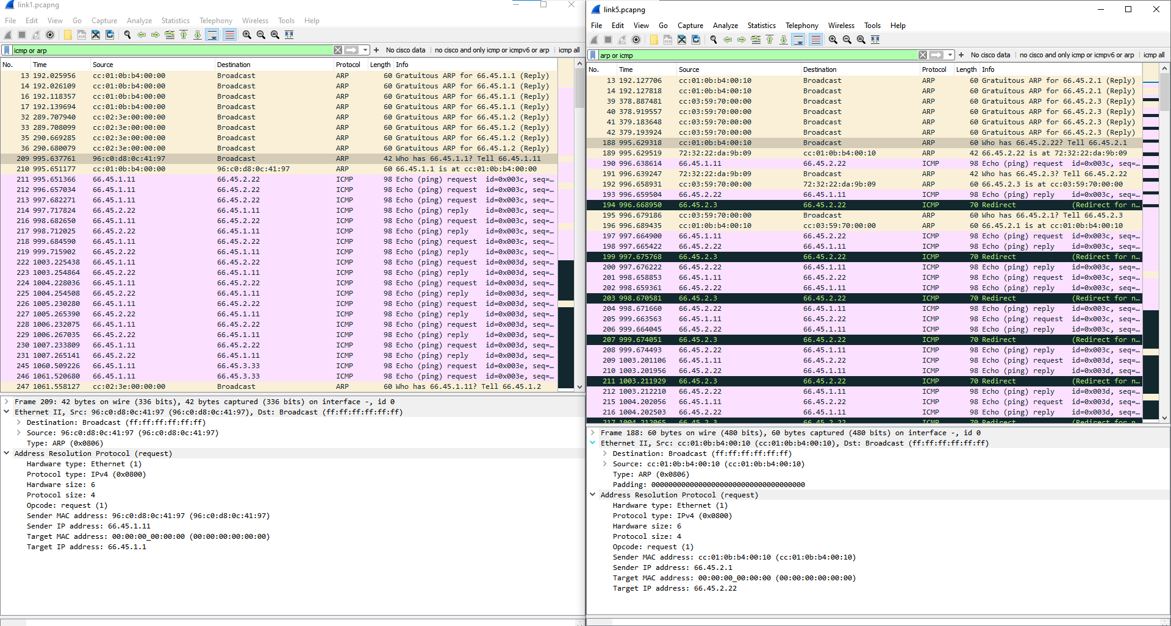
Similarly for PC1 to PC3 ping, and PC2 to PC3 ping.
(6pts) Is the “traceroute” output in part h. what you expected to see for each route? Explain your observations and highlight the packet flows in the Wireshark capture that illustrate what is going on. Take screenshots of the relevant Wireshark outputs to support your answer. Include the screenshots here.
Ans.
PC1 to PC2 traceroute: I expected to see the traffic to go via Router1 and then to PC2 which is what Is observed, because the default router for PC1 is Router1.
PC1 to PC3 traceroute: I expected to see traffic via Router1 to Router 3 to PC3 because my PC1 default is Router1.
For PC2 to PC3 traceroute: I expected to see traffic via Router 3 and then to PC3 because for PC2 I’ve set Router3 as default Router.
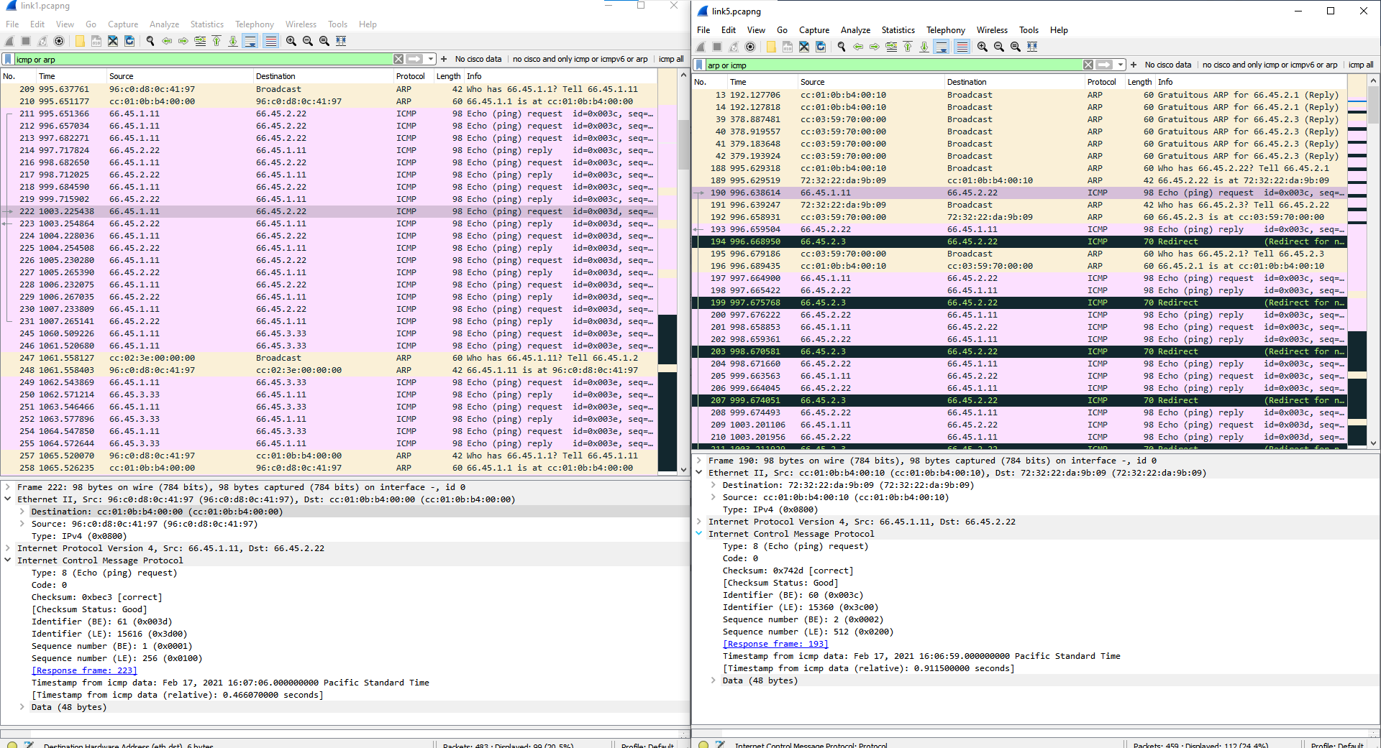
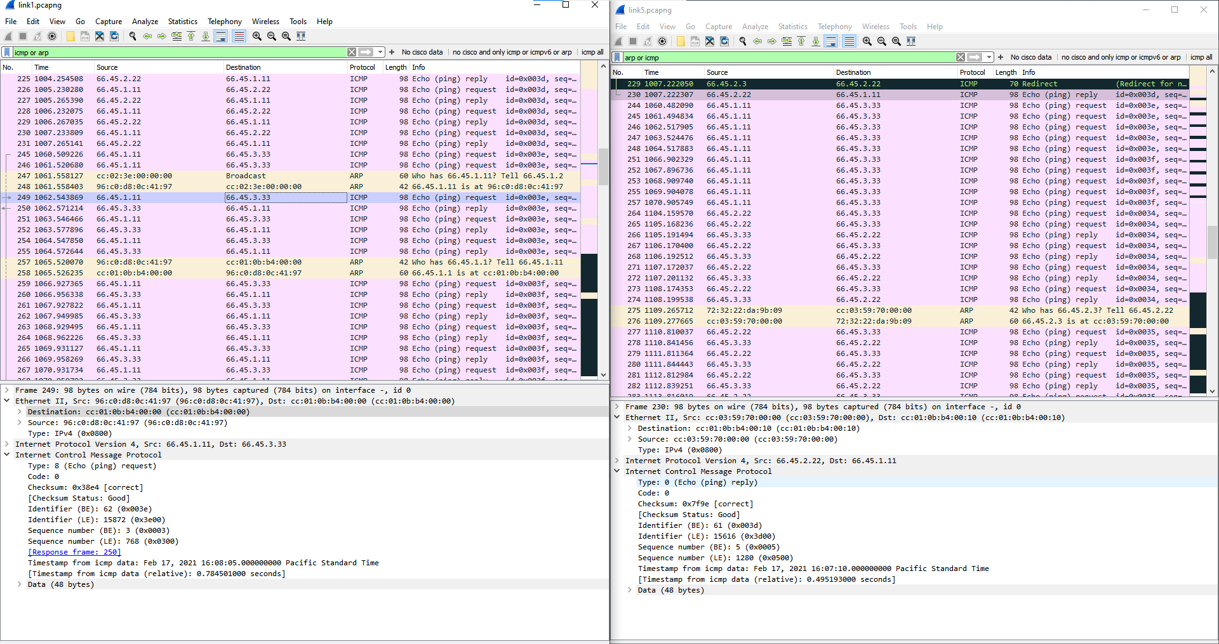
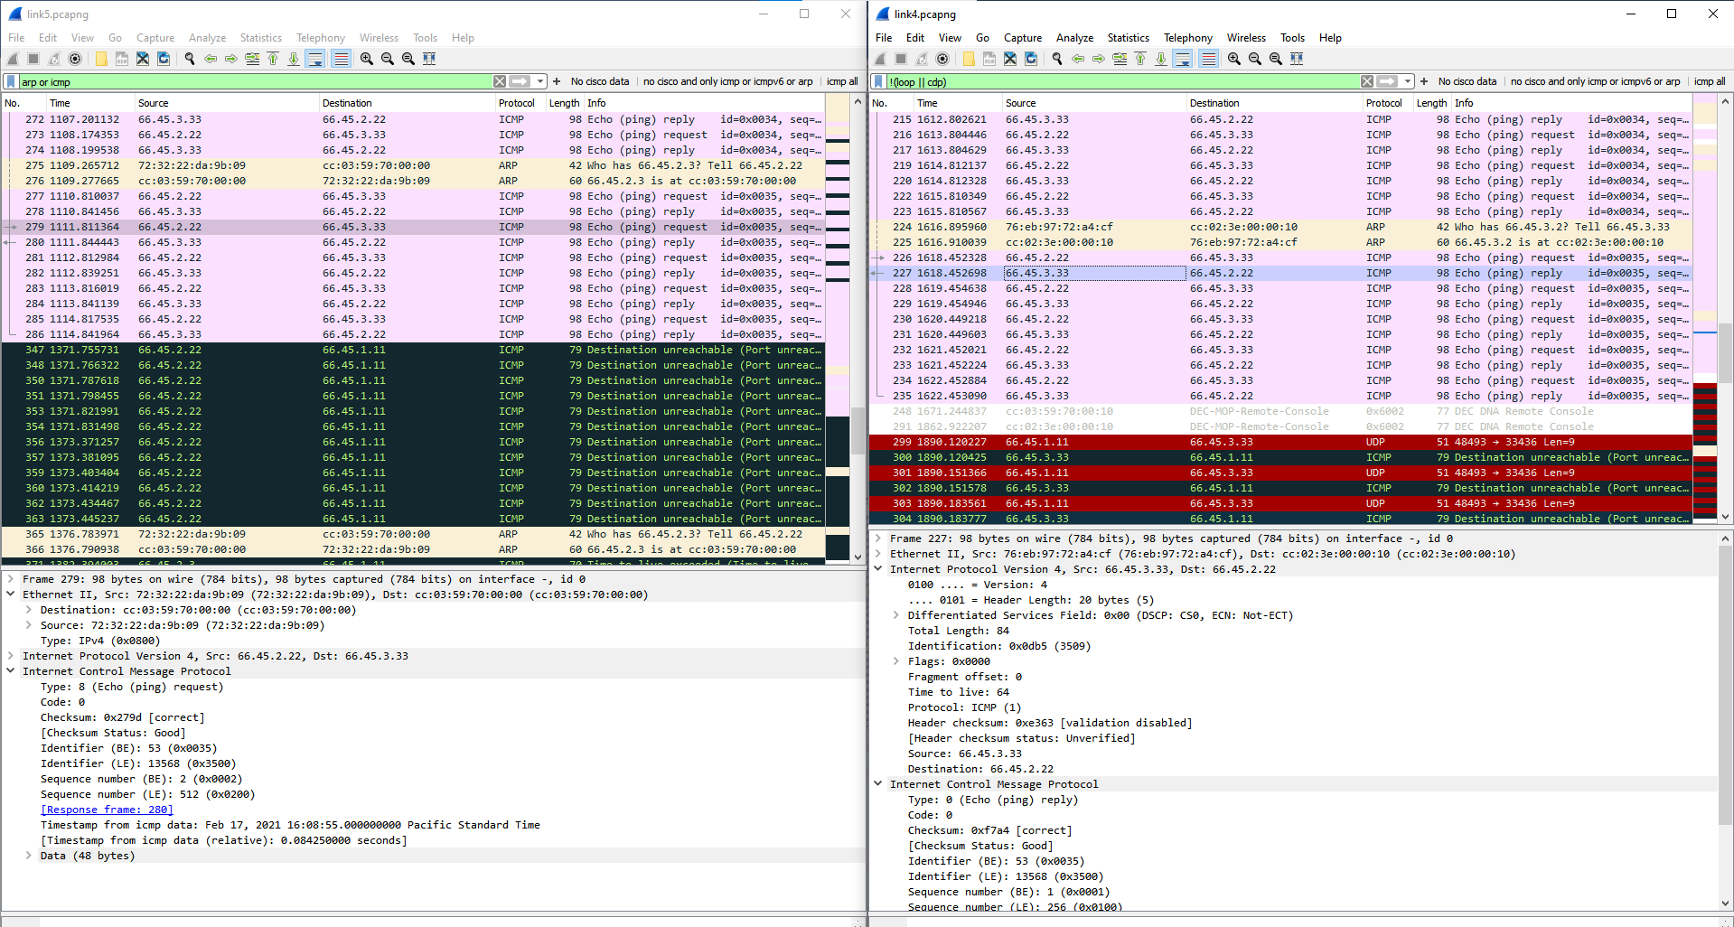
  - (3pts) What can be done to the device configuration to avoid/fix some of the unexpected behavior that you may have observed?
    - One unexpected was the traceroute for PC1 to PC3 ping because of my default configuration to Router1, which causes 2 hops for PC3 which can be done in one hop if PC1 has mapped PC3’s host in routing table to go via Router2.
  - Stop GNS3. Quit GNS3. Quit VMware.
  - Save your Quiz response word document (StudentID_LastName.docx) and make sure it is included with your “project” submission.

