CS 232P Lab Quiz
Documents:
Quiz#.doc actual quiz document. # refers to quiz #, e.g., 1 means Quiz1. You will make your own copy of this document and use it to paste screenshots and add your responses to the questions. (see more instructions below).
Start Quiz
- Create a folder called LastNameProjects on your desktop to store all your GNS3 project folders and other Quiz related material. Lastname is YOUR Last Name, e.g., SmithProjects. NOTE: No spaces in LastName. E.g.: De Lauren → DeLauren.
- Open GNS3 on your laptop and make sure that all components are working and fired up (green dots).
- Set GNS3 to automatically store all your project files in the folder “LastNameProjects”
- When asked for project name, use the following notation: STUDENTID_probX, e.g. 12345678_prob1. You should generate a GNS3 project for each problem in the Quiz. Note: a quiz may only have “1” problem.
- Open Quiz#.docx. Use “Save as” to create a copy of Quiz#.docx in your LastnameProjects folder to use as your answer sheet. Give it name: StudentID_LastName.docx, e.g., 12345678_Smith.docx. Save it in folder LastnameProjects.

- For each problem, store all Wireshark output and screenshots in the corresponding GNS3 folder in LastnameProjects. Note that GNS3 creates a folder per project.
Example Folder Structure
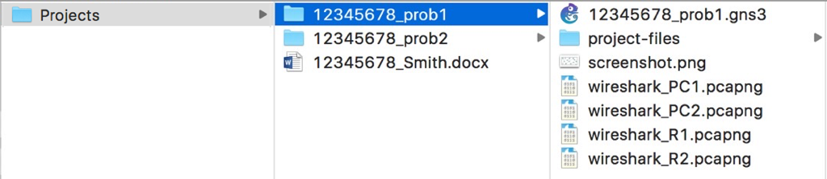

5. When completely done, stop GNS3 and then Quit GNS3. If you don’t, the GNS3 process will hang and could cause submission problems.
6. Submit your LastnameProjects folder by first creating a “zip” or “tar” file of your folder and uploading that in the LabQuiz Assignment window.

