CS 232P: Quiz 1 Labs 0 – 2
Time 1h 10m
January 25th, 2021

Student Name: Vineet Bharot

Student ID: 88649968

From the .doc file “IPAddresses_GlobalNetID”, fill in the 3 PC IPv4 addresses assigned to you and the IPv6 Global ID:
PC1 IP Address (from .doc file): ______192.168.12.103_______________
PC2 IP Address (from .doc file): ______192.168.12.104_______________
PC3 IP Address (from .doc file): ______192.168.12.105_______________
IPv6 Global ID (from .doc file): ________fd15:8f7e:158f::/48_____________
NOTE:
Any quiz submitted with the same IP addresses as someone else’s, the student with the wrong IP Address (i.e., using IP addresses other than the ones assigned to you in the Excel Sheet), will get “0” points.

- (10pts) You are given the following network topology.
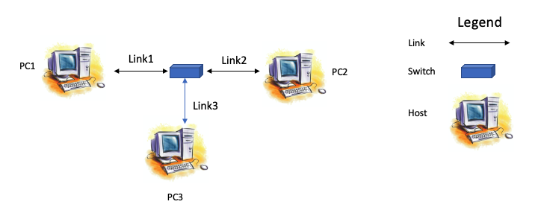
Figure 1
  - Start a GNS3 project and setup the network shown in Figure 1.
  - Configure the hosts, PC1, PC2 and PC3, with the IP4 addresses assigned to you in the .doc file “IPAddresses_GlobalNetID”.
    - IP Address/prefix PC1: 192.168.12.103/24
    - IP Address/prefix PC2: 192.168.12.104/24

    - IP Address/prefix PC3: 192.168.12.105/24
  - (1.5pt) Use the annotate feature in GNS3 to include all IPv4 addresses/prefix on your project panel. Take a screenshot of your GNS3 project panel and paste it here.
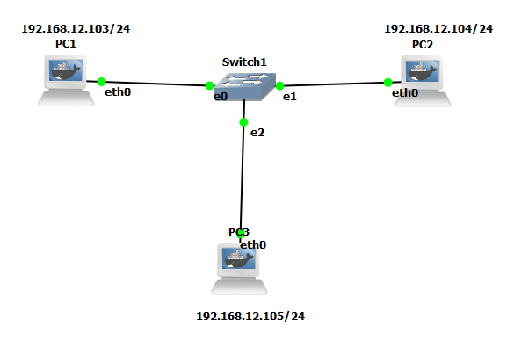

  - Start Wireshark capture on the link from Switch1 to PC1 (Link1). Set filters to only capture ICMP and ARP messages.
  - (1pt) Ping from PC1 to PC2
PC1% ping PC2 –c 5
Take a screenshot of the ping output on PC1’s console. Paste here.
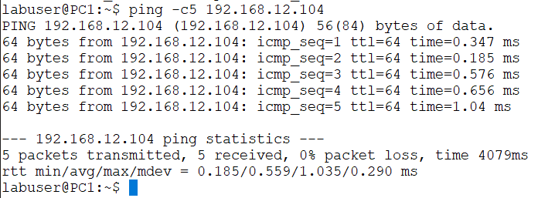
  - (1pt) Stop Wireshark capture. Save the captured data. Take a screenshot showing the ICMP and ARP messages. Paste here. 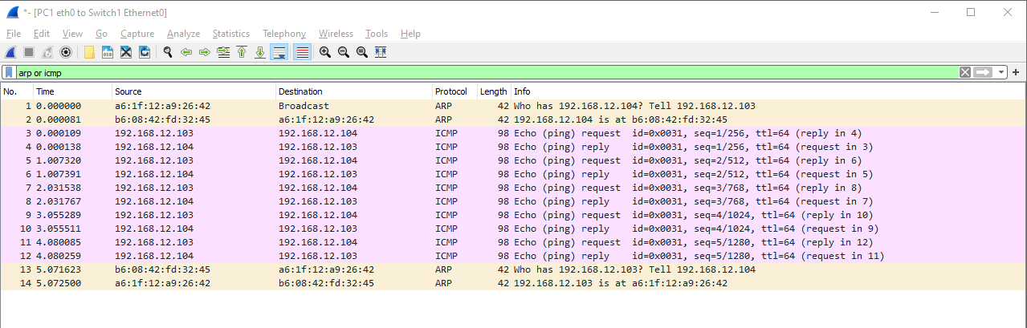
  - (1pt) Using your saved Wireshark output, Identify the ARP reply and response packets on Link1, and extract the Ethernet/MAC addresses being used for the ARP exchange. Take a screenshot of the ARP Request and Reply packets and save the image. List the MAC addresses of the captured packets on Link1 below. Include the screenshots to support your response here. 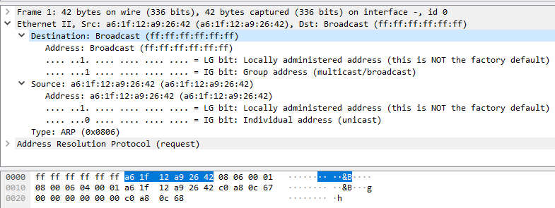
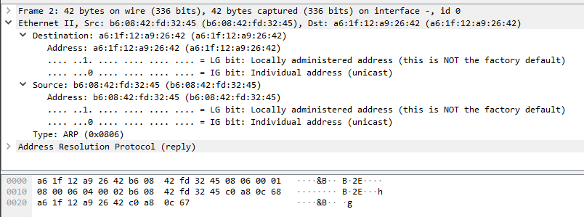

Link1 Mac Addresses
ARP Request: Source: a6:1f:12:a9:26:42 Destination: ff:ff:ff:ff:ff:ff
ARP Reply: Source: b6:08:42:fd:32:45 Destination: a6:1f:12:a9:26:42
  - (0.75pt) Show the neighbor cache for each PC. Take a screenshot and save. Include the screenshots here. 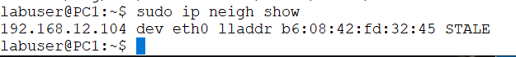
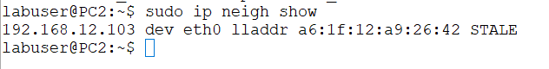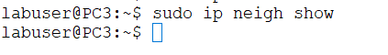
  - (0.75pts) From the neighbor cache, identify the Link-Local IPv6 address of dev eth0 on PC1, PC2 and PC3. Fill in the table below

PC | Link-local IPv6 Address (eth0)
PC1 | fe80::a41f:12ff:fea9:2642/64
PC2 | fe80::b408:42ff:fefd:3245/64
PC3 | fe80::5cf2:32ff:fe4d:f491/64

  - Start a Wireshark capture on Link3 between PC3 and Switch1.
  - Using the Global Network ID assigned to you in the “.doc” file “IPAdresses_GlobalNetID”, create an IPv6 global unicast address for each host. Assume that the 3 PCs are all in subnet “3”. Use the IPv4 host number of each PC, as the last byte “in hex” notation for each of the PCs’ IPv6 interface IDs. List the configured addresses here including the network prefix for each:

PC1 IPv6 global configured address: fd15:8f7e:158f:0003::0067/48 (wrong 64)
PC2 IPv6 global configured address: fd15:8f7e:158f:0003::0068/48 (wrong 64)
PC3 IPv6 global configured address: fd15:8f7e:158f:0003::0069/48 (wrong 64)
  - (1.5pts) Use ip route show all to display the configuration of each PC and verify the above assigned IPV6 addresses. Take a screenshot of each console, save and include here. 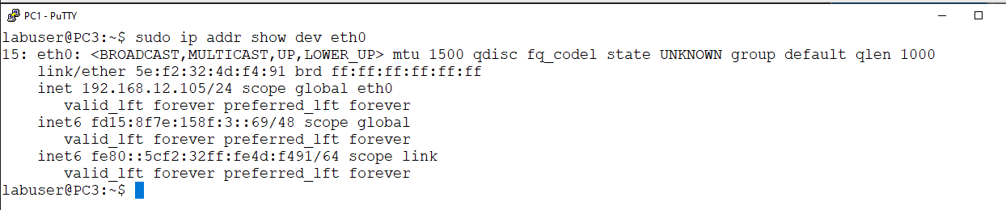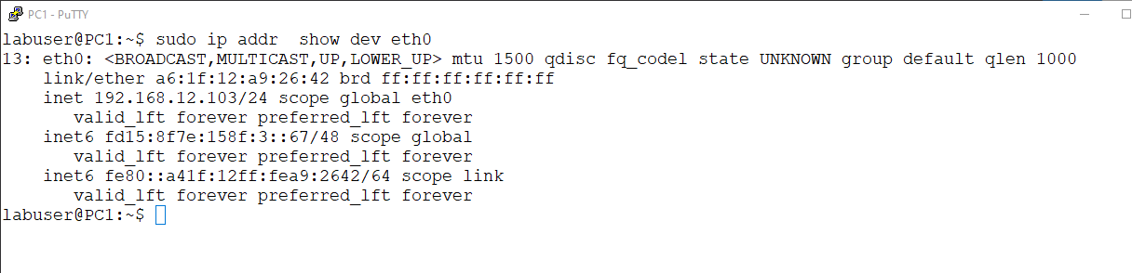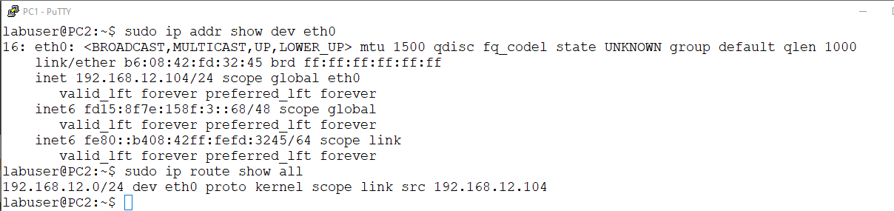
  - (1.5pts) From the Wireshark output, identify the “IPv6 address” verification packet for each PC. Take a screenshot of each one you observed and include here. 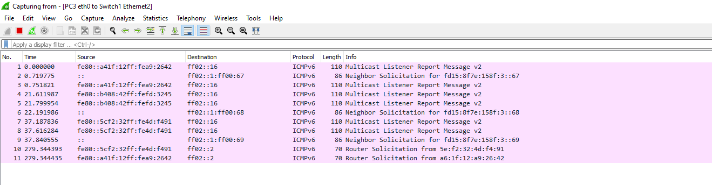

  - (3pts) For each verification packet, fill in the table below:

PC | Frame Layer Address (MAC) | IPv6 Address
PC1 | Source: a6:1f:12:a9:26:42  Destination:33:33:00:00:00:16(wrong 67) | Source: ::  Destination: ff02::1:ff00:67
PC2 | Source:b6:08:42:fd:32:45  Destination: 33:33:00:00:00:16(wrong should be 68) | Source: ::  Destination: ff02::1:ff00:68
PC3 | Source:5e:f2:32:4d:f4:91  Destination: 33:33:00:00:00:16(wrong should be 69) | Source: ::  Destination: ff02::1:ff00:69
  - (1pt) Using the IPv6 configured addresses above, issue the following two pings. Screenshot the console output, save and include here.
    - PC1 pings (-c2) PC3 (WRONG SHOULD BE OTHER WAY AROUND)
    - PC2 pings (-c2) PC3 (WRONG SHOULD BE OTHER WAY AROUND)
    - 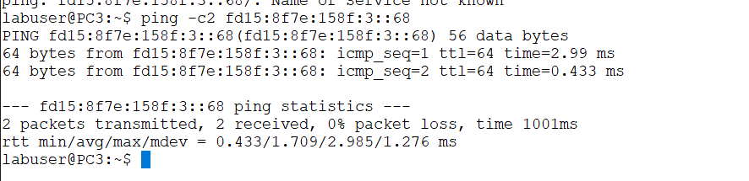
  - (2pts) Stop Wireshark. Take a screenshot of the Wireshark capture for each set of pings. Save and include here. Identify/highlight on the screenshot (i.e., markup) the different stages of the “ping” communication between each pair of PCs.
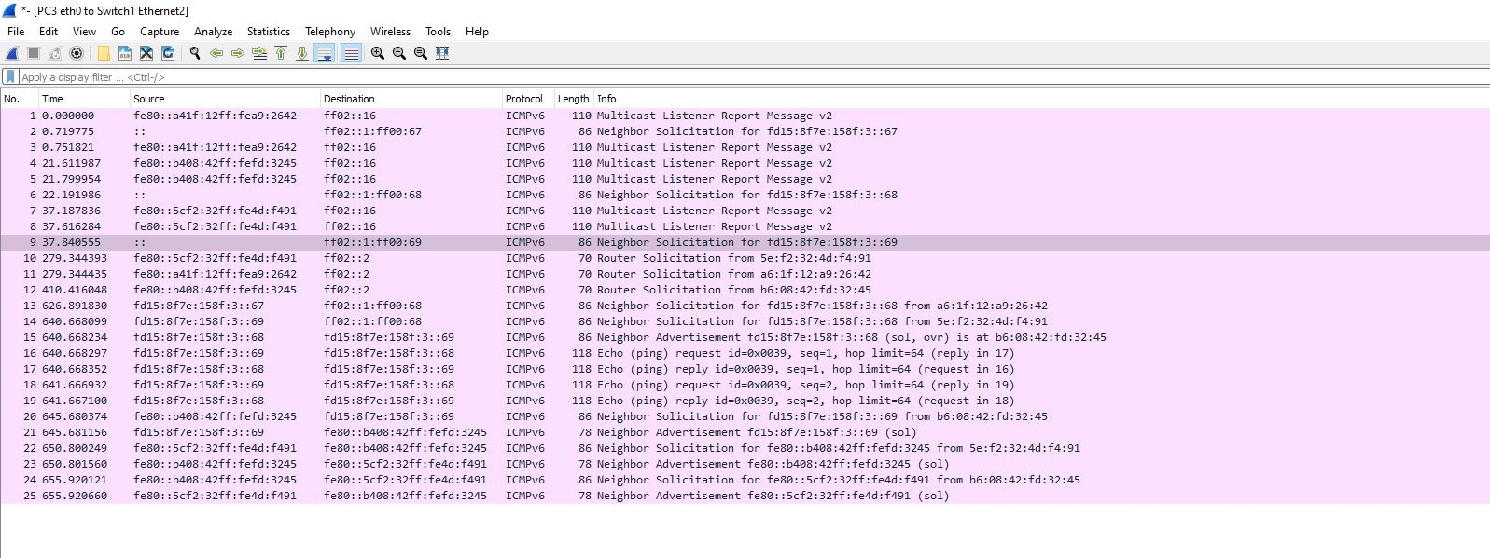
  - Stop GNS3. Quit GNS3. Quit VMware.
  - Save your Quiz response word document (StudentID_LastName.docx) and make sure it is included with your submission. Also include the Wireshark output(s). Helps us verify your claims - we can check your simulation and results - should you have any issue with your responses and the grading.

