(U) APPENDIX C: Intelligence Community (IC) Geographic Information System (GIS) Portal

(U) IC GIS Portal
(U) The IC GIS Portal is a collaborative geospatial content management system that enables the discovery and sharing of geospatial information for the IC, Department of Defense (DoD), and mission partners. Users can create, organize, secure, and manage geographic assets and connect end-users with useful apps, maps, and geographic data. The IC GIS Portal includes many built-in and customizable web mapping applications, including:
- (U) Story Maps: a simple yet powerful way to inform, engage, and collaborate across organizations with any mission narrative you want to tell that involves maps, places, locations, or geography. Story Maps make it easy to harness the power of maps to tell a story. Story Maps are hosted web applications that let authors combine maps with narrative text, images, and multimedia, including video. The Story Map components can integrate media contents accessible via Uniform Resource Locator (URL) from any location.
- (U) Web AppBuilder: enables the creation of customized applications, allowing for a more tailored web mapping application without the need to write code. Web AppBuilder and portal-based hosting can enable groups to develop custom web experiences without overhead for web-hosting or development environments. Web AppBuilder (Developer Edition) provides an extensible framework for developers to create custom widgets and themes that can be shared within the GIS Portal infrastructure.
- (U) Web maps: allows users to create geospatial products that combine ArcGIS and Open Geospatial Consortium (OGC) web services from content accessible across the community. Within the geospatial information products, the producer can define symbology and the end user’s interaction with the geospatial content. The authoring experience also provides a simplified workflow allowing non-traditional GIS users to produce geographic products. Through the collaboration tools of Portal, multiple users can contribute to a product and build off work templates enabling faster information sharing.
(U//FOUO) Focused on a community-wide approach with low barriers to entry, the Portal spans 55 agencies and 140,000 users. It supports a range of users, including GIS experts with desktop workflows to all-source analysts using web-based capabilities for the first time. Historically, there are approximately 10,000 unique users per month and 45,000 API calls per month.
(U//FOUO) The IC GIS Portal is available across five security networks as shown in Table 1.
Table 1: (U) IC GIS Portal Security Networks
(U//FOUO) Domain | (U//FOUO) URL
JWICS | https://portal.geo.cloud.ic.gov
SIPRNet | https://portal.geo.nga.smil.mil
NIPRNet | https://portal.geo.nga.mil
WWW | https://nga.maps.arcgis.com
STONE GHOST | https://portal.geo.nga.us.qlat

(U) A screenshot of the IC GIS Portal Landing Page is shown in Figure 1.

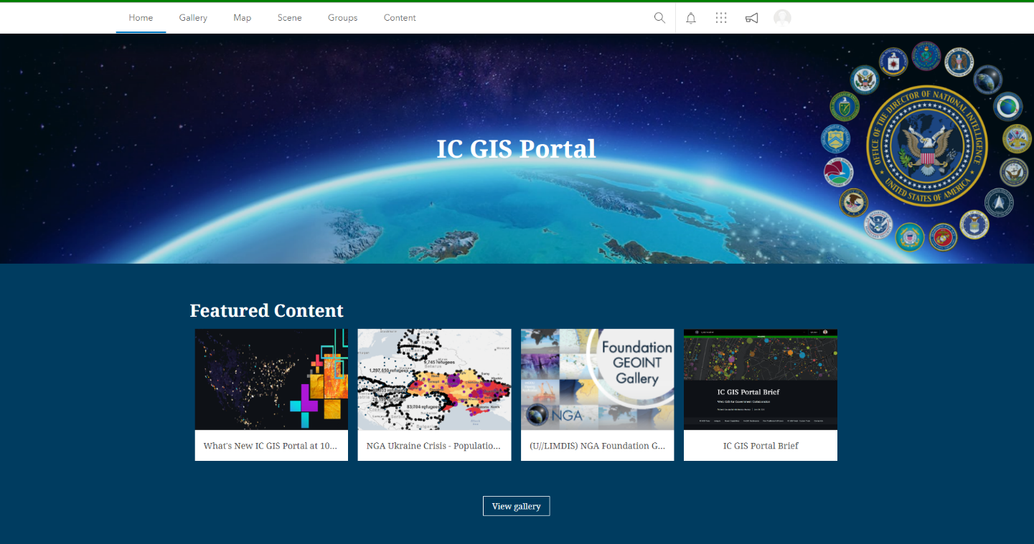
(U) Key functions provided by the IC GIS Portal include:
Figure 1: (U//FOUO) IC GIS Portal Landing Page
This Figure is U//FOUO
This Figure is U//FOUO
- (U) Provides self-service discovery, visualization, analysis, sharing and collaboration.
- (U) Enables users to publish and service-enable data.
- (U//FOUO) Enables users to analyze with geoprocessing tools, ArcGIS Insights, and ArcGIS Notebooks.
- (U//FOUO) Creating and sharing dynamic maps and applications using templates (Dashboards, StoryMaps) and other standardized production templates for analysis and dissemination.
- (U//FOUO) No-code applications: Creating no-code and low-code user applications that bring together content and services using Experience Builder and Web App Builder, exposing visualization and analytic processing.
- (U) Development platform: developers have access to hosted APIs, geoprocessing tools, and analysis tools to create custom applications.
- (U) Collaboration between GIS Portals: aka Portal–to–Portal collaboration which increases discovery and sharing by leveraging automated workflows.
- (U) Extension of the ESRI platform to provide and maintain Government-Off-The-Shelf (GOTS) tools available to other DoD / IC organizations and users with ArcGIS Enterprise implementation. Table 2 includes the list of GOTS customizations and a description of each. These tools are adopted and leveraged by internal and external organizations.

Table 2: (U//FOUO) GOTS Customizations
(U) GOTS Customizations | (U//FOUO) Description
(U) Portal Classification Tool (PCT) | (U//FOUO) Allows users to apply a classification to Portal content items.
(U) Group Ownership | (U//FOUO) Allows Portal users to designate specific groups to allow group members to transfer ownership.
(U) Announcement Manager | (U//FOUO) Allows those assigned to a Portal Admin role to manage announcements on the Portal home page.
(U) IC Minimal Gallery | (U//FOUO) Gallery tailored for the DoD / IC; supports the display of classification on Portal items.
(U) Metrics Dashboard | (U//FOUO) A dashboard that allows users to view metrics specific to their own Portal content items.
(U) Portal Analytics | (U//FOUO) Filter that allows integration of third-party analytic platforms (e.g., Matomo) with Portal.
(U) Authoritative Data Tooltip | (U//FOUO) Tooltip that provides additional detail about items marked as authoritative (owner username, data marked, and email).
(U) Widgets, Additional Capability | (U//FOUO) Advanced Mobility and Share Widgets.

(U//FOUO) Key components of the IC GIS Portal’s current technology stack include ArcGIS Enterprise, GEOINT Access and Information Sharing (GEOAxIS) integration, Matomo, HTML5, ArcGIS JavaScript APT, Dojo, Dijit, PaaS, GitHub, Jira, Python (with Flask), Java, Perl, Angular, HTML with CSS, in-house built GN editor, Confluence, AWS/C2S, Zookeeper, Documentum, Apache Tomcat, Alfresco HTTP, Oracle, Postgres, ImageMagick, and ODS S3 buckets.

