# Prob1:

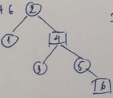

# Prob2:

a. 1, 2, 3, 4, 5, 6, 7, 8

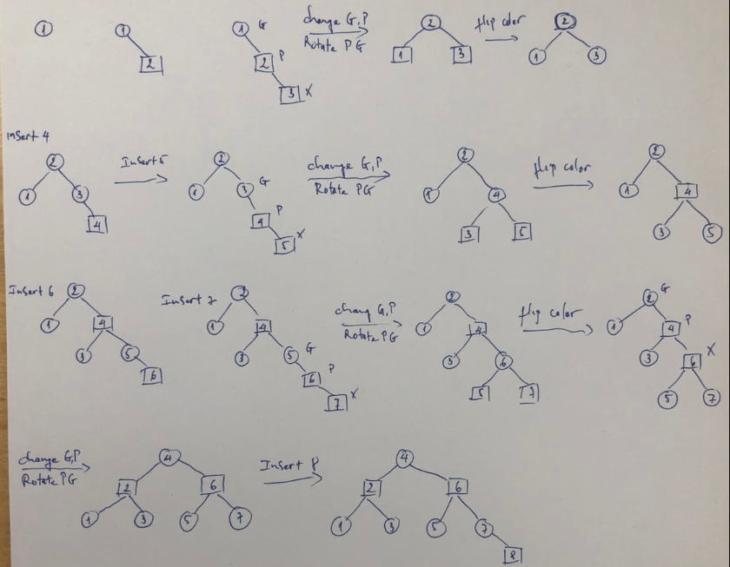

b. 3, 2, 1, 5, 4, 6

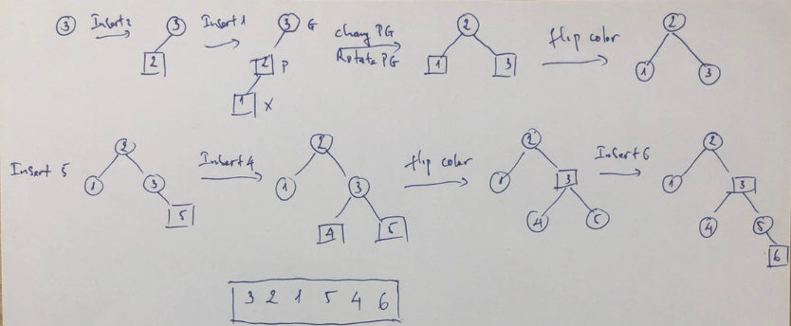

# Prob3:

static boolean IsPrime(int n) {

for (int i = 2; i < n; i++) {

if (n % i == 0)

return false;

}

return true;

}

**Asymptotic running time: O(n)**

# Prob4:

A. with T(n) = O(n)

* T(b) = O(2b)

B. b2 is o(2b), obviously