# Prob1:

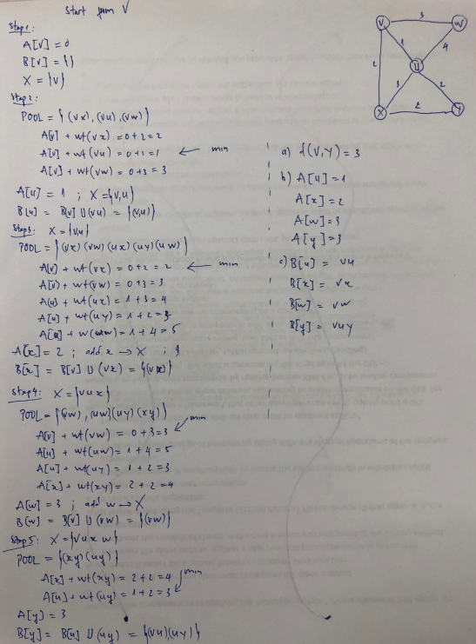

# Prob2:

1. There is no shortest path because Dijkstra’s Algorithm does not accept negative weight.
2. Dijkstra’s Algorithm: O(mn), DFS: O(m+n). When the range of weight is small DFS will be faster but when range of weight is big (like O(n4)) the running time of DFS will be O(m+n4)

# Prob3:

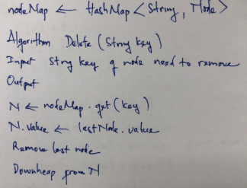

# Prob4:

