# readFileSync

1st request

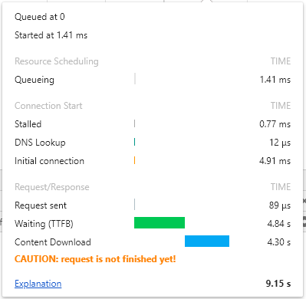

2nd Request

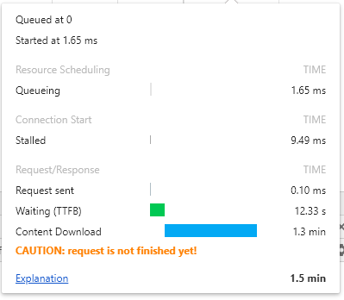

Since it read file Sync, 2nd request must wait for first request finish reading file to memory, so the waiting time of 2nd request is 12s, must longer than 1st one

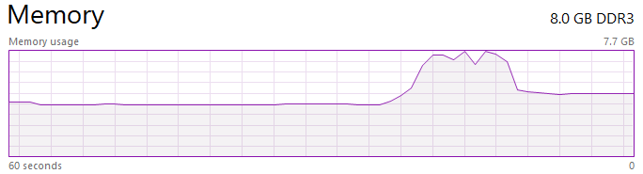

# readFile

1st

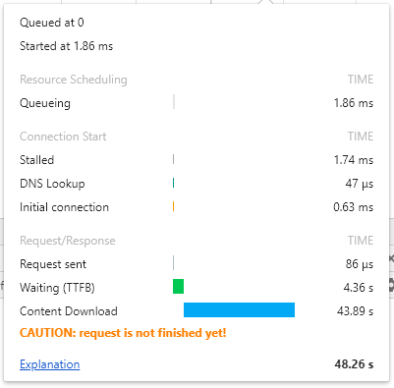

2nd



Since server not waiting for finishing reading file to the memory, the waiting time of both requests are almost the same

But till consume memory

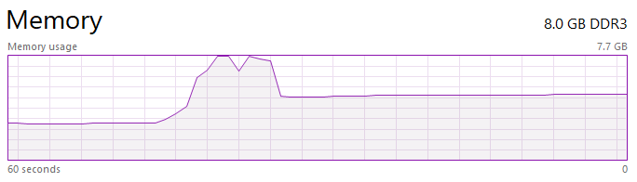

# createReadStream

1st

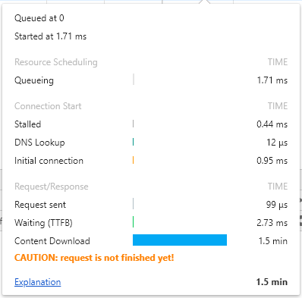

2nd



Since server not waiting for finishing reading file to the memory, the waiting time of both request is almost the same

But consume much less memory (almost nothing) compare to readFile

