Daily Report for IVY Training #2
Date: 20/1/2024
Name: Bui Tuan Anh

- Tech stack covered
- Langgraph chat bot by Answer common questions by searching the web
Key Learnings:
- Langgraph Chatbot: Answer common questions by searching the web
- Progress
- Basic chatbot with LangGraph
We'll first create a simple chatbot using LangGraph. This chatbot will respond directly to user messages. Though simple, it will illustrate the core concepts of building with LangGraph. By the end of this section, you will have a built rudimentary chatbot.
Start by creating a StateGraph. A StateGraph object defines the structure of our chatbot as a "state machine". We'll add nodes to represent the llm and functions our chatbot can call and edges to specify how the bot should transition between these functions.
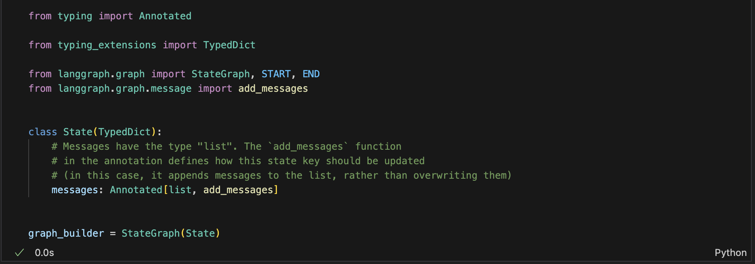
Next, add a "chatbot" node. Nodes represent units of work. They are typically regular python functions.
def chatbot(state: State):
return {"messages": [llm.invoke(state["messages"])]}
# The first argument is the unique node name
# The second argument is the function or object that will be called whenever
# the node is used.
graph_builder.add_node("chatbot", chatbot)

The add_messages function in our State will append the llm's response messages to whatever messages are already in the state.

Next, add an entry point. This tells our graph where to start its work each time we run it.
s
graph_builder.add_edge(START, "chatbot")
Similarly, set a finish point. This instructs the graph "any time this node is run, you can exit."
graph_builder.add_edge("chatbot", END)
Finally, we'll want to be able to run our graph. To do so, call "compile()" on the graph builder. This creates a "CompiledGraph" we can use invoke on our state.
graph = graph_builder.compile()
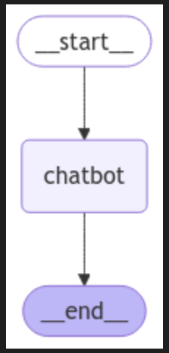
Here is the flow of basic LangGraph basic chatbot
Part 2: Enhancing the Chatbot with Tools
Define a tool
from langchain_community.tools.tavily_search import TavilySearchResults

tool = TavilySearchResults(max_results=2)
tools = [tool]
tool.invoke("Give me current weather in viet nam?")
output:
[{'url': 'https://www.weatherapi.com/',
'content': "{'location': {'name': 'Hanoi', 'region': '', 'country': 'Vietnam', 'lat': 21.033, 'lon': 105.85, 'tz_id': 'Asia/Bangkok', 'localtime_epoch': 1737414919, 'localtime': '2025-01-21 06:15'}, 'current': {'last_updated_epoch': 1737414900, 'last_updated': '2025-01-21 06:15', 'temp_c': 14.3, 'temp_f': 57.7, 'is_day': 0, 'condition': {'text': 'Mist', 'icon': '//cdn.weatherapi.com/weather/64x64/night/143.png', 'code': 1030}, 'wind_mph': 4.9, 'wind_kph': 7.9, 'wind_degree': 136, 'wind_dir': 'SE', 'pressure_mb': 1016.0, 'pressure_in': 30.0, 'precip_mm': 0.0, 'precip_in': 0.0, 'humidity': 82, 'cloud': 0, 'feelslike_c': 14.1, 'feelslike_f': 57.3, 'windchill_c': 15.2, 'windchill_f': 59.3, 'heatindex_c': 15.2, 'heatindex_f': 59.3, 'dewpoint_c': 9.6, 'dewpoint_f': 49.3, 'vis_km': 2.9, 'vis_miles': 1.0, 'uv': 0.0, 'gust_mph': 8.8, 'gust_kph': 14.2}}"},
{'url': 'https://www.easeweather.com/asia/vietnam/january',
'content': 'Weather in Vietnam in January 2025 - Detailed Forecast Weather in Vietnam for January 2025 Your guide to Vietnam weather in January - trends and predictions In general, the average temperature in Vietnam at the beginning of January is 23.7\xa0°C. Vietnam in January average weather Temperatures trend during January in Vietnam In January, Vietnam experiences varied weather conditions, with the northern regions typically being cooler than the south. Moving towards the end of January, the southern city of Ho Chi Minh City enjoys warmer weather with average temperatures around 28°. Overall, January in Vietnam offers a diverse range of weather conditions, from cooler temperatures in the north to warmer and drier climates in the south.'}]
Next we need to create a function to actually run the tools if they are called. We'll do this by adding the tools to a new node.
Below, we implement a BasicToolNode that checks the most recent message in the state and calls tools if the message contains tool_calls. It relies on the LLM's tool_calling support, which is available in Anthropic, OpenAI, Google Gemini, and a number of other LLM providers.
We will later replace this with LangGraph's prebuilt ToolNode to speed things up, but building it ourselves first is instructive.
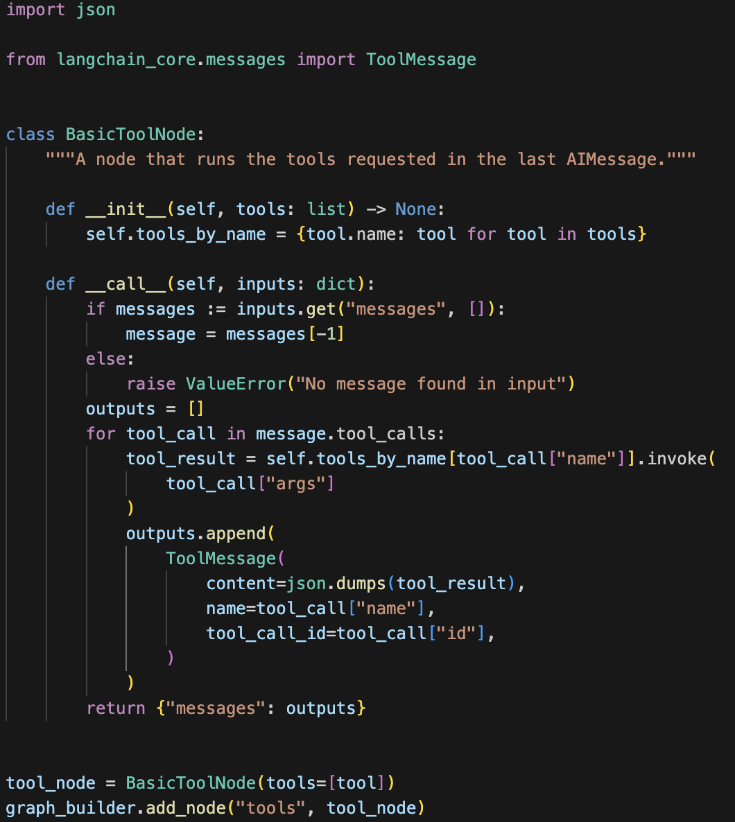
With the tool node added, we can define the conditional_edges.
Recall that edges route the control flow from one node to the next. Conditional edges usually contain "if" statements to route to different nodes depending on the current graph state. These functions receive the current graph state and return a string or list of strings indicating which node(s) to call next.
Below, call define a router function called route_tools, that checks for tool_calls in the chatbot's output. Provide this function to the graph by calling add_conditional_edges, which tells the graph that whenever the chatbot node completes to check this function to see where to go next.
The condition will route to tools if tool calls are present and END if not.
Later, we will replace this with the prebuilt tools_condition to be more concise, but implementing it ourselves first makes things more clear.
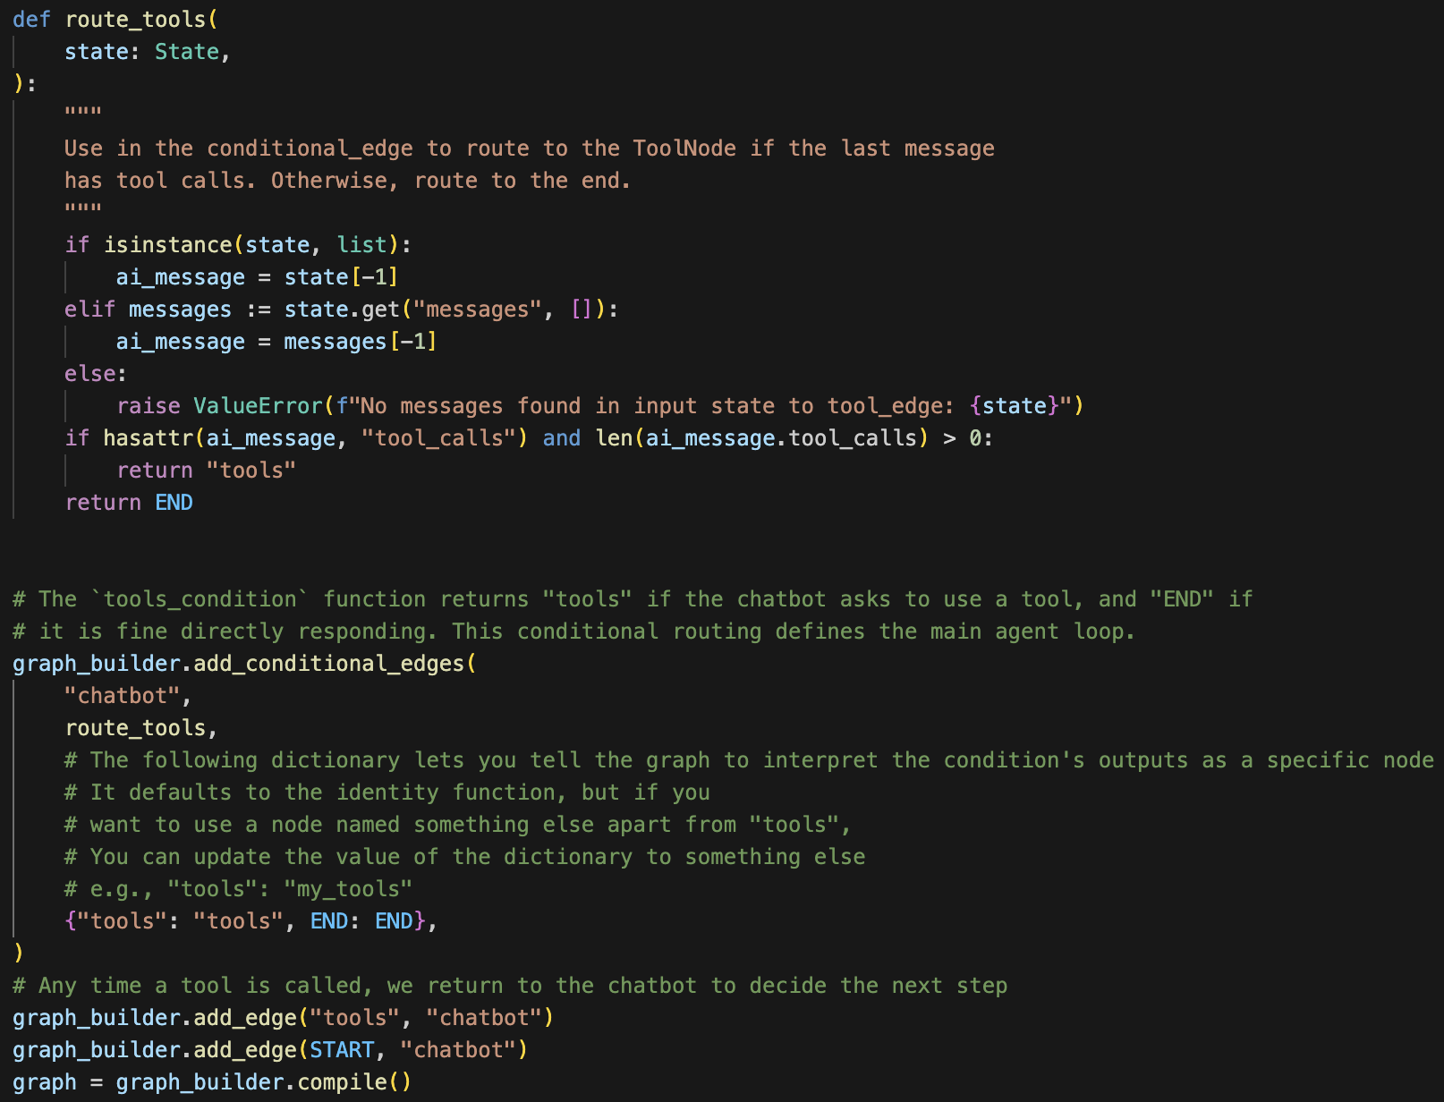
Notice that conditional edges start from a single node. This tells the graph "any time the 'chatbot' node runs, either go to 'tools' if it calls a tool, or end the loop if it responds directly.
Like the prebuilt tools_condition, our function returns the END string if no tool calls are made. When the graph transitions to END, it has no more tasks to complete and ceases execution. Because the condition can return END, we don't need to explicitly set a finish_point this time. Our graph already has a way to finish!
Let's visualize the graph we've built. The following function has some additional dependencies to run that are unimportant for this tutorial.
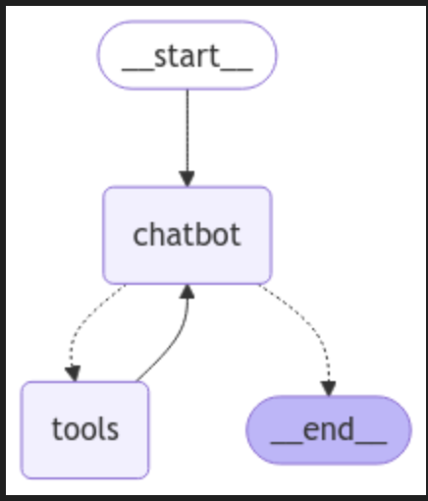\
user_input = "What do you know about LangGraph?"
stream_graph_updates(user_input)
Output:
Assistant: LangGraph is a library designed to help build stateful multi-agent applications using language models. It provides tools for creating workflows and state machines to coordinate multiple AI agents or language model interactions. LangGraph is built on top of LangChain, leveraging its components while adding graph-based coordination capabilities. It's particularly useful for developing more complex, stateful AI applications that go beyond simple query-response interactions.

