Daily Report for IVY Training #5
Date: 23/1/2024
Name: Bui Tuan Anh

- Tech stack covered
- FastAPI
- ChromaDB
- SQLlite
- RAG
- Progress
Firstly, i discover about FastAPI, framework of backend in Python.
Folder Structure
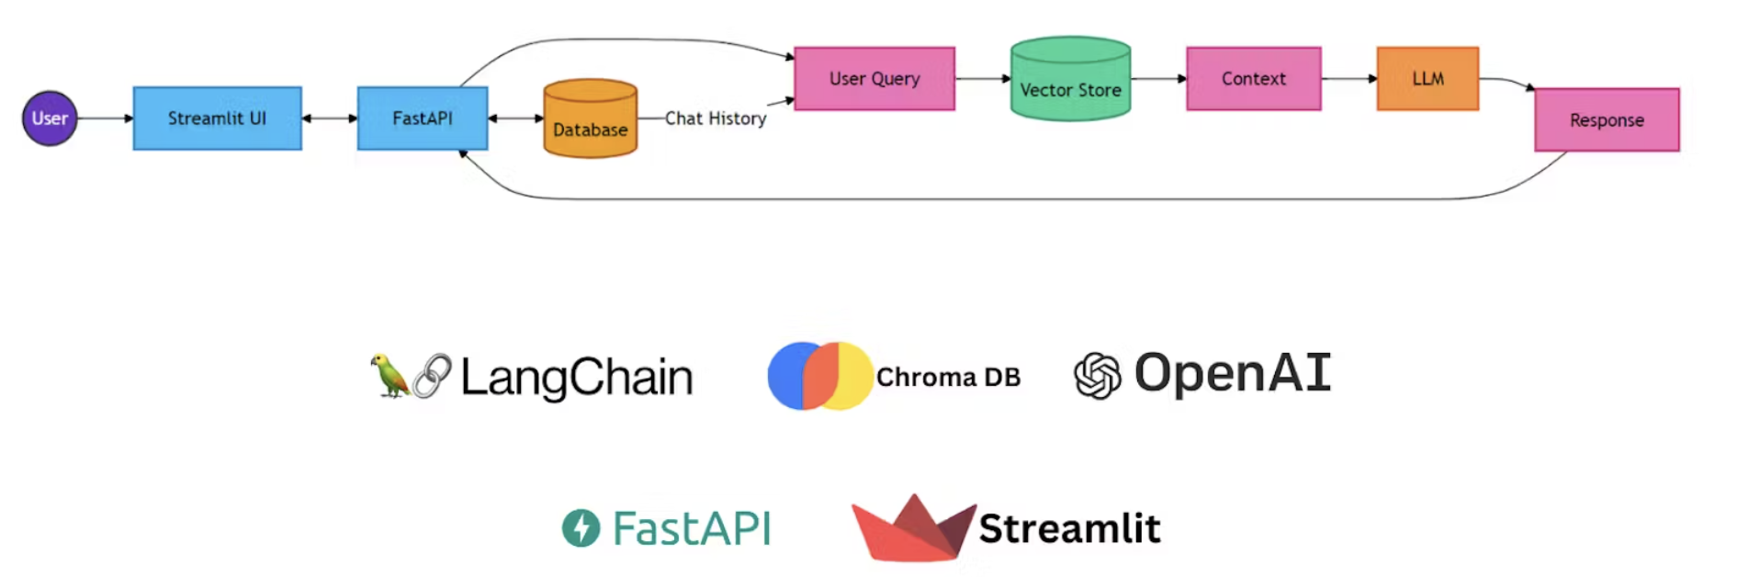
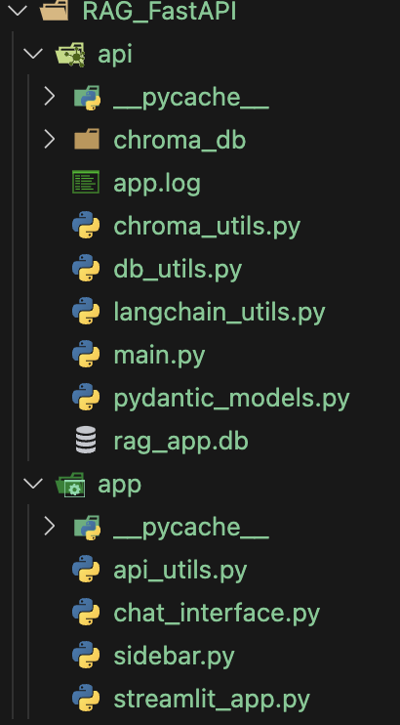

main.py: This is the entry point of our FastAPI application. It defines the API routes and orchestrates the different components of our system.
chroma_utils.py: Contains utilities for interacting with the Chroma vector store, including functions for indexing documents and performing similarity searches.
db_utils.py: Handles database operations, including storing and retrieving chat history and document metadata.
langchain_utils.py: Encapsulates the LangChain-specific logic, such as creating the RAG chain and configuring the language model.
pydantic_models.py: Defines Pydantic models for request and response validation, ensuring type safety and clear API contracts.
Setting Up the FastAPI Application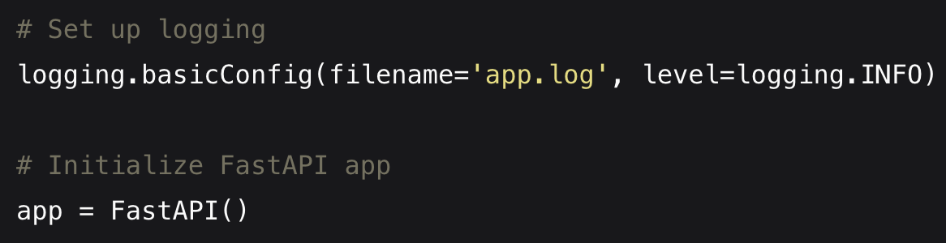
Defining API Endpoints
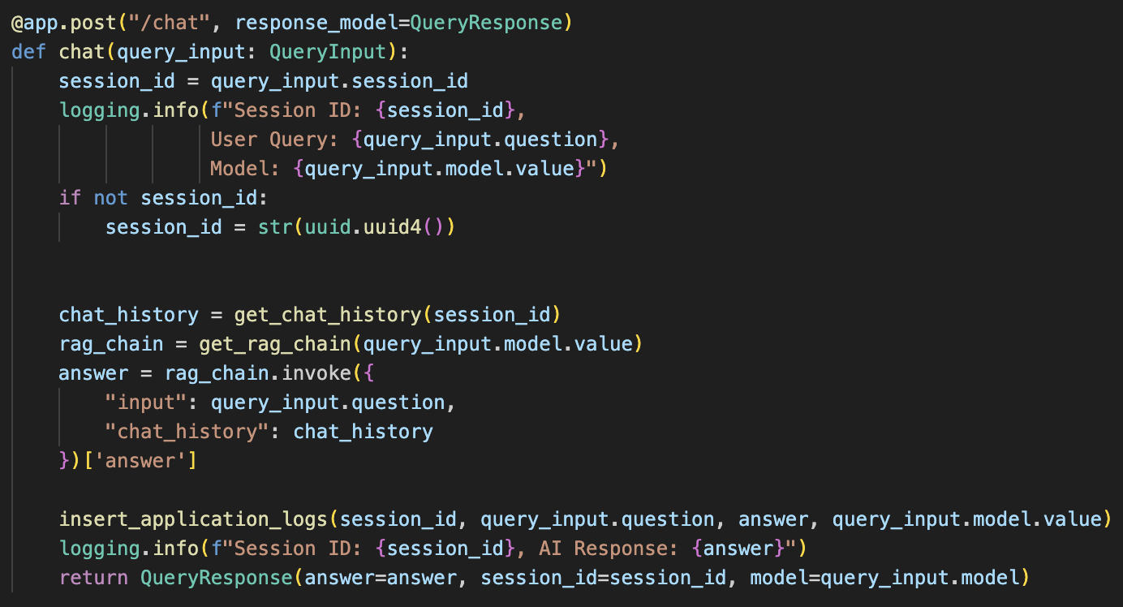

Data Models with Pydantic
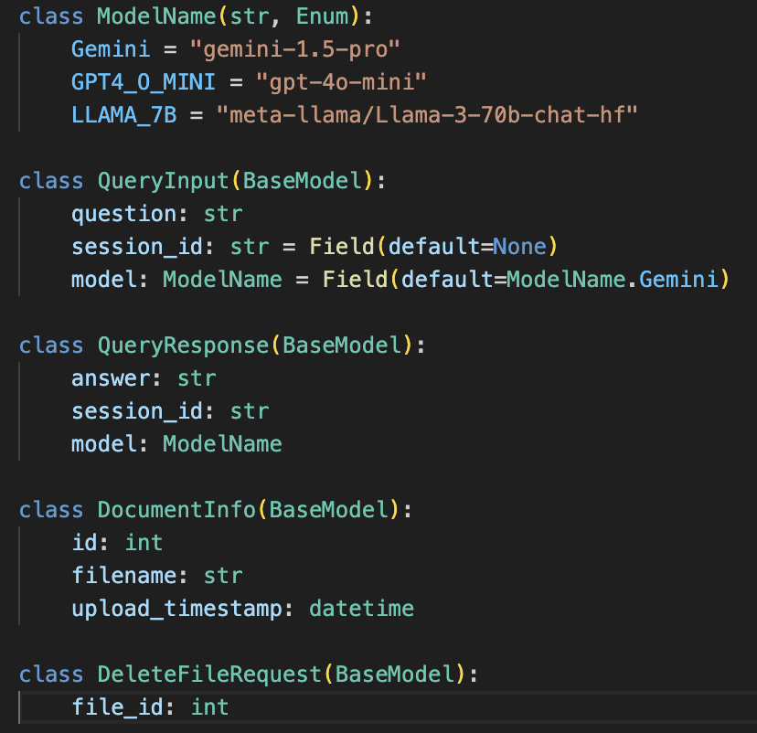
ModelName (Enum):
This enum defines the available language models for our RAG system.
Using an enum ensures that only valid model names can be used.
QueryInput:
Represents the input for a chat query.
question: The user's question (required).
session_id: Optional session ID. If not provided, one will be generated.
model: The language model to use, defaulting to GPT4_O_MINI.
QueryResponse:
Represents the response to a chat query.
answer: The generated answer.
session_id: The session ID (useful for continuing conversations).
model: The model used to generate the response.
DocumentInfo:
Represents metadata about an indexed document.
id: Unique identifier for the document.
filename: Name of the uploaded file.
upload_timestamp: When the document was uploaded and indexed.
DeleteFileRequest:
Represents a request to delete a document.
file_id: The ID of the document to be deleted.
- Managing Documents and Chat History
The db_utils.py file contains functions for interacting with our SQLite database. We use SQLite for its simplicity and ease of setup, making it perfect for prototyping and small to medium-scale applications. Tomorrow i will try to move to SQLAchemy for this database.
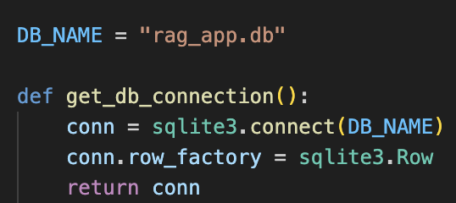
Creating Database Tables

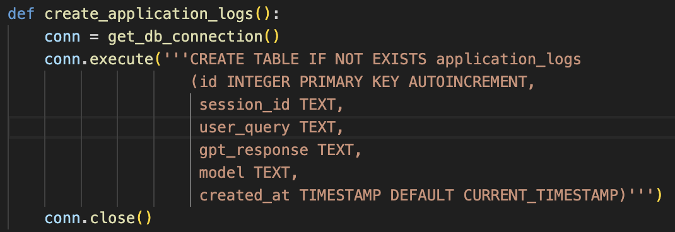
Managing Chat Logs
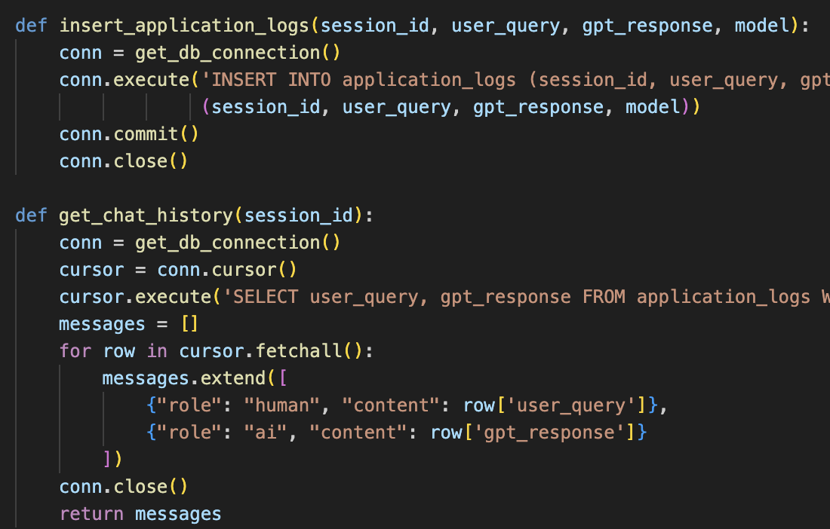
Vector Store Integration
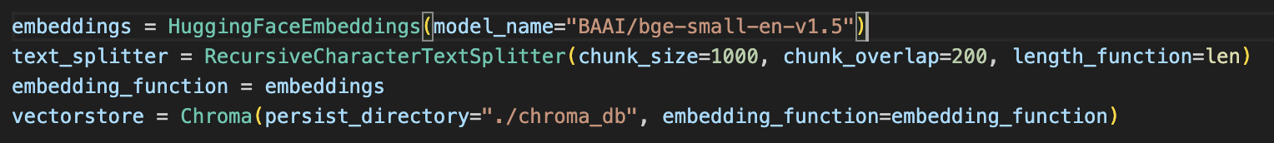
Here, we import necessary modules and initialize our text splitter, embedding function, and Chroma vector store. The RecursiveCharacterTextSplitter is used to split documents into manageable chunks, while OpenAIEmbeddings provides the embedding function for our documents.
Document Loading and Splitting

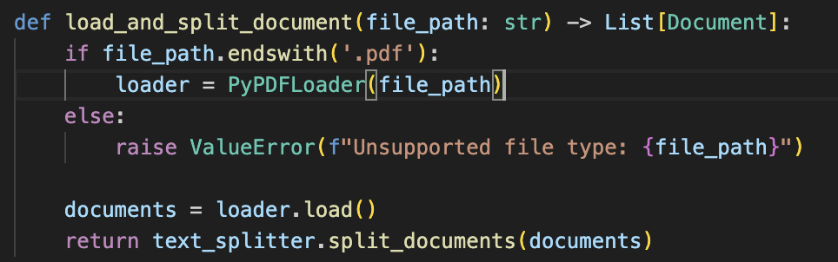

This function handles loading PDF document types and splitting it into chunks. It uses the appropriate loader based on the file extension and then applies our text splitter to create manageable document chunks.
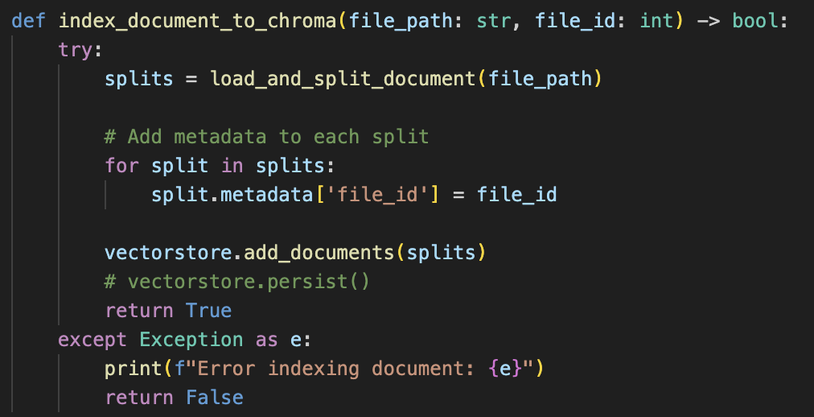
This function takes a file path and a file ID, loads and splits the document, adds metadata (file ID) to each split, and then adds these document chunks to our Chroma vector store. The metadata allows us to link vector store entries back to our database records.
LangChain RAG Implementation
Setting Up Prompts
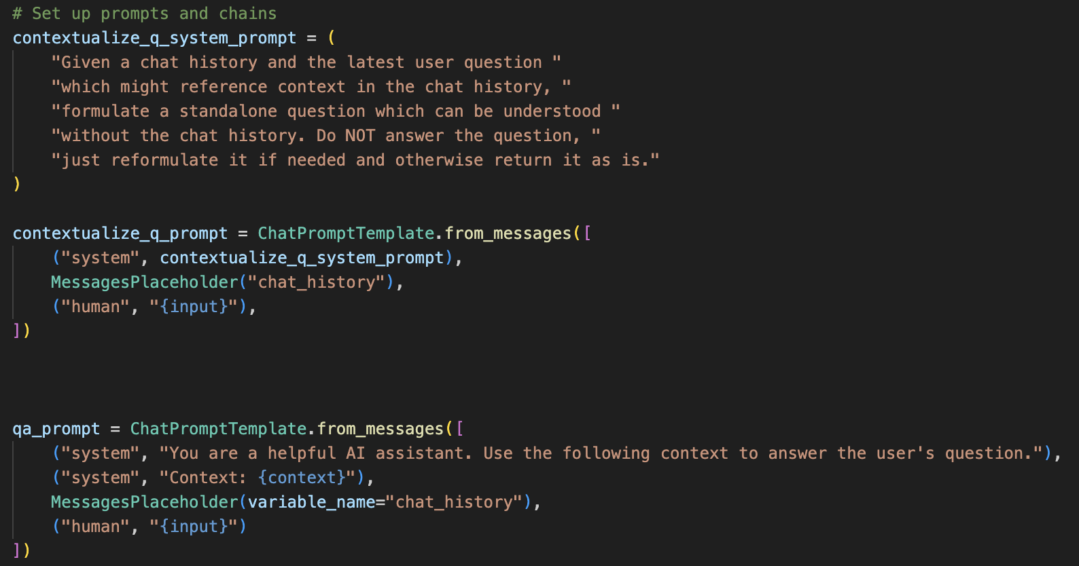
We define two main prompts:
contextualize_q_prompt: Used to reformulate the user's question based on chat history.
qa_prompt: Used to generate the final answer based on the retrieved context and chat history.
Creating the RAG Chain
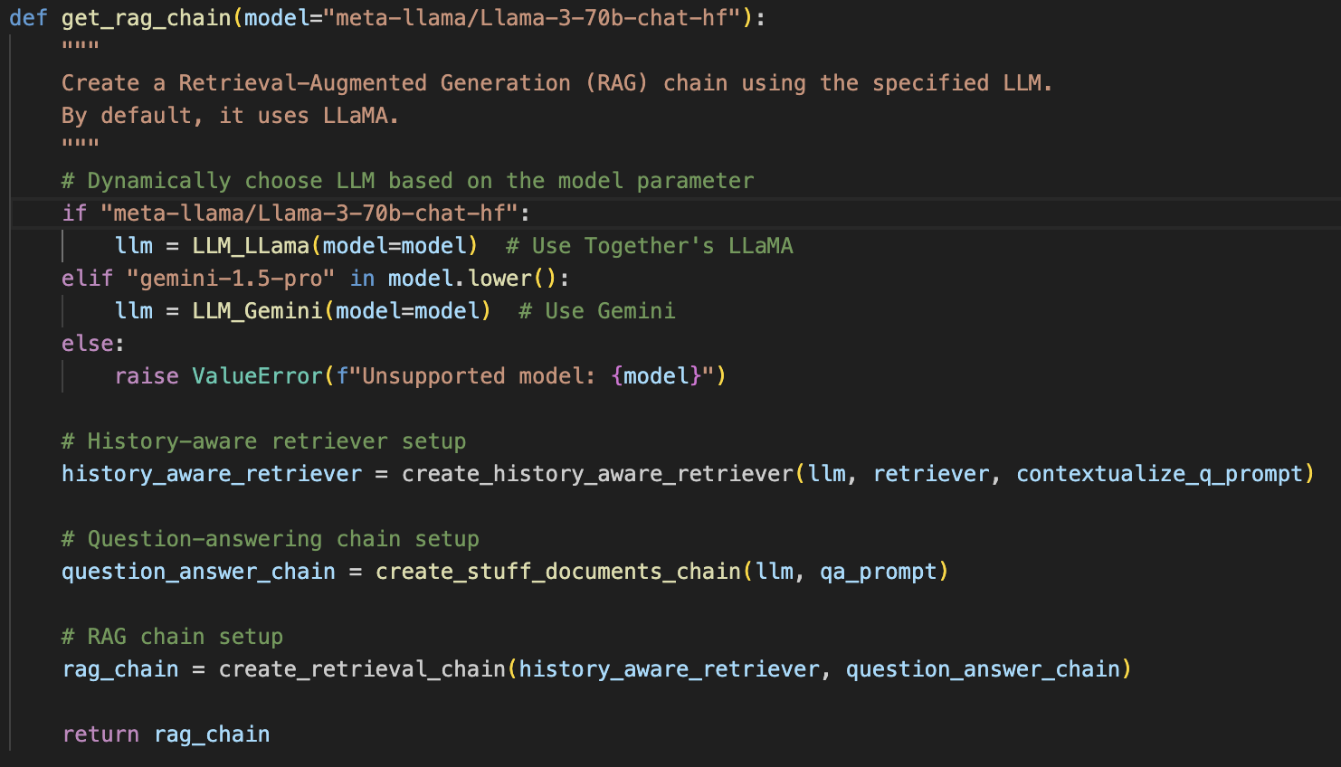
- It initializes the language model Gemini or Llama with the specified model name.
- Creates a history-aware retriever that can understand context from previous interactions.
- Sets up a question-answering chain that combines retrieved documents to generate an answer.
- Finally, it creates the full RAG chain by combining the retriever and question-answering chain.
Integration with Main Application
In our main.py, we use this RAG chain in the chat endpoint:
This shows how the RAG chain is instantiated with the user-specified model and invoked with the user's question and chat history.
By centralizing our LangChain logic in langchain_utils.py, we maintain a clean separation of concerns and make it easier to modify or extend our RAG system in the future. This modular approach allows us to easily experiment with different models, retrievers, or chain structures without affecting the rest of the application.
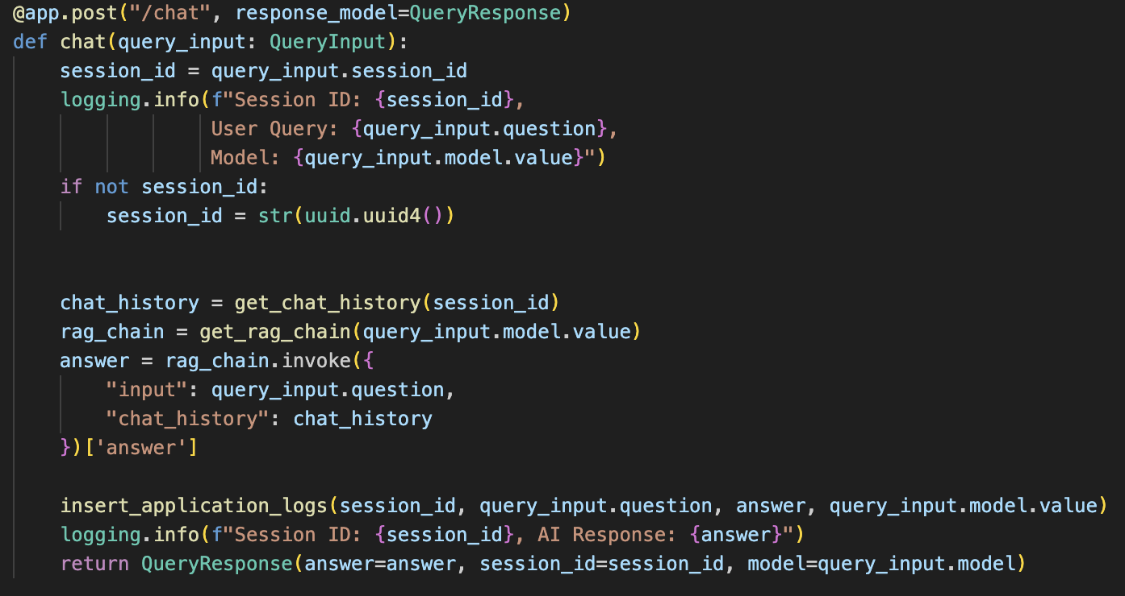
Next day planning: I will learn how to work with streamlit and connect from FastAPI to Streamlit and sync backend with front end. And update database from SQLite to SQLAchemy and the Conservation Chatbot to Langgraph.

