Daily Report for IVY Training #4
Date: 22/1/2024
Name: Bui Tuan Anh

- Tech stack covered
- Memory in RAG
Key Learnings:
- "Memory" of past questions and answers
- Progress
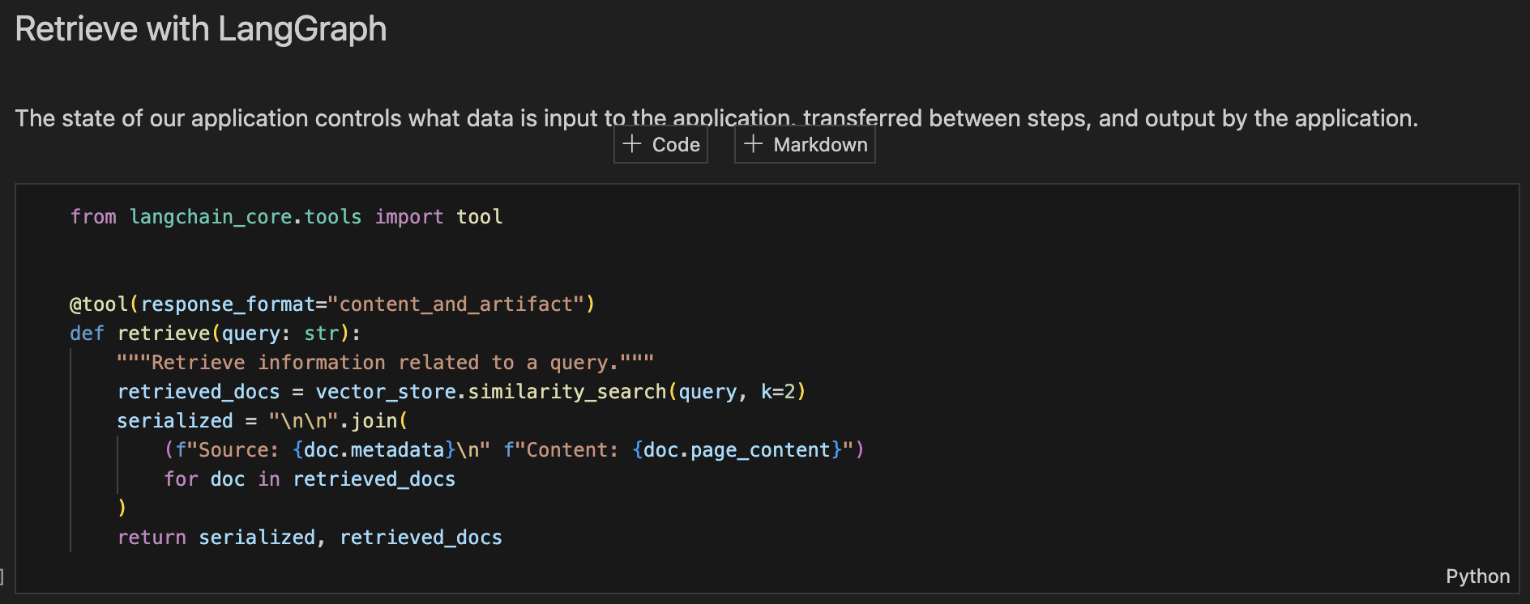
Leveraging tool-calling to interact with a retrieval step has another benefit, which is that the query for the retrieval is generated by our model. This is especially important in a conversational setting, where user queries may require contextualization based on the chat history. For instance, consider the following exchange:
Human: "What is Task Decomposition?"
AI: "Task decomposition involves breaking down complex tasks into smaller and simpler steps to make them more manageable for an agent or model."
Human: "What are common ways of doing it?"
In this scenario, a model could generate a query such as "common approaches to task decomposition". Tool-calling facilitates this naturally. As in the query analysis section of the RAG tutorial, this allows a model to rewrite user queries into more effective search queries. It also provides support for direct responses that do not involve a retrieval step (e.g., in response to a generic greeting from the user).
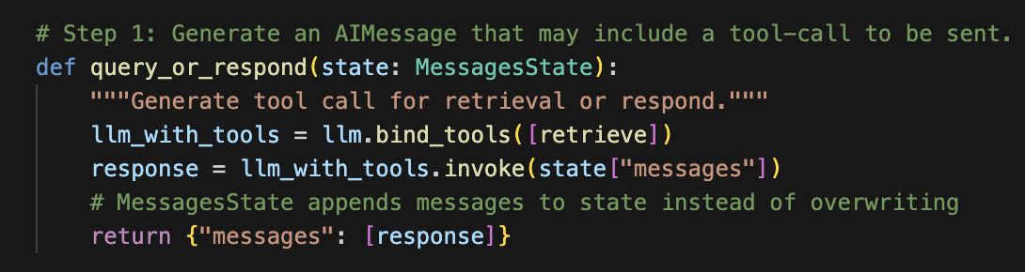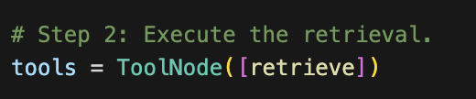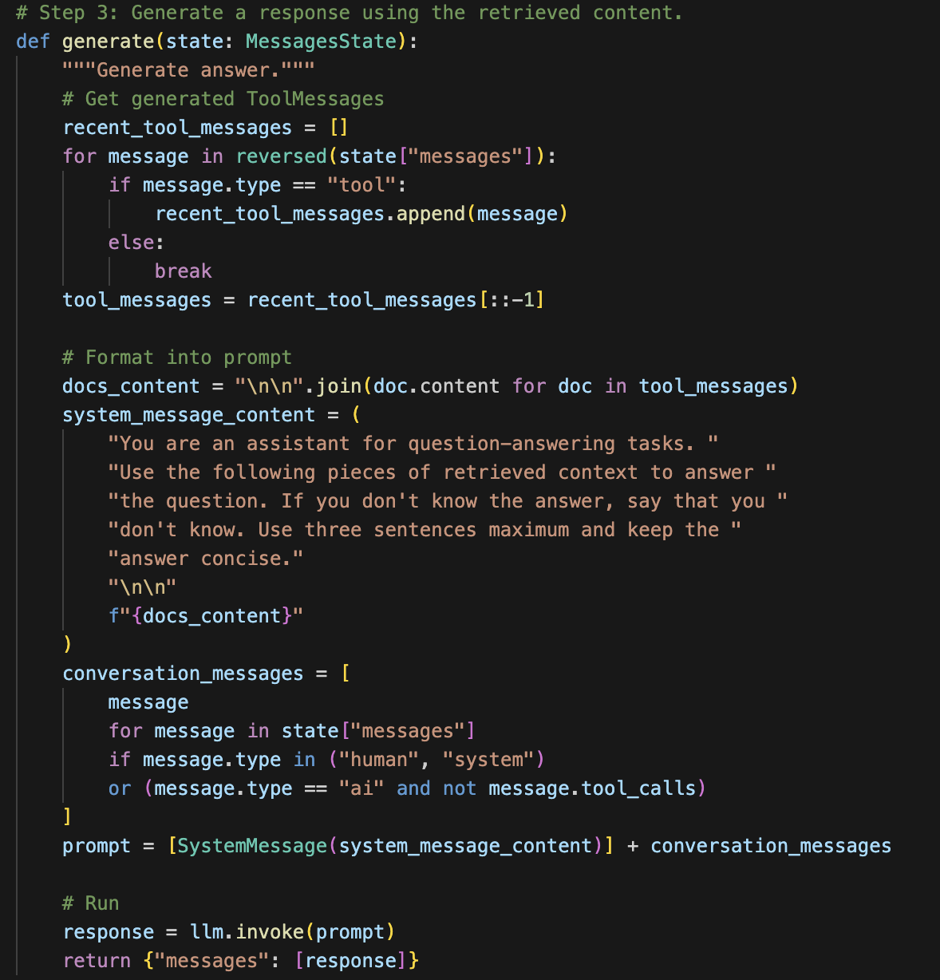
Our graph will consist of three nodes:
- A node that fields the user input, either generating a query for the retriever or responding directly;
- A node for the retriever tool that executes the retrieval step;
- A node that generates the final response using the retrieved context.
Finally, we compile our application into a single graph object. In this case, we are just connecting the steps into a sequence. We also allow the first query_or_respond step to "short-circuit" and respond directly to the user if it does not generate a tool call. This allows our application to support conversational experiences-- e.g., responding to generic greetings that may not require a retrieval step
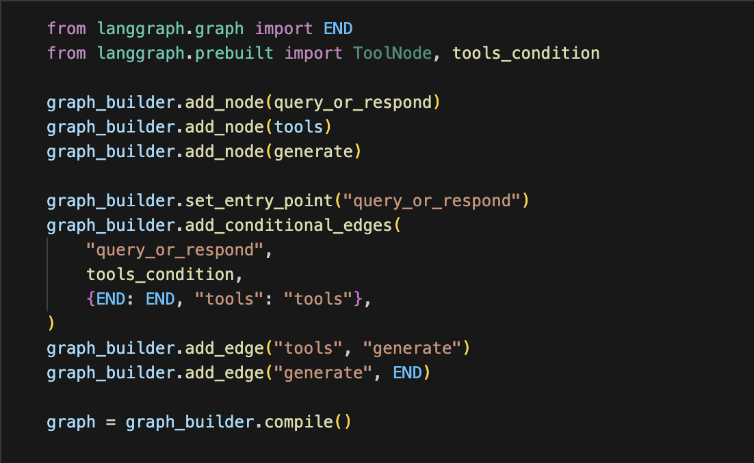
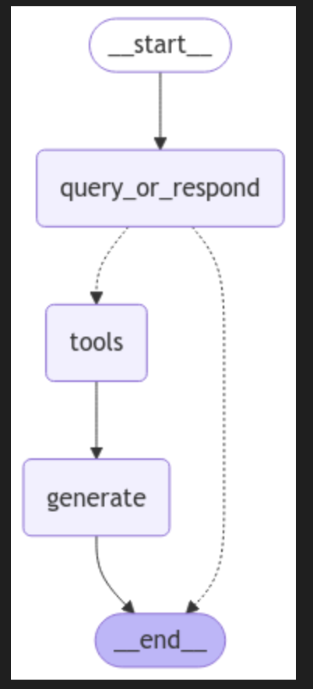
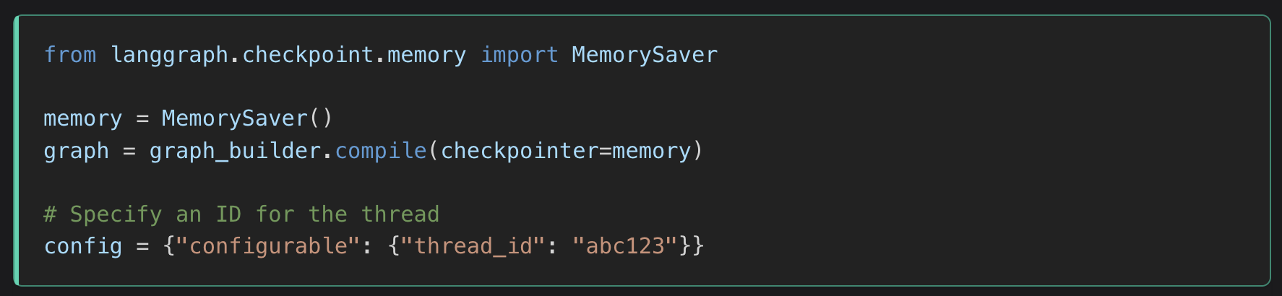
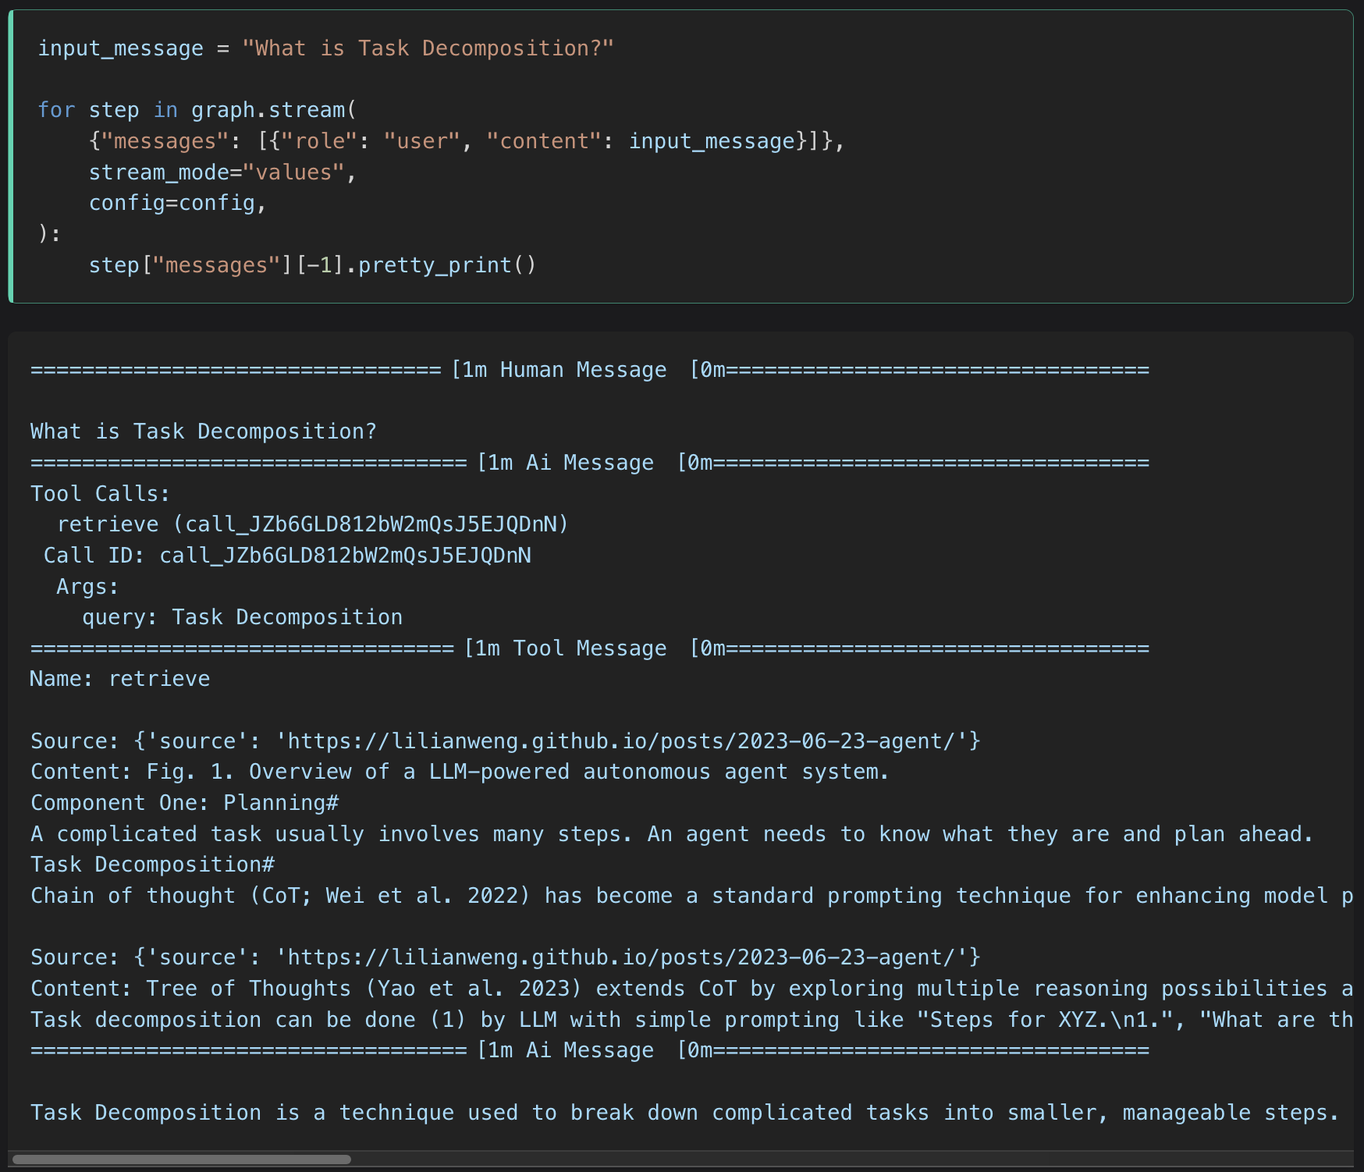
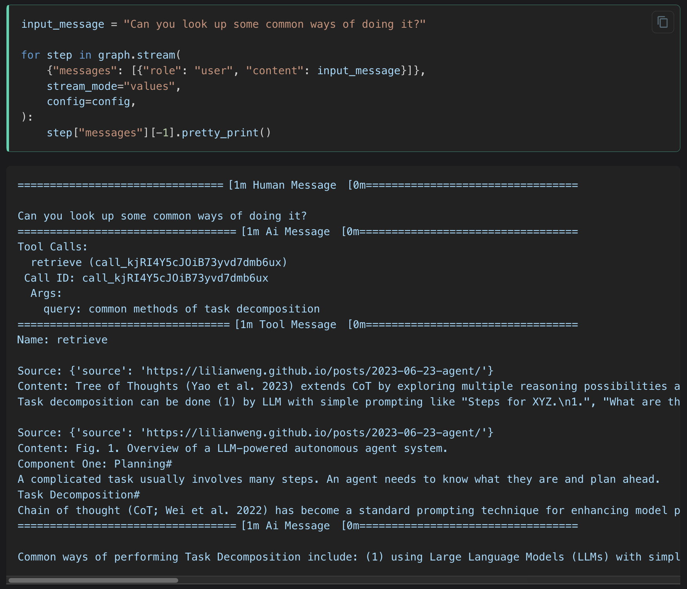
Management of chat history
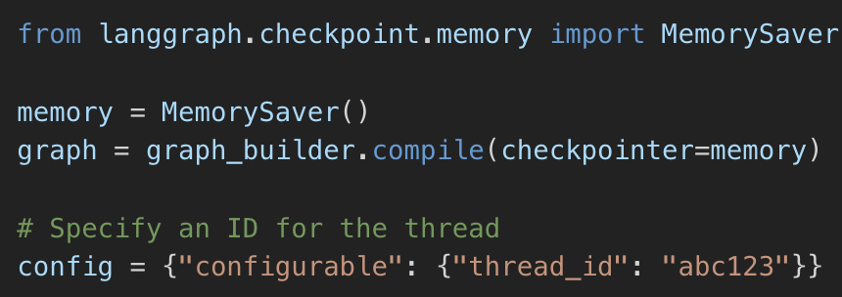
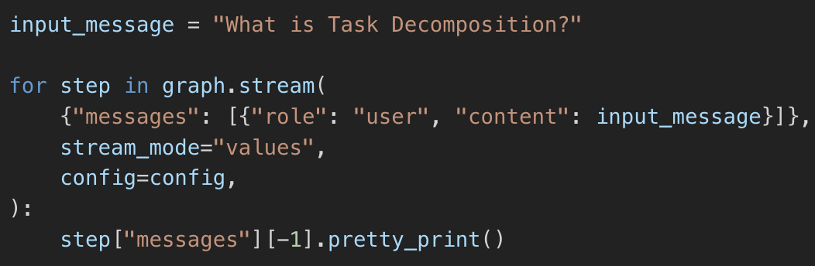
In production, the Q&A application will usually persist the chat history into a database, and be able to read and update it appropriately.
To manage multiple conversational turns and threads, all we have to do is specify a checkpointer when compiling our application. Because the nodes in our graph are appending messages to the state, we will retain a consistent chat history across invocations.
LangGraph comes with a simple in-memory checkpointer.

