Daily Report for IVY Training #3 (Github)
Date: 21/1/2024
Name: Bui Tuan Anh

- Tech stack covered
- PDF Load in Langchain, langchain parser PDF
- Vector DB Installation, VectorStore Embedding
Key Learnings:
- PDF (unstructured data io), langchain parser PDF
- Vector DB Installation, VectorStore Embedding
- Progress
- PDF (unstructured data io), langchain parser PDF
First, you'll need to choose a PDF to load. We'll use a document from Nike's annual public SEC report.
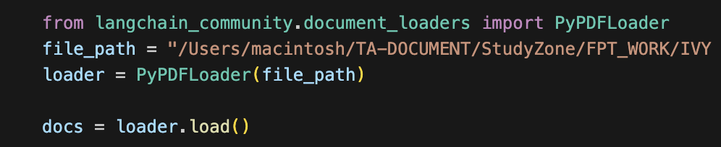
This step is to load it into a format that an LLM can more easily handle, since LLMs generally require text inputs. LangChain has a few different built-in document loaders for this purpose which you can experiment with. Above, i will use one powered by the pypdf package that reads from a filepath.
Note:
The loader reads the PDF at the specified path into memory.
It then extracts text data using the pypdf package.
Finally, it creates a LangChain Document for each page of the PDF with the page's content and some metadata about where in the document the text came from.
Splitting documents
Our loaded document has large characters which is too long to fit into the context window of many models. Even for those models that could fit the full post in their context window, models can struggle to find information in very long inputs.To handle this we’ll split the Document into chunks for embedding and vector storage. This should help us retrieve only the most relevant parts of the blog post at run time.
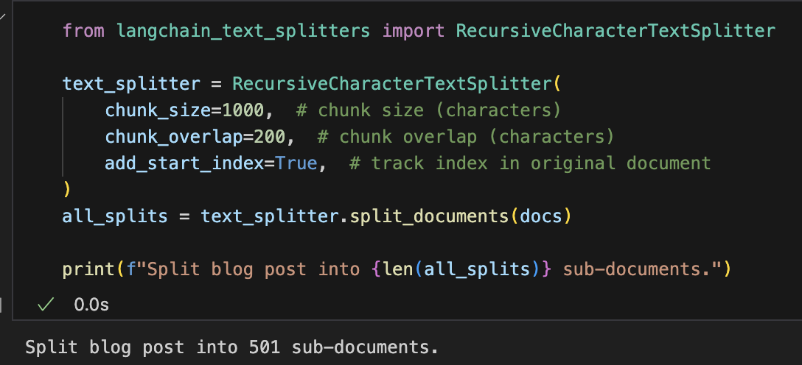
RecursiveCharacterTextSplitter: Recursively split the document using common separators like new lines until each chunk is the appropriate size. This is the recommended text splitter for generic text use cases.
TextSplitter: Object that splits a list of Documents into smaller chunks.
Storing documents
Now i need to index our 66 text chunks so that we can search over them at runtime.
Our approach is to embed the contents of each document split and insert these embeddings into a vector store. Given an input query, i can then use vector search (ChromaDB) to retrieve relevant documents.
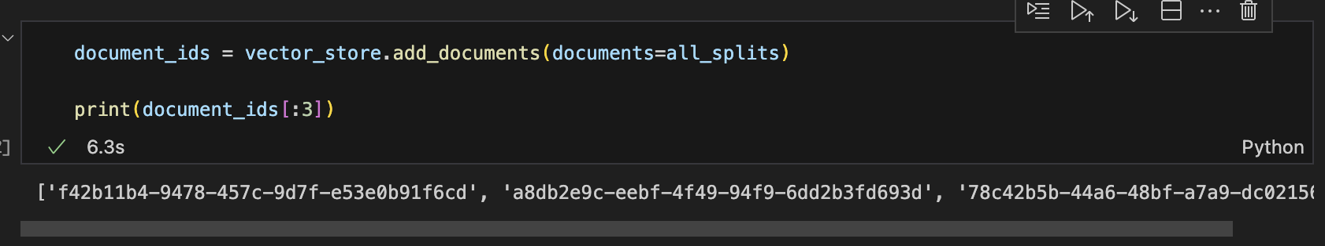
Embeddings: Wrapper around a text embedding model, used for converting text to embeddings. (BAAI/BAAI/bge-small-en-v1.5).
VectorStore (ChromaDB) : Wrapper around a vector database, used for storing and querying embeddings.
This completes the Indexing portion of the pipeline. At this point we have a query-able vector store containing the chunked contents of our blog post. Given a user question, we should ideally be able to return the snippets of the blog post that answer the question
Finally, you'll use some built-in helpers to construct the final rag_chain
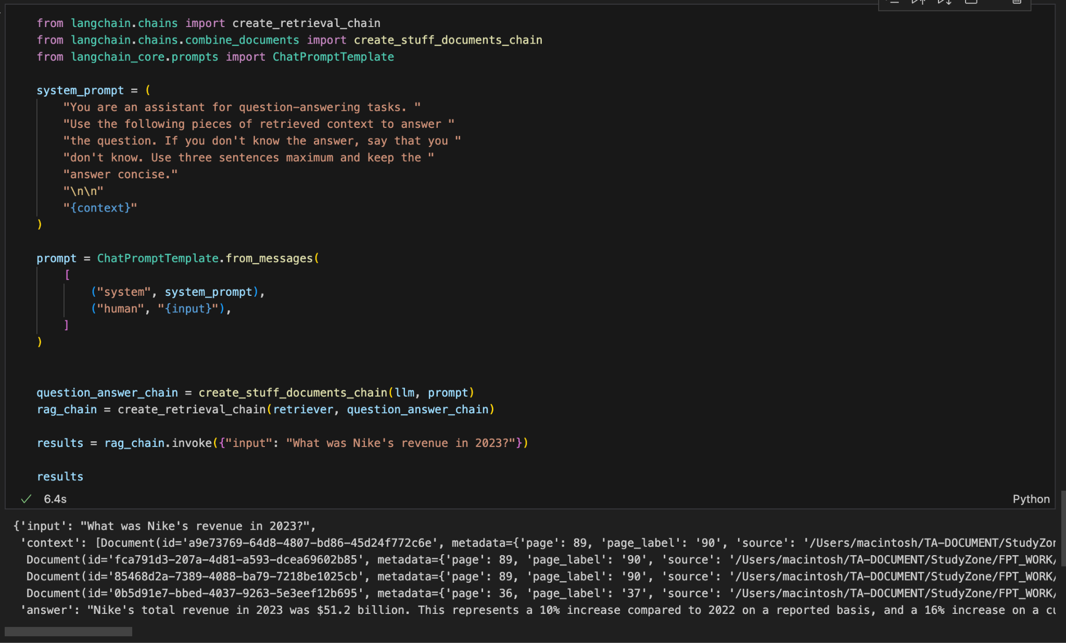
Thats all for today, tomorrow i will combine RAG with Langgraph for more optimize chatbot.

