**Presented By: Varun Narayan Upadhay**

**Zamiya Akbar**

**Adarsh Patel**

FLIGHT BOOKING SYSTEM

Author Name

[Email address]

**INTRODUCTION**

**Airline reservation systems** (**ARS**) are systems that allow an airline to sell their inventory (seats). It contains information on schedules and fares and contains a database of reservations (or passenger name records) and of tickets issued .

The Airline Reservation System projecimplementation of a general Airline Ticketing website which helps the customer to search the availability and prices of various airline tickets, along with the different packages available with the reservations.

This project also covers various features like online registration of the users, modifying the details of the website by the management staff or administrator of the website by adding deleting or modifying the customer details flights or

packages information in general this website would be designed to perform like any other airline ticketing website available online.

**Existing System**

The existing system is that the passenger must fill up the data manually and must submit it to the reservation counter. It may take a lot of time to process it and to book the flight. Therefore, there is wastage of time. Since the data is entered manually, the probability of error or mistakes is high.

**Proposed system**

Objective is to overcome the major limitation of the existing enabling effective management of the customer details there by improving the performance. With improved computerization being involves in the maintenance of customer details, error & inconsistencies can be kept at par Easy retrieval of data will be made possible by finding techniques. Validation of data will ensure only accurate, valid & complete data is stored in the database. Proper monitoring of the processes from customer registration to activation.

**List of Stackholders**

|  |  |  |  |  |
| --- | --- | --- | --- | --- |
| **S No.** | **NAME** | **EMAIL** | **ROLE** | **RACI** |
| **1.** | **Shammi**  **Kapoor** |  | **CG**  **mentor** | **IC** |
| **2.** | **Hariom**  **Dubey** |  | **TIT**  **mentor** | **A** |
| **3.** | **Dr. Manoj Tyagi** |  | **TIT**  **mentor** | **A,I** |
| **4.** | **Zamiya**  **Akbar** |  | **TIT**  **student** | **R** |
| **5.** | **Varun**  **Upadhyay** |  | **TIT  student** | **R** |
| **6.** | **Adarsh**  **Patel** |  | **TIT  student** | **R** |

## Functional Requirement

## User Login

## 2. User  Search for flight (arrival +destination +date of travel)

## 3. user Select the flight (base on time / perfernces)

## 4. user enter detials

## 5. make payment

## 6.confrimation notification

## **USER INTERFACES**

## **Home.jsp**-The home page for Airline Reservation System Website

## **Register.jsp**-The page provided for the Customer Registration

## **Customer.jsp** - The home page that appears after the customer logs in

## **FlightSearch.jsp**-The page which helps the customer to search for the available flights

## **FlightBooking.jsp**-The page which enables the customer to make reservation for the flights available online

## **Actors**

## 1.Admin

## 2.User

## 3.Airline (operators)

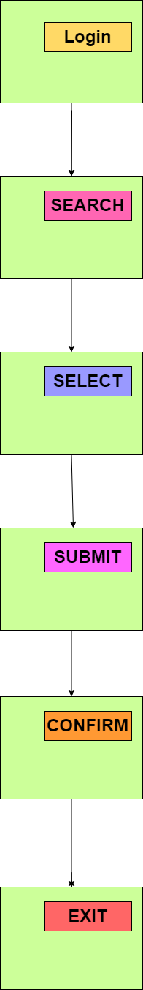

**UI MOCK**

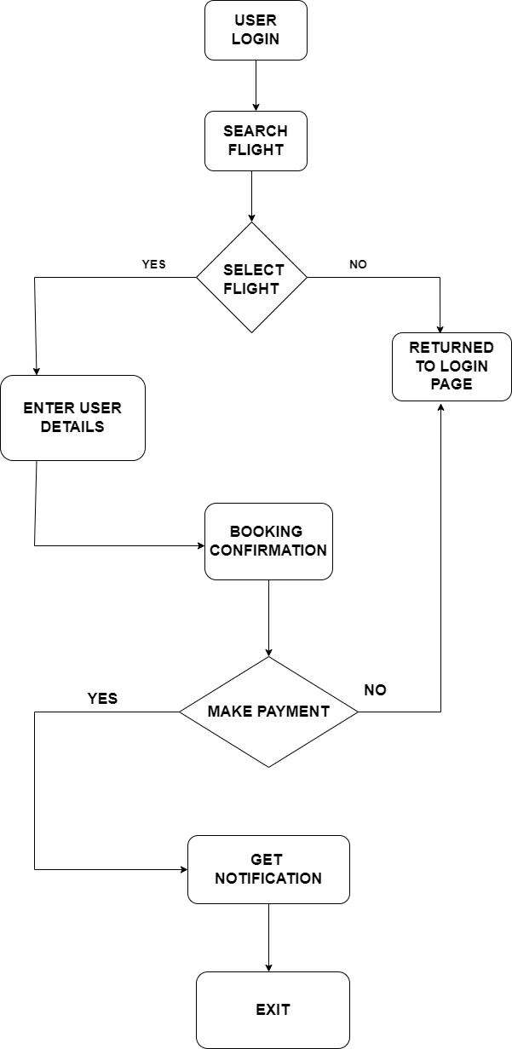

**DATA FLOW DIAGRAM**

**CLASS DIAGRAM**

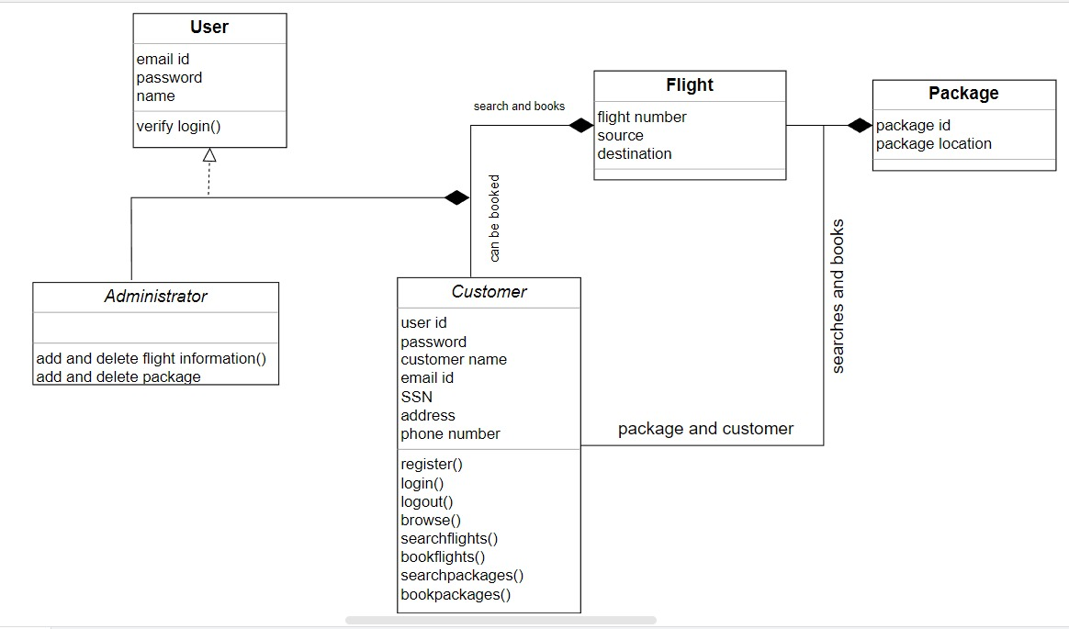

**TOOLS AND TECHNOLOGIES**

**Technologies Used In FrontEnd**

* HTML
* CSS
* Bootstrap
* React

**Technologies Used In Backend**

* JAVA
* Spring Boot
* Maven
* Thymeleaf
* Java Server Pages
* Java Persistance API

**Tools Used**

* **Server –** Apache Tomcat Server (Version 9)
* **IDE-** Spring Tool Suit
* **Data Base-** Postgres SQL
* Windows 10 or 11
* RAM: 1GB or Above

**Sequence DIAGRAM**

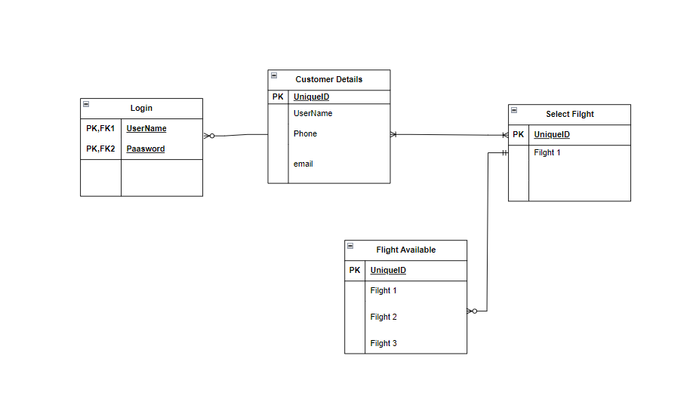

**VERSIONING**

|  |  |  |  |  |  |  |
| --- | --- | --- | --- | --- | --- | --- |
| DATE | VERSION | AUTHOR | REVIEWER | APPROVED DATE | APPROVE | REMARKS |
| 28/03/2023 | 1.0 | Varun , Zamiya  And Adarsh |  |  |  |  |
|  |  |  |  |  |  |  |