搖桿對應

|  |  |  |  |  |
| --- | --- | --- | --- | --- |
|  | 紅燈不亮 | 紅燈亮 | 功能 | 修改 |
| 按鈕上 | a1 -32767 | a5 -32767 |  |  |
| 按鈕下 | a1 32767 | a5 32767 |  |  |
| 按鈕左 | a0 -32767 | a4 -32767 |  |  |
| 按鈕右 | a0 32767 | a4 32767 |  |  |
| 左搖桿上 | a1 -32767 | a1 0~-32767 | 前進 |  |
| 左搖桿下 | a1 32767 | a1 0~32767 | 後退 |  |
| 左搖桿左 | a0 -32767 | a0 0~-32767 | 往左 | 往左 |
| 左搖桿右 | a0 32767 | a0 0~32767 | 往右 | 往右 |
| 三角 | 0 | 0 |  |  |
| X | 2 | 2 | 緊急停止 | 緊急停止 |
| 正 | 3 | 3 |  |  |
| 圓 | 1 | 1 |  |  |
| 右搖桿上 | 0 | a3 0~-32767 |  | 前進 |
| 右搖桿下 | 2 | a3 0~32767 |  | 後退 |
| 右搖桿左 | 3 | a2 0~-32767 |  |  |
| 右搖桿右 | 1 | a2 0~32767 |  |  |
| L1 | 4 | 4 | 往左一點 | 往左一點 |
| L2 | 6 | 6 |  |  |
| R1 | 5 | 5 | 往右一點 | 往右一點 |
| R2 | 7 | 7 |  |  |
| Select | 8 | 8 |  |  |
| Start | 9 | 9 |  |  |
| mode | 12 | 12 |  |  |
| 左搖按鈕 | 10 | 10 |  |  |
| 右搖按鈕 | 11 | 11 |  |  |

將controller.py覆蓋原donkeycar/parts/controller.py

其做法是增加類別，複製PS3改名PS2

class PS2Joystick(Joystick):

'''

An interface to a physical PS2 joystick available at /dev/input/js0

Contains mapping that work for Raspian Stretch drivers

'''

def __init__(self, *args, **kwargs):

super(PS2Joystick, self).__init__(*args, **kwargs)

self.axis_names = {

0x00 : 'left_stick_horz',

0x01 : 'left_stick_vert',

0x02 : 'right_stick_horz',

0x05 : 'right_stick_vert',

0x04 : 'L2_pressure',

0x03 : 'R2_pressure',

}

self.button_names = {

0x138: 'select',

0x139: 'start',

0x13c: 'PS', # a 316

0x136: 'L2',

0x134: 'L1',

0x135: 'R1',

0x137: 'R2',

0x130: "triangle",

0x132: "cross",

0x133: "square",

0x131: "circle",

0x220: 'dpad_up', # d 544

0x221: 'dpad_down', # e 545

0x222: 'dpad_left', # f 546

0x223: 'dpad_right', # 10 547

}

與

class PS2JoystickController(JoystickController):

'''

A Controller object that maps inputs to actions

'''

def __init__(self, *args, **kwargs):

super(PS2JoystickController, self).__init__(*args, **kwargs)

def init_js(self):

'''

attempt to init joystick

'''

try:

self.js = PS2Joystick(self.dev_fn)

if not self.js.init():

self.js = None

except FileNotFoundError:

print(self.dev_fn, "not found.")

self.js = None

return self.js is not None

def init_trigger_maps(self):

'''

init set of mapping from buttons to function calls

'''

self.button_down_trigger_map = {

'select' : self.toggle_mode,

'circle' : self.toggle_manual_recording,

'triangle' : self.erase_last_N_records,

'cross' : self.emergency_stop,

'dpad_up' : self.increase_max_throttle,

'dpad_down' : self.decrease_max_throttle,

'start' : self.toggle_constant_throttle,

"R1" : self.chaos_monkey_on_right,

"L1" : self.chaos_monkey_on_left,

}

self.button_up_trigger_map = {

"R1" : self.chaos_monkey_off,

"L1" : self.chaos_monkey_off,

}

self.axis_trigger_map = {

'left_stick_horz' : self.set_steering,

'right_stick_vert' : self.set_throttle,

}

增加型別

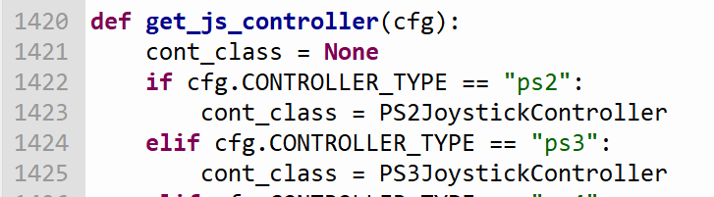

上述與jstest測量有不同 右邊搖桿對應是5 不是3

增加除錯訊息

可在816行增加 print(“axis=”,axis,”axis_val=”,axis_val)

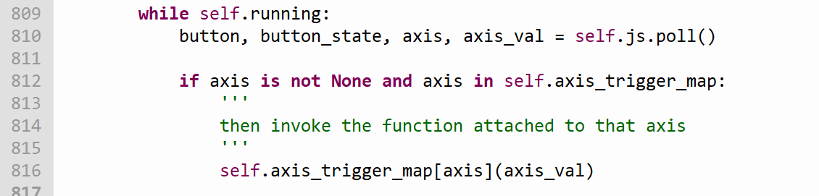

**sudo apt-get install evtest**

**evtest**