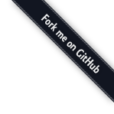

# Dropify

## Override your input files with style

Before

## Basic HTML input file

Now

Your so fresh input file — Default version

You can add a default value

You can set the height

You can combine options

You can disabled the input

Also with a default file

You can add a max file size

You can disable remove button

You can use events

You can destroy it Init/Destroy

Multiple options are available

Only portrait or square images, 2M max and 2000px max-height.

## French one

"Et voilà"

"Avec options"

[Github repository](https://github.com/JeremyFagis/dropify)

2016 © [Jeremy FAGIS](http://www.fagis.fr)