A Project Report on
SELF-SUPERVISED CONTRASTIVE LEARNING FOR DOPPLER REGIME CLASSIFICATION IN OTFS SYSTEMS

submitted in partial fulfilment of the requirements for the course

MACHINE LEARNING
25SC2107E

in

A.Y.: 2026-27

by

Lokesh Vobilishetty 2520040040

KNSV Madhusudhan 2520040089

Varanasi Sreekar 2520040019

Under the Esteemed guidance of

Mr. N Lava Prasad

Assistant Professor,

Department of ECE





DEPARTMENT OF ELECTRONICS & COMMUNICATION ENGINEERING

Abstract:

Orthogonal Time Frequency Space (OTFS) modulation represents information in the delay-Doppler domain, where a doubly-selective wireless channel appears as a sparse and nearly time-invariant response. This property makes OTFS a strong candidate for high-mobility links in 5G-Advanced and 6G, yet its receiver performance depends on knowing how the Doppler shift of the channel behaves. A channel whose Doppler shifts fall on integer grid points, one with fractional shifts that leak energy across neighbouring bins, and one that fluctuates rapidly within a frame require different estimation and equalisation strategies. Recognising the prevailing Doppler regime automatically is therefore a useful building block for adaptive receivers. Supervised classifiers can perform this task, but they need large, carefully labelled channel datasets that are expensive to produce.

This project proposes a self-supervised contrastive learning framework for Doppler regime classification. Synthetic OTFS channels are generated for low, medium and high mobility and converted to delay-Doppler representations. An encoder is first pretrained without labels: two stochastic augmentations of every sample are passed through a shared convolutional network, and an NT-Xent contrastive loss pulls the two views together while pushing apart views of other samples. The pretrained encoder is then combined with a lightweight CNN classifier, which is fine-tuned using only a small labelled subset.

Contrastive pretraining converged smoothly over 20 epochs, with the training loss falling from about 3.24 to 2.41. On a held-out test set of 180 samples, the classifier reached an overall accuracy of 95.0 percent (171 of 180), with class-wise accuracies of 96.7 percent for low, 91.7 percent for medium and 96.7 percent for high Doppler. All errors occurred between neighbouring regimes, and no low-Doppler sample was confused with high Doppler. The results show that useful Doppler-regime features can be learned from unlabelled delay-Doppler data, reducing the dependence on costly annotation.

Signature of the Supervisor Course Instructor

INDEX
Abstract ii
1. Introduction 1
1.1 Background 1
1.2 Problem Context 1
1.3 Related Work 2
1.4 Objectives 2
1.5 Contributions and Report Organisation 3
2. System Model 4
2.1 OTFS Transmitter and Receiver 4
2.2 Delay-Doppler Channel 4
2.3 Definition of the Doppler Regimes 5
2.4 Dataset Generation 6
3. Proposed Methodology 7
3.1 Framework Overview 7
3.2 Input Representation 7
3.3 Augmentation Strategy 7
3.4 Encoder and Projection Head 8
3.5 NT-Xent Contrastive Loss 8
3.6 Supervised Fine-Tuning 8
3.7 Evaluation Metrics 9
4. Implementation and Results 10
4.1 Software Environment 10
4.2 Training Configuration 10
4.3 Contrastive Pretraining Behaviour 10
4.4 Classification Performance 11
4.5 Discussion 12
4.6 Limitations 13
5. Conclusion and Future Scope 14
5.1 Conclusion 14
5.2 Future Scope 14
References 15

1. Introduction

1.1 Background
Wireless communication is steadily moving into scenarios where the transmitter, the receiver, or both are in fast motion. In such links the channel is doubly selective: multipath propagation spreads the signal in delay, while relative motion spreads it in frequency through the Doppler effect. Conventional multicarrier schemes such as OFDM place data on narrow subcarriers and assume that the channel stays almost constant during one symbol. When Doppler spread becomes a sizeable fraction of the subcarrier spacing, subcarrier orthogonality is lost and inter-carrier interference limits the achievable throughput.
Orthogonal Time Frequency Space (OTFS) modulation addresses this limitation by working in a different domain. Information symbols are placed on a two-dimensional delay-Doppler grid and are spread over the whole time-frequency plane by a pair of two-dimensional transforms. Because the physical reflectors that shape the channel change slowly compared with the carrier phase, the channel in the delay-Doppler domain is sparse and compact, and each symbol experiences the full diversity of the channel. These properties have made OTFS a leading candidate waveform for high-mobility scenarios in future cellular and non-terrestrial networks.

1.2 Problem Context
An OTFS receiver is only as good as its knowledge of the channel. The structure of the Doppler response determines which estimation method is appropriate, how much guard space is needed around pilots, and how complex the detector has to be. When every Doppler shift lies exactly on a grid point, the response is a set of clean isolated peaks and simple low-complexity detection works well. When the shifts are fractional, the response spreads along the Doppler axis, and the receiver must account for this leakage. When the channel changes quickly inside a frame, the sparse model itself becomes a poor description. A receiver that can identify which of these situations it is facing can switch to a matching processing chain instead of always running the most expensive one.
The recognition task is naturally framed as pattern classification on delay-Doppler observations. Learning-based classifiers are well suited to it, but they normally rely on labelled examples. For wireless channels, labels require either controlled measurement campaigns or detailed ground-truth knowledge of the propagation environment, both of which are costly. The question investigated in this work is whether the structure of unlabelled delay-Doppler data can be exploited to learn good features first, so that only a small labelled set is needed afterwards.

1.3 Related Work
OTFS was introduced by Hadani et al. as a modulation that converts a time-varying multipath channel into a time-invariant one in the delay-Doppler domain [1]. Subsequent work developed detection and equalisation algorithms for the resulting input-output relation. Message-passing detectors that exploit the sparsity of the effective channel matrix were shown to achieve near-optimal performance at reasonable complexity, and the effect of fractional delay and Doppler on the sparsity of that matrix was analysed in detail [2]. These studies make clear that the Doppler behaviour of the channel directly affects receiver design.
In parallel, self-supervised learning has become a mainstream way of learning representations without labels. Contrastive methods construct positive pairs from two augmented views of the same sample and treat other samples in the batch as negatives. SimCLR showed that a simple recipe of strong augmentation, a convolutional encoder, a small projection head and the NT-Xent loss is enough to learn highly transferable features [3]. Momentum-based variants such as MoCo reduce the dependence on large batches [4], and the earlier contrastive predictive coding framework demonstrated the idea on sequential data [5]. Supervised contrastive learning further showed that pairing the contrastive objective with label information can improve classification [6].
Most applications of these ideas have been in computer vision, with fewer studies on physical-layer wireless data. This project takes the SimCLR-style pipeline and adapts the data view, the augmentations and the downstream task to delay-Doppler channel observations from OTFS systems.

1.4 Objectives
- To generate a synthetic OTFS channel dataset that covers low, medium and high Doppler conditions and to represent every sample on the delay-Doppler grid.
- To design augmentations that perturb nuisance factors such as noise, amplitude and alignment while leaving the Doppler regime of the sample unchanged.
- To pretrain a convolutional encoder with an NT-Xent contrastive objective using no labels.
- To fine-tune a compact CNN classifier on a small labelled subset and evaluate it with accuracy, confusion matrix and class-wise precision, recall and F1.

1.5 Contributions and Report Organisation
The main contribution is an end-to-end self-supervised pipeline for Doppler regime classification that couples a realistic OTFS channel simulator with contrastive representation learning and a lightweight supervised head. The remainder of the report is organised as follows. Chapter 2 develops the OTFS system model and defines the Doppler regimes quantitatively. Chapter 3 describes the proposed learning framework in detail. Chapter 4 presents the implementation setup, results and discussion. Chapter 5 concludes the report and lists directions for future work.

2. System Model

2.1 OTFS Transmitter and Receiver
Consider an OTFS frame with M delay bins and N Doppler bins, occupying a bandwidth B = MΔf and a duration T = NT_s, where Δf is the subcarrier spacing and T_s = 1/Δf. The information symbols x[k,l] are drawn from a QAM alphabet and arranged on the delay-Doppler grid, with k = 0,…,N−1 indexing Doppler and l = 0,…,M−1 indexing delay. The transmitter first maps the grid to the time-frequency plane using the inverse symplectic finite Fourier transform (ISFFT):
X[n,m] = (NM)^(−1/2) Σₖ Σₗ x[k,l] · e^{ j2π( nk/N − ml/M ) } (1)
The time-frequency samples X[n,m] are then converted to a continuous time-domain waveform by the Heisenberg transform with a transmit pulse g_tx(t). At the receiver the process is reversed: a Wigner transform with receive pulse g_rx(t) returns time-frequency samples Y[n,m], and the symplectic finite Fourier transform (SFFT) produces the delay-Doppler observations y[k,l]. Figure 2.1 shows this chain.
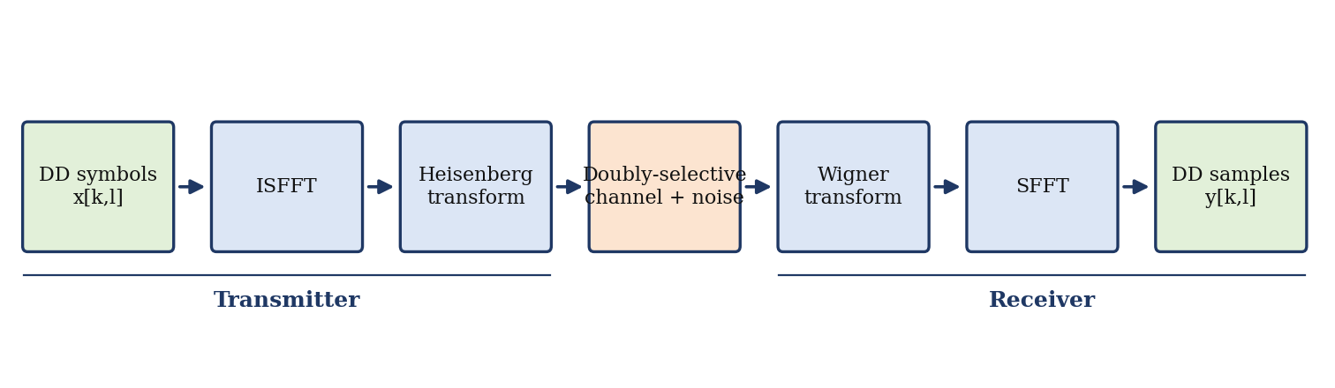
Figure 2.1: OTFS transmit-receive chain in the delay-Doppler domain.

2.2 Delay-Doppler Channel
A multipath channel with P propagation paths is described in the delay-Doppler domain by the spreading function
h(τ,ν) = Σᵢ hᵢ · δ(τ − τᵢ) · δ(ν − νᵢ), i = 1,…,P (2)
where hᵢ, τᵢ and νᵢ are the complex gain, delay and Doppler shift of the i-th path. The delay and Doppler of each path are related to geometry: τᵢ is the excess path length divided by the speed of light and νᵢ = (v/c) f_c cos θᵢ, where v is the relative speed, f_c the carrier frequency and θᵢ the angle of arrival. Expressed on the grid, the delay and Doppler of each path become τᵢ = lᵢ/(MΔf) and νᵢ = kᵢ/(NT_s), with lᵢ and kᵢ not necessarily integers. For ideal rectangular pulses and integer lᵢ, kᵢ the input-output relation reduces to a two-dimensional circular convolution:
y[k,l] = Σᵢ hᵢ · x[ (k − kᵢ)_N , (l − lᵢ)_M ] + w[k,l] (3)
where w[k,l] is additive white Gaussian noise and (·)_N denotes the modulo-N operation. Because the number of paths is small, y[k,l] depends on only a few shifted copies of the transmitted grid. This sparsity is what makes delay-Doppler observations a compact and informative input for a learning algorithm.

2.3 Definition of the Doppler Regimes
Three regimes are considered in this work, defined by how the Doppler shifts relate to the resolution of the grid and to the frame duration.
- Low Doppler (integer): each kᵢ falls on an integer bin, so the response consists of sharp isolated peaks and the effective channel matrix is very sparse.
- Medium Doppler (fractional): at least one kᵢ is non-integer. The finite Doppler resolution 1/(NT_s) cannot represent it exactly, and the energy spreads over neighbouring bins following a Dirichlet-kernel pattern with slowly decaying sidelobes.
- High Doppler (rapidly varying): the Doppler spread is large enough, or the gains change fast enough within one frame, that the response is smeared over many bins and the sparse model no longer holds.
In the dataset labels, these regimes correspond to the low, medium and high Doppler classes reported in Chapter 4. For a fractional Doppler offset the leakage along the Doppler axis for a path at Doppler index κ is given by the magnitude of the Dirichlet kernel,
|D(k)| = | sin(π(k − κ)) / ( N · sin(π(k − κ)/N) ) | (4)
which equals one when κ is an integer and decays only as 1/|k − κ| otherwise. Figure 2.2 illustrates the three regimes with a three-path channel, showing how the same underlying scatterers appear on the grid under each condition.
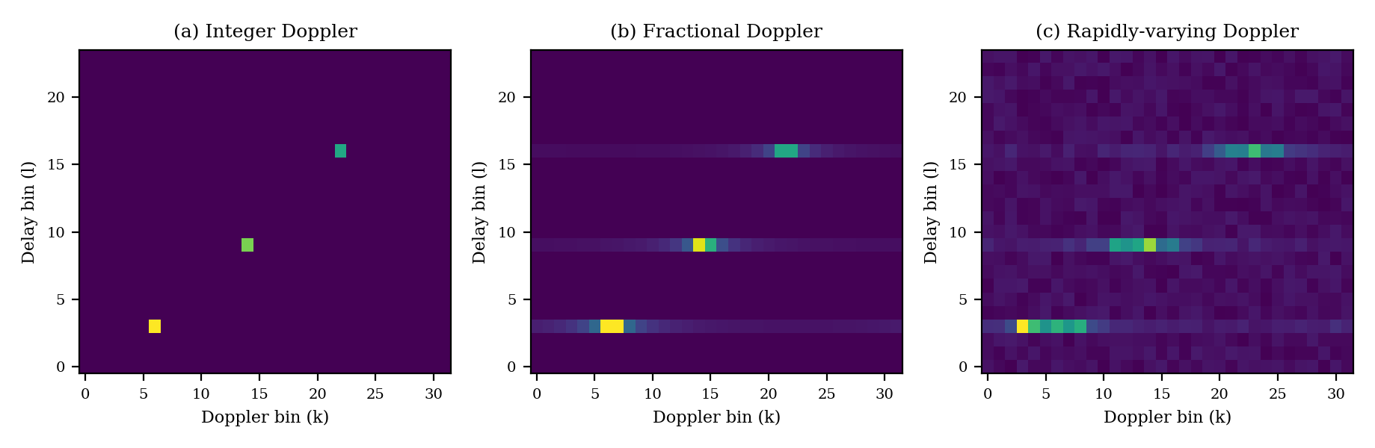
Figure 2.2: Illustrative delay-Doppler magnitude responses for the three regimes (schematic, generated for explanation).

2.4 Dataset Generation
Channel realisations are produced by a simulator that draws the number of paths, the path gains, delays and Doppler shifts from distributions appropriate for each mobility profile. Low-mobility samples use Doppler shifts that fall on grid points, medium-mobility samples draw continuous Doppler shifts and high-mobility samples additionally include fast variation of the path gains during the frame. For every realisation an OTFS frame is transmitted, noise is added at a randomly chosen signal-to-noise ratio, and the received grid is converted to a two-dimensional magnitude map that forms the input to the networks. Using several SNR values in the same dataset prevents the classifier from relying on a single noise level.
The data are split into three parts: a large unlabelled portion for contrastive pretraining, a small labelled portion for fine-tuning, and a balanced test set of 180 samples with 60 samples per regime that is never used during training.

3. Proposed Methodology

3.1 Framework Overview
The framework follows the standard two-phase self-supervised recipe. In the pretraining phase, the encoder sees only unlabelled delay-Doppler maps and learns by solving an instance discrimination task. In the downstream phase, the projection head used for pretraining is removed, the encoder output is passed to a CNN classifier, and the system is trained on a small labelled set. The design goal is that most of the representational effort is spent in the label-free phase, so that the supervised phase can be short and light.

3.2 Input Representation
Each sample is a single-channel image of size M × N containing the magnitude of the received delay-Doppler grid. Magnitudes are used because the Doppler regime is reflected in the spread and shape of the energy rather than in its absolute phase. Every sample is normalised to zero mean and unit variance so that the encoder is not biased by overall received power. The two image axes retain their physical meaning, delay along one and Doppler along the other, which allows two-dimensional convolutions to exploit local structure such as peak sharpness and sidelobe patterns.

3.3 Augmentation Strategy
Contrastive learning is only as useful as its positive pairs, and the augmentations define what the encoder is asked to ignore. In this problem the label is a property of the Doppler structure, so the transformations must never change that structure. The family of transformations T therefore contains operations that alter nuisance factors only:
- Additive Gaussian noise with a random standard deviation, imitating different SNR conditions.
- Random amplitude scaling, so that the learned features do not depend on received power.
- Random circular shifts along the delay axis, which preserve the Doppler pattern since a delay offset moves peaks without changing their shape.
- Random masking of small rectangular regions, forcing the encoder to rely on the global pattern rather than on a single bin.
Augmentations that shift or resample the Doppler axis are deliberately excluded because they would turn one regime into another and corrupt the positive pairs. Two views t₁(x) and t₂(x) are created independently for each sample in every training step.

3.4 Encoder and Projection Head
The encoder f(·) is a compact convolutional network made of stacked convolution, batch normalisation and ReLU layers with pooling, followed by global average pooling that produces a fixed-length embedding h = f(x). A two-layer projection head g(·) maps h to a lower-dimensional vector z = g(h) on which the contrastive loss is computed. Following common practice, the loss is applied to z, but only h is used for downstream classification, because the projection head tends to discard information that is useful beyond the pretext task.
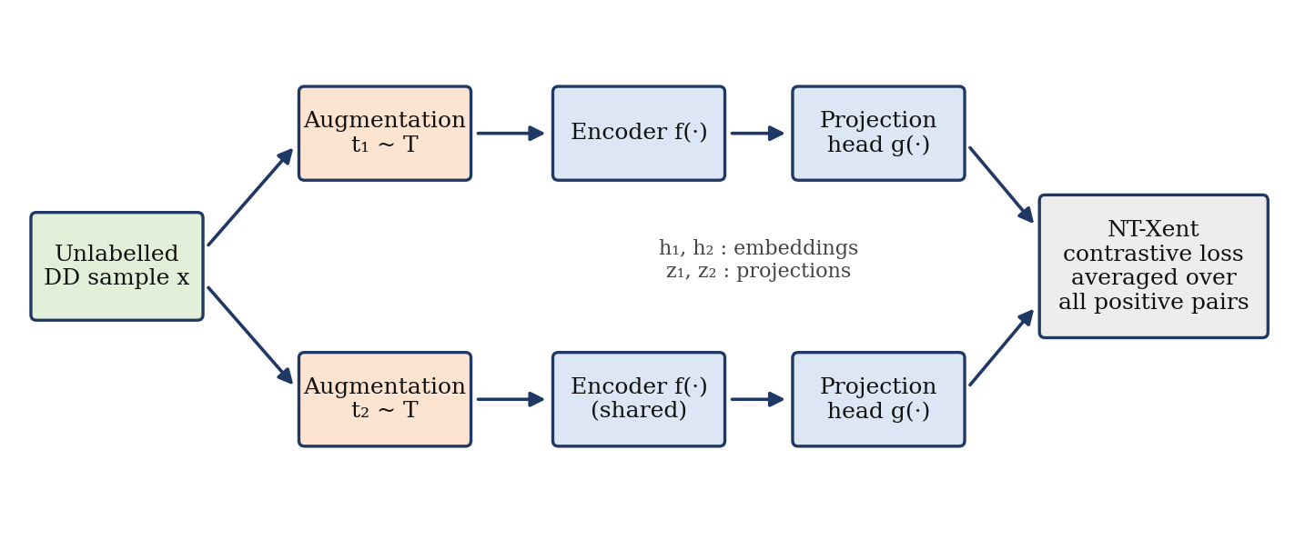
Figure 3.1: Self-supervised pretraining stage with a shared encoder and NT-Xent loss.

3.5 NT-Xent Contrastive Loss
For a mini-batch of B samples, 2B augmented views are produced. For a positive pair (i, j), the normalised temperature-scaled cross-entropy loss is
ℓ(i,j) = − log [ exp( sim(zᵢ, zⱼ)/τ ) / Σ_{k=1, k≠i}^{2B} exp( sim(zᵢ, zₖ)/τ ) ] (5)
where sim(u,v) = uᵀv / (‖u‖‖v‖) is cosine similarity and τ is a temperature parameter. The total loss is the average of ℓ(i,j) over all positive pairs, counted in both directions. Minimising it increases the similarity between two views of the same sample relative to its similarity with every other view in the batch. As a result, samples with similar delay-Doppler structure end up close to each other in the embedding space, which is exactly the clustering behaviour needed to separate the regimes later.

3.6 Supervised Fine-Tuning
After pretraining, the projection head is discarded. The encoder is connected to a CNN classifier head with a small number of convolutional or fully connected layers and a three-way softmax output. The classifier is trained with the cross-entropy loss on the small labelled subset. The encoder weights can be kept frozen or updated with a reduced learning rate; in both cases the number of labelled samples needed is far smaller than for training the whole network from scratch.
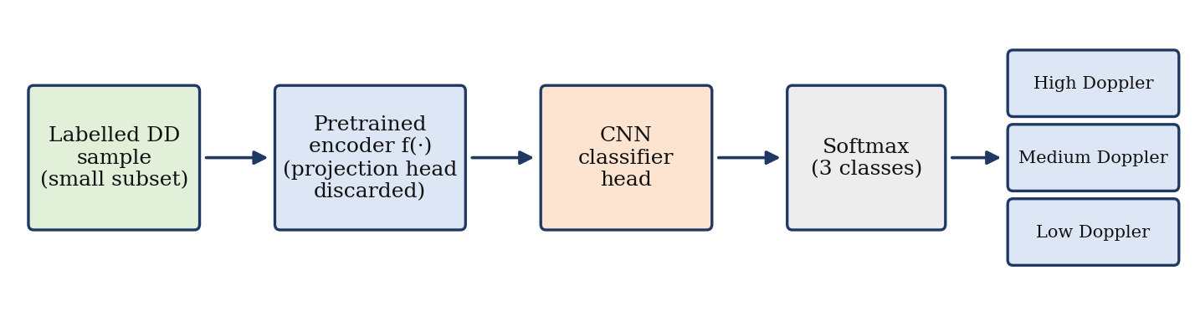
Figure 3.2: Downstream classification stage using the pretrained encoder.

3.7 Evaluation Metrics
Performance is measured on the held-out test set using overall accuracy, the confusion matrix and class-wise precision, recall and F1-score. For class c with true positives TPc, false positives FPc and false negatives FNc,
Precision = TPc/(TPc + FPc), Recall = TPc/(TPc + FNc) (6)
F1 = 2 · Precision · Recall / (Precision + Recall) (7)
The confusion matrix is particularly informative here because the regimes form an ordered scale, and a model that errs between neighbouring regimes is behaving more sensibly than one that confuses the extremes.

4. Implementation and Results

4.1 Software Environment
The OTFS simulator and channel generation were written in MATLAB, which provides convenient tools for multipath fading and mobility modelling. The delay-Doppler data were exported and used in Python, where the encoder, the contrastive training loop and the classifier were implemented in PyTorch. Scikit-learn and Matplotlib were used to compute the evaluation metrics and produce the plots in this chapter.

4.2 Training Configuration
Table 4.1 summarises the training configuration. The contrastive stage was trained for 20 epochs, and the validation loss was monitored on held-out unlabelled data to check for over-fitting of the pretext task.
Table 4.1: Training configuration
Item | Setting
Pretraining epochs | 20
Pretext objective | NT-Xent (SimCLR-style)
Optimiser | Adam
Encoder output | Fixed-length embedding via global average pooling
Classifier | Lightweight CNN head with 3-way softmax
Test set | 180 samples (60 per regime), unseen during training

4.3 Contrastive Pretraining Behaviour
Figure 4.1 shows the training and validation loss across the 20 pretraining epochs. The training loss decreases steadily from about 3.24 at the first epoch to about 2.41 at the last, with the steepest drop in the first five epochs, after which the curve flattens as the encoder saturates the pretext task. The validation loss is noisier, which is expected because it is computed on a smaller set with random augmentations, but it follows the same downward trend and settles near 2.5. The small and stable gap between the two curves in the later epochs indicates that the encoder is not memorising training pairs.
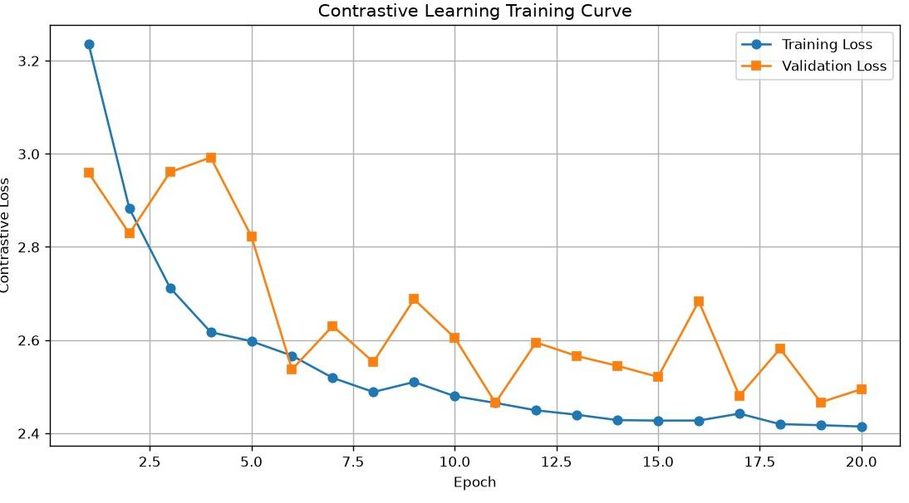
Figure 4.1: Contrastive learning training and validation loss over 20 epochs.

4.4 Classification Performance
On the 180-sample test set the fine-tuned classifier correctly labelled 171 samples, giving an overall accuracy of 95.0 percent. The confusion matrix in Figure 4.2 shows where the remaining nine errors occur: two low-Doppler samples were predicted as medium, five medium-Doppler samples were predicted as low, and two high-Doppler samples were predicted as medium.
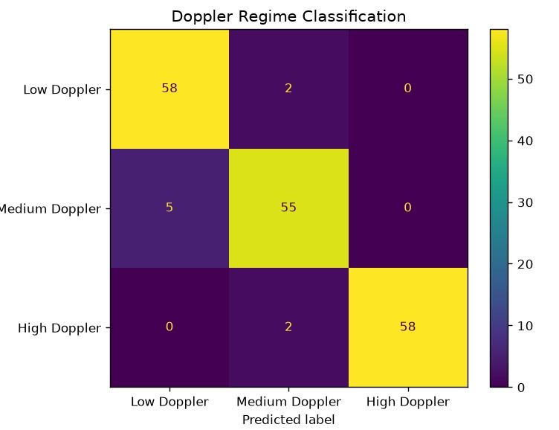
Figure 4.2: Confusion matrix of the Doppler regime classifier on the test set.
From the confusion matrix, class-wise precision, recall and F1-score were computed and are given in Table 4.2. The macro-averaged F1-score is 0.950, which agrees with the overall accuracy and confirms that performance is balanced across classes.
Table 4.2: Class-wise performance on the test set
Regime | Correct / Total | Precision | Recall | F1-score
Low Doppler | 58 / 60 | 0.921 | 0.967 | 0.943
Medium Doppler | 55 / 60 | 0.932 | 0.917 | 0.924
High Doppler | 58 / 60 | 1.000 | 0.967 | 0.983
Overall / Macro | 171 / 180 | 0.951 | 0.950 | 0.950

Figure 4.3 compares the number of true samples in each class with the number predicted. The model slightly over-predicts the low-Doppler class (63 predicted against 60 true) and slightly under-predicts the medium class (59 against 60), while the high-Doppler class is matched closely.
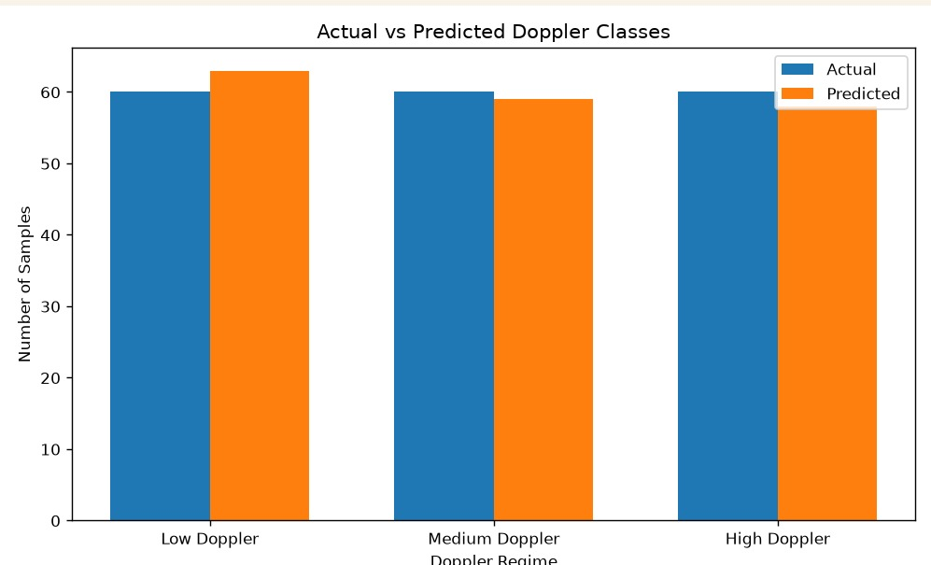
Figure 4.3: Actual versus predicted sample counts per Doppler regime.

4.5 Discussion
Three observations follow from the results. First, the high-Doppler class has perfect precision, meaning that no sample from another regime was ever labelled as high Doppler. Rapidly varying channels leave a distinct signature that the contrastive features capture well. Second, there is no confusion between the low and high regimes at all. Every error involves the medium class, so the model respects the ordered structure of the problem and the mistakes are those a human observer would also find hardest.
Third, the main weakness is the medium class, where five samples were mistaken for low Doppler. This is physically reasonable: a fractional Doppler shift that lies close to an integer bin produces very little leakage, and the response becomes almost indistinguishable from the integer case, especially at low SNR. A similar argument explains the two high-Doppler samples labelled as medium, which probably correspond to the mildest rapidly varying channels. Such boundary cases represent genuine overlap between regimes rather than a failure of representation learning.
These results support the central premise of the project. The encoder was trained without any labels, yet its embeddings were separable enough that a lightweight classifier trained on a small labelled subset reached 95 percent accuracy. In practical terms, the cost of annotating channel data can be shifted largely out of the pipeline.

4.6 Limitations
- All data are synthetic. Real measurements include hardware impairments, imperfect synchronisation and propagation effects that the simulator does not model.
- The test set contains 180 samples, so each individual error changes the class accuracy by roughly 1.7 percentage points. Larger test sets would give tighter estimates.
- Regime boundaries are defined by the simulator. Real channels vary continuously, and a regression or soft-label formulation may suit them better than three hard classes.

5. Conclusion and Future Scope

5.1 Conclusion
This project investigated self-supervised contrastive learning for classifying the Doppler regime of OTFS channels. After establishing the delay-Doppler system model and defining low, medium and high Doppler regimes through their effect on the delay-Doppler grid, a SimCLR-style framework was developed in which a convolutional encoder is pretrained with the NT-Xent loss on unlabelled data and then paired with a lightweight CNN classifier trained on a small labelled subset. Augmentations were chosen to vary noise level, amplitude, delay alignment and local occlusion without altering the Doppler structure.
The pretraining loss decreased smoothly over 20 epochs, and the final classifier achieved 95.0 percent accuracy on a balanced 180-sample test set, with class-wise accuracies between 91.7 and 96.7 percent and a macro F1-score of 0.950. Errors were confined to neighbouring regimes, which is consistent with the physical continuity between them. The work shows that representations learned without labels are sufficient for reliable regime identification, offering a data-efficient route towards mobility-aware OTFS receivers.

5.2 Future Scope
- Benchmark systematically against a fully supervised CNN trained on the same labelled data, and plot accuracy as a function of the number of labelled samples to quantify the label-efficiency gain.
- Evaluate robustness over a wider range of SNR values and under pilot-based channel estimation errors.
- Replace the three discrete classes by a continuous Doppler-spread estimate or a finer set of regimes.
- Validate on over-the-air or measured high-speed rail and vehicular channel data, and study domain adaptation from simulation to real data.
- Use the predicted regime to switch between detection algorithms inside an OTFS receiver and measure the resulting bit-error-rate and complexity gains.

References
[1] R. Hadani, S. Rakib, M. Tsatsanis, A. Monk, A. J. Goldsmith, A. F. Molisch and R. Calderbank, “Orthogonal time frequency space modulation,” in Proc. IEEE Wireless Communications and Networking Conference (WCNC), San Francisco, CA, USA, 2017, pp. 1–6.
[2] P. Raviteja, K. T. Phan, Y. Hong and E. Viterbo, “Interference cancellation and iterative detection for orthogonal time frequency space modulation,” IEEE Transactions on Wireless Communications, vol. 17, no. 10, pp. 6501–6515, Oct. 2018.
[3] T. Chen, S. Kornblith, M. Norouzi and G. Hinton, “A simple framework for contrastive learning of visual representations,” in Proc. International Conference on Machine Learning (ICML), 2020, pp. 1597–1607.
[4] K. He, H. Fan, Y. Wu, S. Xie and R. Girshick, “Momentum contrast for unsupervised visual representation learning,” in Proc. IEEE/CVF Conference on Computer Vision and Pattern Recognition (CVPR), 2020, pp. 9729–9738.
[5] A. van den Oord, Y. Li and O. Vinyals, “Representation learning with contrastive predictive coding,” arXiv preprint arXiv:1807.03748, 2018.
[6] P. Khosla, P. Teterwak, C. Wang, A. Sarna, Y. Tian, P. Isola, A. Maschinot, C. Liu and D. Krishnan, “Supervised contrastive learning,” in Advances in Neural Information Processing Systems (NeurIPS), vol. 33, 2020.
[7] D. P. Kingma and J. Ba, “Adam: A method for stochastic optimization,” in Proc. International Conference on Learning Representations (ICLR), 2015.
[8] A. Paszke et al., “PyTorch: An imperative style, high-performance deep learning library,” in Advances in Neural Information Processing Systems (NeurIPS), vol. 32, 2019.

