
Student Assessment Submission and Declaration
When submitting evidence for assessment, you must sign a declaration confirming that the work is your own.
Student name: | ERAY AKDENIZ | BSU ID No | 575632
Submission date: | 7 October 2026
Declaration: | I confirm that this submission represents my own work.
Programme: | Computing Foundation
Module name and code: | WEBDEV II (CCO5104)
Title: | Assignment 2 – Multi Device Application (Gardening Company App)
Assessor name: | Zanab Safdar
Github link | https://github.com/vocodexx/Webdev-Assignment-2.git
Youtube link | https://youtu.be/QDlg8dkDt8s
Student signature: ERAY

1. Project Brief
For this project I developed Rootfolk Gardens, a responsive web application for a gardening company based in Surrey. I wanted the project to do more than show information about the business, so I built it around a full customer journey. A visitor can view the services and company information, then create an account and use a customer area to manage their garden service. Registered users can add garden details, upload photographs, ask for a quote, check available appointments, book a service and view their previous visits. They can also request to move or cancel a booking. An administrator area is included so that Rootfolk can review quote requests, send prices and manage customer requests. The application uses React for the front end and Express.js for the back end.

Technology Used
The main technologies used were React, React Router, JavaScript, CSS and Express.js. I used bcrypt for password hashing and Multer for garden photograph uploads. The project is split into client and server folders so that the front-end interface and the back-end logic are easier to understand and maintain.

2. Development Breakdown

2.1 Responsive Design and Visual Layout
The visual style was based on the existing Rootfolk business material. The main colours are dark forest green, cream, botanical green and a muted gold. I used these colours because they match the gardening theme and also make the business feel established and professional. The first homepage version did not work as well as I expected because the right-hand side used a promotional image that already contained text and other information. This made the page look crowded and repeated content that was already shown in the website itself. I changed this by using the garden photography more cleanly and separating the website content from the original promotional design.
I also changed the layout depending on screen size instead of only shrinking the desktop version. On a large screen, sections such as the hero area, service content and dashboard cards can use two or more columns. On smaller screens these sections stack vertically, buttons become easier to press, text sizes reduce slightly and the navigation becomes more compact. I tested the layout at desktop, tablet and mobile widths using the browser developer tools. Media queries were used to control the layout changes. This was important because the brief gives a large amount of the mark to responsive design and interaction across different devices (MDN Web Docs, 2025).

2.2 React Structure, Routing and Authentication
I used React because the application contains several areas that need to update without reloading the whole page. React Router is used to move between the public homepage, login and registration pages, the customer dashboard and the administrator section. I created reusable components for parts such as the navigation, protected routes and the portal layout so that the same code does not have to be repeated on every page.
The authentication state is handled through an AuthContext. When a user logs in, the application stores the current user information and makes it available to protected pages. A ProtectedRoute component checks whether the user is logged in before showing customer pages, and it also checks the administrator role before allowing access to the admin dashboard. Passwords are not stored as plain text. They are hashed on the server using bcrypt. React state is also used for forms, loading states, error messages and information received from the API (React, 2026; React Router, 2026).

2.3 Garden Photos and Quote Requests
One of the main features is the quote request system. A customer first creates a garden profile and uploads photographs of the area that needs work. I decided to make photographs part of the quote process because the condition and size of a garden can affect the amount of work required. The customer is asked to provide at least two images before a quote request can be sent. This makes the feature useful for the business rather than being an upload feature with no purpose.
The photographs are sent from React using FormData because image files cannot be handled in the same way as normal JSON form values. On the Express server I used Multer to receive and store the uploaded images (Multer, 2026). The server also checks that the selected images belong to the signed-in customer's garden. This is important because front-end checks can be bypassed, so the important validation also needs to happen on the server. The administrator can then view the service request, garden details and photographs before entering a final quote. The customer can accept or decline the quote before moving to the booking stage.

2.4 Availability, Booking and Change Requests
After a quote has been accepted, the customer can check available dates and time slots. The server compares the possible time slots with current bookings and returns only the slots that are available. When a booking is submitted, the server checks the slot again before saving it. I included this second check because two users could open the availability page at a similar time, so checking only in the browser would not be reliable.
I also added booking status values to make the application closer to the way the business would work. A customer cannot directly delete an appointment. Instead, they can send either a cancellation request or a reschedule request. The current booking stays active until the administrator reviews the request. The booking can therefore move through states such as confirmed, reschedule requested, cancellation requested, cancelled and completed. Completed visits are then shown in the customer's visit history so that they can see when Rootfolk last attended and what work was carried out. I found this part useful because it required more than just displaying data; the front end and back end both had to deal with the same booking rules.

3. Critical Reflection
The part I think worked best is the complete flow from requesting a quote to making a booking. The features are connected to each other instead of being separate demonstrations. Garden information and photographs are used to request a quote, an accepted quote allows the customer to view availability, and a completed booking is then shown in the visit history. This gave the application a clear purpose and also gave me several opportunities to use React and Express together.
The design also improved during development. My first hero layout was too close to the original business flyer and looked unbalanced on the right side. After seeing it running in the browser, I changed the image treatment and spacing so that it worked as a web page rather than as a copy of the flyer. This showed me that a design can look suitable as a static graphic but still need changes when it is used as an interactive website. I also found that checking the mobile layout early was useful because some parts that looked fine on a desktop became too crowded when the width was reduced.
There are still limitations in the current version. The application stores its data in JSON files because this made the project easier to set up and demonstrate, but this would not be the best choice for a real business with many customers. A relational database such as PostgreSQL would be more suitable because it would handle relationships between users, gardens, quotes, bookings and visits more reliably. The uploaded photographs are also stored locally. In a production version I would move these to cloud storage and add stronger controls over image size, file scanning and deletion.
The availability system is also simplified. It uses fixed appointment slots and does not calculate travel time, the length of different jobs, staff availability, weather or holidays. A real system would need these factors before showing a slot as available. The application does not currently send real confirmation emails or text messages either. If I continued the project I would add notifications for quote updates, booking confirmations and approved changes. I would also carry out more accessibility testing using keyboard navigation and a screen reader instead of only checking the visual layout and form labels.
Overall, the project helped me understand why important rules should be checked on the server as well as in React. It also improved my understanding of breaking a larger application into smaller components and routes. If I developed it again, I would set up the data model earlier and plan the booking states before building the pages. This would reduce the amount of changing between the front-end layout and back-end logic later in the project.

4. Conclusion
Rootfolk Gardens developed from a basic gardening website idea into a responsive service-management application. The finished project combines a public business website with customer and administrator areas. It demonstrates responsive design, React components and routing, authentication, image uploads, Express API routes, quote handling, availability checking, bookings and visit history. The project still has areas that could be extended for real commercial use, but the current version meets the main aim of creating a responsive application with meaningful communication between the front end and back end.

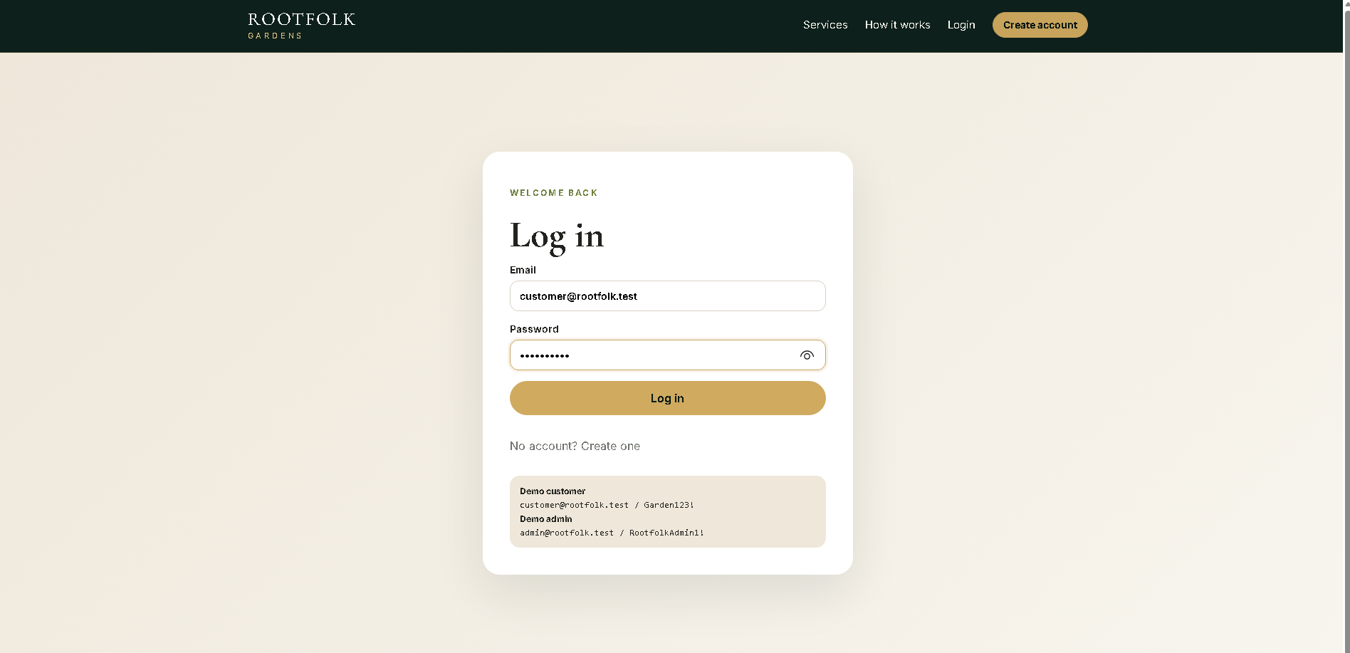
5.Code Structure and Website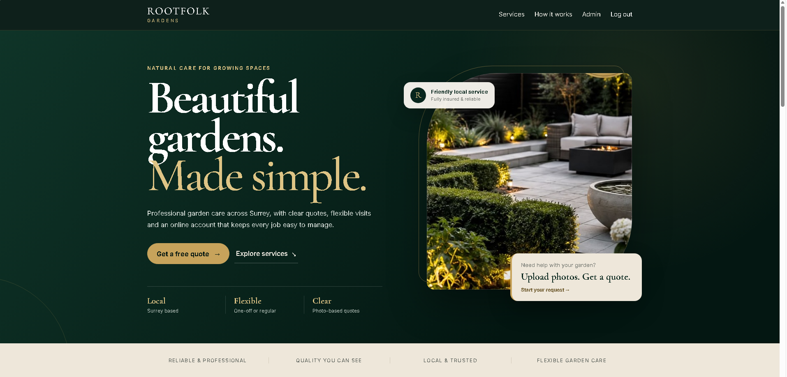

Figure 1.2 Log in
Figure 2 Main Web site

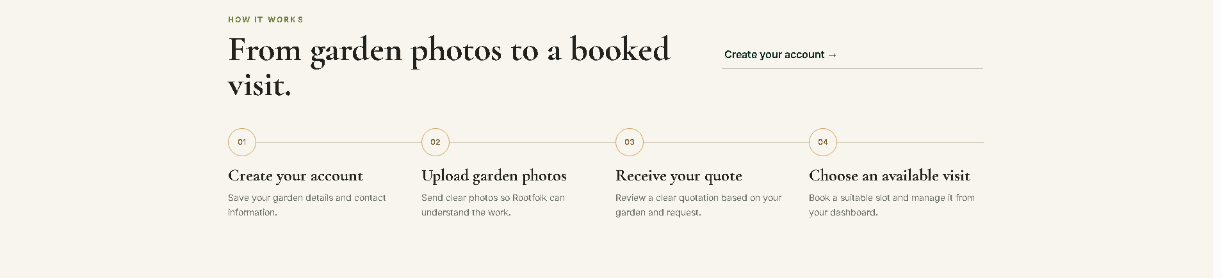
Figure 3 How it works section

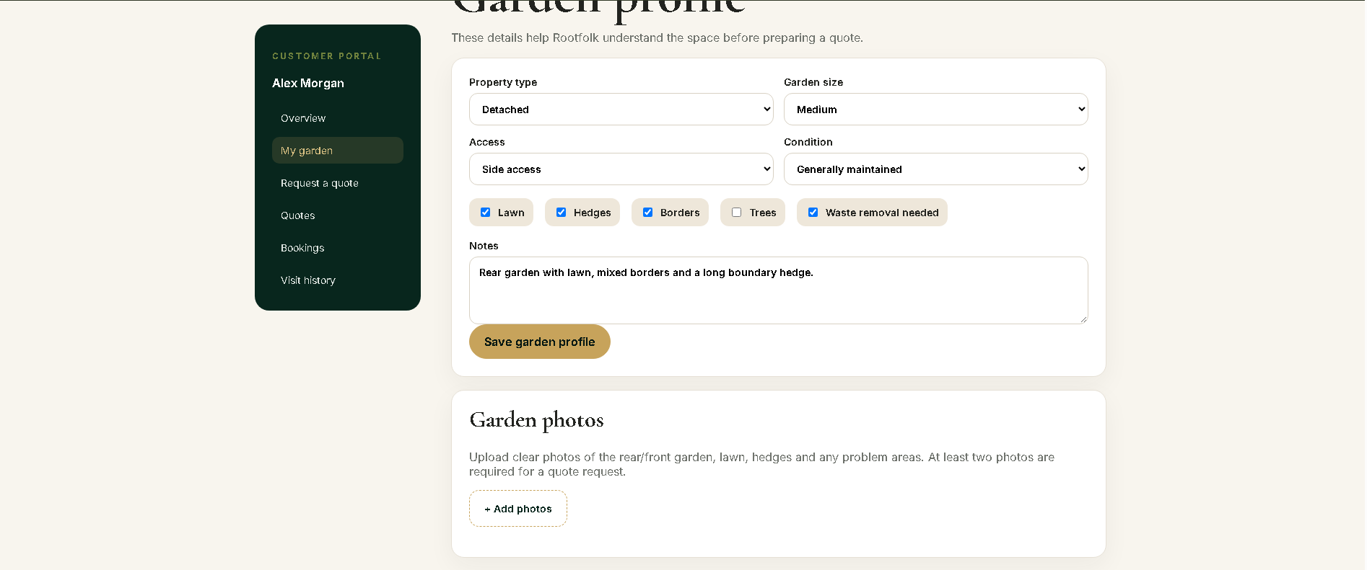
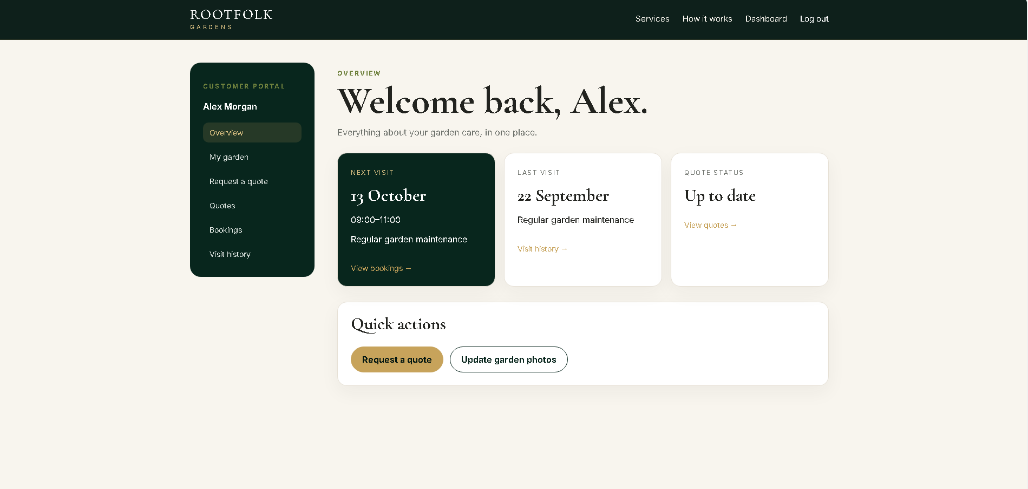
Figure 4.1 Customer Own Garden Detail Upload
Figure 5 Customer overview
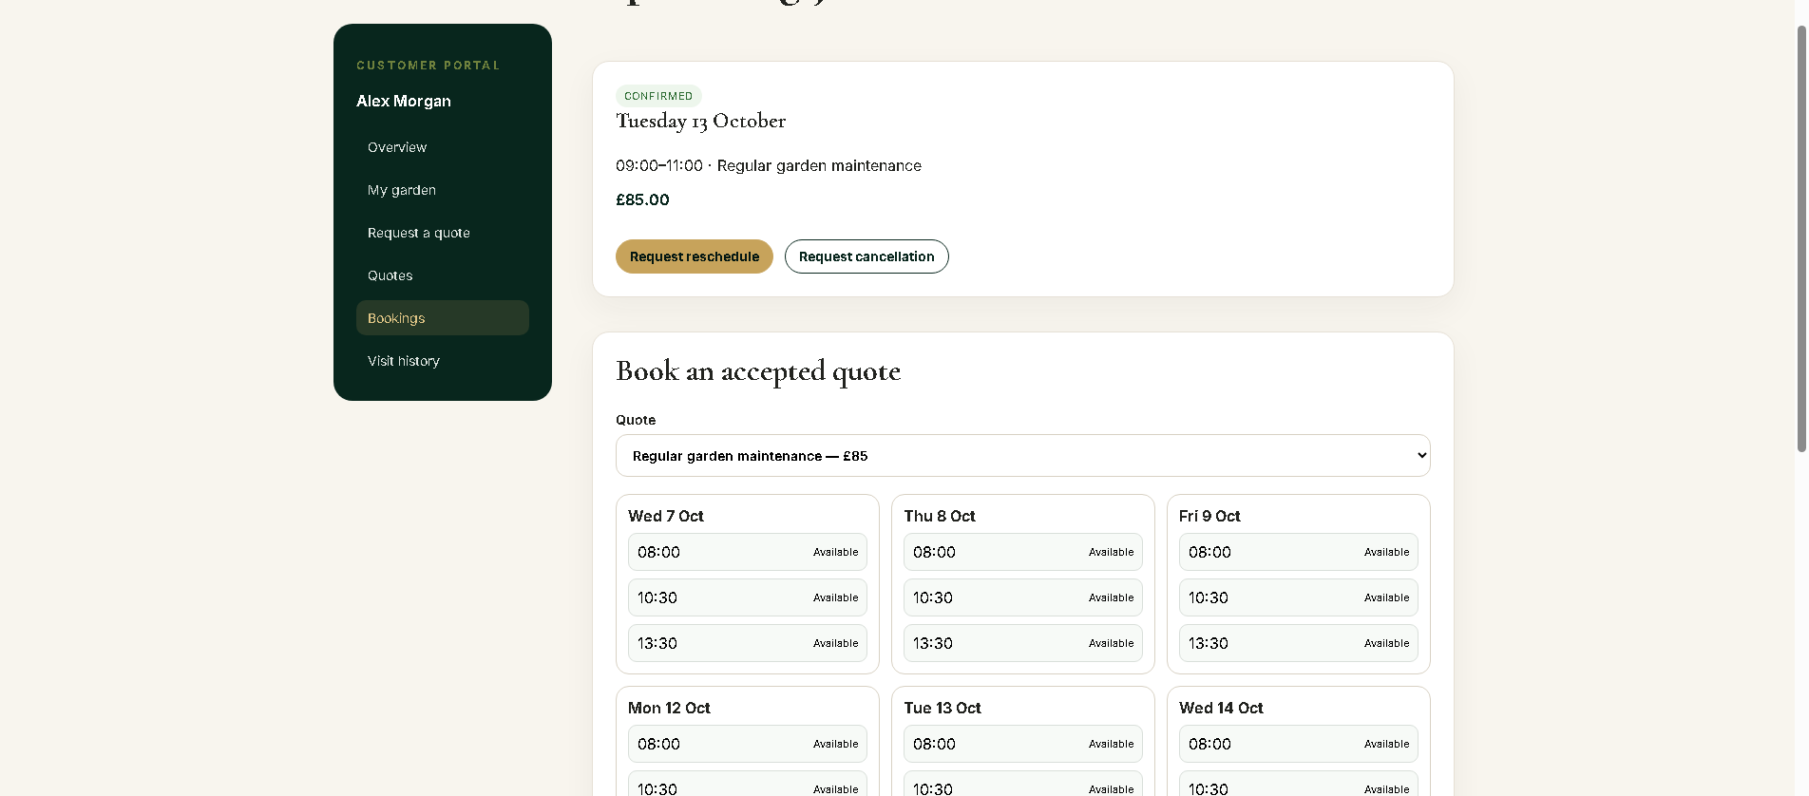

Figure 6 Booking timeslot for visit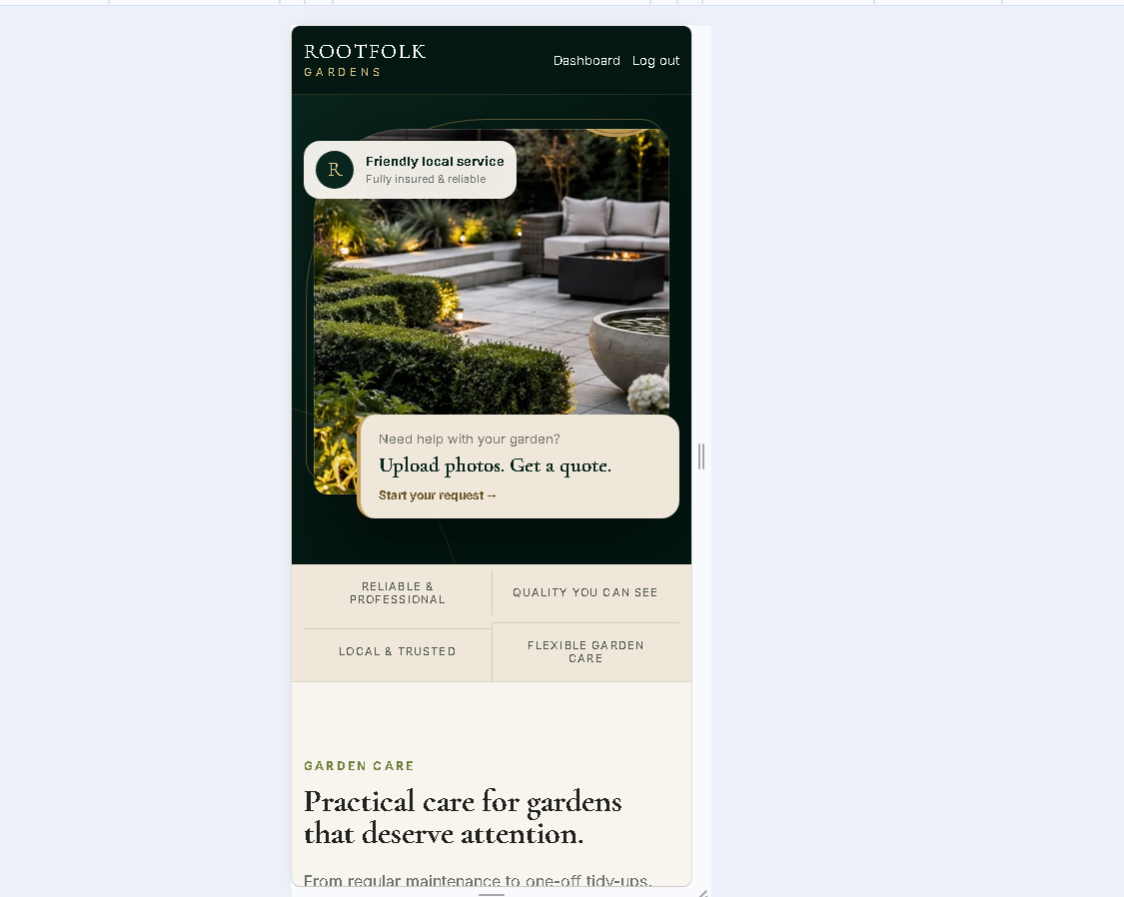
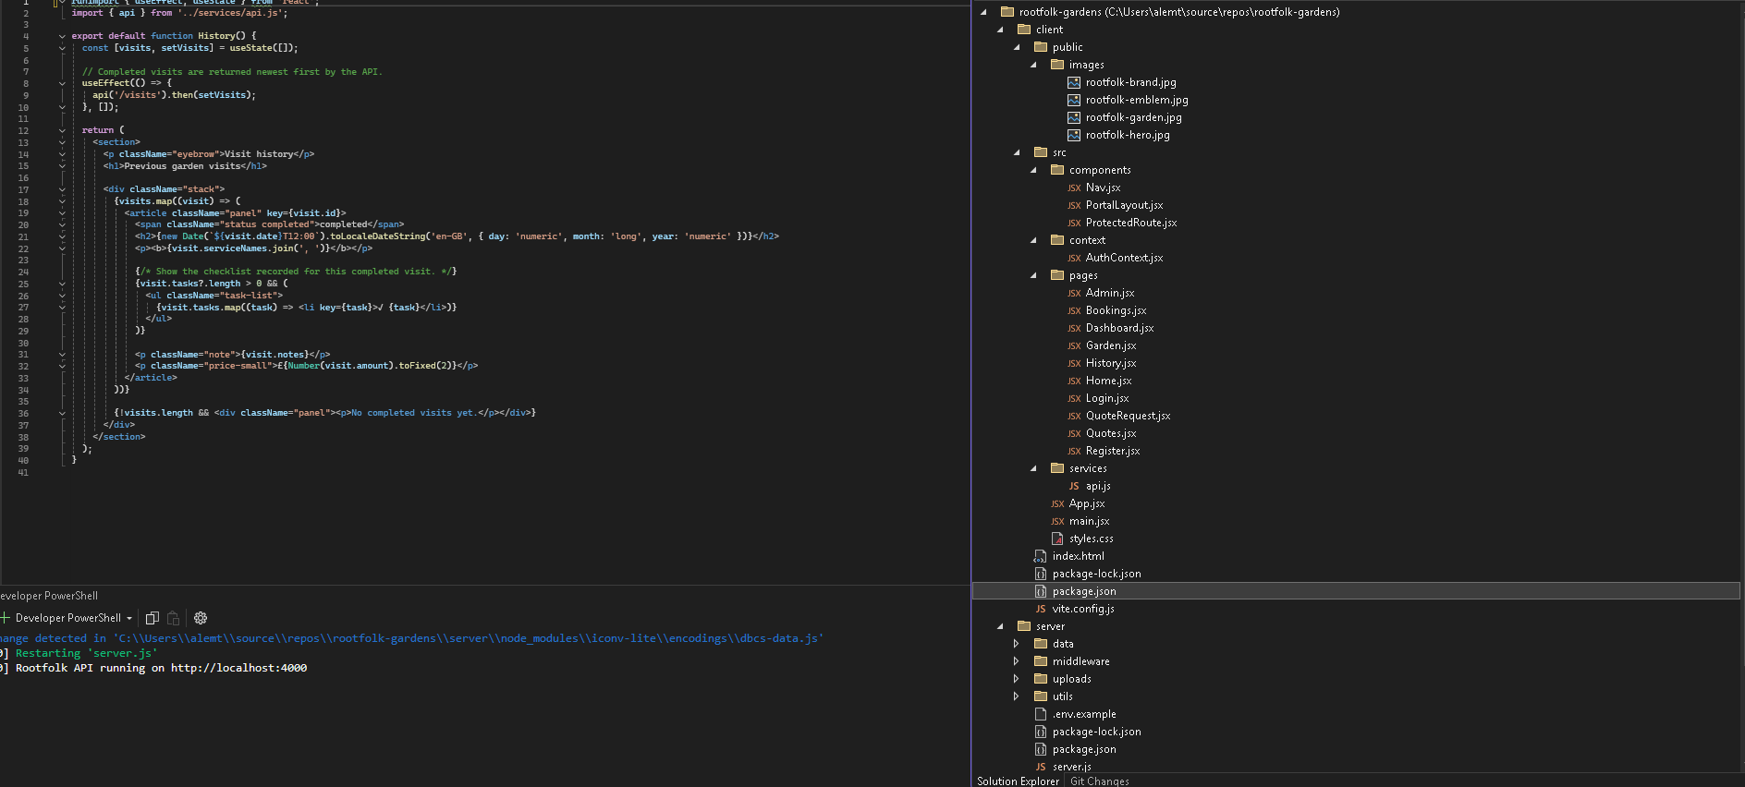
Figure 7 Coding structure
Figure 8 Mobile view

References

Express.js (2026) Routing. Available at: https://expressjs.com/en/guide/routing/ (Accessed: 6 October 2026).
MDN Web Docs (2025) Media queries. Available at: https://developer.mozilla.org/en-US/docs/Web/CSS/CSS_media_queries/Using_media_queries (Accessed: 6 October 2026).
Multer (2026) Multer package documentation. Available at: https://www.npmjs.com/package/multer (Accessed: 6 October 2026).
React (2026) State: A Component's Memory. Available at: https://react.dev/learn/state-a-components-memory (Accessed: 6 October 2026).
React Router (2026) Routing documentation. Available at: https://reactrouter.com/ (Accessed: 6 October 2026).
bcrypt.js (2026) bcryptjs package documentation. Available at: https://www.npmjs.com/package/bcryptjs (Accessed: 6 October 2026).

