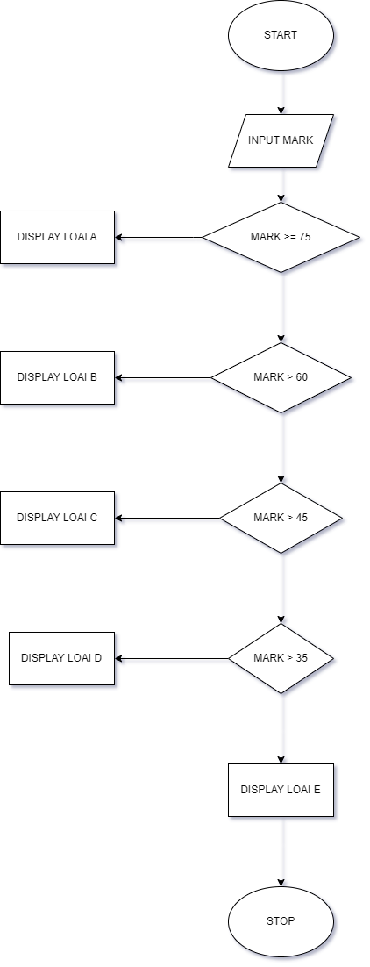BEGIN

INPUT MARK

IF MARK >= 75

DISPLAY LOAI A

ELSE IF MARK > 60

DISPLAY LOAI B

ELSE IF MARK > 45

DISPLAY LOAI C

ELSE IF MARK > 35

DISPLAY LOAI D

ELSE DISPLAY E

END IF

END