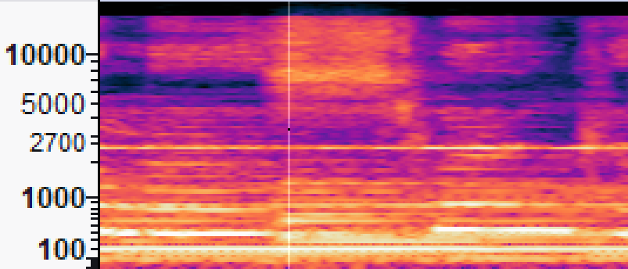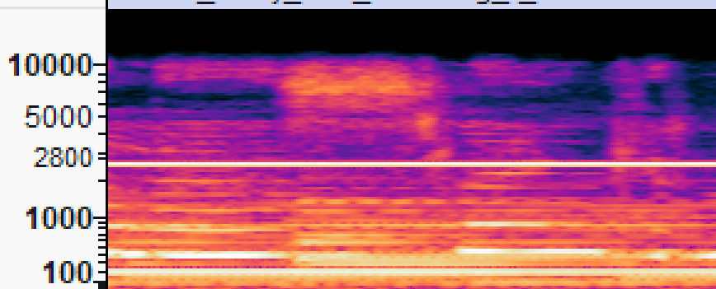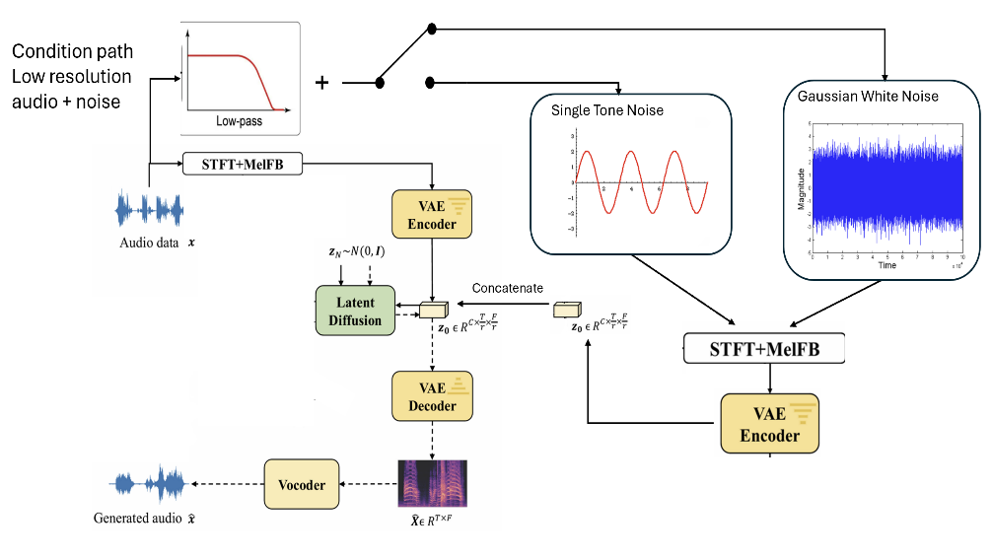

The model predicts higher frequencies in low-resolution audio and try to reduce white noise.

Conclusions

The model predicts higher frequencies in low-resolution audio and reduces single-tone noise.

AUDIOSR

Niv Aharon Cohen, Michael Berger

Model’s architecture

* Convert low-resolution audio to high-resolution audio using the AUDIOSR model.
* Denoise audio by removing noise types such as single-tone and white noise using the AUDIOSR model with small improvments**.**

Project goals

Results

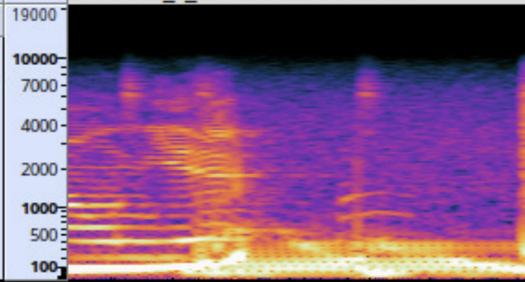

* The model showed positive results in noise removal, even with low-resolution audio.
* It was more effective at reducing single-tone noise compared to white noise, likely due to longer training on single-tone noise.
* The model is versatile and, with minor adjustments, can be adapted to handle additional features and various types of noise.