INTERNATIONAL ORGANISATION FOR STANDARDISATION
ORGANISATION INTERNATIONALE DE NORMALISATION
ISO/IEC JTC 1/SC 29/WG 11
CODING OF MOVING PICTURES AND AUDIO

ISO/IEC JTC 1/SC 29/WG 11 NXXXX
Warsaw, PL – June 2015

Source: | Requirements
Status: | Draft
Authors: | Claudio Alberti, Marco Mattavelli (EPFL), Leonardo Chiariglione (CEDEO), Ioannis Xenarios, Nicolas Guex, Heinz Stockinger, Thierry Schuepbach, Pascal Kahlem, Christian Iseli, Daniel Zerzion, Dmitry Kuznetsov (SIB), Yann Thoma, Enrico Petraglio (HEIG-VD), Cenk Sahinalp, Ibrahim Numanagic (Simon Fraser University), James Bonfield (Wellcome Trust Sanger Institute), Vadim Zalunin (EBI), Jaime Delgado (UPC), Walter Allasia (Eurix), Spencer Cheng (Morphbius), Jan Voges (Leibniz University Hannover, Institut fuer Informationsverarbeitung).
Title: | Requirements on Genome Compression and Storage

Table of Contents
1 Purpose 2
2 Terminology 2
3 Standards and implementations 2
4 Genomic information life cycle 3
4.1 From sequencing to analysis 3
4.2 Requirements 5
4.2.1 Sequence reads extraction – unmapped reads 5
4.2.2 Mapping and Assembly – mapped/aligned reads 6
4.3 General requirements 7
5 Conclusion 7

Purpose
This document is a first attempt at collecting requirements for assessing the merit of existing solutions for supporting the functionality of a “Genomic Information Transport Layer" (GITL). The final objective is to design and to specify such layer if no existing solutions prove to be adequate.
By Transport Layer we intend the abstract definition of the data structure that includes all collection of heterogeneous data, associated to the genomic information generated by sequencing machines during the different stages of genomic data processing that is referred to as "genomic information life cycle".

Terminology

Term | Definition
Alignment | A sequence read mapped on a reference DNA sequence
BAM | Compressed binary version of SAM
CRAM | GIR that includes SAM + Compression configuration
FastA | GIR that includes header and sequence reads (nucleotides sequence)
FastQ | GIR that includes FastA + Quality Scores
GIR | Genomic Information Representation
Indel | An additional or missing nucleotide in a DNA sequence with respect to a reference DNA sequence.
MAF | Mutation Annotation Format. File format used to mark the genes and other biological features in a DNA sequence
Mate pairs | Two reads from the same (long) DNA strand extracted by sequencing machines. The orientation is the opposite of paired ends.
Paired ends | Couple of reads produced by the same (short) DNA fragment by sequencing both ends. The orientation is the opposite of mate pairs.
Quality score | A quality score is assigned to each nucleotide base call in automated sequencing processes. It expresses the base-call accuracy.
Read header | Each sequence read stored in FastA and FastQ format starts with a textual field called “header” containing a sequence identifier and an optional description
SAM | GIR that is human readable and includes FastQ + Alignment and analysis information
Sequence read | The readout, by a specific technology more or less prone to errors, of a continuous part of a segment of DNA extracted from an organic sample

Standards and implementations
Currently the interest of MPEG in a Genomic Information Representation (GIR) standard covers two aspects:
- the compression of genomic data generated by sequencing processes (FastA and FastQ) so that such data can be compressed and efficiently processed without decompression whenever possible and appropriate
- the definition of a data format (GITL) that carries compressed genomic data and compressed metadata generated during the "genomic information life cycle"
In MPEG "standard" typically means a description of the normative sequence of operations to be performed on compressed and/or transported data in order to reconstruct data into their original (uncompressed) form. This is what MPEG calls "decoding" process. A reference implementation of a "decoder" is typically developed and actually assumes a "normative" status. Conversely one or more implementations of "encoders" are also developed as reference examples, but they assume only an "informative" status.

Genomic information life cycle

From sequencing to analysis
The typical steps of the genomic information life cycle are described in the table below

 | Step | Description | File format
1 | Sequence reads extraction | The process of extraction of fragments of DNA/RNA in the form of sequences of nucleotides from a biological sample. Sequences of nucleotides are commonly referred to as “reads”. This information is usually encoded as FastA files including a textual header and a sequence of nucleotides symbols (A,C,G,T,N). If a quality score is added to each nucleotide read, the file is called FastQ. | FastA  FastQ
2 | - Mapping and Assembly | Sequence alignment refers to the process of arranging sequence reads by finding regions of similarity that may be a consequence of functional, structural, or evolutionary relationships among the sequences. When the alignment is performed with reference to an existing DNA sequence the process is called “mapping”. | SAM  BAM  CRAM
2 | - Assembly | Sequence assembly refers to merging aligned fragments of a much longer DNA sequence in order to reconstruct the original sequence. It does not necessarily imply the use of an external reference. When no external reference is used, the process is referenced to as “de-novo” assembly. | SAM  BAM  CRAM
3 | Variant detection | Variant detection (a.k.a. variant calling) is the process of translating the output of DNA sequencing machines, (short reads mentioned in step 1 and aligned in step 2), to a summary of the unique characteristics of the organism being sequenced. These characteristics are called “variants” because they are expressed as differences between the organism under study and a reference genome. | VCF
4 | Variant annotation | Variant annotation is the process of assigning functional information to the DNA variants identified in step 3. This implies the classification of variants according to their relationship to coding sequences in the genome and according to their impact on the coding sequence and the gene product. | MAF
5 | Functional & Structural Analysis | Analysis of DNA (variant, CNV = copy number variation, methylatyion etc,) strands to define their relationship with genes (and proteins) functions and structure. | Several different solutions

Table 1 - The main stages of a typical genomic processing pipeline

With respect to the previous table, step 5 covers a vast horizon, and could open up interpretation of variant ‘severity’ relationship with phenotypes, etc… This goes relatively far from compression and transport of sequence reads. In the scope of this work it might be important to leave open the door to ‘pointers’ to extra containers of annotations, but it must be realized that this annotation (associated knowledge) is constantly revised and very dynamic. Analogy with a movie would be akin to storing the “assay” from a movie “critic” that comments on the signification of a character appearing at the Nth minute of the movie wearing a pink hat. Interpretations will differ.
This step is mentioned here for the sake of completeness but the involved information does not probably need to be encoded and transported together with the genomic information.

Figure 1 depicts a functional diagram of the typical genomic information life cycle expressed as different processing steps and intermediate file formats.

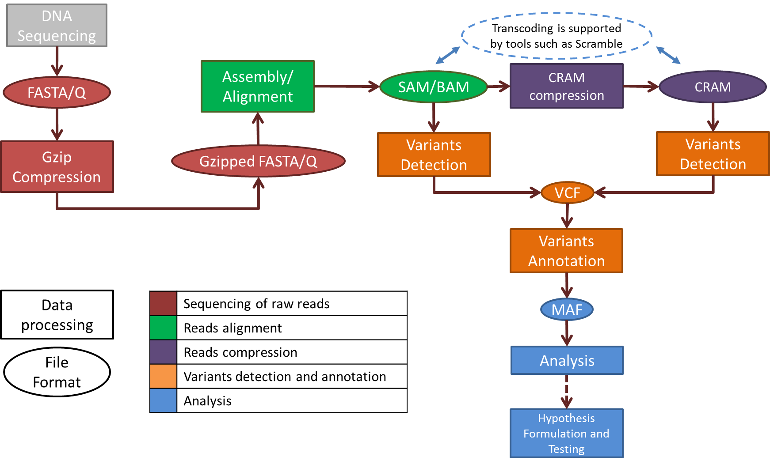

Figure 1 - Typical structure of a genomic information processing pipeline from sequencing to analysis

A simplified vision of the relation among the file formats used in genome processing pipelines is depicted in Figure 2. In this diagram file inclusion does not imply the existence of a nested file structure but it only represents the type and amount of information that can be encoded for each format (i.e. SAM contains all information in FastQ, but organized in a different file structure). The BAM format is not represented because it’s the compressed equivalent of SAM.

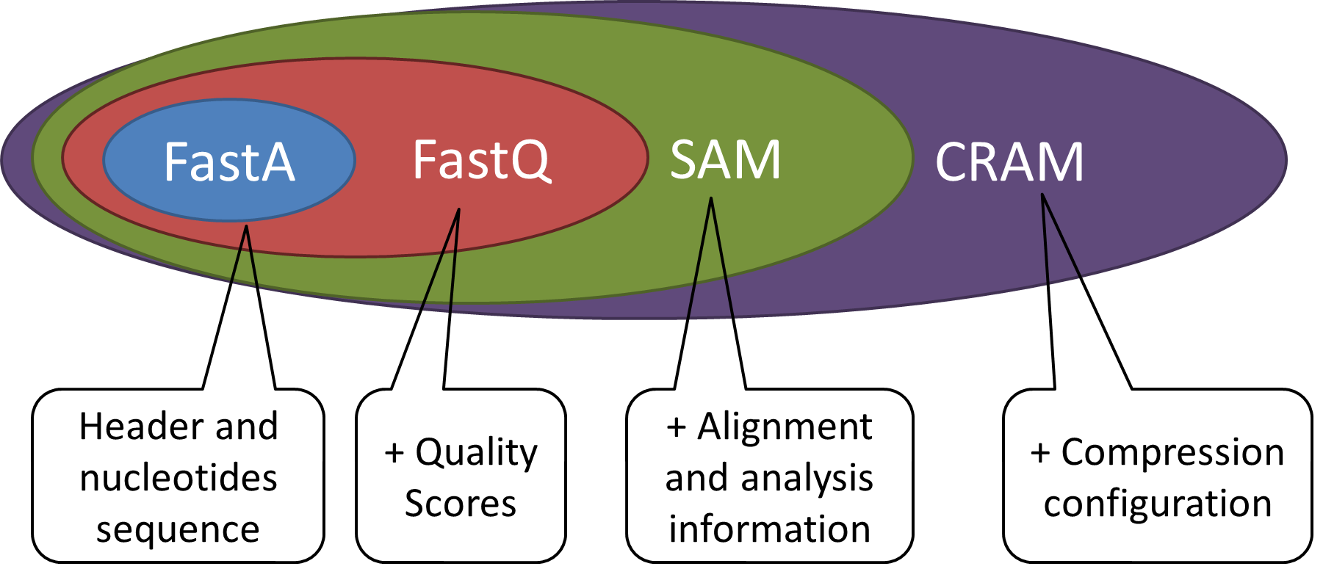
Figure 2 - Relationship among some of the most popular file formats

Requirements
This section introduces the definition of the requirements an appropriate solution to genomic information representation (GIR) and transport (GITL) should meet at the first two stages of the processing pipeline introduced earlier and listed in Table 1.
Variants calling, mutations annotation and functional analysis are likely to have different requirements in terms of information representation and transport and will be addressed in a separate stream of work.

Sequence reads extraction – unmapped reads
Compression of FastQ description is not taken into account in this list of requirements as this is an obsolete field no more used by the main NGS machines manufacturers.

Req ID | Requirement for compression | Rationale
1.1 | Lossless compression of reads headers.
1.2 | Lossy compression of reads headers.  In case of lossy compression sequence reads shall be uniquely identifiable. | e.g. to link one read to the respective paired read
1.3 | If the sequencing process produced paired-end or mate-reads, then pairing information shall be preserved | Needed to be able to preserve physical relations among reads
1.4 | When present, any FastQ description string shall be lossless preserved. | FastQ comments are rarely used, but might be present in old archives. This is to preserve backward compatibility.
1.5 | Lossless compression of nucleotides sequences supporting a minimum of 5 symbols (A, C, G, T, N) | Note: today most machines use A,C,G,T,N but other symbols might be adopted soon such as the IUPAC ambiguity codes
1.6 | Lossless compression of quality scores shall be supported. | 96 quality levels are possible but rarely more than 40 are used.
1.7 | Lossy compression of quality scores shall be supported. Lossy compression should respect rate distortion metrics that MPEG needs to identify with their associated boundaries. | Investigations are needed to define the most appropriate rate distortion metrics and the associated boundaries that lossy compression of QS needs to satisfy.
1.8 | Compressed data shall be structured so that efficient querying of data and parallel processing are enabled and compression efficiency is preserved | This is intended to enable efficient parallel processing of data without affecting compression efficiency.
1.9 | Compressed data streaming shall be supported. | This implies that data consumption shall be possible before data transfer completion.
1.10 | The association among headers, nucleotides and quality scores must be preserved
1.11 | The compression process shall support the assessment of integrity. | Integrity check shall be possible by providing appropriate information.
Req ID | Requirement for transport | Rationale
1.12 | Information enabling data protection shall be conveyed | Ability to prevent unauthorized access shall be available. Information needed for protection of data (control for access, modification, publication, etc.) shall be conveyed.
1.13 | Information enabling accountability and traceability shall be conveyed | Data access and manipulation shall be traceable together with the identity of parties having access to data.  Information on how to verify integrity and authenticity of the data shall be conveyed.
1.14 | Information enabling transparency shall be conveyed | How and for which purpose the information is used should be known. Usage restriction shall be applicable to the data.

Mapping and Assembly – mapped/aligned reads
This section lists additional requirements for aligned data. All requirements listed for raw data still apply.

Req ID | Requirement for compression | Rationale
2.1 | If a reference genome is used, it shall be a resource unambiguously identifiable and available to the decompressor. | It can be either embedded in the content or remotely referenced.  Referencing external reference genomes is a threat to preservation.
2.2 | From aligned/mapped reads, it shall be possible to reconstruct the original unmapped reads, including pair information if present. | Raw data with pairing information shall be available to enable re-alignment of reads according to different alignment criteria
2.3 | Access to indels (polymorphism that corresponds to the addition or removal of a number of bases in a DNA sequence) and differences with respect to the reference genome must be possible for selected segments of the alignment.
2.4 | Uniquely identify each aligned read (a.k.a. alignment) and its mate pair if applicable.
2.5 | Lossless compression of attributes associated to each read expressing:  - presence of multiple fragments  - all fragments aligned  - unmapped fragments  - reverse strand  - signalisation of first or last fragment  - quality control failure  - PCR or optical duplicate  - Secondary and supplementary flags  - Template length  - Mapping pairing information
2.6 | Lossless compression of mapping/alignment information.
2.7 | Support mapping quality expression. | The current metric for mapping quality is expressed as “phred-scaled posterior probability that the mapping position" is wrong.

General requirements
Req ID | Requirement | Rationale
3.1 | Data formats at any level must support their migration | Encoded data need to provide all the required information for migrating to a new format. Information loss shall be measurable.
3.2 | Data resiliency must be supported
3.3 | Support the encoding of any additional metadata | This is intended to make the format extensible to include additional metadata.

Conclusion
The main goal of this document is the identification of the most important stages of a typical genomic processing pipeline and the definition of a first draft list of requirements specific to each stage.
Particular focus is devoted to sequence data produced by the Next Generation Sequencing machines (unmapped data) and to aligned reads.
The list of requirements presented in this document is proposed as a starting point and as a support to further discussion and refinement.

