INTERNATIONAL ORGANISATION FOR STANDARDISATION
ORGANISATION INTERNATIONALE DE NORMALISATION
ISO/IEC JTC1/SC29/WG11
CODING OF MOVING PICTURES AND AUDIO

ISO/IEC JTC1/SC29/WG11 MPEG2015/Mxxxx
Month YYYY, City, Country

Source | Leibniz University Hannover (Institut fuer Informationsverarbeitung (TNT))
Status | Input documents
Title | Approaches To SAM File Compression
Author | Jan Voges, Dipl.-Ing. Marco Munderloh (Institut fuer Informationsverarbeitung (TNT))

Table Of Contents
1 Introduction 1
1.1 Outline 2
1.2 Software Framework 2
2 Block-based Compression Of Nucleotide Sequences 2
2.1 Prior Work 2
2.2 Proposed Compression Mechanism 3
3 Predictive Coding Of Quality Scores 4
3.1 Prior Work 4
3.2 Observations 4
3.3 Modeling The Source With A Markov Chain 5
3.3.1 Drawbacks And Recommendations 5
3.4 Markov Model With Line Context Support 5
3.5 Linear Prediction With FIR Filters 6
3.6 Entropy Coding Of Prediction Errors 7
4 Results 7
5 References 7

Introduction
Due to novel high-throughput next-generation sequencing (NGS) technologies, the sequencing of huge amounts of genetic information has become affordable. On account of this flood of data, IT costs may become a major obstacle compared to sequencing costs. High-performance compression of genomic data is required to reduce the storage size and transmission costs.
Raw sequencing data (mainly the base sequences – also known as reads - and the quality scores) is stored in so-called FASTQ files, whereas mapped sequence data is stored in so-called SAM files. SAM files are plain-text human-readable files containing the reads and quality scores as well as mapping information with respect to some reference genome.
Mapped sequencing data represented in SAM files contains more redundancy, as typically multiple reads are mapped to the same location on the reference genome. The average amount of reads mapping to the same location is referred to as coverage.
It has been shown by Tembe et al. [7] and Deorowicz and Grabowski [8], that splitting the data into separate streams for sequence reads, quality scores etc. (and compressing them independently) yields significant gains over general-purpose programs like gzip [2].
All recent contributions to the topic of FASTQ and/or SAM file compression employ this scheme of separately compressing the sequence reads and quality scores etc.
Based on statistical analysis performed on a reference data set (issued by the appointed MPEG ad-hoc group on genome compression), new proposals for sequence and quality score compression in SAM files have been developed.

Outline
We propose a sequence compressor which assumes aligned and position-sorted data. Our sequence compressor combines the mapping locations, the CIGAR strings and the actual sequences to implicitly assemble local parts of the donor genome and compress the sequence reads.
Regarding the compression of quality scores, we propose to use a compressor based on a Markov model with variable memory locations to boost prediction performance. Due to the large alphabet of quality scores (and thus a huge memory consumption of the Markov model), we furthermore propose employing FIR filter-based compression for quality scores.

Software Framework
We developed a compression framework called tsc (written in C) to evaluate compression mechanisms for the different fields present in a SAM file. The SAM file is split into separate streams for each SAM field [1]. Dedicated compression algorithms can then be employed in a block-by-block manner on each field or on a combination of fields. New compression modules for e.g. quality scores can easily be added.
Furthermore, we developed a framework to perform statistical analysis on the given dataset in MATLAB®. The framework is based on samsplit, a C program to split a SAM file into separate files for each field, some Perl scripts and a MATLAB® library to read and process the different file types.
We provide tsc via a Git repository hosted at TNT and the statistical framework as ZIP archive.

Block-based Compression Of Nucleotide Sequences

Prior Work
Current implementations (e.g. Quip [6] and sam_comp [3]) use an order-2 arithmetic coder to compress the nucleotide sequences. In order to exploit the redundancy present in the data, an arithmetic coder needs a priori knowledge. This practically excludes random access to the compressed data as the prediction performance increases with the amount of data the Markov model can be trained on.
The authors of DeeZ [5] made a new approach, called “local assembly” (implicit assembly of the donor genome using the mapping information present in SAM files). DeeZ nevertheless needs an external reference (in FASTA format).
The authors of Quip [6] implemented an assembly-based compression scheme for nucleotide sequences, too. They use the first 2.5 million reads to assemble so-called contigs which are then used in place of a reference sequence to encode aligned reads. This algorithm does not require a reference – this means that the resulting compressed files are entirely self-contained - but has the drawback that the best match of a specific read to the previously assembled reference has to be found (using k-mers and a Bloom filter).

Proposed Compression Mechanism
We propose a block-based compression scheme similar to that from DeeZ. In contrast to DeeZ, our compressor does not require a reference and is able to work on smaller block granularities (of course smaller block sizes have a negative impact on compression ratio). Our compression schmeme therefore is less complex but should nevertheless yield comparable compression ratios.
Our approach proposes to encode sequence reads block-wise exploiting the mapping location, the CIGAR strings and the sequence read itself. The first read in a block is encoded as plain text. Read is then aligned to the previous read using its CIGAR string and its mapping location. The trailing substring extending beyond the previous read is encoded as plain text. Unmapped reads are encoded as plain text, too.
The context read might be highly erroneous or not aligned to the reference. We address this issue by keeping track of previous reads to be able to select the best matching read to encode read .
To illustrate the feasibility of our approach, the nucleotide sequences of some high-coverage sequencing data are shown in Figure 2. The corresponding mapping locations are shown in Figure 1.
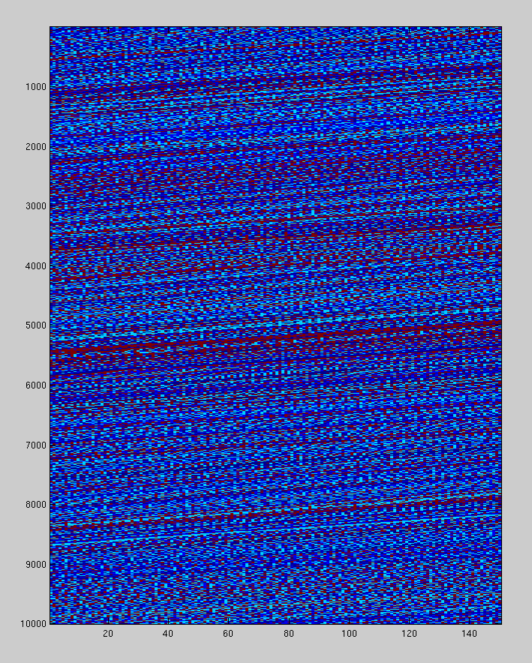Figure 2: Nucleotide sequences
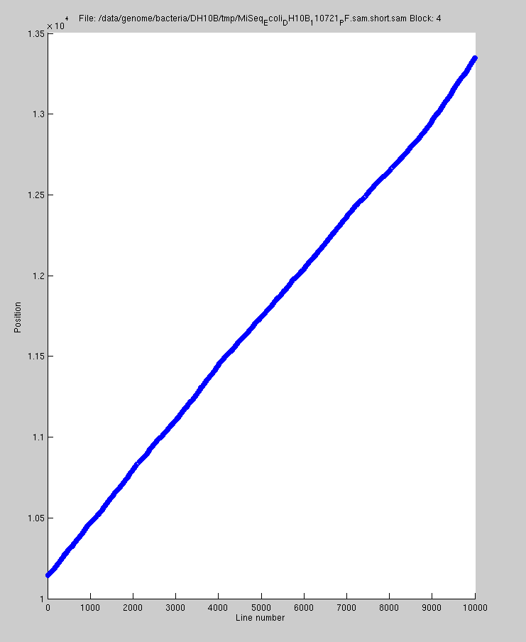Figure 1: Mapping locations

Note: Per block, the initial read and the trailing substrings of subsequent reads can be regarded as locally assembled genome.

Predictive Coding Of Quality Scores

Prior Work
The quality scores yield the largest first-order entropy among all field present in a typical SAM file, mainly due to their large alphabet.
The authors of Fqzcomp [3] state the following dependencies for a sequence of quality scores:
- Any score q_{i} has a strong correlation to the direct previous quality scores q_{i-1},q_{i-2},... decreasing the further back we go [4].
- A known issue with the Illumina base-caller causes many sequences to end with quality score 2 (“#”).
- There is a correlation between position and quality values. Quality values are typically reducing along the length of the sequence.
- Sequences as a whole tend to be good or bad.
The authors of Fastqz [3] additionally state that it was observed that the quality values tend to start with a common maximum value.
Current SAM compression implementations exploit this observations by employing a Markov model with the memory ranging over the direct predecessors in the quality score stream.

Observations
In terms of performing some statistical analysis regarding the quality scores, we converted the quality scores into a single stream.
A snapshot of some typical quality score lines and their histogram is shown in Figures 3 and 4.
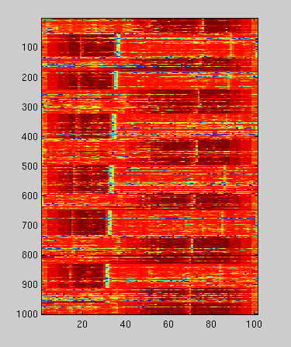Figure 3: Quality score lines
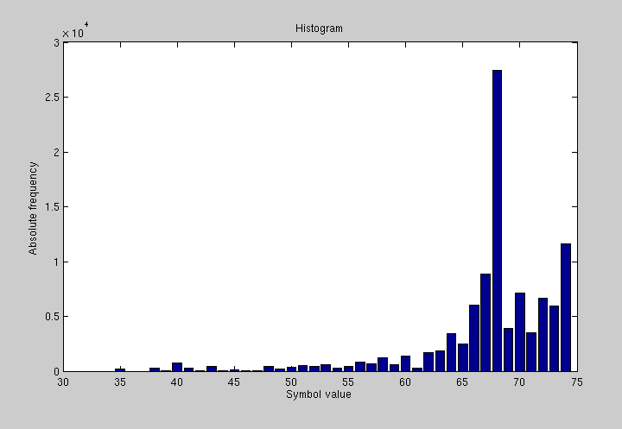Figure 4: Histogram

The autocorrelation function of such a stream is show in Figure 5. The auto-correlation does not resemble a delta impulse and thus the power spectral density is not constant. This means, that the source has some kind of memory. Thus, it is highly suitable to model the source with a Markov chain.
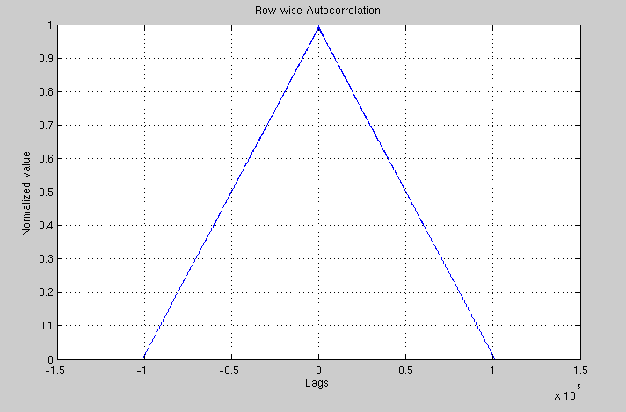Figure 5: Autocorrelation function of a quality score stream

In order to find further dependencies it might be beneficial to investigate the correlation between base calls and quality scores as well as CIGAR strings and base calls.

Modeling The Source With A Markov Chain
Common SAM file compression approaches [4,5] noted that quality scores usually contain a trailing sequence of low quality values. We made this observations, too, and propose first to trim the trailing low quality values.
Current SAM file compressors model the quality score source as a Markov chain, predicting the current symbol with a maximum likelihood predictor using the direct predecessors.
The maximum likelihood predictor selects in each state the symbol with the greatest conditional probability as prediction value :

Drawbacks And Recommendations
This source model consumes a huge amount of memory since we have to keep track of relative symbol frequencies. This model also needs a large amount of data to train in order to tightly fit the model to the data. We propose to store the prediction table (generated during compression) in the file header to speed up decompression. Prediction tables for the individual blocks can then be delta-encoded. This would enable random access to the compressed data.

Markov Model With Line Context Support
The authors of Fqzcomp [3] state, that quality score lines as a whole tend to be “bad” or “good”. Additionally, we made the observation, that in some datasets subsequent quality score lines are “similar”.
We respond to this using a so-called line context, i.e. a structure holding some number of previous lines from the current block. The Markov memory is divided into one part containing the memory locations on the current line (“intra-line memory”) and one part containing the memory locations on some specific line from the line context (“inter-line memory”).
Choosing the right line from the line context to boost prediction performance is crucial. For each line we compute a four-dimensional identification vector for each quality score line, containing its length, its arithmetic mean, its variance and its Levensthein distance to the first line in the line context. In the process of encoding line , we first select the one specific line from the line context with the least identification vector distance. Consecutively, the intra-line memory is placed on line and the inter-line memory is placed on the selected line from the line context.
This compression approach yields a relatively low encoder complexity yet employing contexts ranging over multiple quality score lines.

Linear Prediction With FIR Filters
Due to the large alphabet of the quality scores (typically ~30 symbols, although more are theoretically possible), Markov models are limited to some low order (typically ).
As an alternative, we propose to use an FIR-filter to predict the current symbol. While it is on the one hand costly to compute the FIR filter coefficients, on the other hand, filter coefficients might be shared between multiple quality score lines.
The basic layout of a predictive encoder can be viewed in Figure 6.
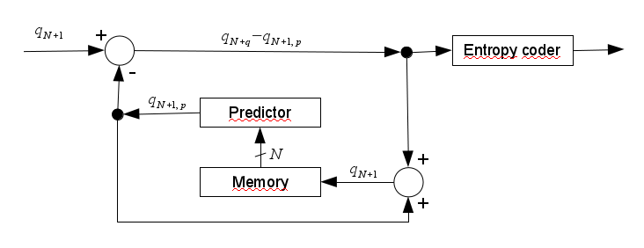Figure 6: Linear predictive encoder schematic
The linear predictor computes the current prediction value by evaluating the linear series of previous symbols weighted with predictor coefficients .

The usual approach to compute the predictor coefficients is to minimize the mean squared error which yields the following condition to compute the filter coefficients.

Thus, we obtain sets of predictor coefficients for a quality score line of length . Using the line context from section 3.4, it could be beneficial to share previously computed predictor coefficients among multiple lines.
In contrast to this minimum-mean-square-error filtering it might be beneficial to investigate and employ minimum-variance prediction and filtering.

Entropy Coding Of Prediction Errors
The histogram of the prediction errors of the Markov model or the FIR filter approximately show a two-sided geometric distribution. We therefore propose to use subsequent Rice coding to obtain the binary representation of the data. This reduces the encoder complexity, as recent compressors such as Quip [6] employ arithmetic coding.

Results
Our approach to compress nucleotide sequences from section 2.2 is not fully evaluated yet, but yields compression ratios comparable to DeeZ.

References
[1] | The SAM/BAM Format Specification Working Group. Sequence Alignment/Map Format Specification
[2] | Ziv., J. & Lempel, A. A universal algorithm for sequential data compression. IEEE Transactions on information theory 23, 337-343 (1977).
[3] | Bonfield, J.K & Mahoney, M. V. Compression of FASTQ and SAM Format Sequencing Data. PloS ONE 8, e59190 (2013).
[4] | Christos Kozanitis, Chris Saunders, Semyon Kruglayak, Vineet Bafna, and George Varghese. Compressing genomic sequence fragments using SlimGene. Journal of Computational Biology: A Journal of Computational Molecular Cell Biology, 18(3):401-13, March 2011. ISSN 1557-8666. doi: 10.1089/cmb.2010.0253
[5] | Faraz Hach, Ibrahim Numanagic & S. Cenk Sahinalp. DeeZ: reference-based compression by local assembly. Nature Methods, Vol. 11, No. 11, November 2014, pp 1082-1084
[6] | Daniel C. Jones, Walter L. Ruzzo, Xinxia Peng & Michael G. Katze. Compression of next-generation sequencing reads aided by highly efficient de-novo assembly. Nucleic Acids Research, 2012, 1-9. doi: 10.1093/nar/gks/754.
[7] | Tembe, W., Lowey, J. and Suh, E. G-SQZ: compact encoding of genomic sequence and quality data. Bioinformatics, 26, 2192-2194, (2010).
[8] | Deorowicz, S. and Grabowski, S. Compression of DNA sequence reads in FASTQ format. Bioinformatics, 27, 860-862. (2011).

Patent right(s) applications
Leibniz Universitaet Hannover, Institut fuer Informationsverarbeitung may have current or pending patent rights relating to the technology described in this contribution and, conditioned on reciprocity, is prepared to grant licenses under reasonable and non-discriminatory terms as necessary for implementation of the resulting ITU-T Recommendation | ISO/IEC International Standard (per box 2 of the ITU-T/ITU-R/ISO/IEC patent statement and licensing declaration form).

