* Welcome Page:

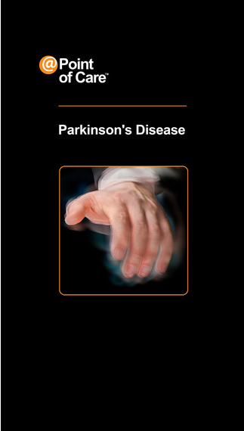

* First Page: Overall Health Today ([link](https://itunes.apple.com/us/app/pd-me/id927178736?mt=8))

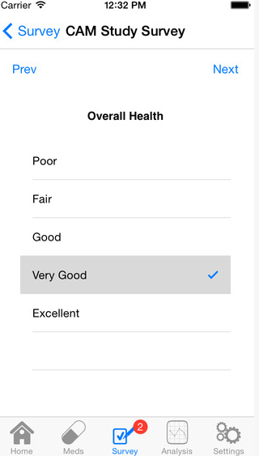 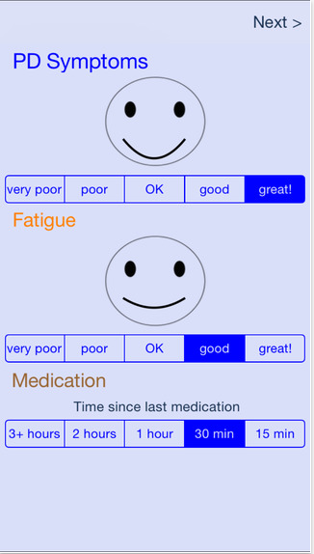

* Personal Profile
  + Today’s Mood (choose from list of smileys)
  + Contact info
  + 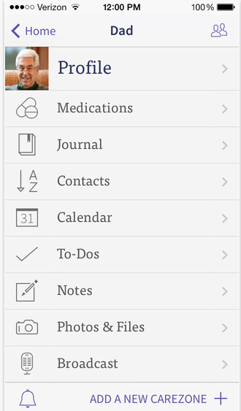
* Tests and Procedures
  + Scans, X-rays and MRIs
* Calendar ([link](https://itunes.apple.com/us/app/senior-care-manager-from-institute/id720869291?mt=8))
  + Daily, Weekly and Monthly view
  + In Daily view: list of drugs, exercises

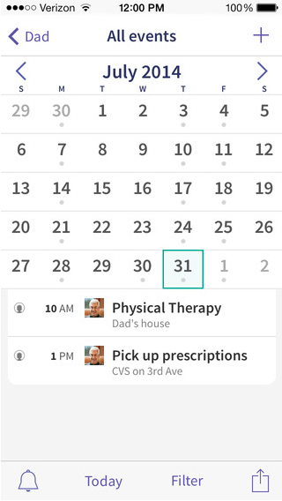

* Prescription, drugs and their side effects([like](https://itunes.apple.com/us/app/medisafe-medication-reminder/id573916946?mt=8))

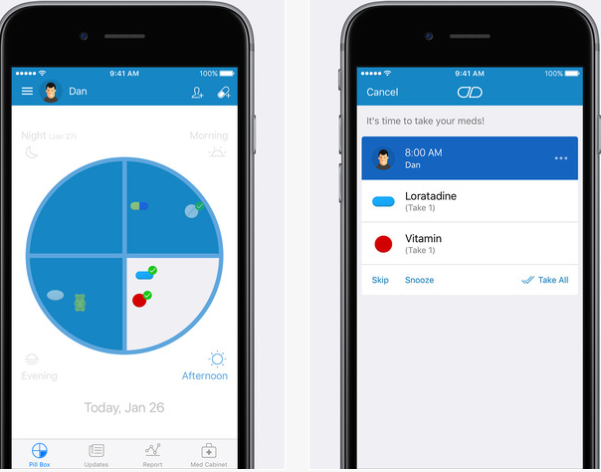

* Appointments (brief description)
  + History
  + Future
* Daily reminder
  + medicine
  + game
  + activity
* Daily exercise (short videos) ([link](https://itunes.apple.com/us/app/parkinson-home-exercises/id473641730?mt=8))
  + 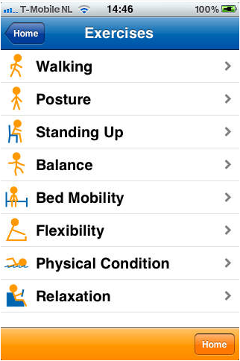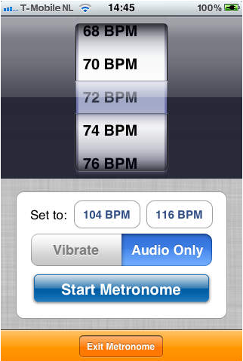 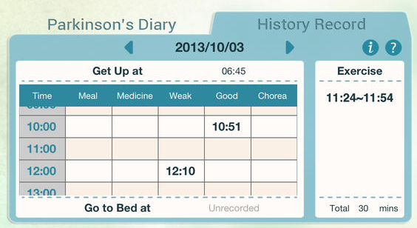
* Questionnaire (Tracking Condition) ([link](https://itunes.apple.com/us/app/parkinsons-diary/id720019439?mt=8))

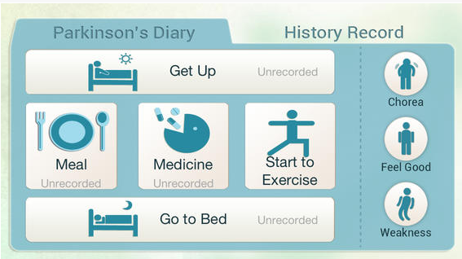

* + Eating

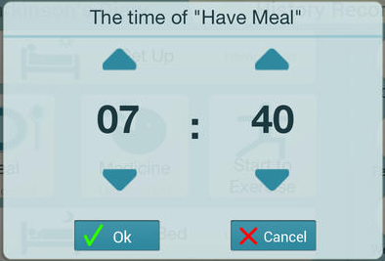

* + Sleeping
  + Dressing
  + Washing/Shave/bath
  + Walking
  + Hobbies
  + Social
* Emergency contact (Voice Accepted)
* List of games:
  + Balancing Games: ([link](https://itunes.apple.com/us/app/studymytremor/id533088021?mt=8))
    - Page1: Select between three games
    - Page2: Main page of game
    - Page3: Score result
    - Page4: Prediction of condition improvement
    - Page5: Improvement Chart/ Diagram

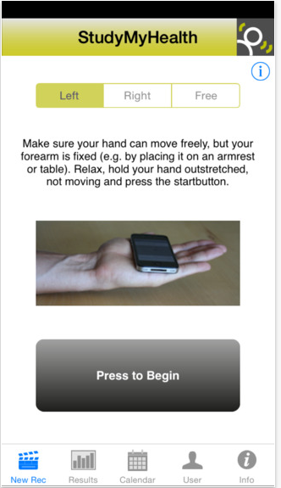

* + Touch sensitive Games:
    - Page1: Difficulty Modes
    - Page2: Different circles with different pressures
    - Page3: SAME
    - Page4: SAME
    - Page5: SAME
  + Tracking Games: ([link](http://www.touchdx.com/solutions/tremortracer))
  + 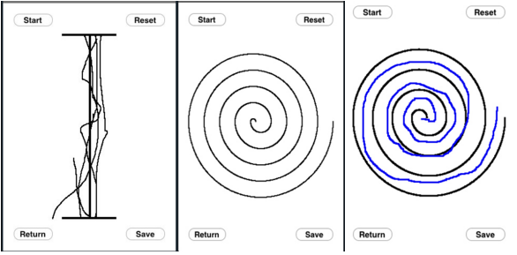
* Speech Data ([link](https://itunes.apple.com/us/app/speak-better-pacing-therapy/id988371335?mt=8))
  + Listen and Repeat
    - Page1: Choose speed
    - Page2: Choose difficulty

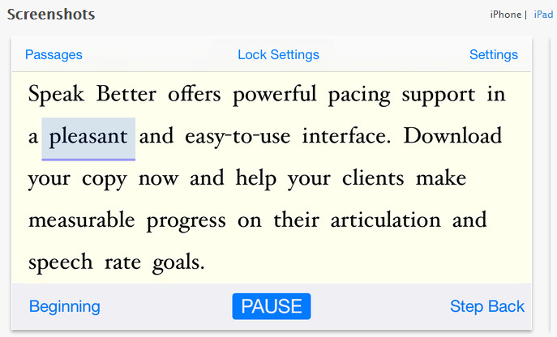

* Sleep Data ([link](https://mysleepbot.com/))

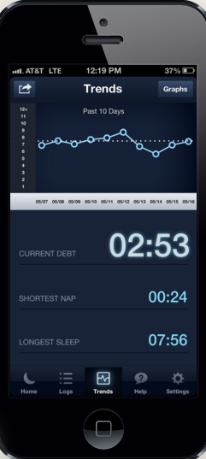

* Body sensor (Bluetooth)

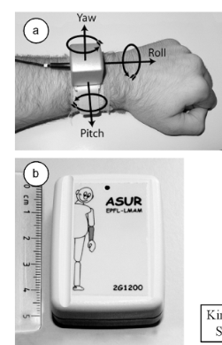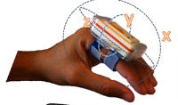

* Patient Search
* Patient portfolio
  + activity
  + game
  + speech
  + sleep
  + side effect of medicines
* Nutrition
  + Meal suggestion
* Symptom Checker: ([link](https://itunes.apple.com/us/app/webmd-trusted-health-wellness/id295076329?mt=8))

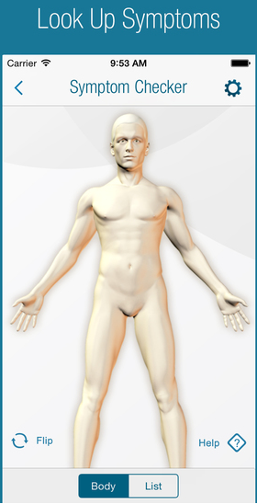

* Local health centers:
  + List of address and contact info of medical centers nearby
* Recent News and Findings Feed
* Tremor-Meter: ([link](https://itunes.apple.com/us/app/tremor-meter/id447804073?mt=8))

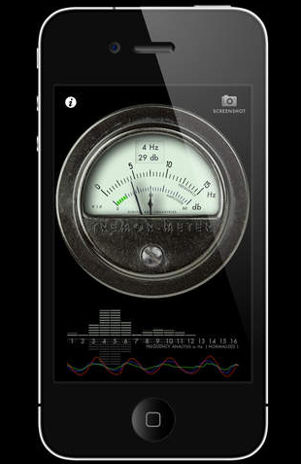

* Progress and Goals: ([link](https://itunes.apple.com/us/app/webmd-pain-coach/id536303342?mt=8))

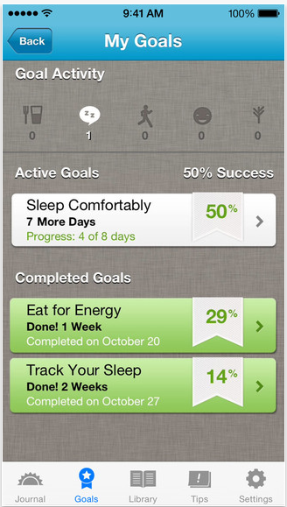

* Apple Watch App: ([link](https://itunes.apple.com/us/app/webmd-trusted-health-wellness/id295076329?mt=8))

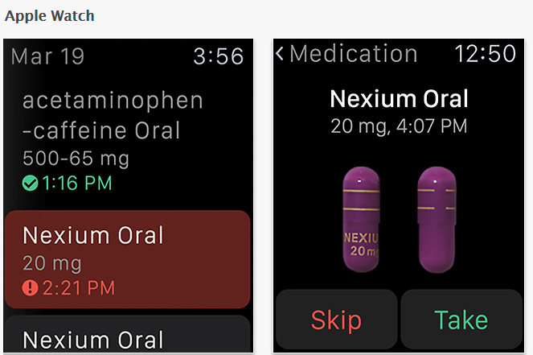

Ride for Parkinson’s: ([link](https://itunes.apple.com/us/app/rides-for-parkinsons/id1003330022?mt=8))

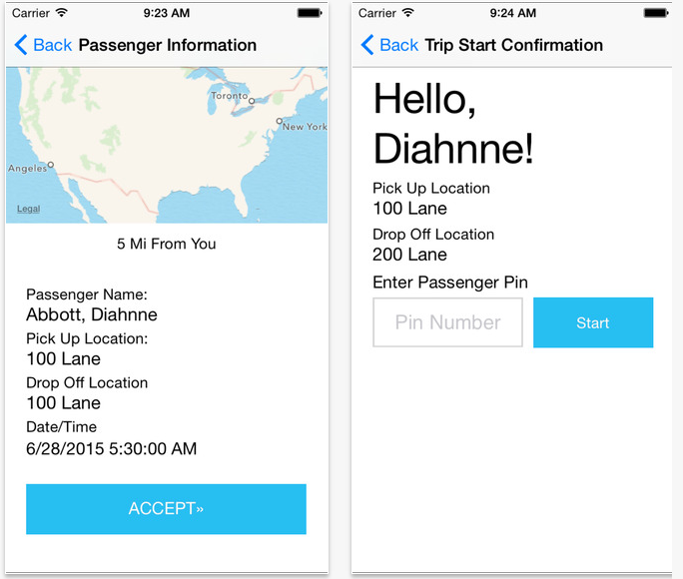

Tutorial: ([link](https://itunes.apple.com/fr/app/smartfiches-neurologie-free/id703726106?mt=8))

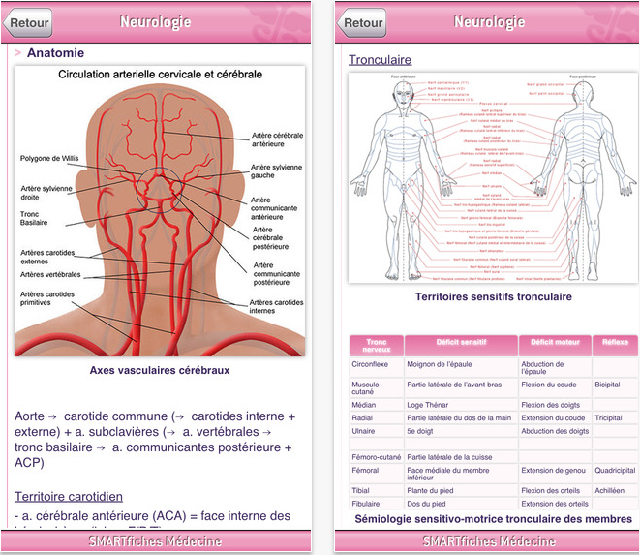

====================

References:

* WebMd Mobile Apps: <http://www.webmd.com/mobile>