Dyskinesia
Monday, February 8, 2016
12:11 PM

Dyskinesia refers to a category of movement disorders that are characterized by involuntary muscle movements,^{[1]} including movements similar to tics or chorea and diminished voluntary movements. Dyskinesia can be anything from a slight tremor of the hands to an uncontrollable movement of the upper body or lower extremities.
Acute dystonia is a sustained muscle contraction that sometimes appears soon after administration of antipsychotic medications

From <https://en.wikipedia.org/wiki/Dyskinesia>

Way to handle
Blue Lenses

From <https://www.youtube.com/watch?v=OrcO2oRv75I>

On-Dyskinesia refers to the choreic and dystonic movements described to the patient as “jerking or twisting movements that occur when your medicine is working.”
Off-Dystonia should be described to the patient as “spasms or cramps that can be painful and occur when your Parkinson’s disease medications are not taken or are not working

Speech
Sleep
Eating/ swallowing pills, …
Dressing
Washing/bath/shave/..
Handwriting
Walk and balance

Publics
Self-conscious
Avoid exciting
Hobbies

From <http://www.movementdisorders.org/MDS-Files1/PDFs/UDysRS_English_FINAL.pdf>

Unified Dyskinesia Rating Scale (UDysRS)

From <http://www.movementdisorders.org/MDS-Files1/PDFs/UDysRS_English_FINAL.pdf>

Off-Dystonia Ratings:
I am interested in spasms or cramps that occur when the Parkinson’s disease medications are not taken or are not working well. We call that time period OFF. Off-dystonia is sometimes painful and often occurs in the early morning or nighttime, but occasionally at other times as well when your Parkinson’s disease medications are not working. The feet and toes can be affected or other body areas

Stiff and Slow
Pain (how severe/ limit you)

0 = Never
1 = Less than 30 minutes a day
2 = Less than 60 minutes a day.
3 = Less than 2 hours a day.
4 = Greater than 2 hours a day.

EFFECTS OF SPASMS OR CRAMPS CALLED OFF-DYSTONIA SEPARATE FROM PAIN ON ACTIVITIES.
During the past week, separate from pain, have spasms or cramps called off-dystonia occurred?
pain limit your activities

Instructions on conducting the examination or videotape.
Communication: Instruct subject to look at evaluator (or camera) and describe a picture (recommended Cookie Thief Drawing, but others can be used). Evaluate interference with communication as judged by ability to maintain eye contact, cadence and pronunciation of words and distraction of subject and listener caused by movements. Ignore dysarthria caused by parkinsonism.

Drinking from a cup: Instruct the subject to pick up a 4 oz cup filled to within 1 cm of brim with water with the dominant hand and bringing it to lips, drink contents and replace cup on table. Ignore bradykinesia or tremor from parkinsonism.

Dressing: Instruct the subject to put on a lab coat and do up three buttons, undo the buttons and take the coat off. [Allow up to 60 seconds]. Ignore bradykinesia or tremor from parkinsonism.

Ambulation: Instruct the patient to rise from a chair, walk 15 feet, return and sit back down in the chair. Ignore tremor or bradykinesia from parkinsonism.

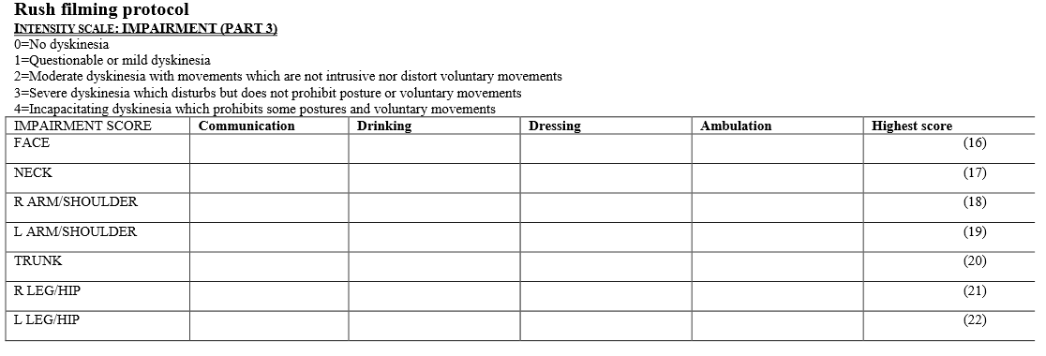

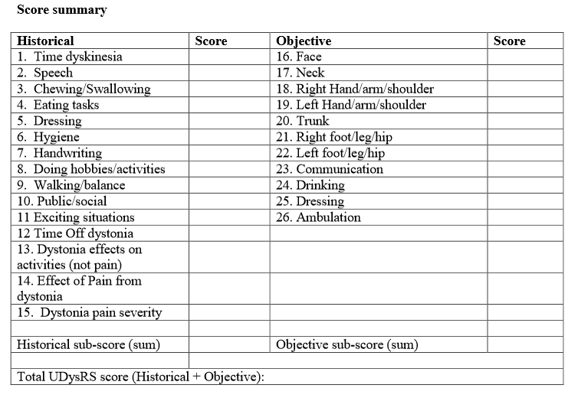

Parkinson
Monday, February 15, 2016
2:20 PM

SYMPTOMS
Tremors- the most noticeable early symptom. It often begins very localised, such as in a finger of one hand. Over time it spreads throughout the whole arm. Tremors often occur when the limb is at rest or when held in a stiff, unsupported position. Tremors also may occur in the lips, feet or tongue.
Bradykinesia- slowness of motion. The individual's movements become increasingly slow and over time muscles may randomly "freeze".
Akinesia- muscle rigidity. Often begins in the legs and neck. These muscles become very stiff. When it affects the muscles of the face the individual adopts a mask like stare.
Digestion problems- the ability to process food slows down, resulting in low energy and constipation.
Depression- Parkinson's causes chemical changes in the brain that may result in depression. This can be an early warning sign, but as depression becomes more common in older adults, it is not often associated with the disease.
Low Blood Pressure- can result in light headedness and fainting.
Temperature sensitivity- perception of temperature can be affected, and may result in hot flashes and excessive sweating.
Leg discomfort- some patients report burning sensations and cramp in the legs.
Balance- There is a progressive loss of coordination and sense of balance, putting the individual at risk of falls.
Over time, Parkinson's sufferers take on similar external characteristics. There is the continual tremor, the stooped posture, the slow shuffle and the blank stare. At the present time there is no cure and it is not completely understood as to what causes the disease. However, it is manageable through medication and lifestyle, especially when identified in the early stages. As Ali himself so famously proved, just because an opponent has you against the ropes, it doesn't mean the fight is over.

From <http://www.parkinsons.org/parkinsons-symptoms.html>

Papers
Monday, February 15, 2016
2:31 PM

- Quantification of Tremor and Bradykinesia in Parkinson’s Disease Using a Novel Ambulatory Monitoring System

Autonomous Sensing Unit Recorder (ASUR)

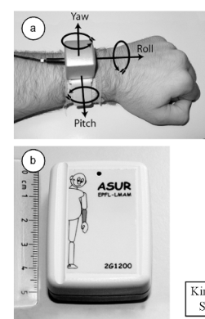
From <http://ieeexplore.ieee.org.proxy-remote.galib.uga.edu/ielx5/10/4067100/04067166.pdf?tp=&arnumber=4067166&isnumber=4067100>

- A method for automatic and objective scoring of bradykinesia using orientation sensors and classification algorithms

Orientation sensor

From <http://ieeexplore.ieee.org.proxy-remote.galib.uga.edu/ielx7/10/4359967/07272072.pdf?tp=&arnumber=7272072&isnumber=4359967>

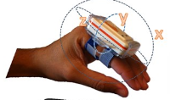

- Accurate telemonitoring of Parkinson’s disease symptom severity using nonlinear speech signal processing and statistical machine learning

From <http://129.67.184.129/tsanas/Preprints/DPhil%20thesis.pdf>

