Nguyễn Khắc Mừng

CNTT40A

1)

**private static int perdetails(int age, String gender, boolean married)** {

int premimum = 300;

if((age < 25) && (gender.equals("male")) && (!married)){

premimum = premimum + 1000;

}

else{

if (married || gender.equals("female")){

premimum = premimum - 100;

if((age >= 46) && (age <= 65)){

premimum = premimum - 150;

}

}

}

System.out.println("premimum" + premimum);

return premimum;

}

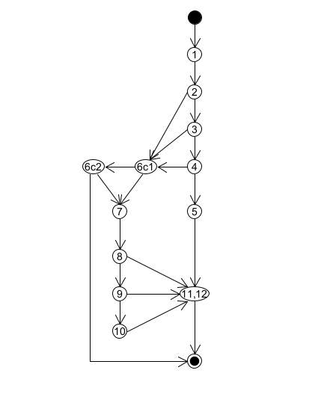

|  |  |  |  |  |  |
| --- | --- | --- | --- | --- | --- |
| **ID** | **Test Path** | **Inputs** | **EO** | **RO** | **Note** |
| tc1 | 1;2(T);3(T);4(T);5;11,12 |  |  |  |  |
| tc2 | 1;2(F);6c1(F);6c2(T);7;8(T);9(T):10;11,12 |  |  |  |  |
| tc3 | 1;2(F);6c1(T);7;8(T);9(T):10;11,12 |  |  |  |  |
| tc4 | 1;2(T);3(T);4(F);6c1(F);6c2(T);7;8(T);9(F);11,12 |  |  |  |  |
| tc5 | 1;2(T);3(F);6c1(F);6c2(T);7;8(T);9(T):10;11,12 |  |  |  |  |
| tc6 | 1;2(T);3(T);4(F);6c1(F);6c2(T);7;8(F);11,12 |  |  |  |  |
| tc7 | 1;2(F);6c1(F);6c2(F);11,12 |  |  |  |  |
| tc8 | 1;2(F);6c1(T);7;8(T);9(F);11,12 |  |  |  |  |

2)

int Test(int a, int b, int c) {

int t;

switch (a) {

case 2:

if (b>9)

t=1;

else

t=8;

break;

case 7:

if (b<0 || b>10)

t=0;

else

if (c>=3)

t=3;

else

t=4;

break;

default:

t=5;

}

return t;

}

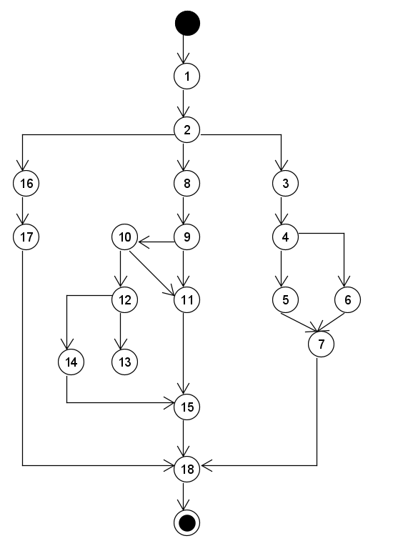

|  |  |  |  |  |  |
| --- | --- | --- | --- | --- | --- |
| **ID** | **Test Path** | **Inputs** | **EO** | **RO** | **Note** |
| tc1 | 1;2;16;17;18 |  |  |  |  |
| tc2 | 1;2;3;4;5;7;18 |  |  |  |  |

3)

void soNT(int n) {

bool co=true

for(int i=2;i<n;i++){

if(n%i==0){

co=false;

break;

}

}

if(n != 1 && co == true)

Console. WriteLine("{0} là số nguyên tố ",n);

Else

Console.WriteLine("{0} không phải là nguyên tố",n);

}

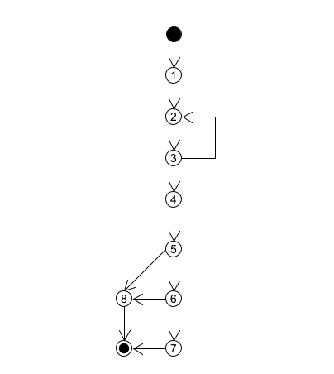

|  |  |  |  |  |  |
| --- | --- | --- | --- | --- | --- |
| **ID** | **Test Path** | **Inputs** | **EO** | **RO** | **Note** |
| tc1 | 1;2;3(F);2;3(T);4;5(T);6(T);7 |  |  |  |  |
| tc2 | 1;2;3(T);4;5(T);6(T);7 |  |  |  |  |
| tc3 | 1;2;3(T);4;5(T);6(F);8 |  |  |  |  |
| tc4 | 1;2;3(T);4;5(F);8 |  |  |  |  |