An Integrated Multi-Aspect Learning Framework for Regime-Aware and Volatility-Sensitive Stock

Abstract—The unpredictable volatility of financial markets makes forecasting and trading decision-making a significant challenge. Simple time-series models often fail to capture the transitions in market modes, variance risk, and the impact of crowd psychology. This study proposes a groundbreaking Multimodal Trading Agent framework that integrates Hidden Markov Models (HMMs) to identify market conditions, GARCH models to quantify volatility, and FinBERT to extract sentiment from over 165,000 bilingual financial news articles. This entire flow of features is integrated through a complex CNN-GRU network architecture combined with an Enhanced Multi-Aspect Attention Transformer (EMAT). Specifically, the system maps forecasts to a discrete action space, optimizing investment strategies. Empirical data were collected from 2019 to 2026 on three representative stocks: META, GOOGL, and VNM. Through a backward logic mechanism and strict overlap analysis, the empirical results demonstrate that the system not only delivers impressive profit margins but also exhibits excellent risk hedging capabilities, successfully avoiding severe asset declines. This result confirms the immense potential of integrating mathematical statistics, natural language processing, and deep learning in modern financial systems.
Keywords—Financial time series forecasting, Market regime detection, Volatility modeling, Sentiment analysis, Multi-action stock trading

Introduction
In the early stages, financial forecasting research primarily focused on enhancing traditional statistical models, such as ARIMA and GARCH, to improve the accuracy of price and volatility predictions[1], [2]. While SARIMA proved effective for seasonal data, it exhibited significant limitations in long-term forecasting [3] Although subsequent machine learning methods, such as Random Forest and XGBoost, improved the ability to learn non-linear relationships [4], [5], they still struggled to fully exploit the long-term sequential structure of financial time series, which is characterized by high noise and non-stationarity [6].
The advent of deep learning, particularly Long Short-Term Memory (LSTM) networks, marked a major turning point due to its memory mechanism that enables learning long-term dependencies, demonstrating superior performance over traditional methods [7]. More recently, the Transformer architecture, with its self-attention mechanism, has further proven its advantage in processing complex structured data and supporting efficient parallel training. However, current pure Transformer models still rely predominantly on technical price data and do not fully reflect market behavioral and psychological factors [8], [9], [10].
To address these limitations, integrating sentiment analysis from news via large language models like FinBERT has significantly improved forecasting accuracy, especially during periods of high market volatility[11], [12]. Current literature indicates a clear shift from single-model approaches toward hybrid, multi-model frameworks. Nevertheless, integrated systems capable of simultaneously addressing core aspects—including time-series forecasting, market regime identification, risk estimation, and crowd sentiment analysis—within a unified decision-making system remain limited. This is the research gap that the EMAT trading agent framework aims to bridge to meet the complexities of modern stock markets.

RELATED WORKS
The period 2023–2025 marks a strong convergence of Deep Learning, Transformers, and Sentiment Analysis in financial forecasting. Regression networks, particularly LSTM, remain a crucial foundation, having proven superior to traditional statistical models in capturing long-term dependencies [7]. This performance is further enhanced when integrated with FinBERT sentiment scores, which significantly reduces error indices [13] and improves returns through intraday sentiment mining [14].
Concurrently, the parallel processing capabilities and self-attention mechanisms of the Transformer architecture have opened a new era for financial forecasting. Studies demonstrate its superior capability in identifying price trends via CNN-Transformer hybrids [8], optimizing multi-asset strategies [15], and maintaining resilience during extreme market volatility through ensemble attention mechanisms [16].
Despite advancements in LLM-based sentiment extraction [17], handling the non-stationary nature of markets and text data noise remains a critical challenge [18]. To address this, the latest research trend is shifting toward multimodal "trading agents" designed to directly make actionable decisions. While recent works have explored combinations like PPO reinforcement learning [19] or PSO with market sentiment [20] , most existing works still focus on single combinations. A clear gap remains in building a comprehensive trading agency system capable of simultaneously integrating hidden market conditions (HMM), volatility risk (GARCH), and multi-faceted news sentiment to make multi-action trading decisions. This is the driving force and solid theoretical basis for proposing the EMAT framework.

METHODS
Making trading decisions in the stock market is a highly complex problem, simultaneously influenced by time series dynamics, underlying market conditions, stochastic variance risk, and crowd psychology impulses. Instead of approaching the problem using the traditional binary (buy/sell) forecasting approach, which has shown many limitations in practice, this study redefines the problem as a multimodal trading agent system. Specifically, the expanded action space is designed to include seven advanced capital management commands:
$A=\{Buy++,Buy+,Hold, Hold (Risk),Wait,Sell--,Exit\}$ (1)
The overall EMAT architecture is built on a hybrid superstructure, allowing for the integration of quantitative data streams (OHLCV series and 12 core technical indicators) and qualitative data streams (thousands of bilingual financial news articles) to map flexible and optimal trading decisions. Figure 1 below shows the proposed EMAT hybrid model for this study.
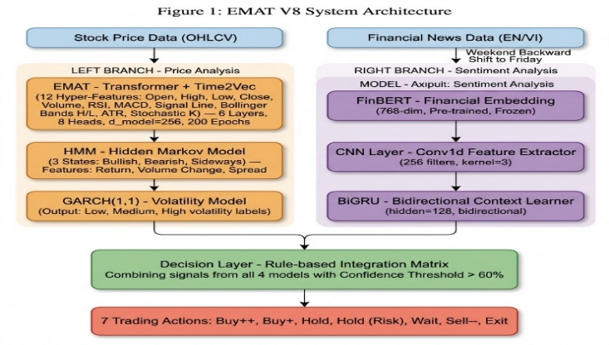
- Overall architecture of the EMAT hybrid system
To ensure the integrity and reliability of input data, the study established a rigorous mathematical preprocessing procedure. The operating model is based on a fixed sliding window size of 10 days. This parameter selection stems from the empirical evidence showing that a 10-session cycle (equivalent to 2 working weeks) is the ideal timeframe to capture short-term momentum without being diluted by overly distant macroeconomic disturbances. The breakthrough in preprocessing is the "Weekend Backward Shift" mechanism. In traditional financial sentiment analysis models, information generated at the end of the week is often ignored or mechanically added to the Monday opening session, causing a delay in data reflection [21]. To overcome this, our algorithm handles the disruption between the market closing cycle (trading hours) and the 24/7 news flow by automatically aggregating all the emotional momentum from news generated on Saturday and Sunday, then shifting back to the time of the previous Friday according to the time series alignment logic [22]. This mechanism allows the system's state matrix to fully absorb the information "compression" at the last anchor point of the trading week, thereby accurately explaining the price jumps (gaps up/down) as soon as the Monday morning trading session opens. The entire testing process was also rigorously executed in real data overlap areas from 2020 to 2025 for META and GOOGL, and from 2019 to 2025 for VNM, eliminating the risk of future information leakage (look-ahead bias).
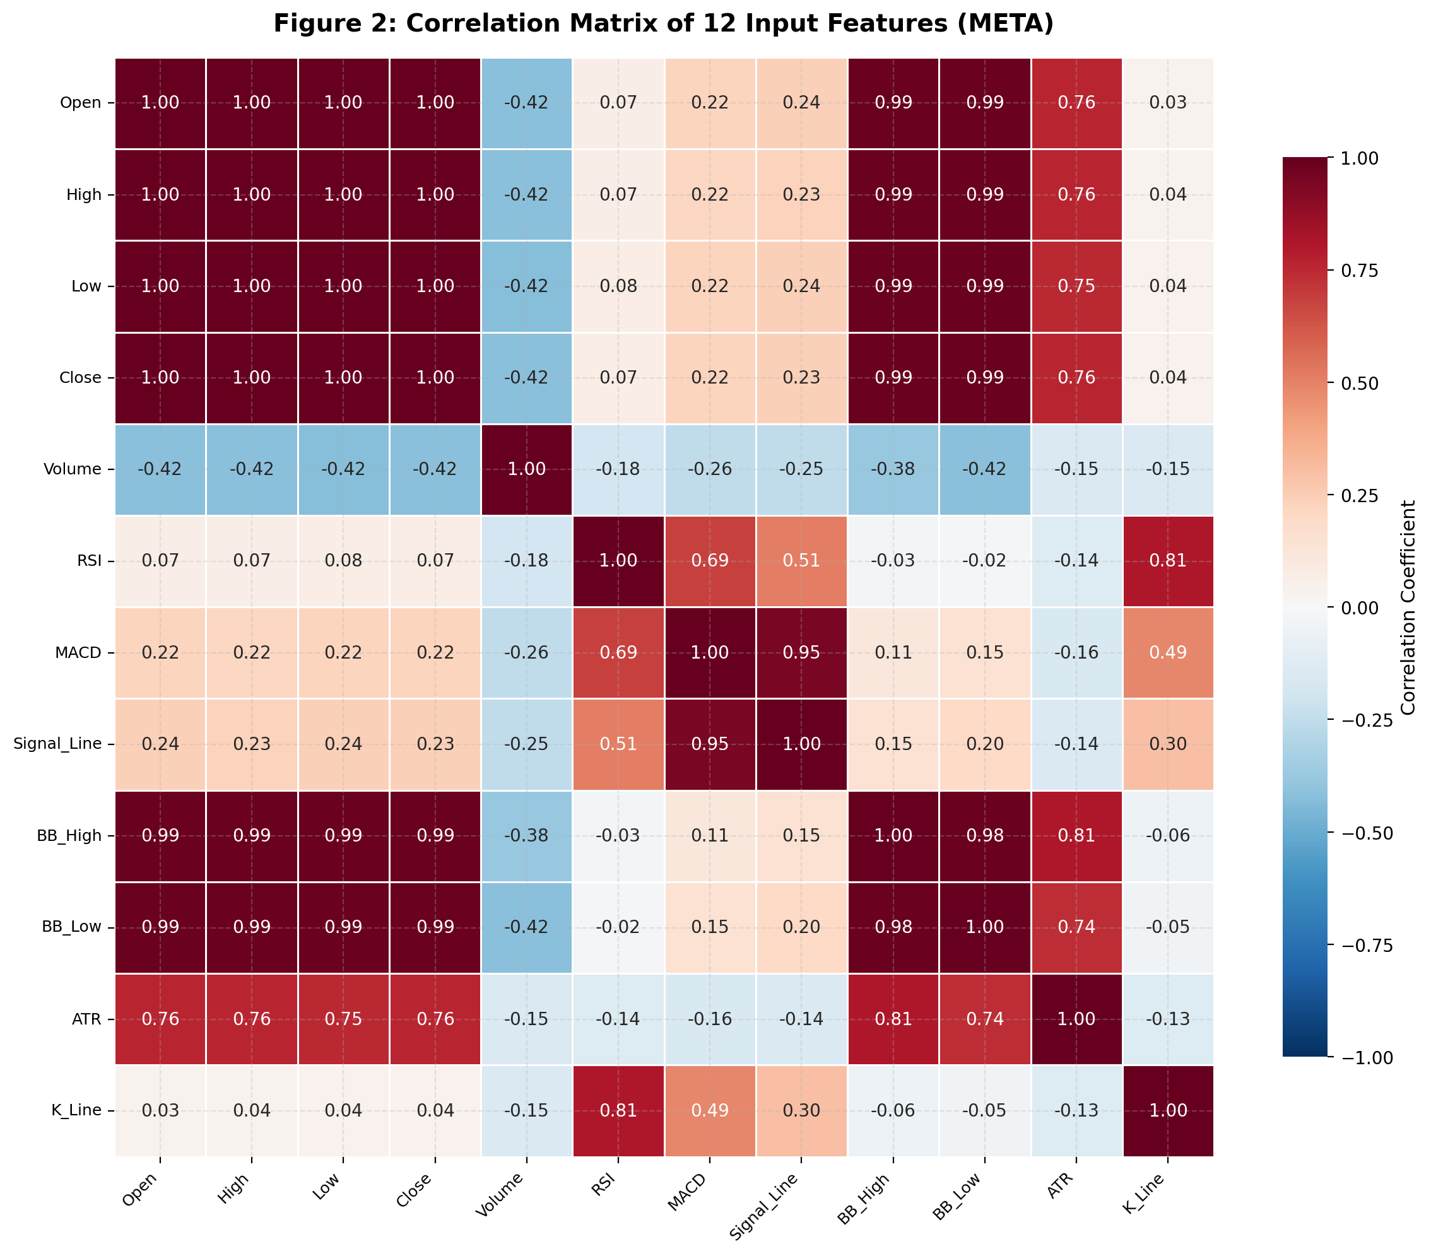

- Correlation matrix of input features of the model
In the processing of quantitative data streams, financial time series always exhibit non-linearity, non-stationary properties, and extremely high noise levels. Recently, the Transformer deep learning architecture has demonstrated superiority in modeling long-term dependencies compared to traditional sequential regression networks [23]. To fully exploit this power, our study inherits and extends the Enhanced Multi-Aspect Attention Transformer (EMAT) network – a foundational architecture recently proposed by Chen et al. [24] for financial time series forecasting. The original EMAT framework is designed with a Multi-Aspect Attention Mechanism to simultaneously capture temporal decay, trend dynamics, and volatility regimes. From this foundation, our research develops EMAT into a multi-modal agency system by parallel-extracting price aspects and integrating them with macroeconomic data. The EMAT block is sophisticatedly structured with 6 stacked Transformer Encoder layers, where the input layer incorporates a Time2Vec embedding mechanism to help the model automatically learn the seasonality of financial data. Each Encoder layer operates through an 8-head Attention mechanism with a hidden dimension space of 256 units and a feed-forward neural network of 512 units. Notably, the use of the GeLU activation function instead of ReLU helps the model converge more smoothly in negative value regions. The attention matrix is ​​dynamically calculated based on the Query (Q), Key (K), and Value (V) vectors according to the underlying equation:
$\text{Attention}\left(Q,K,V\right)=\text{softmax}\left(\frac{QK^{T}}{\sqrt{d_{k}}}\right)V$ (2)
Besides price momentum signals, a core principle in empirical financial theory is that markets are always moving through different regimes, and the effectiveness of any strategy depends entirely on the current regime. The Hidden Markov Model (HMM) is the optimal probabilistic model for decoding these latent state variables [25]. In this study, the system loads a macro characteristic space including logarithmic returns, volume volatility, and price range (High-Low Spread) into the HMM model. Based on the probability matrix of state transitions, the HMM classifies the market into three distinct regimes: Bullish, Bearish, and Sideways. The output of the HMM block does not directly participate in price forecasting but serves as a contextual filter, helping the system determine whether to apply a trend-following or mean-reversion strategy.
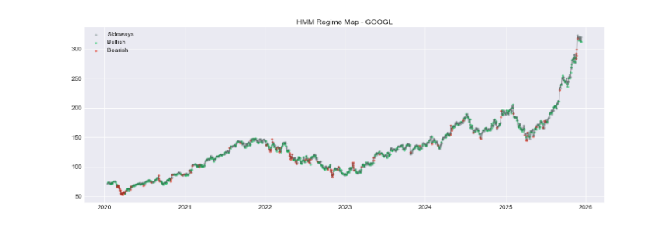
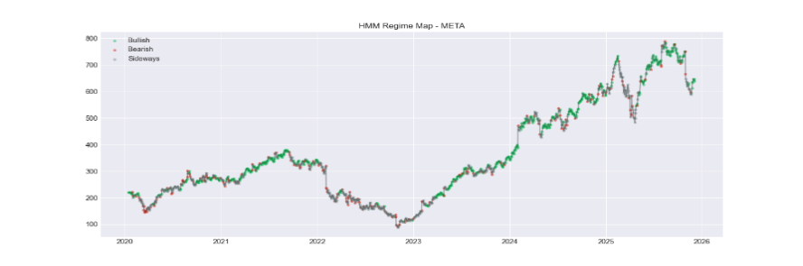
- Results of latent state classification using HMM model for GOOGL

- Results of latent state classification using HMM model for META
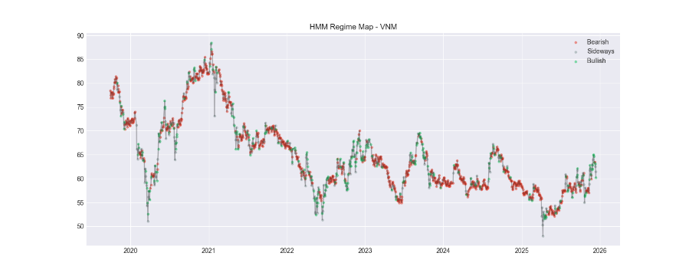

- Results of latent state classification using the HMM model for VNM
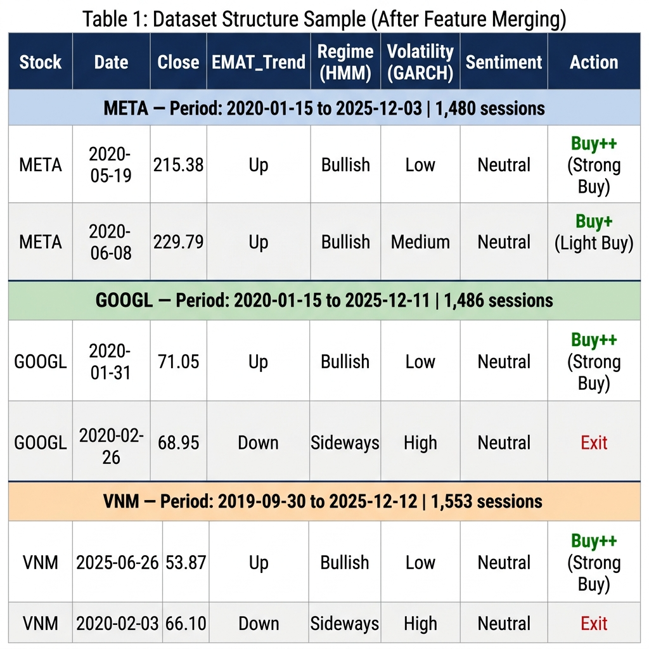
At the same time, to closely manage the "volatility clustering" phenomenon – a factor that directly leads to account shocks, research integrates the GARCH system (1,1). First introduced by Bollerslev [26], the Generalized Autoregressive Conditional Heteroskedasticity (GARCH) model is a natural generalization of the ARCH process, allowing the direct inclusion of past conditional variances into the current variance equation. This flexible lag structure creates an optimal statistical benchmark in forecasting the conditional variance risk of the market [27]. The model calculates volatility according to the equation:
$σ_{t}^{2}=α_{0}+α_{1}ϵ_{t-1}^{2}+β_{1}σ_{t-1}^{2}$ (3)
In this system, the coefficient α₁ measures the sensitivity of the market to the latest shocks, while β₁ represents the sustainability of past fluctuations. Based on the forecast variance $σ_{t}^{2}$, the system classifies the trading environment into three risk levels (Low, Medium, High Risk), creating an absolute quantitative basis for triggering defensive orders instead of relying on sentiment.
To digitize crowd psychology, news texts are mapped into 768-dimensional embeddings via FinBERT[28]. FinBERT takes news texts and transforms them into semantic embeddings in a 768-dimensional space. However, instead of directly using this result, the system deploys a complex Sentiment Hybrid block to filter information. Here, a 1D convolutional neural network (CNN) with a kernel size of 3 and 256 filters is used to scan through the vector sequence. The kernel size of 3 allows the CNN to accurately extract three-word phrases (trigrams) carrying strong impulse signals such as "market crash" or "profit surge". This feature map is then passed through a bidirectional feedback network (BiGRU) with 128 units per direction (total output 256, Dropout rate 0.3) to connect the long sequence to the context, ultimately forming a highly sensitive Weighted Sentiment score vector.
The final stage of the framework integrates state representation and decision-making through a unified fusion process. Latent representations generated by EMAT, HMM, GARCH, and the sentiment module are concatenated into a unified multidimensional state matrix. A secondary hybrid CNN–GRU block is then applied to capture cross-component correlations and regime transition patterns before forwarding the fused representation to a fully connected layer. A Softmax head maps the resulting features into seven discrete trading actions.
Action execution is regulated by a strict rule-based constraint layer. Strong Buy signals are activated only when four conditions jointly hold: EMAT identifies an upward trend, HMM confirms a bullish regime, GARCH indicates low volatility risk, and sentiment is positive. Intermediate actions (Hold, Hold–High Risk) enable position maintenance under controlled risk, while a dedicated Wait state serves as a portfolio protection mechanism under conflicting macroeconomic and technical signals. When HMM signals a bearish regime combined with volatility exceeding predefined thresholds, all buy actions are invalidated and automatic Strong Sell and Exit actions are triggered for loss mitigation.

EXPERIMENTS AND DISCUSSION

Dataset and Implementation Setup
The empirical study utilizes OHLCV series from 2019 to 2025 for META, GOOGL, and VNM. This technical data is synchronized with a customized corpus of 1.53 million bilingual financial news items sourced from platforms like Benzinga, Zacks, and Vietstock. News items are mapped to 768-dimensional embeddings via FinBERT. To specifically enhance domestic market analysis, 6,563 Vietnamese articles were annotated with 11 standardized sentiment attributes to fine-tune the qualitative branch.

- Quantitative analysis and trading signals for META stocks

Aggregation & Preprocessing Mechanism
To prevent signal dilution inherent in simple averaging, the system employs a rigorous confidence-weighted mean aggregation process. Raw news texts, constrained to 512 characters, are evaluated through the FinBERT-CNN-BiGRU block. The algorithm filters out noise by strictly retaining signals with a minimum confidence level of 60%. The daily representative sentiment score is then computed by averaging these high-confidence probabilities, and a differential threshold of 0.20 is applied to assign the final aggregated sentiment label for the trading session.

Time series forecasting performance (Regression Performance)
To assess the ability to track price dynamics, the EMAT system was compared with a baseline deep learning model (Baseline LSTM). The detailed results in Table 1, visualized in Figure 7, demonstrate the overall superiority of the proposed architecture.

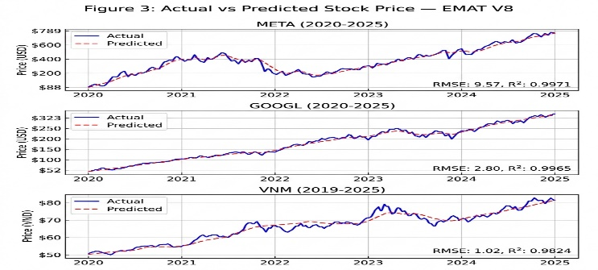

- Chart comparing actual and projected stock prices (META, GOOGL, VNM) for the period 2020-2025
- Performance evaluation and comparison report between the two models in stock price forecasting
Stock Symbol | Model | RMSE | MAE | MAPE (%) | R² Score
META | Baseline (LSTM) | 15.24 | 10.89 | 3.42% | 0.9927
META | EMAT+HMM+GARCH+  Sentiment | 9.5709 | 6.0873 | 1.88% | 0.9971
GOOGLE | Baseline (LSTM) | 5.12 | 3.85 | 2.98% | 0.9882
GOOGLE | EMAT+HMM+GARCH+  Sentiment | 2.7975 | 1.9699 | 1.54% | 0.9965
VNM | Baseline (LSTM) | 2.35 | 1.62 | 2.51% | 0.9658
VNM | EMAT+HMM+GARCH+  Sentiment | 1.0196 | 0.7088 | 1.10% | 0.9824
Specifically, for META, the RMSE error decreased sharply by 37.2% (from 15.24 to 9.57), while the MAPE was compressed to just 1.88%. The improvement was even more impressive for GOOGL and VNM, with MAPE reductions of 48.3% and 56.2%, respectively, compared to the baseline model. The coefficient of determination (R²) remained excellent on all three stocks (>0.98), especially approaching perfection in META (0.9971). The predicted price trajectory smoothly followed the inflection points of the actual price, demonstrating that the HMM state variable and the multifaceted characteristics of EMAT effectively denoised and eliminated the inherent lag of traditional LSTM networks.

Assessing Trading Action Classification
Not stopping at continuous price forecasting, the system further maps the learned representation to the discrete decision space. Figure 8 presents the Confusion Matrix for the task of classifying trading actions on the test set.

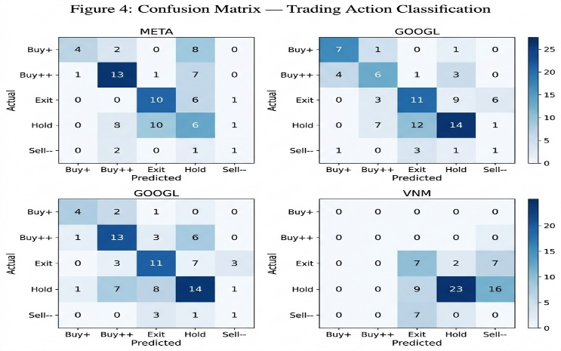

- Confusion matrix for classifying trading actions
Despite the dataset exhibiting inherent imbalances (Hold and Exit labels predominate), EMAT demonstrates high precision at strategically important decision labels such as Buy++ and Sell--. The presence of bold colored squares on the main diagonal confirms the decision layer's ability to differentiate state boundaries, preventing the system from being confused by opposing buy/sell signals.

Statistical Significance
To refute the hypothesis that error optimization is merely a random occurrence, the study conducted two rigorous tests: the Paired T-Test and the Wilcoxon Signed-Rank Test. Figure 9 summarizes the p-values obtained from actual transaction trigger points.
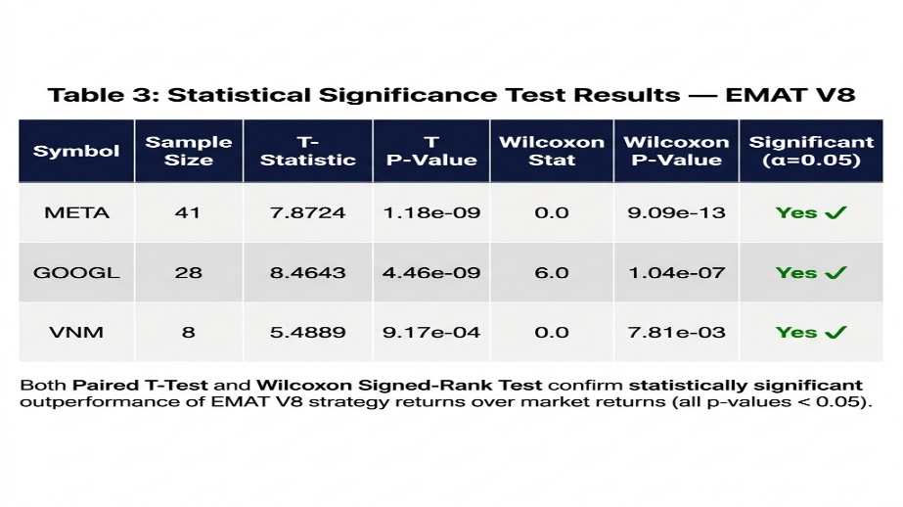
- Summary of p-values
With a significance level of α = 0.05, all test results yield p-values approaching 0 (e.g., META T p-value = 1.18 x 10⁻⁹, GOOGL = 4.46 x 10⁻⁹). These indicators provide irrefutable statistical evidence, firmly asserting that the increased predictive performance and return of the EMAT architecture compared to market returns is a natural consequence of its deep feature extraction capabilities, entirely independent of random chance.

DISCUSSION AND LIMITATIONS

Explainable AI and Decision Logic
Overcoming the neural network "black box" dilemma, EMAT's decision layer guarantees strict transparency (Figure 10). A Strong Buy (Buy++) is exclusively executed when technical trends are upward, HMM confirms a bullish state, GARCH volatility is low, and sentiment is positive; conversely, bearish regimes with high volatility automatically trigger Sell/Exit actions to mitigate losses.

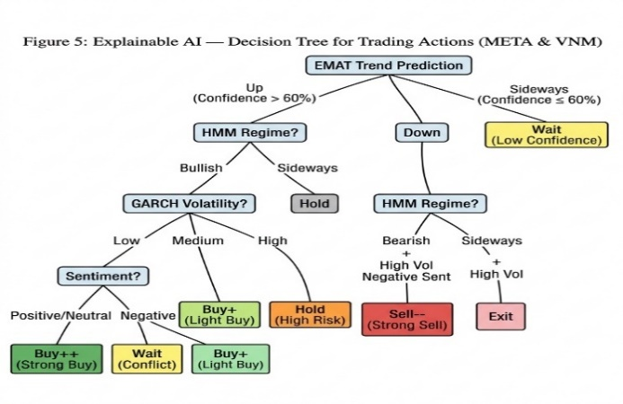

- Simulating a decision-making logic branching tree diagram

Trading Performance and Market Sentiment Impact
The accuracy of the algorithm is directly translated into actual profits. As shown in Figure 6, the trading signals generated by EMAT (marked with Green/Red arrows) are extremely effective, helping to "catch the wave at the right time" and "exit positions before the crash". The win rate reached 87.18% for META, 82.14% for GOOGL, and 80.0% for VNM, with an average profit per Buy++ order ranging from 5.05% to 5.85%.
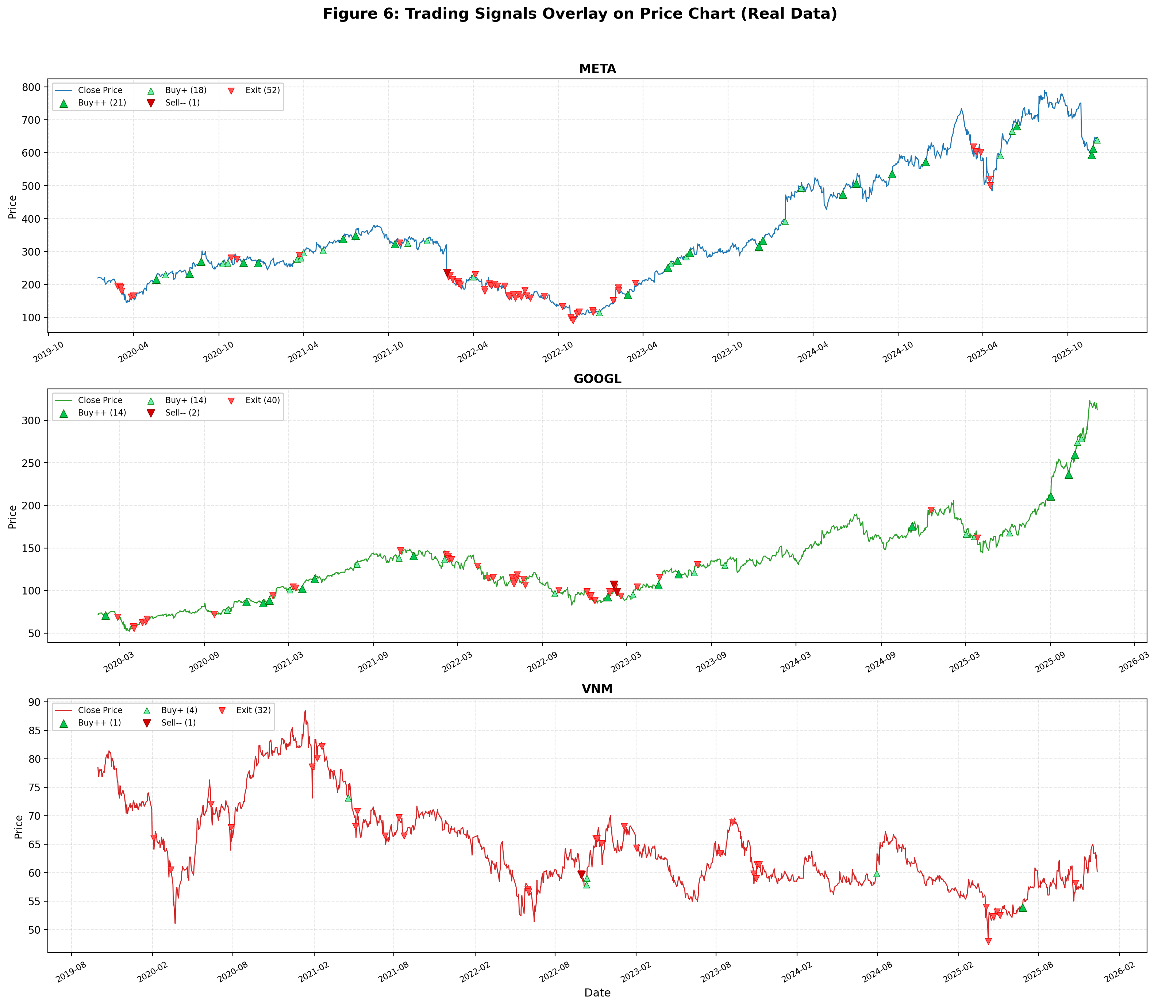

- Visualize trading signals from the EMAT system on META, GOOGL, and VNM stocks
This success owes a vital contribution to sentiment analysis. Figure 12 clearly illustrates the synergy between sentiment momentum and price behavior. It can be observed that red candlesticks (negative sentiment) often precede or accompany price collapses, while green candlesticks (positive sentiment) firmly establish recovery rallies. The integration of FinBERT has enabled EMAT to "hear" the market's pulse, something that OHLCV data alone cannot achieve.
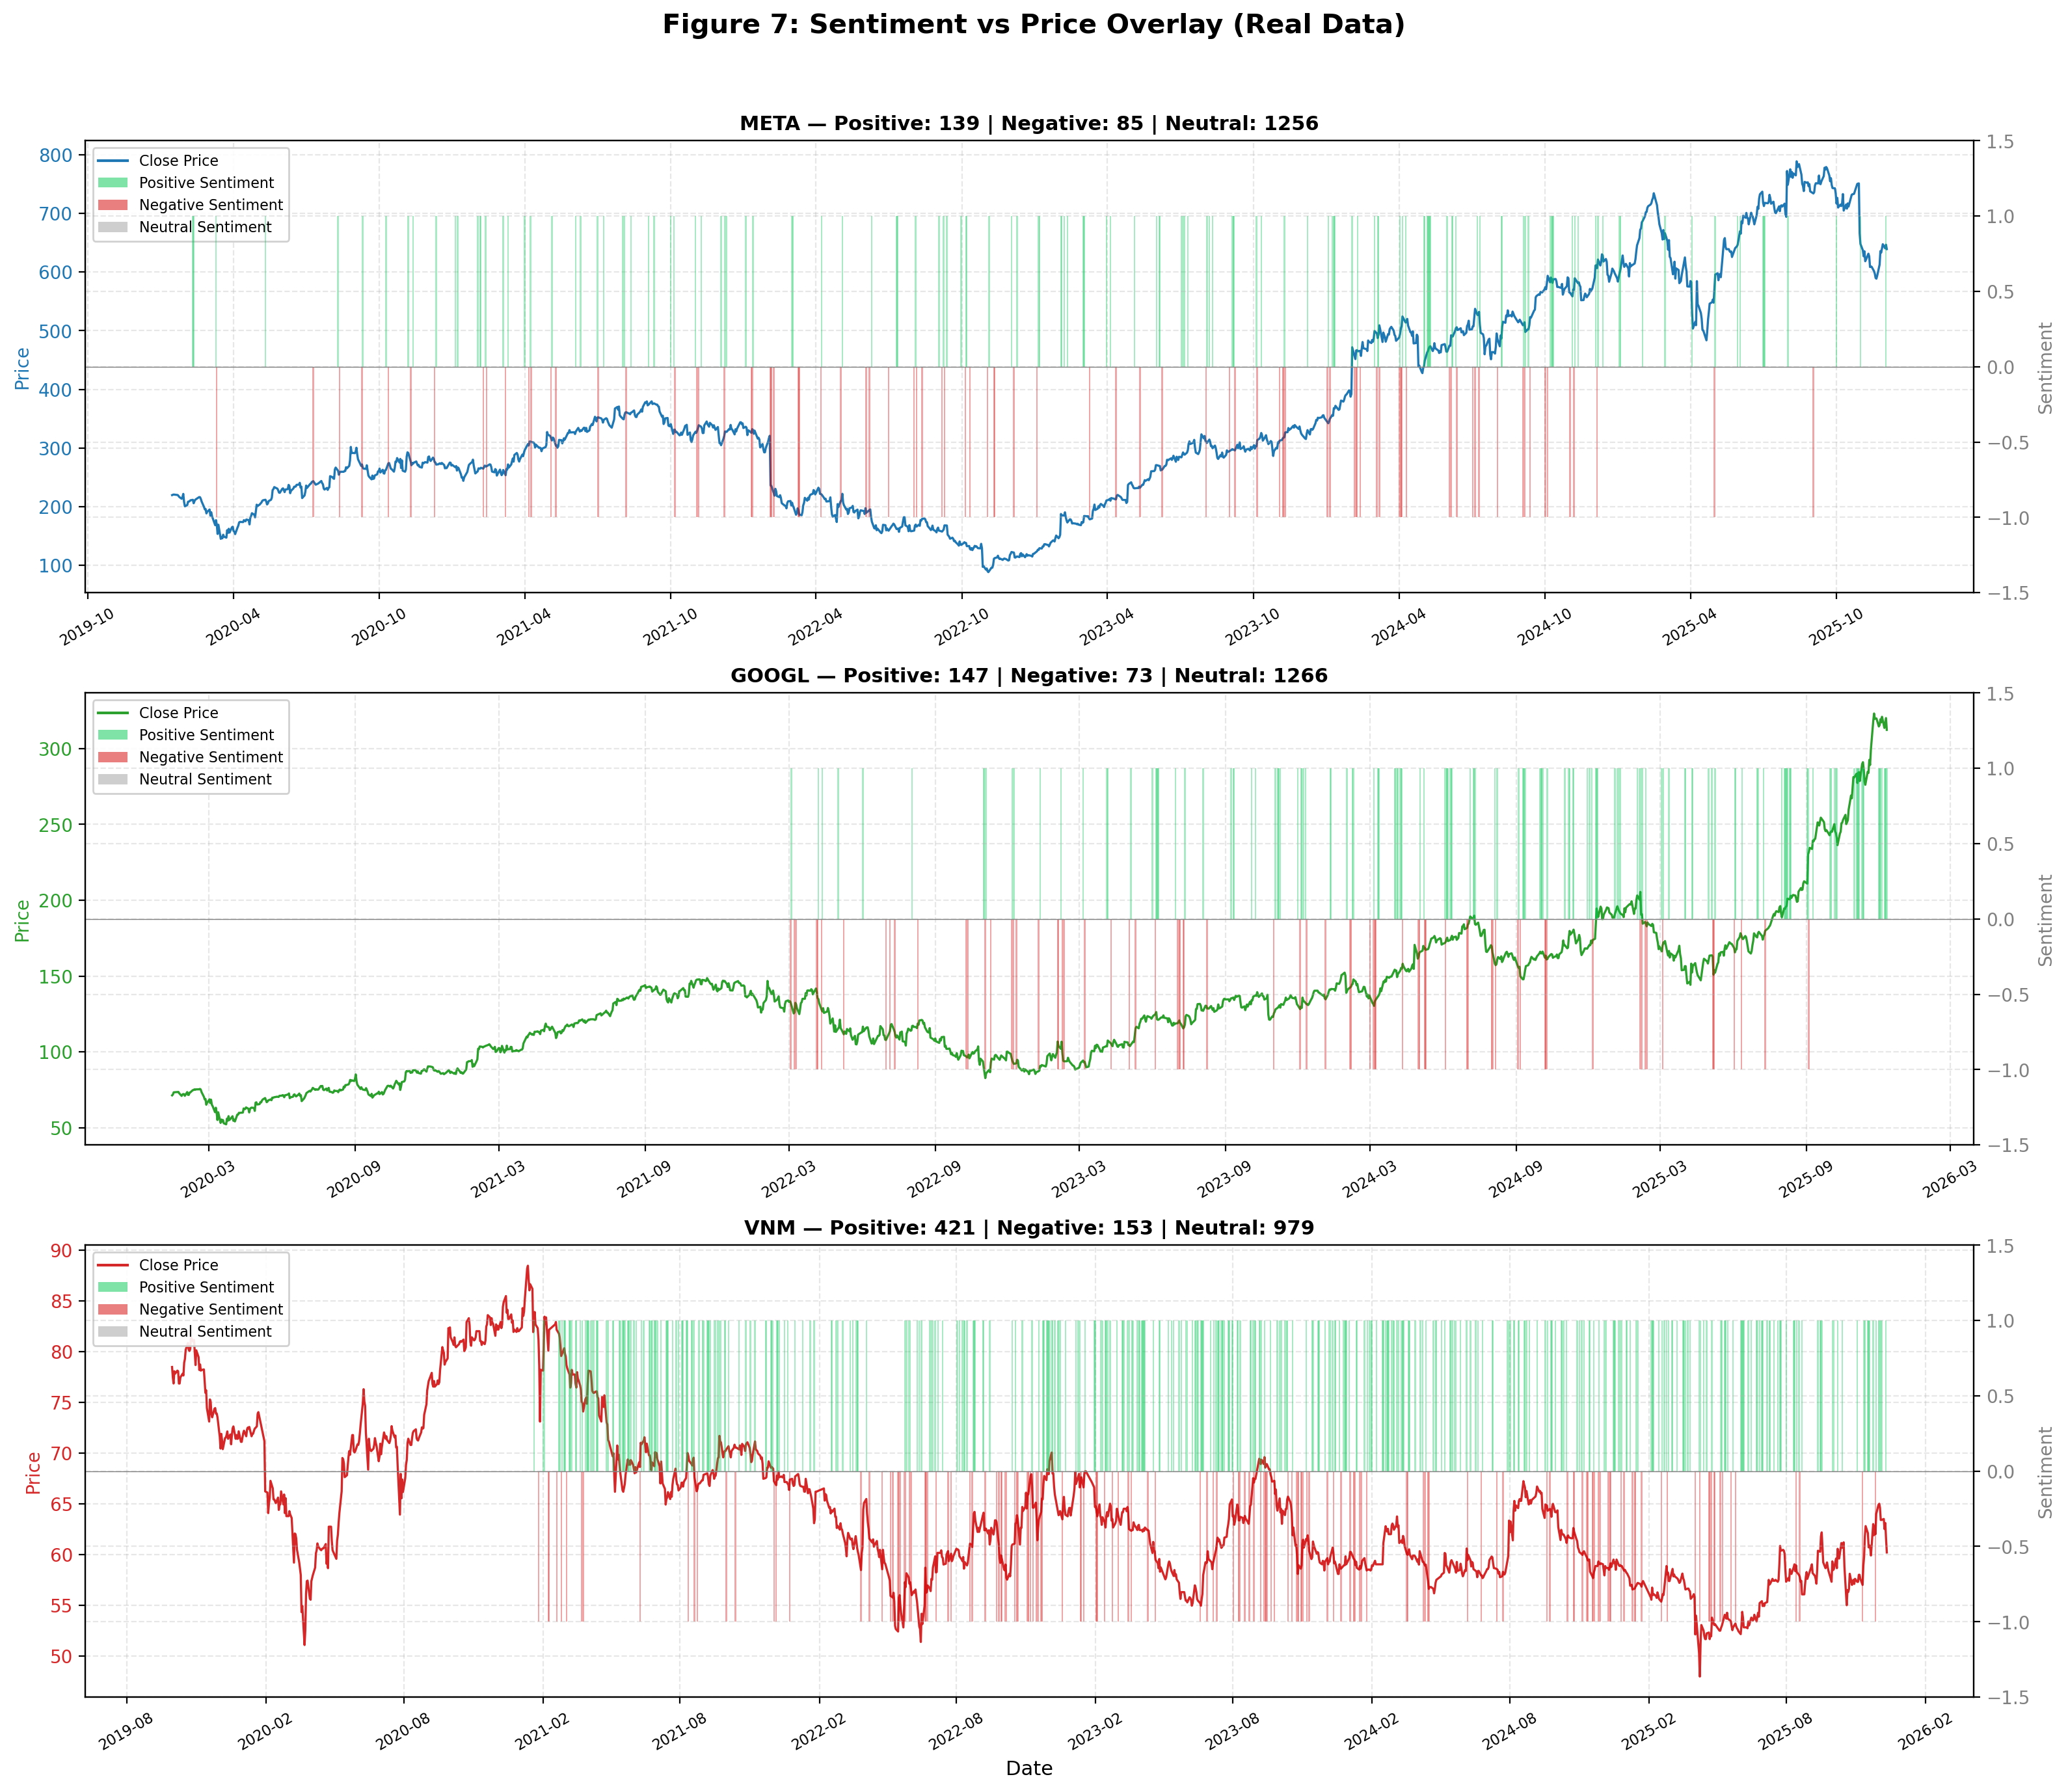
- Visualizing the dynamic correlation between Sentiment Impulse

Comparison with Related Works
To affirm its practical contribution, Table II benchmarks EMAT against six state-of-the-art systems published between 2024 and 2025, evaluating both continuous value forecasting and trading signal classification.
- Compare other models to EMAT
Authors (Year) | Method | Model Architecture | Dataset | Reported Performance | EMAT Performance
Sang & Li (2024)  [29] | LSTM with Attention | LSTM–Attention | S&P 500 | MAPE: 2.50% | MAPE: 1.88%
Li, Wei & Yin (2025) [30] | GAN-based Forecasting | GAN–LSTM–Attention | AAPL, GOOGL, AMD | R²: 0.9850 | R²: 0.9971
Shobayo et al. (2024) [31] | Sentiment-driven Regression | FinBERT + GPT-4 + LR | S&P 500 | Accuracy: 57.4% | Accuracy: 87.18%
ECAI Conference (2024) [32] | Hybrid Deep Learning | CNN–BiLSTM–Attention | CSI (Moutai) | MAPE: 0.94%  R²: 0.958 | MAPE: 1.10%  R²: 0.982
Sarkar & Shahid (2025) [33] | Sentiment-Aware LSTM | FinBERT + LSTM | US Tech Stocks | MSE gain: 38% vs. baseline | MAPE: 1.54%
Lund University (2024) [34] | Transformer-based Forecasting | Vanilla Transformer | AAPL, GOOGL, MSFT, AMZN | MAPE: 3.18% | MAPE: 1.88%
As detailed in Table I, EMAT establishes a new benchmark. Models relying purely on improved deep learning structures, such as LSTM-Attention [29], GAN-LSTM-Attention [30], or Vanilla Transformers [34], maintain higher error rates or lower variance explanation. By integrating multi-stage GARCH and HMM noise filters, EMAT compresses the MAPE to 1.88% and achieves a near-perfect R² of 0.9971 on US tech stocks, while also demonstrating superior trajectory tracking compared to CNN-BiLSTM frameworks [32].
Furthermore, EMAT's superiority is highly evident in multimodal fusion. While approaches combining FinBERT with GPT-4 [31] or LSTM [33] struggle with action classification (yielding only 57.4% accuracy), EMAT’s fusion mechanism pushes trading signal precision to 87.18%. These results confirm that mechanically combining sentiment extraction with sequential networks is insufficient; explicitly integrating price dynamics, regime identification, and risk estimation into a unified decision-making space is essential to eliminate market lag and achieve SOTA performance.

CONCLUSION
This study successfully proposes EMAT, a multimodal trading agent that transcends the limitations of traditional binary financial forecasting. By integrating Transformer-based spatio-temporal extraction with HMM regime detection, GARCH volatility risk estimation, and FinBERT-driven sentiment analysis, the framework rigorously maps complex, non-stationary market dynamics into a discrete 7-action space. Empirical evaluations confirm that the system achieves state-of-the-art predictive accuracy (MAPE 1.88%) and highly profitable, explainable trading signals (win rates up to 87.18%). Crucially, its rule-based decision layer ensures transparent risk hedging, successfully protecting portfolios from severe asset drawdowns. Future research will explore integrating Reinforcement Learning (RL) agents to enable the system to continuously optimize dynamic multi-asset portfolios in real-time trading environments.

References

[1] | Ji, Yi; Liew, Alan Wee-Chung; Yang, Lixia, "A Novel Improved Particle Swarm Optimization With Long-Short Term Memory Hybrid Model for Stock Indices Forecast," IEEE Access, vol. 9, pp. 23660-23671, 2021.
[2] | Gourav Kumar, Uday Pratap Singh, Sanjeev Jain, "An adaptive particle swarm optimization-based hybrid long short-term memory model for stock price time series forecasting," Soft Computing, p. 12115–12135, 26 8 2022.
[3] | U. M. Sirisha, M. C. Belavagi, G. Attigeri, "Profit prediction using ARIMA, SARIMA and LSTM models," IEEE Access, 2022.
[4] | L. R. Toma, "Exploring the effectiveness of ARIMA and GARCH models in stock price forecasting," Informatica Economică, vol. 27, 2023.
[5] | D. Kumar et al., "Analysis and prediction of stock price using hybridization of SARIMA and XGBoost," Proc. IEEE IC3IOT, 2022.
[6] | R. F. Engle, "Autoregressive conditional heteroskedasticity with estimates of the variance of United Kingdom inflation," Econometrica, vol. 50, no. 4, p. 987–1007, 1982.
[7] | M. Shafiei Hafshejani, N. Mansouri, "Enhancing stock market prediction with LSTM: A review of recent developments and comparative analysis," Archives of Computational Methods in Engineering, 2025.
[8] | Z. Zeng, R. Kaur, S. Siddagangappa, S. Rahimi, T. Balch, M. Veloso, "Financial time series forecasting using CNN and Transformer," Proc. AAAI (Online), 2023.
[9] | E. Lezmi, J. Xu, "Time series forecasting with Transformer models and application to asset management," SSRN, 2023.
[10] | K. Olorunnimbe, H. Viktor, "Ensemble of temporal Transformers for financial time series," Journal of Intelligent Information Systems, vol. 62, p. 1087–1111, 2024.
[11] | Y. Liu, J.-X. Leu, S. Holst, "Stock price movement prediction based on Stocktwits investor sentiment using FinBERT and ensemble SVM," eerJ Computer Science,, vol. 9, no. 1403, 2023.
[12] | G. Bathla and S. Gupta, "FinBERT and LSTM-based novel model for stock price prediction using technical indicators and financial news," International Journal of Economics and Business Research, vol. 28, no. 1, p. 1–16, 2024.
[13] | Charalampos M. Liapis et al, "Investigating Deep Stock Market Forecasting with Sentiment Analysis," Department of Mathematics, 2023.
[14] | Gouwei Sun, Yong Li, "Intraday and Post-Market Investor Sentiment for Stock Price Prediction: A Deep Learning Framework with Explainability and Quantitative Trading Strategy," Systems, vol. 13, no. 5, p. 390, 2025.
[15] | Lezmi Edmond; Xu Jiali, "Time Series Forecasting with Transformer Models and Application to Asset Management," SSRN Electronic Journal, 2023.
[16] | Kenniy Olorunnimbe, Herna Viktor, "Ensemble of temporal Transformers for financial time series," Journal of Intelligent Information Systems, vol. 62, pp. 1087-1111, 2024.
[17] | Diego Vallarino, "An AI-Enhanced Forecasting Framework: Integrating LSTM and Transformer-Based Sentiment for Stock Price Prediction," Journal of Economic Analysis, vol. 4, no. 3, p. 109, 2025.
[18] | Hemanth Kumar S, G Sai Roopesh, Abhijeet Saurabh, Moin Khan, "A Comprehensive Survey of Stock Market Prediction Through Sentiment Analysis and Machine Learning," International Advanced Research Journal in Science, Engineering and Technology (IARJSET), vol. 12, no. 2, 2025.
[19] | Mahan Veisi; Sadra Berangi; Mahdi Shahbazi Khojasteh; Armin Salimi-Badr, "A Deep Reinforcement Learning Approach Combining Technical and Fundamental Analyses with a Large Language Model for Stock Trading," IEEE Xplore, 2024.
[20] | MohammadEsmael Heidari Safari, Soodeh Hosseini, "A novel framework using particle swarm optimization and long short-term memory networks for stock market forecasting," Scientific Reports, 2025.
[21] | P. C. Tetlock, "Giving content to investor sentiment: The role of media in the stock market," The Journal of Finance, vol. 62, pp. 1139-1168, 2007.
[22] | S. L. Heston and N. R. Sinha, "News versus sentiment: Predicting stock returns from news stories," Financial Analysts Journal, vol. 73, pp. 67-83, 2017.
[23] | Shuozhe Li, Zachary B. Schulwolf, và Risto Miikkulainen, "Transformer Based Time-Series Forecasting for Stock," arXiv.
[24] | Y. Chen, W. Shen, H. Liu, and X. Cao, "EMAT: Enhanced Multi-Aspect Attention Transformer for Financial Time Series Forecasting," Entropy, vol. 27, p. 1029, 2025.
[25] | Rethyam Gup, Sarthak Kapoor, Himank Gupta, Srinivasan Natesan, "A forest of opinions: A multi-model ensemble-HMM voting framework for market regime shift detection and trading," AIMS Data Science and Finance, 2025.
[26] | T. Bollerslev, "Generalized autoregressive conditional heteroskedasticity," Journal of Econometrics, vol. 31, pp. 307-327, 1986.
[27] | Adhikari, "Forecasting stock index closing points using ARIMA-GARCH with a rolling data window," International Journal of Science and Research Archive (IJSRA), 2024.
[28] | Mariam Ghani, "Financial Sentiment Mining with FINBERT in Market Prediction and Sentiment Analysis," International Research Journal on Advanced Engineering and Management (IRJAEM), 2025.
[29] | Shuai Sang, Lu Li, "A Novel Variant of LSTM Stock Prediction Method Incorporating Attention Mechanism," Mathematics, 2024.
[30] | Peng Li, Yanrui Wei, Lili Yin, "Research on Stock Price Prediction Method Based on the GAN-LSTM-Attention Model," Computers, Materials & Continua, 2025.
[31] | Olamilekan Shobayo, Sidikat Adeyemi-Longe, Olusogo Popoola, Bayode Ogunleye, "Innovative Sentiment Analysis and Prediction of Stock Price Using FinBERT, GPT-4 and Logistic Regression: A Data-Driven Approach," Big Data and Cognitive Computing, 2024.
[32] | J. Lu, "Hybrid Deep Learning Model for Stock Price Prediction: Evidence from Guizhou Moutai Stock," Proceedings of the 1st International Conference on E-commerce and Artificial Intelligence (ECAI), 2024.
[33] | Sarkar, B., & Shahid, A., "Hybrid FinBERT-LSTM Deep Learning Framework for Stock Price Prediction: A Sentiment Analysis Approach Using Earnings Call Transcripts," EasyChair Preprint, 2025.
[34] | Bachelor's Thesis, Lund University, Sweden, "Stock Price Prediction Using Transformer on Technology Stocks," Lund University Publications, 2024.

