TECHNICAL PORTFOLIO
Vo Hong Quan
AI Engineer: Reinforcement Learning for Robot Control
Learning-based control for robots: modeled, trained and benchmarked in simulation.

EMAIL  vohongquan.6524@gmail.com | PHONE  (+84) 363 645 485
GITHUB  github.com/vohongquann | WEBSITE  vohongquann.github.io/Portfolio

01 • PROFILE

Professional Profile

Professional Summary
Robotics and AI engineer focused on learning-based control. Builds physical models, trains RL policies and benchmarks them against PID and LQR. intern role where learned control meets real machines.

Core Competencies
REINFORCEMENT LEARNING  PPO, SAC, reward design, hyperparameter tuning, frozen policy cascades | CONTROL SYSTEMS  Cascaded PID, LQR, motor and sensor modeling, step-response analysis
ROBOTICS & SIMULATION  NVIDIA Isaac Sim and Isaac Lab, PhysX, URDF from CAD, ROS 2 | EMBEDDED DEPLOYMENT  Policy deployed on ESP32; networks sized for an STM32 flight controller
MACHINE LEARNING & VISION  PyTorch, TensorFlow, Keras, scikit-learn, OpenCV, YOLO | TESTING & EVALUATION  Randomized evaluation episodes, baselines, pytest, reproducible scripts

Tools & Technologies
• Design / simulation: NVIDIA Isaac Sim, Isaac Lab, PhysX, MATLAB (Simulink, Simscape, RL Toolbox), URDF
• Programming / firmware: Python, C/C++, MATLAB
• Hardware / platforms: modeled Crazyflie 2.1 Brushless, Pololu Balboa 32U4, Quanser QUBE-Servo 2; ESP32
• Management / collaboration: Git, GitHub, Conda

02 • BACKGROUND

Experience, Education & Achievements

Experience / Internship / Research
Feb 2025 – Present | Research Assistant - Robotics Lab, Ho Chi Minh City University of Technology and Engineering  • Train and evaluate RL controllers for real-time robotic systems.  • Design reward functions and tune hyperparameters for stable policies.

Education
DEGREE  Bachelor of Robotics and Artificial Intelligence | INSTITUTION  Ho Chi Minh City University of Technology and Engineering
TIME PERIOD  Aug 2022 – Dec 2026 (expected) | HIGHLIGHTS  GPA 3.22/4.0  Coursework: Machine Vision, Artificial Intelligence, Artificial Neural Networks, Practice of Artificial Intelligence

Certifications
• TOEIC Listening & Reading: 715/990 - IIG Vietnam - 2025

03 • SELECTED WORK

Selected Project Portfolio

01 | Crazyflie-IsaacLab: RL-Tuned PID Gains for a Crazyflie Quadrotor  Small networks tune the PID gains of each layer of a four-layer flight cascade.  Individual project • Python, PyTorch, PPO, Isaac Lab • Jan 2026 – Sep 2026  Key result: 23–62% lower tracking error than the hand-tuned PID on all four layers.

02 | BalancingRobot-IsaacLab: Self-Balancing Robot with an RL Cascade  A velocity policy balances the robot; a frozen position policy drives it to a goal.  Individual project • Python, PPO, ROS 2, LQR, PID • Jun 2025 – Dec 2025  Key result: no falls in 768 randomized episodes; goals reached within 8 mm (median).

03 | RotaryPendulum-IsaacLab: Learned Cascade PID for a Rotary Inverted Pendulum  PPO retunes six gains of a two-loop PID at 100 Hz.  Individual project • Python, PPO (rsl_rl), NVIDIA Isaac Lab, PhysX, URDF • Feb 2025 – May 2025  Key result: swing-up in 0.40 s across 256 robots with individual motor constants.

CASE STUDY 01

Crazyflie-IsaacLab: RL-Tuned PID Gains for a Crazyflie Quadrotor
Small PPO networks tune each layer of a four-loop Crazyflie flight controller.
ROLE  Individual: modeling, training, evaluation | TIME PERIOD  01/2026 – 09/2026
DOMAIN  Robotics / Control / Reinforcement learning | LINKS  GitHub: github.com/vohongquann/Crazyflie-IsaacLab

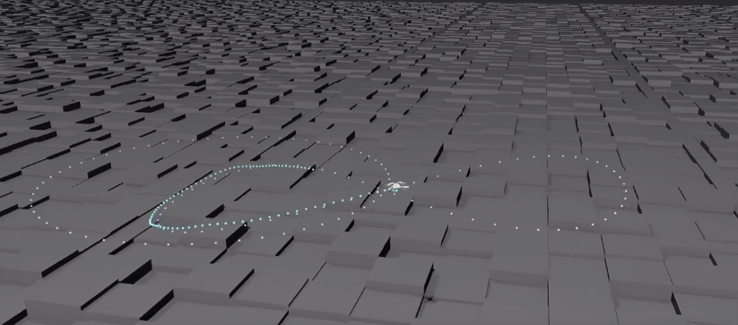

ENGINEERING PROBLEM  Track position through four loops at 50–500 Hz with networks small enough for the STM32. | MY CONTRIBUTION  • Built a four-layer flight controller (50–500 Hz) and physics-based Crazyflie model in Isaac Lab 3.0.  • Trained one PPO MLP per layer to tune 9 PID gains, reducing tracking error 23–62% versus PID (attitude: 15.5° to 5.9°).  • PID and RL gains layer by layer, wrote the report scripts, a pytest suite and a demo video.

Solution & System Architecture
Commands: random targets, circle and figure eight
Small PPO MLP: observations → 9 PID gains
Cascade: position 50 Hz → velocity 100 Hz → attitude 250 Hz → rate 500 Hz → motors
Crazyflie model: motor curve, mixer, 1 kHz PhysX
Evaluation: tracking error and motor chatter across 64 drones

Measured Results
15.5° → 5.9°  attitude error, PID → RL gains | 0.85 → 0.46 m/s  velocity error, PID → RL gains | 2.6–6.3×  motor chatter vs PID on the outer layers

CASE STUDY 02

BalancingRobot-IsaacLab: Self-Balancing Robot with an RL Cascade
A velocity policy balances a Pololu Balboa; a frozen position policy drives it to a goal.
ROLE  Individual: modeling, training, ROS 2 | TIME PERIOD  06/2025 – 12/2025
DOMAIN  Robotics / Control / Reinforcement learning | LINKS  GitHub: github.com/vohongquann/BalancingRobot-IsaacLab

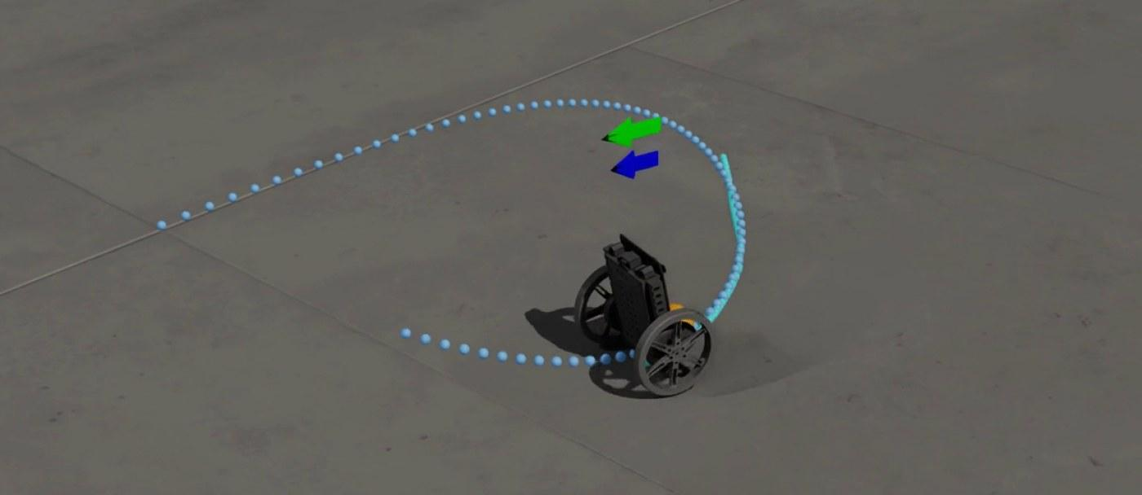
Position cascade following a figure eight.

ENGINEERING PROBLEM  Balance and navigate from a noisy IMU and encoders under random starts and pushes. | MY CONTRIBUTION  • Trained a PPO velocity policy that maps commands and raw IMU/encoder data to wheel torques.  • Added a frozen position policy; recorded zero falls in 768 randomized episodes and 8 mm median goal error.  • Beat LQR on speed steps: 0.026 m/s error in 0.36 s versus 0.067 m/s in 1.1 s.

Solution & System Architecture
Noisy IMU and wheel encoders
Complementary filter → position policy → frozen velocity policy
Goal → speed/turn command → wheel torque; compare RL, LQR and PID
Pololu Balboa model in Isaac Lab / PhysX
768 episodes: pushes, noise and randomized dynamics

Measured Results
0 falls  in 768 randomized episodes, every policy | 8 mm  median distance to the goal when the next goal comes | 0.026 m/s  speed-step error, settled in 0.36 s (LQR: 0.067 m/s, 1.1 s)

CASE STUDY 03

RotaryPendulum-IsaacLab: Learned Cascade PID for a Rotary Inverted Pendulum
PPO retunes both loops of a QUBE-Servo 2 cascade PID at 100 Hz.
ROLE  Individual: modeling, training, evaluation | TIME PERIOD  02/2025 – 05/2025
DOMAIN  Robotics / Control / Reinforcement learning | LINKS  GitHub: github.com/vohongquann/RotaryPendulum-IsaacLab


Pendulum balanced while tracking an arm-angle command.

ENGINEERING PROBLEM  Swing up, balance and track arm angles with quantized encoders and varied motor constants. | MY CONTRIBUTION  • Modeled the QUBE-Servo 2 from CAD with a DC motor and quantized encoders at 500 Hz.  • Trained a PPO policy on 4,096 robots in 64 minutes to tune six cascade-PID gains at 100 Hz.  • Validated on 256 randomized robots: 0.40 s swing-up, 0.23–0.50 s settling and at most 1.4° median overshoot.

Solution & System Architecture
Arm command, encoder angles and velocities (12 observations)
PPO at 100 Hz: 12 observations → 6 PID gains
Outer PID 250 Hz → inner PID 500 Hz → voltage
QUBE model: PWM, current, back-EMF and torque; PhysX at 500 Hz
256 robots with randomized motor constants

Measured Results
0.40 s  median swing-up time (95th percentile 0.48 s) | 0.23–0.50 s  median arm-step settling time | ≤ 1.4°  median overshoot, steady error ≤ 0.24°

04 • EVIDENCE & CONTACT

Technical Evidence & Contact
Clickable source code, results and videos.

Repositories / Documents
01 | Crazyflie-IsaacLab | Cascaded RL gain tuning, Crazyflie 2.1 Brushless: github.com/vohongquann/Crazyflie-IsaacLab
02 | BalancingRobot-IsaacLab | Frozen RL cascade for a Pololu Balboa: github.com/vohongquann/BalancingRobot-IsaacLab
03 | RotaryPendulum-IsaacLab | Learned cascade PID, QUBE-Servo 2: github.com/vohongquann/RotaryPendulum-IsaacLab
04 | GitHub profile | All repositories: github.com/vohongquann
05 | Portfolio website | Interactive demos and CV download: vohongquann.github.io/Portfolio


GitHub profile: github.com/vohongquann

Contact
EMAIL  vohongquan.6524@gmail.com | PHONE  (+84) 363 645 485
GITHUB  github.com/vohongquann | WEBSITE  vohongquann.github.io/Portfolio

