BeachWell: An AI Workload Planner for CSULB Students
CECS 458/558, Fall 2026, Dr. Moon. Phase 1: Integrated Ideation, Market Validation and Feasibility Report
Team: Vo Hong Vy Le, Deborah Shaw
Summary. BeachWell shows students how heavy each week of their semester will be. It reads the student's Canvas deadlines, gives every week a Workload Score from 0 to 100, helps spread the work into lighter weeks, and suggests campus events where the student can take a break. It is planned as a free campus service that helps students deal with stress early and points them to support CSULB already offers.

1. Industry, Target User and Problem
Industry: student wellness and academic success in higher education. Target users: CSULB undergraduates during midterms and finals, especially commuters, students who work and first-generation students. Campus partners: Student Affairs, Counseling and Psychological Services (CAPS) and Associated Students, Inc. (ASI).
Problem. Big deadlines from different classes often land in the same few weeks. Canvas shows each due date, but not how much work a week really holds, so students usually notice the crunch too late. They then lose sleep and miss the free support that is already on campus.
- School is the top stress source: 87% of U.S. college students say education is their main source of stress [2].
- Stress is common: in a 2024–25 survey of more than 84,000 students, 32% reported moderate-to-severe anxiety [1].
- Help is easy to miss: ASI holds free de-stress events every finals week [8], but CAPS appointments that are not urgent can take weeks [7].
Why CSULB: the campus has over 42,000 students [3]; about half are first-generation [4] and most commute [5], so their time on campus is limited. Every class uses Canvas [6], which gives us one simple source of deadlines.

2. Proposed Solution and User Workflow
- Connect. The student pastes their Canvas calendar link [9] and adds class times. A 20-second daily check-in (sleep and stress) is optional.
- Score. Each of the next seven weeks gets a Workload Score from 0 to 100 and a level (Light, Moderate, Heavy or Overload), with a short reason such as "3 big deadlines in 4 days."
- Plan. Large assignments are split into short study sessions placed in lighter weeks, with breaks and simple tips. The plan can be added to Google or Apple Calendar.
- Recharge. For each busy week, the app suggests two or three campus events that match the student's interests and free time.
Students can also drag a what-if slider to see an overload week drop to a lower score when they start earlier, and the app learns each student's pace over time. A safety check reads every note; if a message shows signs of crisis, the app immediately shows CAPS and the 988 Lifeline. BeachWell gives plans and suggestions only; it never diagnoses.
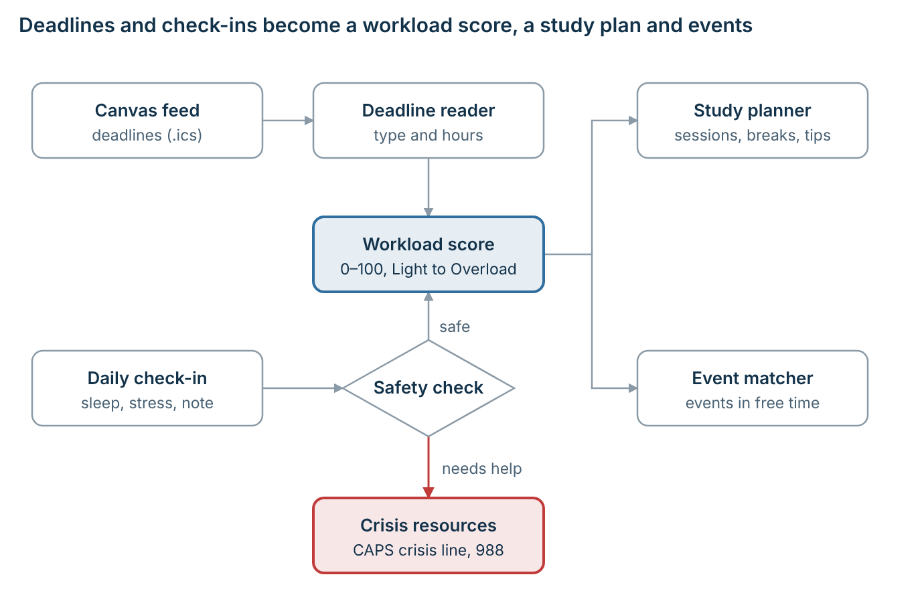
Figure 1. How BeachWell works.

3. AI Application Plan
Part | What it receives | What it produces | How it works
Deadline reader | Assignment names and descriptions from Canvas | Type of work and estimated hours | Gemini AI model, with simple rules as a backup
Workload score | Hours of work, deadline timing, sleep and stress | Score from 0 to 100 and a level, with reasons | A clear scoring formula, adjusted to each student's pace
Planner | Assignments, due dates, class times | Study sessions, breaks, tips | Schedules the earliest deadlines first, never during class
Event matcher | Student interests, free time, event list | Top 3 events for each busy week | Gemini matches by meaning, then checks free time
Safety check | Notes the student writes | "OK" or "show help now" | Keyword rules plus Gemini; the help message is fixed

Why AI is needed: assignment names are messy ("Lab 4," "Milestone 2"), and simply counting deadlines treats a quiz the same as a final project. AI estimates how much work each item really is and matches events by meaning, so "I want to move but hate crowds" leads to yoga, not a concert. Fixed rules handle the parts that must always be reliable: scheduling and the crisis response.

4. Market and Existing Solutions
Existing option | What it does | What is missing
Canvas calendar [9] | Lists due dates for all classes | Shows dates, not workload; no warning or plan
Google Calendar, Notion, to-do apps | Let students plan by hand | Students must guess the effort; no campus support
TimelyCare [10] | Online counseling used by 400+ colleges | Helps after stress builds; does not know deadlines or campus events
ASI events, CAPS workshops [8][11], BeachSync [12] | Free de-stress events and club listings | Shared with everyone; not matched to who is busy or when they are free

The gap: no current tool predicts a student's hardest weeks from their own deadlines and then helps them plan and find support. BeachWell works alongside Canvas, CAPS and ASI rather than replacing them.

5. Business Feasibility
Value. Students see busy weeks coming and get a plan that fits their schedule. The university helps students earlier and gets more students to the wellness programs it already runs.
How it would be offered. BeachWell would be free for students and offered through Student Affairs and ASI, starting with a small pilot. It needs no new campus systems because it uses the Canvas calendar students already have, and running costs are low (AI usage and basic web hosting). It can also save the university money: students who plan ahead need fewer urgent CAPS appointments, and more students attend wellness events the university already pays for.
Possible challenges. Students may not check in daily: the score still works from Canvas alone. Privacy: each student's data stays private; staff only see anonymous totals for groups of 10 or more. Health concerns: the app never gives medical advice, and its crisis message is fixed.

6. Technical Approach and Initial Scope
Tools. A Python web server with a small built-in database (SQLite), a simple web page that works on phones, and Google Gemini for the AI parts. If no AI key is available, the app still runs using simple rules, so anyone can test it. A first working version is already built and passes 32 automated tests.
First version includes: Canvas import, editable time estimates, the weekly workload scores with what-if slider, daily check-in with safety check, study plan with calendar export, event suggestions and pace learning. Not included this term: direct Canvas integration, phone notifications and a mobile app.

7. Data Plan and Evaluation
The project does not depend on real users. We collect no personal student data. Most test data is created by our code or copied from public CSULB web pages, and the team prepares four small sets by hand, about six hours of work in total.
Data | Where it comes from | Privacy
Campus events (about 20 programs) | Copied from public ASI, CAPS and recreation pages | Public; source link kept
Practice semesters (40) | Created by our code, each with one known busy week | No real people
Time estimates (60 assignments) | Each team member estimates hours on their own; we compare | Made-up examples
Sample students (24) | Short interest statements; we mark the best events for each | Made-up examples
Safety test messages (60) | Written by the team: everyday stress vs. messages needing help | No real posts
Classmate test (8–10 people) | 10-minute demo with sample classes, then a short survey | Consent; nothing saved

How we measure success. Each AI part is compared with a simple non-AI method:
Part | What we measure | Compared with
Time estimates | Average error in hours | Same hours for every assignment type
Workload score | How often it finds the real busy week (F1 score) | Counting deadlines per week
Pace learning | Whether estimates improve over the term | No learning
Planner | Rule breaks; hours in the busiest week | No plan
Event matcher | How many of the top 3 picks fit the student | Keyword match; most popular events
Safety check | Share of crisis messages caught (goal: 95%+) | Keyword rules only

Early tests with our first version already beat every simple method (for example, time-estimate error of 1.75 vs. 2.58 hours). We will repeat all tests with the team's own labels and with Gemini for the final report.

8. Risks and Milestones
Risk | How we handle it
The safety check misses a student in crisis | Rules and AI both check; help contacts appear on every page
Time estimates are wrong | Students can fix any estimate, and the app learns their pace
An "Overload" label makes students more anxious | Calm wording, always shown with a plan
Event details go out of date | Every event links to its source; unconfirmed events are marked "expected"
AI service changes or limits use | Fixed model version, saved results and a no-AI backup mode

Date (2026) | Milestone
Oct 23 | Event list, test labels and safety messages ready
Oct 30 | Workload score tested against simple methods using Gemini
Nov 13 | Full app working from scores to plan to events
Nov 20 | Phase 2 progress report and GitHub documentation
Dec 4 | All tests, classmate test and review of errors finished
Dec 11 | Pitch video and final report

Team roles: Vo Hong Vy Le: backend, AI parts and testing. Deborah Shaw: web page, research, event list and reports. Both label the test data separately.

References
[1] University of Michigan School of Public Health (2025). Healthy Minds Study: College student depression, anxiety decline for third consecutive year. https://sph.umich.edu/news/2025posts/college-student-mental-health-third-consecutive-year-improvement.html
[2] Frontiers in Psychology (2022). Academic Stress and Mental Well-Being in College Students: Correlations, Affected Groups, and COVID-19. https://www.frontiersin.org/journals/psychology/articles/10.3389/fpsyg.2022.886344/epub
[3] CSULB (2025). CSULB student enrollment for fall 2025 climbs to record levels. https://www.csulb.edu/node/615216
[4] CSULB. How Cal State Long Beach is guiding first-generation students to reach their goals. https://csulb.edu/news/article/how-cal-state-long-beach-guiding-first-generation-students-to-reach-their-goals
[5] Daily 49er / LB Current (2022). The new traditional student is a commuter. https://lbcurrent.com/?p=70335
[6] CSULB Academic Technology Services. Canvas Migration. https://csulb.edu/node/544151
[7] CSULB College of Natural Sciences and Mathematics. Health and Wellness resources. https://csulb.edu/node/551226
[8] ASI CSULB. Get energized this Finals Week with Beach Pride Events! https://mail.asicsulb.org/corporate/connect/beachfront/843-get-energized-this-finals-week-with-beach-pride-events
[9] Instructure Canvas Community. How do I view the Calendar iCal feed to subscribe to an external calendar as a student? https://community.canvaslms.com/t5/Student-Guide/How-do-I-view-the-Calendar-iCal-feed-to-subscribe-to-an-external/ta-p/331
[10] TimelyCare. Five reasons to choose TimelyCare. https://timelycare.com/five-reasons-to-choose-timelycare/
[11] CSULB. Counseling and Psychological Services (CAPS). https://www.csulb.edu/student-affairs/counseling-and-psychological-services
[12] CSULB Student Life & Development. Student Organizations (BeachSync). https://www.csulb.edu/student-affairs/student-life-development/student-organizations

