

**MINISTRY OF EDUCATION AND TRAINING**

**FPT UNIVERSITY**

Capstone Project Document

**Cosmetic Online Shopping**

|  |  |
| --- | --- |
| **Group 2** | |
| **Group members** | Võ Huỳnh Đức Minh – SE130160 Nguyễn Công Bảo – SE130160 |
| **Supervisor** | Hồ Hoàn Kiếm |
| **Ext. Supervisor** | N/A |
| **Capstone Project Code** | COSA |

- Ho Chi Minh City, 5 April 2020 -

**USER GUIDE**

1. **Software description**

Web application:  
**Display shop’s items:** user can watch some recommendation product display on shopping web site and interactive with them by click on product to view product detail.  
**Search product:** user can find the product by fill the search text box on top and click on search to searching product.  
**Shopping cart:** after view product, user can add them to cart collection and update quantity of product. The total price of shopping cart will display on bottom corner of page . Finally, user can submit order with their choice about payment and delivery.  
**Manage user account:** Admin can modify or set role of user account and manage their information.  
**Mange product store:** Admin can create new product, modify exist product or delete them on store.  
**Check register validation:** all the field of register page will be validate to conform with the system require.

1. **Platform**

|  |  |
| --- | --- |
| Tool / Technique | Name / version |
| Frontend | HTML, CSS, JavaScript, Ajax, Bootstrap |
| Backend | C#,API |
| Web server | IIS Express |
| Development tool | Visual Studio 2019, Visual Studio Code |
| DBMS | SQL Server 2014 |
| Modeling tool | StarUML 5.0 |
| Document tool | Microsoft Word 2010 |

1. **Browser version**

The user interface uses Vietnamese language.

Use consistent palette of colors between the text and the background.

The user interface displays best on 1024x768-screen size.

Web application: works with Firefox(v69.0 or above),Safari(v13 or above), Chromes (v80.0 or above), Internet Explorer (v11 or above) browse

Use HTTP protocol 1.1 for communication between the web browser and the web server

1. **Web application design**
2. **Main page**

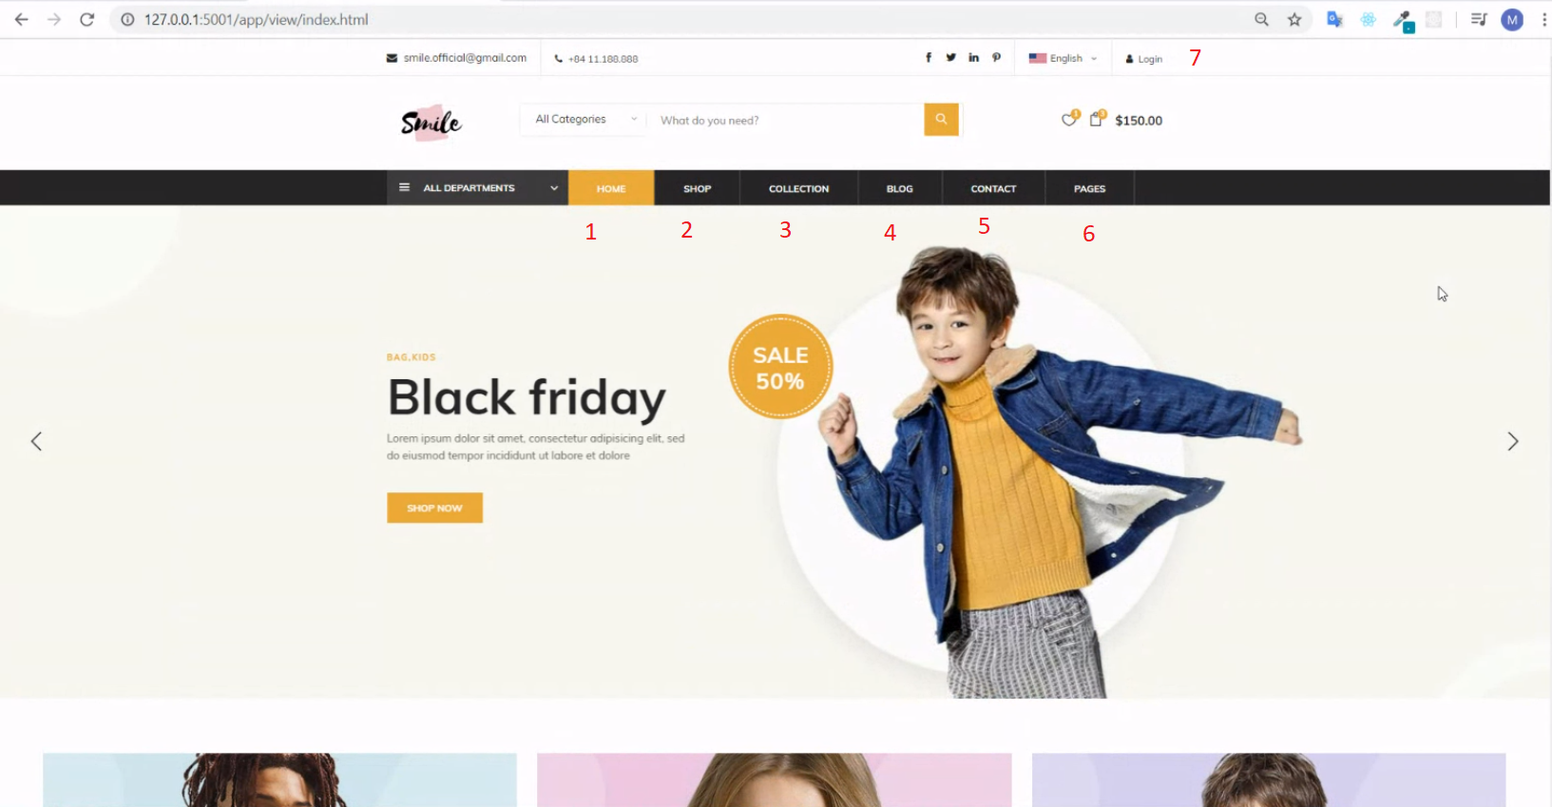

|  |  |  |  |  |
| --- | --- | --- | --- | --- |
| No | Function | Description | Validation | Outcome |
| 1 | viewHome | Introduction website | N/A | Transfer to home page |
| 2 | viewShop | List all product | N/A | Transfer to view shop page |
| 3 | viewCollection | List all new collection | N/A | Transfer to view collection page |
| 4 | viewBlog | List blog to interactive | N/A | Transfer to blog page |
| 5 | viewContract | List | N/A | Transfer to contract page |
| 6 | viewPage | view another page | N/A | Transfer to view page |
| 7 | getLogin | Get login by user/admin account | N/A | Transfer to login page |

1. **Login page**

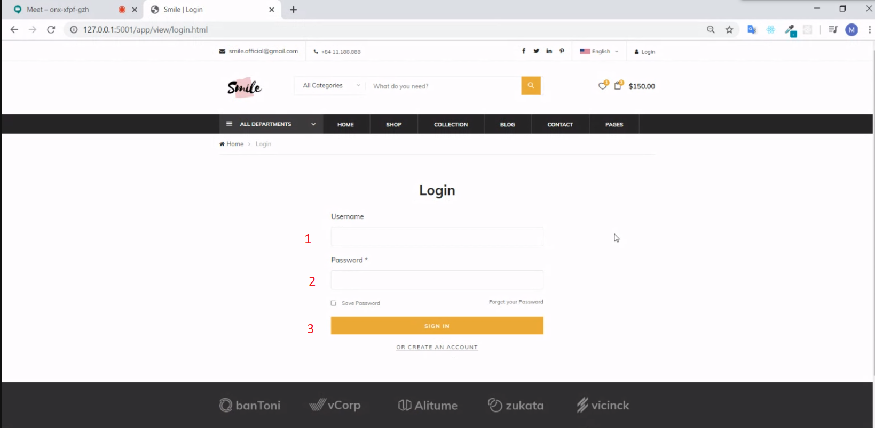

|  |  |  |  |  |  |  |  |
| --- | --- | --- | --- | --- | --- | --- | --- |
| No | Field Name | Description | Read only | Mandatory | Control Type | Data Type | Length |
| 1 | txtUsername | Input username | no | no | Text Field | String | N/A |
| 2 | txtPasword | Input password | no | no | Text Field | String | N/A |

|  |  |  |  |  |
| --- | --- | --- | --- | --- |
| No | Function | Description | Validation | Outcome |
| 3 | Login button | Click to submit authentication data | txtUsername & txtPassword must be filled | Login to user |

1. **Admin page**

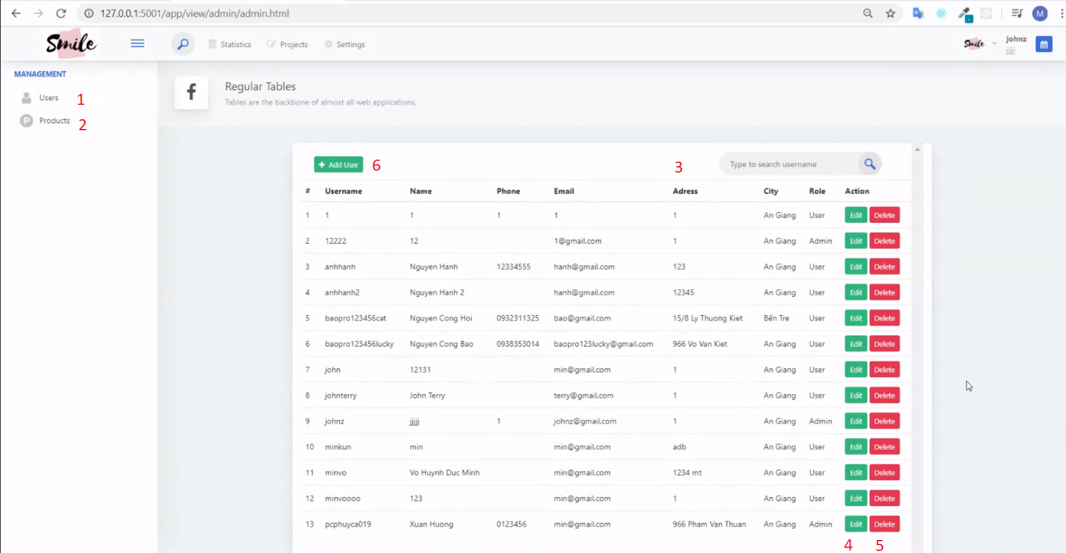

|  |  |  |  |  |  |  |  |
| --- | --- | --- | --- | --- | --- | --- | --- |
| No | Field Name | Description | Read only | Mandatory | Control Type | Data Type | Length |
| 3 | txtSearch | Input username to search | no | no | Text Field | String | N/A |

|  |  |  |  |  |
| --- | --- | --- | --- | --- |
| No | Function | Description | Validation | Outcome |
| 1 | User tab | User manage screen | N/A | Transfer to user manage tab |
| 2 | Product tab | Product manage screen | N/A | Transfer to product manage tab |
| 4 | Add User | Add new User | N/A | Add user to database |
| 5 | Update User | Update existence user | N/A | update user in database |
| 6 | Delete User | Delete existence user | N/A | delete user in database |