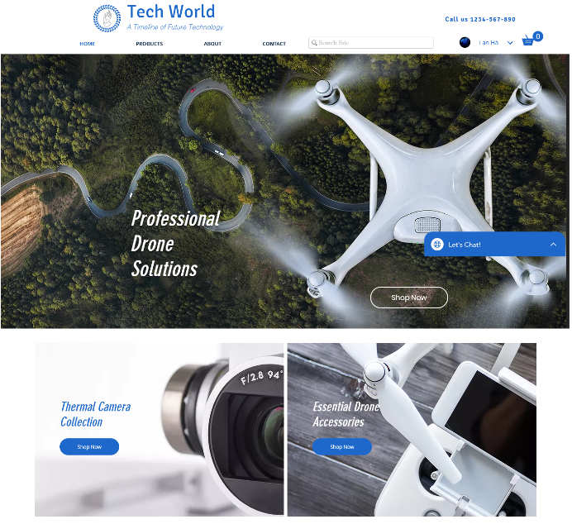

Online Retail Application



Project proposal – class itit17cs11

Group P - Member list:

Hà Thị Thanh Lan ITITIU15009

Nguyễn Đức Phi Hồng ITITIU17022

Võ Huy Thành ITITIU17026

**Table of contents**

1. **Overview**
2. **Project Organization**
3. **Schedule and Milestones**
4. **References**
5. **Overview**

Nowadays, people live in the active and busy society. They do not have too much time for shopping, trading goods or buying directly some necessary items in malls, shops. In addition, the technology innovation leads to many activities of human are now performing on the Internet. People are used to searching an information of product before buying or they will order that product immediately on the Website in order to save their time. Therefore, we are going to develop a **Retail Website** which is used for trading online base on the requirement of shop owner. Specifically, the Website is used to display and sell many product in varied categories included fashion, household, electric, book, etc. Customers can view products or buy online through the **Retail Website** in convenient and economical way.

The **Retail Website** is used by everyone and could be accessed from anywhere through all devices (mobile, computer, tablet, etc.) being connected to the Internet.

Time: 15 weeks from 11th February 2019

1. **Project Organization**

|  |  |  |
| --- | --- | --- |
| **Name** | **Task/Deliverable** | **Contact** |
| Hà Thị Thanh Lan | **Report** | halaninformation@gmail.com |
| Hà Thị Thanh Lan | **Cover page** |  |
| Nguyễn Đức Phi Hồng | **ERD** |  |
| Nguyễn Đức Phi Hồng | **Relational Database Schema** |  |
| Võ Huy Thành | **Database** |  |
| Võ Huy Thành | **Program** |  |
|  | **Conclusions** |  |

1. **Schedule and Milestones**

|  |  |  |
| --- | --- | --- |
| **ID** | **Week** | **Milestone Criteria** |
| 1 | Week 1 | Choosing a topic in the document and create a team. |
| 2 | Week 2 | Team can have an overall view of what they need to accomplish , Write a report |
| 3 | Week 3 | Design an ERD conceptual schema based on the specification of the chosen topic |
| 4 | Week 4 |
| 5 | Week 5 | Design a conceptual schema in the basic relational model that corresponds to the ERD schema designed |
| 6 | Week 6 |
| 7 | Week 7 |
| 8 | Week 8 | Create a database containing the tables listed in the schema designed |
| 9 | Week 9 |
| 10 | Week 10 |
| 11 | Week 11 | Required to implement a Java program that provides the capability to run queries on the database management system. |
| 12 | Week 12 |
| 13 | Week 13 |
| 14 | Week 14 | Fix problem in a project |
| 15 | Week 15 | Presentation |

1. **References**

<https://viettelidc.com.vn/>

<https://www.pavietnam.vn/>

<https://www.w3schools.com/>

<https://www.mysql.com/>