**Problem Statement:**

Write a JavaScript code to do online booking of theatre tickets and calculate the total price based on the below conditions:

1. If seats to be booked are not more than 2, the cost per ticket remains $9.
2. If seats are 6 or more, booking is not allowed.
3. If seats to be booked are more than 2 but less than 5, based on the number of seats booked, do the following:
   * Calculate total cost by applying a discount of 5, 7, 9, 11 percent, and so on for customer 1,2,3 till 5.
   * Try the code with different values for the number of seats.

Write the following custom functions to implement given requirements:

1. calculateCost(seats): Calculate and display the total cost to be paid by the customer for the tickets they have bought.
2. calculateDiscount(seats): Calculate discount on the tickets bought by the customer. Implement using arrow functions.

**Expected Output:**

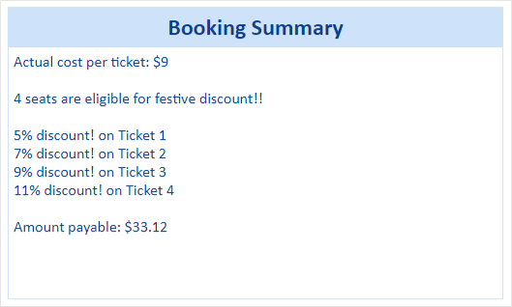

**Starter code:**

1. <!DOCTYPE html>
2. <html>
3. <head>
4. <title>Booking Summary</title>
5. <style>
6. div*#maincontent {*
7. height: 250px;
8. width: 500px;
9. border: 1px solid *#CEE2FA;*
10. text-align: left;
11. color: *#08438E;*
12. font-family: calibri;
13. font-size: 20;
14. padding: 5px;
15. }
16. div*#heading {*
17. text-decoration: bold;
18. text-align: center;
19. margin-top: 80px;
20. width: 500px;
21. border: 1px solid *#CEE2FA;*
22. text-align: center;
23. color: *#08438E;*
24. background-color: *#CEE2FA;*
25. font-family: calibri;
26. font-size: 20;
27. padding: 5px;
28. }
29. h2 {
30. padding: 0;
31. margin: 0;
32. }
33. </style>
34. </head>
36. <body>
37. <center>
38. <div id="heading">
39. <h2>Booking Summary</h2>
40. </div>
41. <div id="maincontent">
42. <script>
43. *//Write the code to display the booking summary*
44. </script>
45. </div>
46. </center>
47. </body>
49. </html>