Modeling Transposition for Single-Axis Trackers Using Terrain-Aware Backtracking Strategies
Kurt Rhee
Nevados Engineering, San Francisco, California, 94107, United States

Abstract—Nevados Engineering has developed a software program and accompanying modeling methodology which can be used in conjunction with industry standard photovoltaic performance modeling software in order to more accurately estimate the performance of trackers which employ terrain-aware backtracking strategies. Nevados has utilized this software to benchmark its proprietary terrain-aware backtracking algorithm against two other backtracking algorithms at one site in the United States. Results at the site indicate that a standard ground coverage ratio based backtracking algorithm would suffer terrain-related inter-row shadowing losses on the order of 6.7%. A common alternative to standard backtracking entitled artificial ground coverage ratio backtracking was able to recover 33% of this lost energy. The proprietary terrain-aware backtracking algorithm was able to recover around 63% of terrain-related energy losses,
2023 IEEE 50th Photovoltaic Specialists Conference (PVSC) | 978-1-6654-6059-0/23/$31.00 ©2023 IEEE | DOI: 10.1109/PVSC48320.2023.10360094
Index Terms—horizontal single-axis tracker, tracker, transpo- sition, backtracking, ray casting, terrain

- Introduction
Horizontal single-axis trackers in utility-scale photovoltaic projects have historically been constructed and modeled as flat arrays of repeating tracker rows, with each row indistinguish- able from the row next to it. As the solar industry has matured, there has been an effort to construct sites on ground that is not flat. Sites that are constructed on variable terrain differ from flat sites in two main important ways.
In terms of hardware, some tracker manufacturers have added the ability to add angular deflection to the tracker torque-tube. This modification allows trackers to conform to the underlying terrain in the north-south direction, and reduces the amount of grading a site may require. Figure 1 and 2 show real world installation as well as a simplified example of how Nevados trackers change torque tube angles within a given tracker respectively.
In terms of software, some tracker manufacturers have developed terrain-aware backtracking strategies which can be used to reduce terrain related shading losses that would otherwise occur if the system were to be controlled by a standard ground coverage ratio (GCR) based backtracking algorithm. A standard GCR based backtracking algorithm takes into account the spacing between trackers, but does not utilize any information regarding the underlying terrain.
These new features introduced by tracker manufacturers can cause some difficulty for performance modeling groups. First, modeling a solar photovoltaic system sited on terrain as it were
flat will not capture row-to-row shading losses if no terrain- aware backtracking algorithm is employed [1] [2] [3]. Second, the number of different terrain-aware backtracking strategies available and their different effects on a performance model are not currently well understood. Third, most performance modeling software programs do not allow for angular deflec- tion within a tracker object. In order to accurately estimate a tracker system on terrain, a performance model not only needs to take into account the unique rotation angles that are generated from the terrain-aware backtracking strategy, it must also take into account the torque tube axis angle deflections that can occur within each tracker object.
At the time of writing, many industry photovoltaic perfor- mance modeling software have not yet implemented all forms of terrain-aware backtracking in their internally calculated tracker rotation angles, though this has not stopped users from modeling its effects in an indirect fashion [1]. Some software programs such as Terabase’s PlantPredict and DNV’s Solar- Farmer give the user the ability to input custom tracker angles which can make the evaluation of terrain-aware backtracking schedules easier.
The main objective of this paper is to illustrate a method for modeling the performance of terrain-aware backtracking algo- rithms that integrates easily with existing industry performance modeling software. The second objective is to demonstrate the magnitude of performance gain that can be expected from different terrain-aware backtracking algorithms compared to operating a plant with a standard ground coverage ratio based strategy on variable terrain.
- Methods
- Backtracking Model Selection and Preprocessing
Backtracking on flat ground and on mono-slopes can be solved in closed form [7]. Backtracking on variable terrain has not been solved in closed form, and a number of different algorithms exist to solve the problem.
  - Types of Terrain-Aware Backtracking Algorithms: In order to model the performance benefit of a terrain-aware backtracking algorithm over a standard GCR based algorithm, one must first define what type of terrain-aware backtracking algorithm the tracker control system will employ. The simplest type of algorithm is called the “Artificial GCR” method. In this method, the GCR used to control the trackers is set artificially higher than the as-built GCR so that the controls

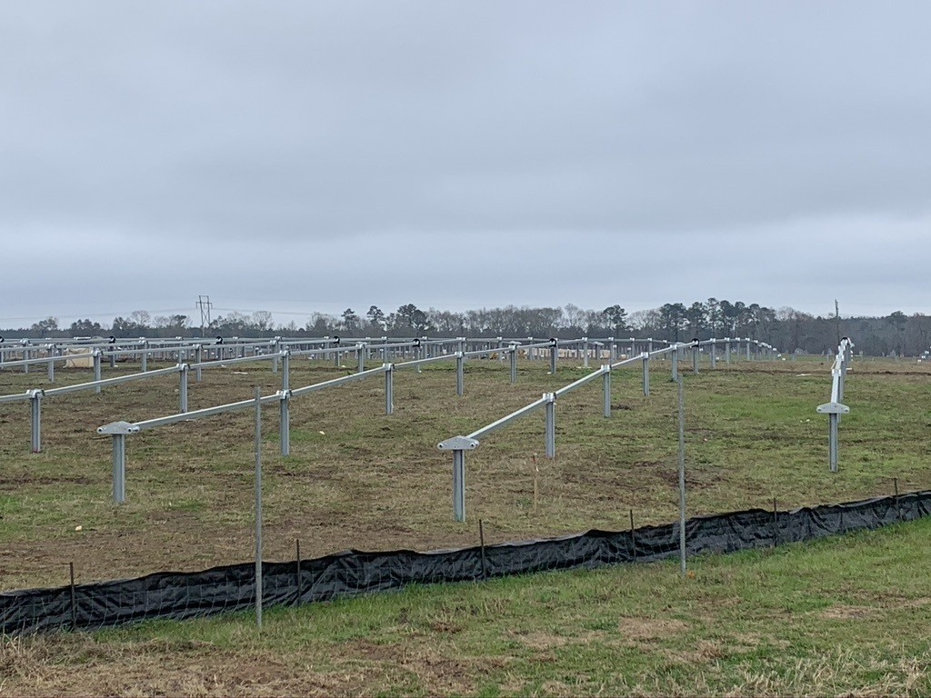

Fig. 1. Nevados trackers being installed on a hill. Angle changes occur along the torque-tube axis at each pile location which allow the Tracker to follow the terrain underneath without the need to level the site.
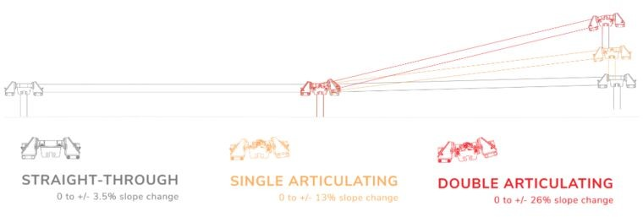

Fig. 2. Simplified bearing design for a Nevados tracker. Using different bearings at each pile location allows Nevados trackers to adjust to changes in elevation from pile to pile, while also using the minimum cost bearing at each pile.

system backtracks the trackers earlier and more aggressively than if it were sited on flat land. For example, if a tracker site is constructed with a GCR of 33% on terrain, a tracker manufacturer may control their trackers with an artificial GCR of 36%. In this way, some terrain shade losses are avoided, but because the algorithm does not take the actual terrain into account, it may leave some rows shaded and other rows more backtracked than they need to be.
Another method which can be used to optimize the tracker rotation angles is to utilize a computational geometry en- gine. In this method, a digital version of the site geometry is created in three dimensions. Then the site geometry is processed via methods borrowed from the graphics processing and computational geometry fields, namely ray-casting and shadow-mapping [5]. Utilising the 3D site geometry allows the algorithm to minimize the angle between the module surface normal vector and the direct insolation coming from the sun, while also avoiding inter-row shadowing for every individual tracker.
It must be mentioned that there are even more possible backtracking algorithms besides the two listed above which can be employed to operate a horizontal single axis tracker site. A tracker company could employ a slope-aware back-
tracking algorithm [7] or use a backtracking algorithm which utilizes machine learning. Comparing these other types of backtracking algorithms is beyond the scope of this paper. Either way, the methods outlined below should provide a framework for comparing diffferent terrain-aware backtracking algorithms should any interested parties choose to extend this work in the future.
  - Preprocessing: Artificial GCR Method: Historically when the artificial GCR method has been deployed, it has been the job of a human operator to manually change the controls GCR set-point until no shading was observed during the commissioning process. Unfortunately, because financing steps come before commissioning, not all developers have been able to take advantage of the performance benefit that this controls strategy may impart on their project.
In order to benchmark the performance of backtracking angles created via a geometry engine to those created by an artificial GCR, Nevados has developed a method which can be used to determine which GCR set-point should be used during modeling. First, an array of rotation schedules is generated using the standard GCR based method. Then, a new array of rotation schedules is created by incrementing the input GCR by 1 percent. For each array of rotation schedules, a metric termed “effective plane of array insolation” is calculated which represents the amount of plane of array insolation we would expect to be converted into electricity.
In the simplified model for effective plane of array insola- tion used in this paper, the contribution of a shaded tracker “bay” to total plant transposition is reduced to only the diffuse portion of the incident insolation. In a Nevados tracker, a bay represents a subsection of a tracker which has a set of modules which all have the same torque tube axis tilt angle, in other words, a set of modules that exist together before an angular deflection of the torque tube occurs. This model is intended to very roughly mimic the effects of electrical mismatch along the string and though the model is an approximation, the magnitude of the resultant calculations is consistent with more rigorous models [1]. A more robust method would be to complete an energy model considering detailed 3D shading and IV curve mismatch as described and executed in [10].
  - Preprocessing: Geometry Engine Method: Some initial processing is needed to convert solar layouts, usually created in a computer aided design software such as AutoCAD, into a format that is usable by the geometry engine program. Once this conversion is complete, no further preprocessing is needed, the computation engine can create individual tracker rotation schedules bespoke to the terrain at each tracker.
- Method for Modeling Transposition Utilizing a Terrain- Aware Backtracking Algorithm
  - Average Transposition: Because not all performance modeling software packages have the ability to calculate transposition for the large number of different torque tube axis angles and rotation angles that a site constructed on terrain may contain, it is necessary to first calculate transposed insolation externally. Transposition in this study was created

using pvlib [8]. Once transposed insolation is calculated for every bay object, then a weighted average can be created with weights corresponding to the number of modules in a given bay. For example if there was a 3 bay tracker with 1 module, 2 modules and 5 modules in each bay respectively, then the transposition could be averaged as followed:

POA = 1/8 × POA₁ + 2/8 × POA₂ + 5/8 × POA₃ (1)
Where POA₁ stands for bay 1 transposition, POA₂ stands for bay 2 transposition and POA indicates plant average plane of array insolation.
This method of calculating and averaging transposed insola- tion can theoretically be broken down into multiple sub-models for enhanced accuracy. For example, instead of averaging all bays at a given site, one could model all bays at a given inverter. Averaging transposition will underestimate mismatch losses for the plant and will therefore cause modeled energy to be higher than actual energy.
  - Retro-Transposition: Some software programs such as PVSyst [13] will retro-transpose plane of array insolation into global horizontal and diffuse horizontal irradiation if plane of array insolation is used as an import. These software programs will then re-transpose the retro-transposed components into the plane of array insolation that is actually used in the simulation model. The results of this retro-transpose, re-transpose process are highly dependent on the underlying transposition models as well as the rotation angles assumed. In PVSyst, the Hay model
[14] is used for retro-transposition and the rotation angles are calculated using one of PVSyst’s suite of tracking modes.
Because one cannot control the rotation angles of single axis trackers in PVSyst, the only option for approximating the operations of a terrain-aware backtracking strategy is to tune the input meteo data. The input meteo data should be tuned so that once it is transposed, the resulting plane of array insolation matches that of a tracker employing a terrain-aware backtracking strategy. In this paper, TRACE uses the pvlib gtidirint function with Perez transposition and a standard GCR-based schedule of backtracking angles. This allows the program to back-solve what global horizontal insolation and diffuse horizontal insolation would be necessary to receive the same amount of plane of array insolation as a terrain- aware backtracking strategy on a GCR-based backtracking simulation.
- RESULTS
- Terrain
In order to generate models, one real world system located in the north-eastern United States was chosen, built with Nevados trackers. The project is sited on a hill and is sloped in all directions, but most of the site is dominated by a north- eastern aspect. In table I, statistics for torque-tube axis-tilt, cross-axis-tilt and axis-tilt mismatch are reported. Torque-tube axis-tilt is reported in the south to north direction with positive numbers indicating that the modules are inclined towards the southerly horizon. A histogram of torque-tube axis-tilt can be
found in Figure 5. Cross-axis-tilt is reported in the west to east direction with positive numbers indicating that a given bay is lower in elevation than the bay directly east of it. A histogram of cross-axis-tilt can be found in Figure 6. Please note that the process for calculating cross-axis-tilt is not entirely clear for trackers with non-continuous torque-tubes, since a given bay may have a different torque-tube axis angle than the bay directly east or west of it. Additionally, a bay may be offset to the north or south of a bay directly to its east or west. In either case, the center point of each bay was used for comparison, and no difference in torque-tube axis-tilt is assumed. Differences in torque-tube axis angle from a given bay, compared to another bay on another tracker in the cross- axis direction are classified as axis-tilt mismatch. For example, if tracker 1 bay 1 has a torque-tube axis-tilt in the north/south direction of 1 degree and tracker 2 bay 1 directly east has a torque-tube axis-tilt in the north/south direction of 2 degrees, then the resulting axis-tilt mismatch would be −1 degrees. Only bays that are compared for cross-axis-tilt are compared for axis-tilt mismatch. A histogram of axis-tilt mismatch can be found in Figure 7.

TABLE I
Site Terrain Characteristics in Degrees

Type | Min. | Mean | Max | St. Dev.
N/S Torque-Tube Axis-Tilt | −3.36 | −1.07 | 3.51 | 1.75
Cross-Axis Slope | −3.98 | −1.31 | 1.41 | 0.90
Axis-Tilt Mismatch | −0.96 | 0.00 | 1.13 | 0.20

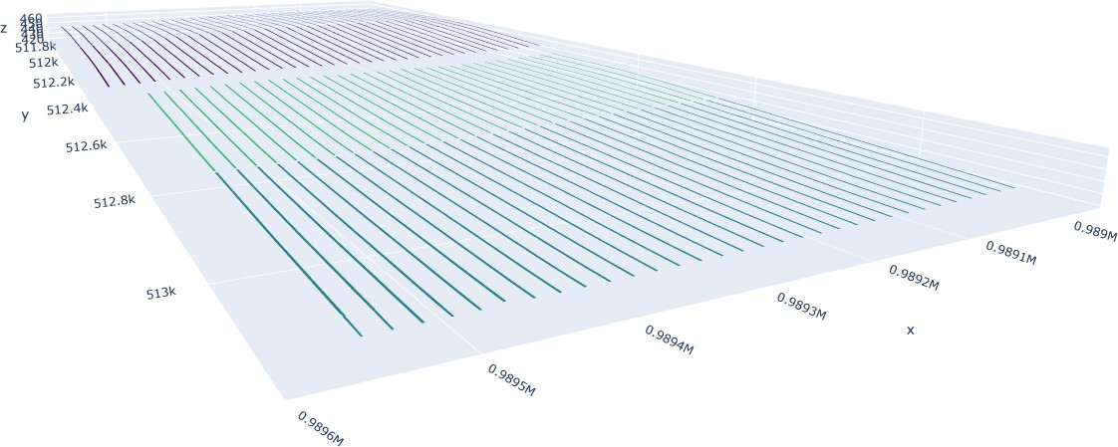

Fig. 3. 3D Model of the site used for schedule generation. Trackers are aligned north to south and are arranged in 4 distinct rows.

- Backtracking
An hourly TMY weather dataset from the NSRDB’s PSMv3 model [12] indicates that the annual average diffuse fraction at the site is 38%, which is relevant in that as the diffuse fraction increases towards a limit of 100%, terrain related inter-row shadowing is expected to be reduced to only the diffuse shading portion of the inter-row shading loss. At the site, backtracking time-steps represent approximately 20% of all daylight tracking time-steps. This 20% represents a smaller impact on overall transposed insolation than true tracking time- steps relative to its proportion, since backtracking is confined to the beginning and end of day when the sun is lower in

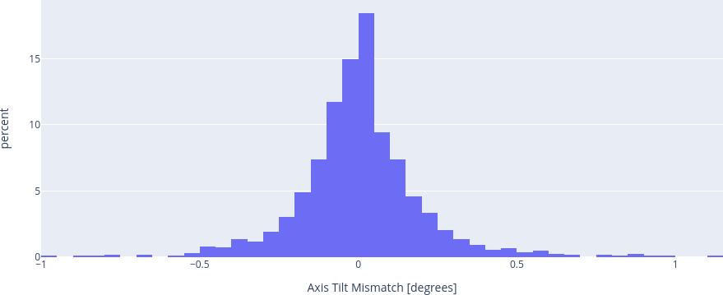

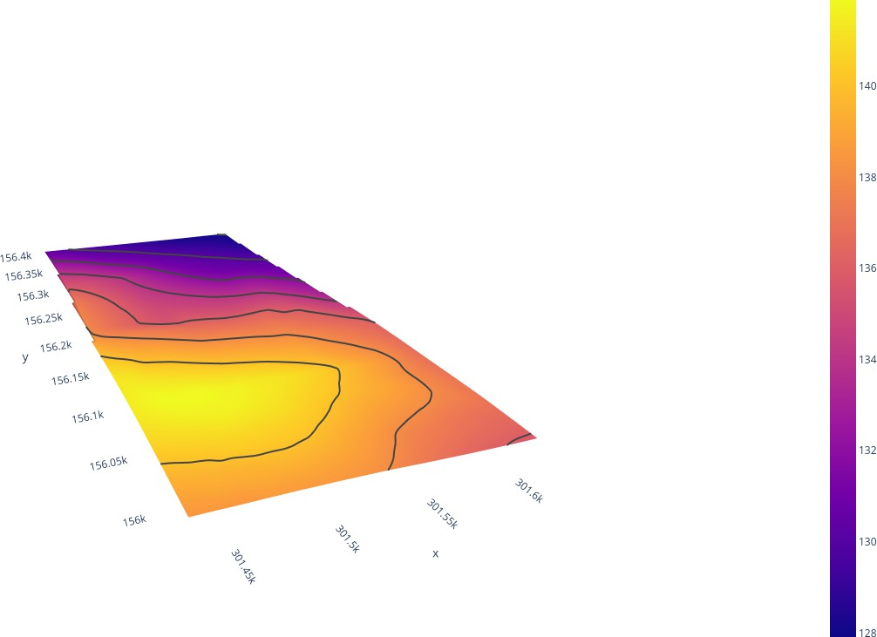
Fig. 4. Site Surface with 2m Contour Lines. Most of the site is oriented towards the north east, though some of the site is oriented towards the south east.

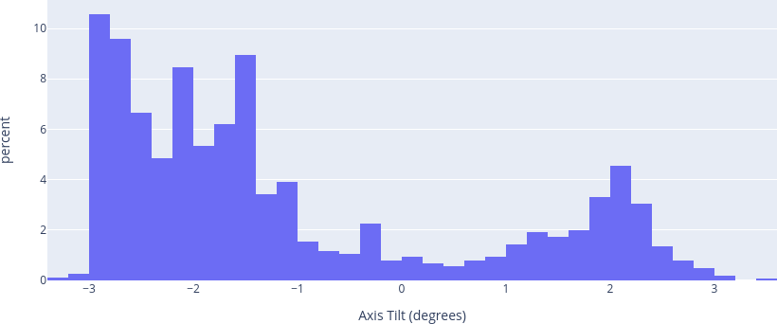

Fig. 5. Histogram of north/south torque-tube axis-tilt for all bays in the system. Evidence of both the dominating northern axis-tilt and smaller southern axis-tilt can be seen as distinct peaks.

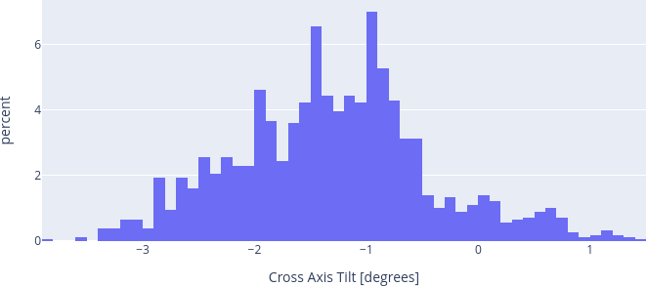

Fig. 6. Histogram of cross-axis-tilt for all bays in the system. The negative peak of the distribution indicates that most of the system’s trackers are lower in elevation than the tracker directly to its west.
Fig. 7. Histogram of Axis-Tilt Mismatch. The peak centered around 0 degrees indicates that most trackers do not vary in north/south torque-tube axis-tilt from their cross-axis neighbors

the sky. Assuming a flat model and Perez transposition [11], backtracking time-steps contribute approximately 16% of total plane of array insolation.
Table II shows the results of 3 different backtracking algorithms which could be used to control the same physical system. Each algorithm’s performance in terms of effective transposition gain relative to the annual global horizontal insolation is shown in the “Gain” column. Each algorithm’s performance in terms of effective transposed insolation is shown in the “Effective Insolation” column. Effective inso- lation is the amount of insolation that is usable to the system for the creation of energy that will not be lost to the effects of inter-row shadowing. The standard GCR based backtracking algorithm uses a set-point of 36% which matches the as-built GCR on site. The artificial GCR based backtracking algorithm uses a set-point of 42% which was calculated to be the most optimal GCR via the methodology described earlier in this paper. Results of the parameter sweep to determine the best GCR set-point for the artificial GCR method can be found in Figure 8.
Some important bookends which can be used to understand each algorithm’s performance are as follows. The annual global horizontal insolation at the site was 1600.32 kWh/m². If the entire site was graded to flat, the system would have a global plane of array insolation value of 2108.79 kWh/m².

TABLE II
Site 1: Backtracking POA

Method | Gain (%) | Effective Insolation (kWh/m2)
Standard GCR | 25 | ∼2000
Artificial GCR | 27.5 | ∼2040
Geometry Engine | 29.3 | 2068.23
POA stands for Plane of Array Irradiance. A ˜ symbol is used to remind the reader that these insolation values were created via an approximation described in the Methodologies section of this paper.

By comparing the table above to the results that could have occurred if the site were graded entirely flat, it can be seen that about 6.7% of usable transposed insolation was lost if the tracker system was operated with a standard GCR based back- tracking algorithm due to terrain-related inter-row shading. Approximately 2.5% absolute additional effective insolation can be captured if the system were to be controlled with the

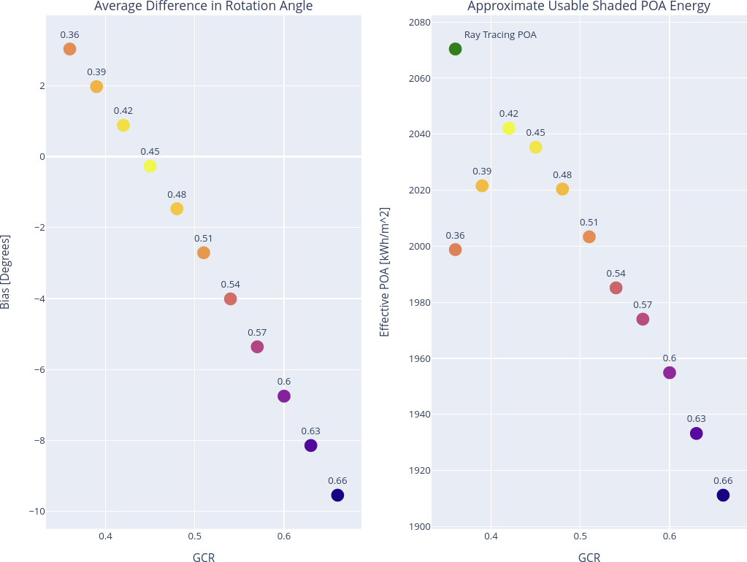

Fig. 8. Left: Mean bias in tracker rotation angle when comparing a standard GCR based backtracking algorithm to the most backtracked tracker in the field when calculating rotation angles via the computational geometry engine. Positive values indicate that the standard GCR based backtracking algorithm is less backtracked at that GCR set-point than the most backtracked result from the computation engine. Negative values indicate that the standard GCR based backtracking algorithm is more backtracked at that GCR set-point than the most backtracked result from the computation engine. Right: Comparison of effective POA using different GCRs compared to the computational geometry engine (green dot). The results from the computational geometry engine backtracking algorithm outperforms a parameter sweep of all ground coverage ratio based backtracking algorithm set-points at the site.
artificial GCR algorithm with a GCR set-point of 42%. 4.3% absolute additional effective insolation can be captured by using a computational geometry engine. These modeled results show the large effects that backtracking algorithm choice can have on system performance and also closely match results from field-testing mentioned in prior work [1].
- Backtracking Meta-Analysis
A few interesting points constituting a meta-analysis of the aforementioned results follow:
  - Contribution of Torque-Tube Axis-Tilt to Transposition Loss: In order to determine, approximately, how much lost transposed insolation can be attributed to the northern aspect of the site, a modeled system was created with all trackers at a 1.07 degree northerly aspect. This aspect represents the average torque-tube axis-tilt for the whole site. Modeling the system with this configuration resulted in a loss of approxi- mately 0.9% global plane of array insolation relative to a flat site. This loss represents 13.4% of the total lost transposed insolation and demonstrates that there is a component of transposed insolation related only to the torque tube axis tilt and not the backtracking rotation angles.
  - Averaging of Backtracking Angles: Another finding of note is that averaging the time series of tracker rotation angles as well as averaging the tracker-axis-tilt before calculating transposition instead of averaging the transposed insolation after the calculation is complete gives nearly the same results. Averaging the rotation angle and torque tube axis angle of every bay at the site for every timestep and then calculating transposed insolation based off of this average gives an annual insolation of 2071.87 kWh/m² compared to 2068.23 kWh/m² when tranposed insolation is averaged after the fact. This represents a 0.18% difference and falls within the uncertainty expected of transposition modeling in general.
  - Retro-Transposition: The method of retro-transposing the plane of array insolation generated with a terrain-aware backtracking algorithm in order to back-calculate the neces- sary horizontal insolation components needed to achieve the same plane of array insolation on a modeled single-axis tracker employing a standard ground coverage ratio based backtrack- ing strategy is new to the industry. Attempting this method at this site showed an R-squared correlation of 0.9998 when the target transposed insolation was retro-transposed in pvlib and then re-transposed in PVsyst. Figure 9 shows a scatter-plot comparing plane of array insolation before the retro-transpose, re-transpose process to plane of array insolation re-transposed in PVSyst.

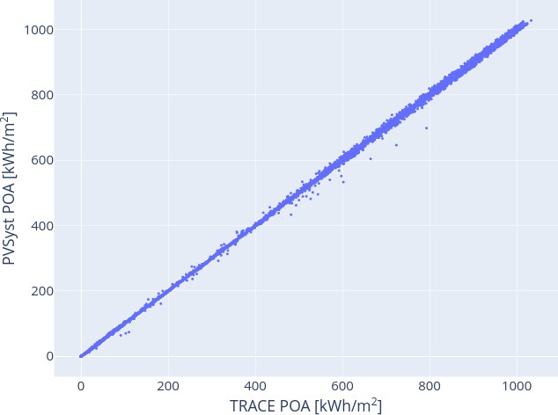
Fig. 9. Plane of array insolation as generated by TRACE on the x-axis compared to plane of array insolation as generated by retro-transposition and re-transposition as generated by PVSyst. The highly correlated nature of the data indicates that the retro-transposition method may be an accurate way to approximate the performance of terrain-aware backtracking strategies in performance modeling software which does not accept custom tracker angles as an input.
Conclusion
Accurately modeling the performance of horizontal single- axis trackers on variable terrain can be a daunting task. A method which can take into account the various intra-tracker torque-tube axis deflections as well as individual tracker rota- tion angles has been demonstrated. Furthermore, this method was used to benchmark three different backtracking algorithms on one site built on terrain. Using an artificial ground coverage

ratio backtracking algorithm can recover around 33% of the losses incurred by terrain-related inter-row shading at the mod- eled site. Backtracking angle calculated via a computational geometry engine on the other hand can recover around 63% of the losses that may be incurred by terrain-related inter-row shading. Additional work must be done to complete the full performance modeling chain at this site and also to repeat these methodologies at different sites due to the fact that terrain varies widely from site to site.
Acknowledgment
I would like to thank Thang Le, David Spieldenner, and Jesse Milam from Terabase for their great suggestions which have been included in this paper as well as the assistance they have provided in using PlantPredict. At NREL, I would like to thank Kevin Anderson for his help in modeling multi-angle transposition, for all of his help editing this paper, and general mentorship. At DNV, I would like to thank Mark Mikofski for his continued guidance in all aspects of performance modeling. At Primoris I would like to thank Jay DeVilbiss for suggesting the use of alternative backtracking strategies during commissioning. At Nevados I would like to thank Brittanie Jackson for proofreading all of my papers as well as Yezin Taha and Sam Prest for dedicating time and resources towards research and development.
References
- M. Leung et al., “Tracker Terrain Loss Part Two,” in IEEE Journal of Photovoltaics, vol. 12, no. 1, pp. 127-132, Jan. 2022, doi: 10.1109/JPHO- TOV.2021.3114599.
- A. Kankiewicz, “PV plant performance challenges from near shading and complex terrain,” Solar Builder Magazine, May 20, 2021. https://solarbuildermag.com/news/pv-plant-performance-challenges- from-near-shading-and-complex-terrain/.
- “Solar Risk Assessment — kWh Analytics”, kWh Analytics, 2022. [On- line]. Available: https://www.kwhanalytics.com/solar-risk-assessment. [Accessed: 27- Jul- 2022].
- K. Passow, L. Ngan, G. Rich, M. Lee and S. Kaplan, “PlantPre- dict: Solar Performance Modeling Made Simple,” 2017 IEEE 44th Photovoltaic Specialist Conference (PVSC), 2017, pp. 600-603, doi: 10.1109/PVSC.2017.8366450.
- K. Rhee, “Terrain Aware Backtracking via Forward Ray Tracing,” 2022 49th IEEE Photovoltaic Specialists Conference (PVSC), 2022
- W.F. Marion and A. P. Dobos, “Rotation angle for the optimum tracking of one-axis trackers,” Nat. Renewable Energy Lab., Golden, CO, USA, Tech Rep. NREL/TP-6A20-58891, 2013. [Online]. Available: htps://www.nrel.gov/docs/fy13osti/58891.pdf
- K. Anderson and M. A. Mikofski, ”Slope-aware back-tracking for single-axis trackers,” Nat. Renewable Energy Lab., Golden, CO, USA, Tech. Rep. NREL/TP-5K00-76626, 2020. [Online]. Available: https://www.nrel.gov/docs/fy20osti/76626.pdf
- William F. Holmgren, Clifford W. Hansen, and Mark A. Mikofski. “pvlib python: a python package for modeling solar energy sys- tems.” Journal of Open Source Software, 3(29), 884, (2018). doi: https://doi.org/10.21105/joss.00884.
- K. Passow, K. Lee, S. Shah, D. Fusaro, J. Sharp and L. Creasy, “Strategies to Optimize and Validate Backtracking Performance of Single-Axis Trackers on Sloped Sites,” 2021 IEEE 48th Photo- voltaic Specialists Conference (PVSC), 2021, pp. 1960-1964, doi: 10.1109/PVSC43889.2021.9518776.
- K. Anderson, “Maximizing Yield with Improved Single-Axis Backtracking on Cross-Axis Slopes,” 2020 47th IEEE Photovoltaic Specialists Conference (PVSC), 2020, pp. 1466-1471, doi: 10.1109/PVSC45281.2020.9300438.
- Perez, Richard, et al. “Modeling daylight availability and insolation components from direct and global insolation.” Solar energy 44.5 (1990): 271-289, doi: 10.1016/0038-092X(90)90055-H
- Sengupta, M., Y. Xie, A. Lopez, A. Habte, G. Maclaurin, and J. Shelby. 2018. ”The National Solar Radiation Data Base (NSRDB).” Renewable and Sustainable Energy Reviews 89 (June): 51-60, doi: 10.25984/1810289
- Mermoud, A. Use and validation of PVSYST, a user-friendly software for PV-system design. In W. Freiesleben (Ed.), Thirteenth european photovoltaic solar energy conference (1995). Bedford: H.S. Stephens.
Retrieved from https://archive-ouverte.unige.ch/unige:119365
- Hay, J.E., Davies, J.A., 1980. Calculations of the solar radiation incident on an inclined surface. In: Hay, J.E., Won, T.K. (Eds.), Proc. of First Canadian Solar Radiation Data Workshop, 59. Ministry of Supply and Services, Canada.

