

PROJECT REPORT
Markov Decision Process
6×6 Grid World Navigation

Reinforcement Learning • Value Iteration • Optimal Policy
Subject | Markov Decision Process (MDP)
Environment | 6×6 Grid World (36 states)
Algorithm | Value Iteration (Bellman Equation)
Language | Python 3 (Jupyter Notebook)
Credit | Based on webinar code by Willian Paiva
Date | April 2026

1. Introduction
This project implements a Markov Decision Process (MDP) in a 6×6 grid-world environment. The objective is to train an agent to navigate from any cell in the grid to a designated target cell (the bottom-right corner) while maximising cumulative reward. The solution employs the classical Value Iteration algorithm to compute optimal state values, and then derives the best policy (action per state) from those values.
MDPs are a foundational framework in reinforcement learning and sequential decision-making. They model situations where an agent interacts with a stochastic environment: at each step the agent observes its current state, selects an action, transitions to a new state with some probability, and receives a scalar reward. The goal is to find a policy — a mapping from states to actions — that maximises expected discounted cumulative reward.

2. Environment Design

2.1 State Space
The state space consists of all 36 cells of a 6×6 grid, indexed by (row, column) tuples from (0,0) (top-left) to (5,5) (bottom-right). Each cell corresponds to exactly one state. The states are categorised into three types:
- Usual cells (yellow): 24 cells with reward = −1. Standard penalty per step to encourage shortest-path solutions.
- Bad cells (rose/pink): 11 cells with reward = −2. Higher penalty to discourage passing through dangerous zones.
- Target cell (green): 1 cell at (5,5) with reward = +10. The terminal goal state.

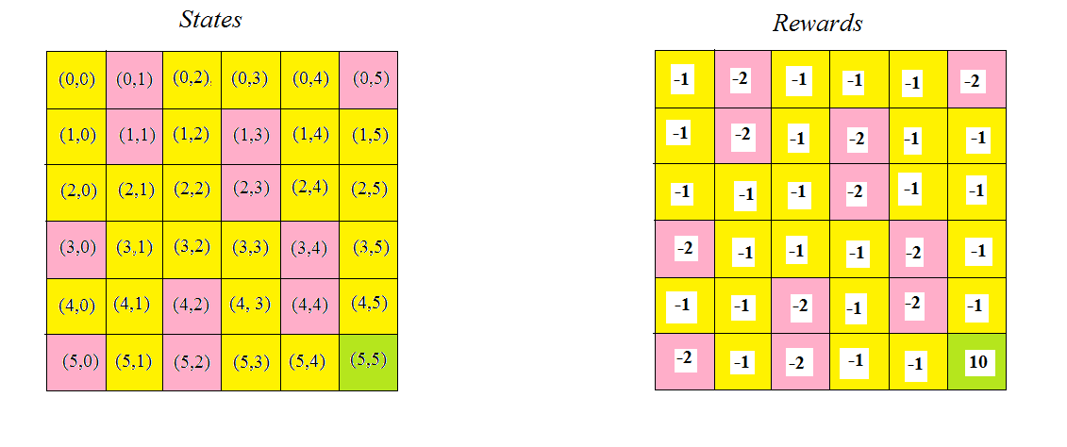
Figure 1: 6×6 Grid World — Yellow = usual cells (−1), Rose = bad cells (−2), Green = target (+10)

2.2 Bad Cell Locations
The following cells carry a penalty reward of −2:
- (0,1), (0,5)
- (1,1), (1,3)
- (2,3)
- (3,0), (3,4)
- (4,2), (4,4)
- (5,0), (5,2)

2.3 Action Space
The agent has four available actions at each non-terminal state:
R — Right | (0, +1) — Move one column to the right
L — Left | (0, −1) — Move one column to the left
U — Up | (−1, 0) — Move one row upward
D — Down | (+1, 0) — Move one row downward

3. Transition Model

3.1 Stochastic Transitions
The environment is stochastic. When an action is taken, the outcome is not deterministic. For any state and chosen action:
- With 80% probability the agent moves in the intended direction (if valid), or stays in place if the move goes out of bounds.
- With 10% each, the agent may move in any of the three other directions (if valid). If a perpendicular or opposite move goes out of bounds, the probability is added to staying in place.
This stochasticity is what makes MDP planning necessary — simple greedy path-following is not sufficient.

3.2 Boundary Handling
Corner cells (e.g. (0,0)): If the intended action is Up or Left (both out of bounds), the agent stays with 80% probability. The remaining 20% is split among valid directions (Down=10%, Right=10%).
Edge cells (e.g. (0,3)): If the intended action is Up (out of bounds), 70% probability of staying, 10% each for Down, Left, Right.

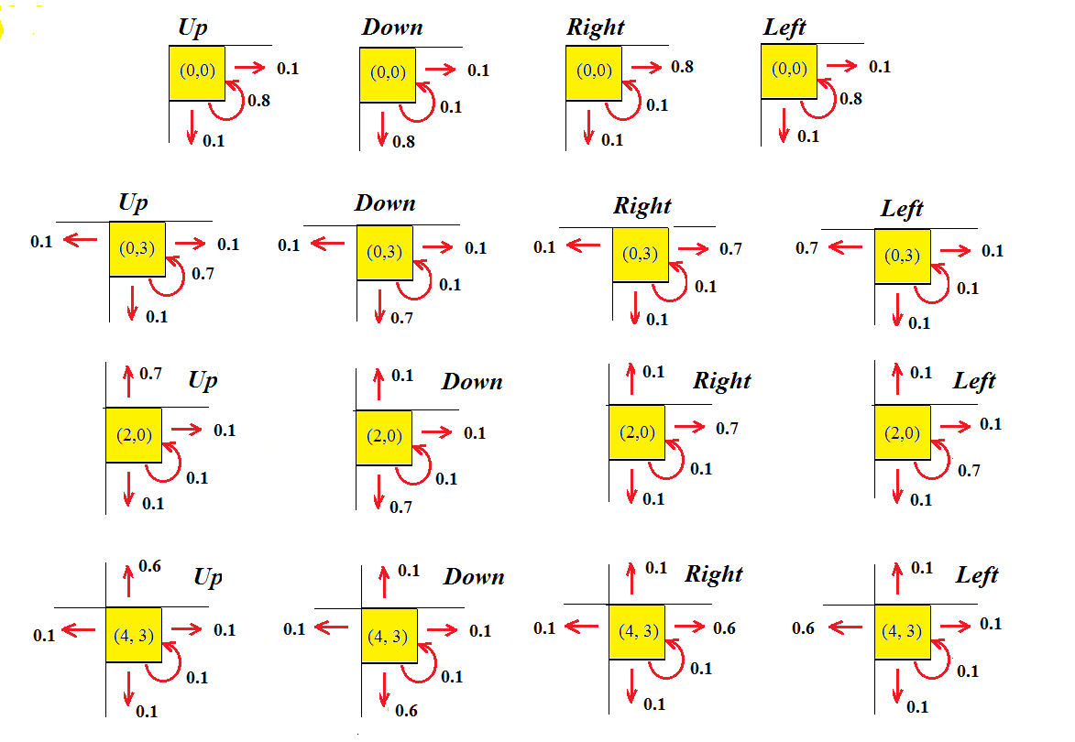
Figure 2: Transition probabilities for various states and actions in the 6×6 grid

3.3 Transition Implementation
Transitions are represented as a nested dictionary: transitions[state][action] = list of [probability, next_state] pairs. The construction algorithm:
- Computes the result state by adding the action vector to the current state coordinates.
- If the result is within bounds, 10% probability is assigned to that state (intended direction partial displacement).
- For each of the three remaining actions, if the resulting state is valid, 10% probability is added.
- The primary (intended) state receives probability 1.0 − count (all remaining probability mass).
- The terminal state (5,5) has a single EXIT action with probability 1.

4. Value Iteration Algorithm

4.1 Bellman Equation
The Value Iteration algorithm finds the optimal value function V*(s) by iteratively applying the Bellman optimality equation:
V(s) = R(s) + γ · max_a [ Σ P(s'|s,a) · V(s') ]
Where:
V(s) | Value (expected total discounted reward) of state s
R(s) | Immediate reward for state s
γ (gamma) | Discount factor = 0.9 — future rewards are discounted by 10% per step
P(s'|s,a) | Transition probability of reaching state s' from s under action a
max_a | Maximisation over all valid actions

4.2 Convergence Criterion
The algorithm iterates until the maximum change in value across all states is below a threshold ε = 0.00001. This guarantees convergence to the true optimal value function V*.

4.3 Hyperparameters
Discount factor γ | 0.9
Convergence threshold ε | 0.00001
Initialisation | V(s) = 0 for all states

5. Software Implementation

5.1 Project Structure
markov_dec_proc_6x6.ipynb | Jupyter Notebook — full implementation
6x6_states.png | Visualisation of the grid world environment
actions_from_cell.png | Transition probability diagram
policy_6x6.png | Visual representation of the optimal policy
README.md | Project documentation and result summary

5.2 MDP Class
A custom MDP class encapsulates the environment. It stores the transition dictionary and reward dictionary, and exposes three methods:
- get_rewards(state) — returns the scalar reward for a state
- get_actions(state) — returns the valid actions from a state
- get_transitions(state, action) — returns the list of [prob, next_state] pairs

5.3 Key Functions
build_actions(state, prob) | Helper that returns a [probability, state_string] pair
value_iteration(env) | Runs Bellman update loop until convergence; returns V dictionary
policy(env) | Calls value_iteration(), then selects best action per state via argmax

6. Results — Optimal Policy

6.1 Policy Visualisation
After value iteration converges, the optimal policy assigns a best action to each of the 36 states. The visualisation below shows the agent's strategy across the grid:

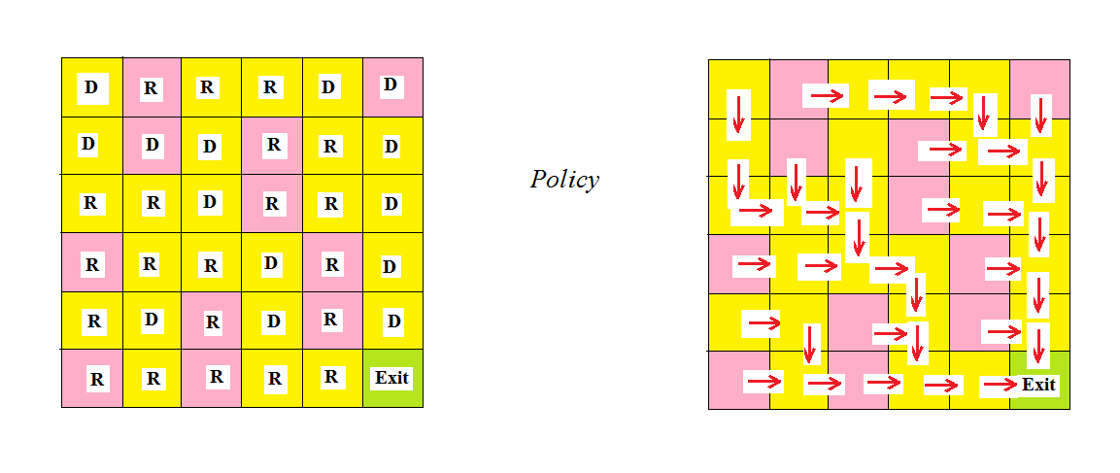
Figure 3: Optimal policy — arrow per cell indicating the best action to reach (5,5)

6.2 Complete Policy Table
The table below lists the optimal action for every state in the 6×6 grid:

State | Best Action | Description
(0,0) | D | Move down from top-left corner
(0,1) | R | Move right (avoid bad cell)
(0,2) | R | Move right toward goal
(0,3) | R | Continue rightward
(0,4) | D | Turn down
(0,5) | D | Move down from top-right
(1,0) | D | Move down
(1,1) | D | Move down
(1,2) | D | Move down
(1,3) | R | Move right
(1,4) | R | Move right
(1,5) | D | Move down
(2,0) | R | Move right
(2,1) | R | Move right
(2,2) | D | Move down
(2,3) | R | Move right
(2,4) | R | Move right
(2,5) | D | Move down
(3,0) | R | Move right
(3,1) | R | Move right
(3,2) | R | Move right
(3,3) | D | Move down
(3,4) | R | Move right
(3,5) | D | Move down
(4,0) | R | Move right
(4,1) | D | Move down
(4,2) | R | Move right
(4,3) | D | Move down
(4,4) | R | Move right
(4,5) | D | Move down
(5,0) | R | Move right along bottom row
(5,1) | R | Move right
(5,2) | R | Move right
(5,3) | R | Move right
(5,4) | R | Move right
(5,5) | EXIT | Goal reached — terminal state

6.3 Policy Observations
- The top row generally moves right and then down to approach the goal column.
- Interior cells route around bad (rose) cells — e.g. (0,1) moves right rather than staying near the penalty zone.
- The bottom row follows a direct rightward path to (5,5).
- State (5,5) has the unique EXIT action, marking it as the terminal state.
- The discount factor of 0.9 encourages the agent to reach the goal quickly rather than loitering.

7. Discussion

7.1 Effect of Stochasticity
Because transitions are stochastic (10% chance of drifting sideways or backwards), the agent cannot simply follow the shortest geometric path. Value iteration accounts for this by computing expected values under all possible transition outcomes. The resulting policy is therefore more conservative in some regions — preferring paths that avoid bad cells even if they are slightly longer, because the 10% drift could land the agent in a −2 penalty cell.

7.2 Role of the Discount Factor
A discount factor of γ = 0.9 means each additional step reduces future rewards by 10%. This incentivises the agent to reach the +10 goal as quickly as possible. A lower γ (e.g. 0.5) would make the agent more short-sighted, potentially tolerating longer paths to avoid penalties. A higher γ (closer to 1.0) would place even more emphasis on reaching the goal.

7.3 Convergence
Value iteration is guaranteed to converge for finite MDPs with a discount factor γ < 1. The threshold ε = 0.00001 ensures the resulting policy is effectively optimal — further iterations change the value function by a negligible amount.

7.4 Extensibility
The modular MDP class design makes this implementation easy to extend:
- Larger grid sizes (e.g. 10×10) require only a new state/reward/transition definition.
- Alternative reward structures (sparse, shaped) can be plugged in without changing the solver.
- Policy iteration or Q-learning could be substituted for value iteration as alternative solvers.

8. Conclusion
This project successfully demonstrates the application of the Markov Decision Process framework to a stochastic grid-world navigation problem. The Value Iteration algorithm, powered by the Bellman optimality equation, converges to an optimal value function and derives a complete policy mapping every state to its best action.
Key achievements:
- Constructed a 6×6 MDP with three cell types and stochastic transition probabilities.
- Implemented a clean, object-oriented MDP environment class in Python.
- Applied Value Iteration with discount factor γ = 0.9 and convergence threshold ε = 0.00001.
- Derived and visualised the optimal policy, showing intuitive navigation behaviour that routes around penalty cells toward the +10 goal.
The project provides a solid foundation for exploring more advanced reinforcement learning methods such as Q-learning, SARSA, or deep RL on larger and more complex environments.

References
- Willian Paiva — Original webinar code and MDP design (primary source).
- Sutton, R. S., & Barto, A. G. (2018). Reinforcement Learning: An Introduction (2nd ed.). MIT Press.
- Russell, S., & Norvig, P. (2020). Artificial Intelligence: A Modern Approach (4th ed.). Pearson.
- Bellman, R. (1957). A Markovian Decision Process. Journal of Mathematics and Mechanics, 6(5), 679–684.

