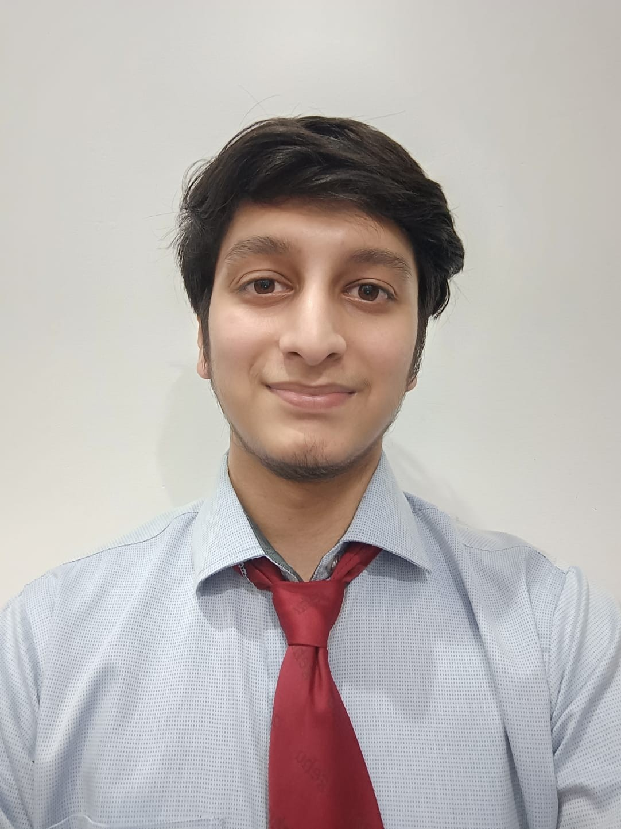PRANAY PAWAN GUPTA

[Pranay-Gupta](https://github.com/void1712) *|* [Pranay Gupta](https://www.linkedin.com/in/pranay-gupta-a0aba4255/) *|* [pranaygupta1712@gmail.com](mailto:pranaygupta1712@gmail.com) *|* 9027845283

# EDUCATION

**Graphic Era Hill University** June 2025

*Bachelor of Technology in Computer Science with specialization in AIML GPA: 8.76 / 10.00*

**R.A Higher Secondary School** 2021

*Higher Secondary Certificate Percentage: 86*

**Kendriya Vidyalaya Bantalab** 2019

*Secondary School Certificate Percentage: 94.4*

# EXPERIENCE

**OCTANET SERVICES PVT LTD.** 1st June 2024 – 1st August 2024

*Web Development Internship*

* Conceptualized and built different projects like **To-Do list** and **Netflix landing page**, focusing on intuitive design and user experience. Leveraging **HTML,CSS** and **JavaScript** to create seamless user journey.

# SKILLS

**Languages**: C , C++ , Python , Java , MySQL , HTML/CSS , JavaScript

**Tools and Technologies**: OpenCV, Flask, GitHub, VS Code, Google Colab, Canva, Figma

**Soft Skills**: Problem Solving , Composed , Teamwork , Communication , Flexible , Leadership , Work Ethic

# PROJECTS

[**Duplicate Question Pairs**](https://github.com/void1712/Duplicate-Question-Pairs) *| Python , NumPy , Pandas , Jupyter Notebook , NLTK , streamlit* July 2024

* Developed an advanced **NLP-based** machine learning model to accurately detect and classify **duplicate question pairs** on

**Quora**, enhancing user experience and content quality.

* Implemented **Random Forest model** and **advanced feature engineering**, reducing **redundancy** and **enhancing** platform efficiency for over 100 million monthly users.

[**Sales Lens**](https://github.com/void1712/Sales-Insights-Data-Analysis) *| SQL, Power BI* April 2024

* Streamlined data extraction and transformation using **SQL Server** on **’MySQL Workbench’** data warehouse, enhancing sales data quality for improved analysis by the sales team.
* Designed and deployed **PowerBI dashboards** for desktop and mobile with interactive year, month slicers, and custom filters.

[**Sign Language Detection**](https://github.com/void1712/Sign_language_detection) *| Python, Computer Vision, OpenCV, Keras, TensorFlow* December 2023

* Developed an **advanced computer vision system** using **deep learning techniques** to recognize **American Sign Language.**
* Leveraged **OpenCV, Keras** and **TensorFlow** to create a robust solution that accurately detects and translates ASL gestures into corresponding letters in real-time.

# 

# ACHIEVEMENTS

* **Solved Over 300+ problems on different coding platforms like Leetcode, GFG and Hacker Rank.**
* **Hacker Rank C++ 5 Star** *|* **Python 4 star.**

# SOCIAL ENGAGEMENTS

* [**Cyber Security Awareness**](https://drive.google.com/file/d/1Jxxn234M6cr7boThheKDREmmv30D98pf/view?usp=sharing): Assisted in organizing a Cyber Security Awareness Program by Innovative Ideas Infotech in my college.
* **Football Tournament**: Played Football and represented our division in the sports event of our college.