EPAM University Programs

DevOps external course

Module 2 Virtualization and Cloud Basic

TASK 2.4

**Danylenko - Homework**

Работа с lxc в Ubuntu

Documentation - <https://help.ubuntu.com/lts/serverguide/lxd.html>

<https://linuxcontainers.org/lxd/getting-started-cli/>

1. Установить lxc

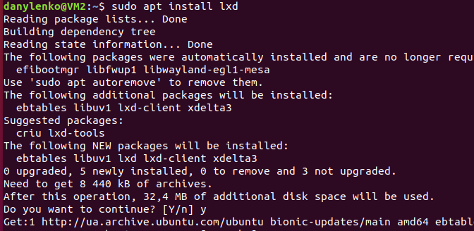

1. Запустить lxc launch для любой из версий Убунту



1. По окончании загрузки убедиться, что машина стартовала lxc list

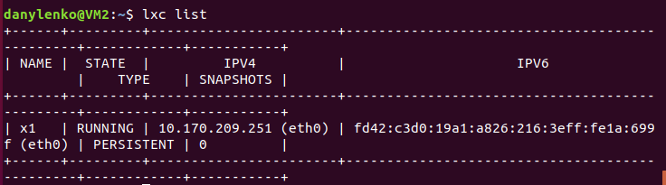

1. Зайдите в контейнер с командной строкой bash /bin/bash



1. Запустите обновление apt-get update

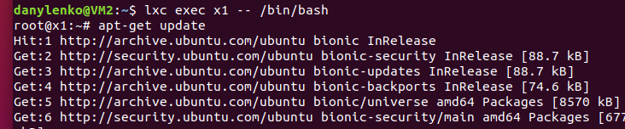



1. Установите (apt-get install) любую программу в контейнер. Например mc. Проверьте работоспособность.

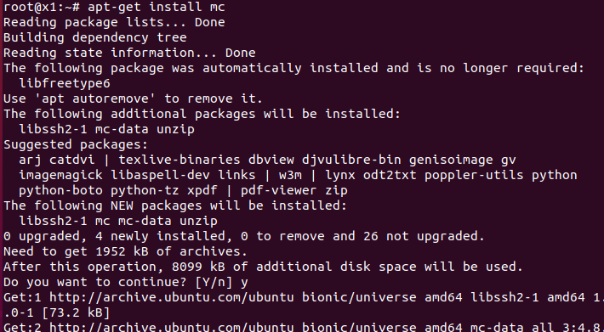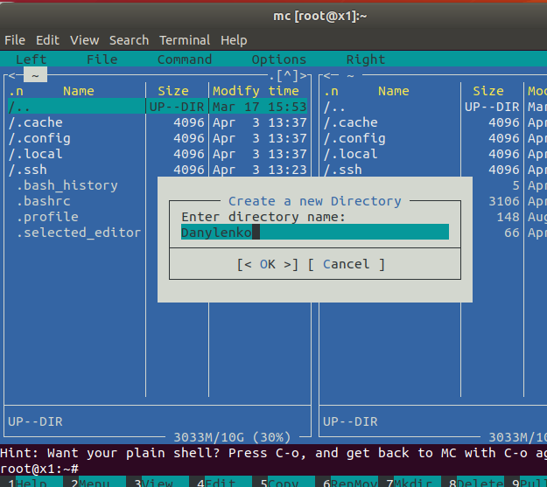

1. Загрузите в контейнер файл

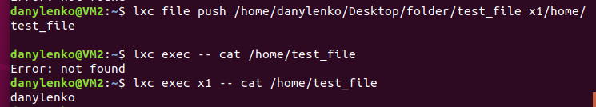

и скачайте с контейнера другой файл

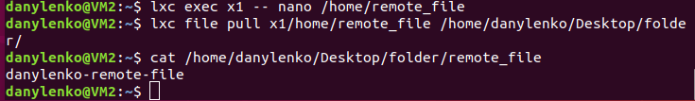

Работа с Docker в Ubuntu

Documentation - <https://www.digitalocean.com/community/tutorials/how-to-install-and-use-docker-on-ubuntu-18-04>

<https://docs.docker.com>

1. Установить docker

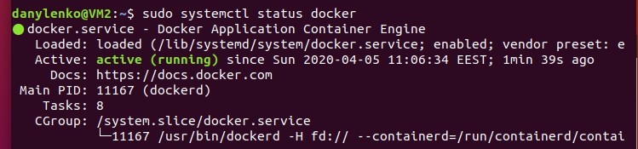

1. Запустить поиск сконфигурированных решений для “ubuntu”

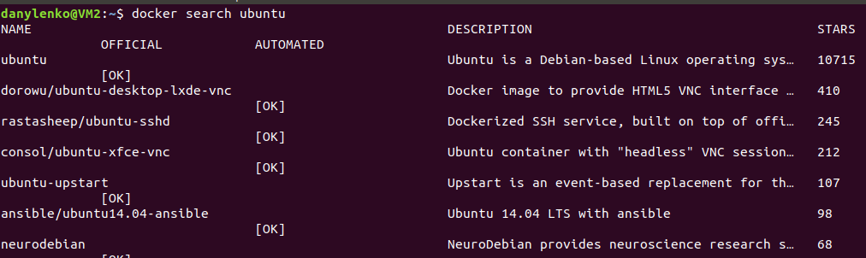

1. Скачать любой из образов на локальную машину.

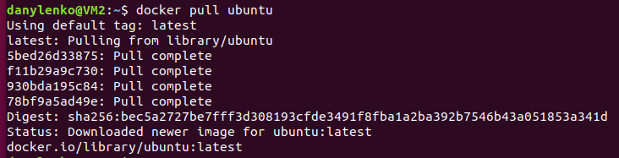

1. Запустить команду просмотра загруженных на компьютер образов.



1. Запустите обновление apt-get update

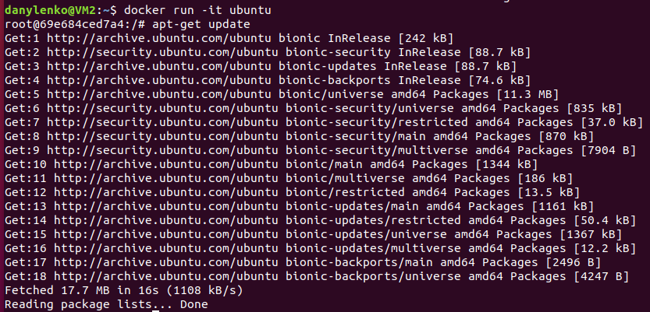

1. Установите (apt-get install) любую программу в контейнер. Например mc. Проверьте работоспособность.

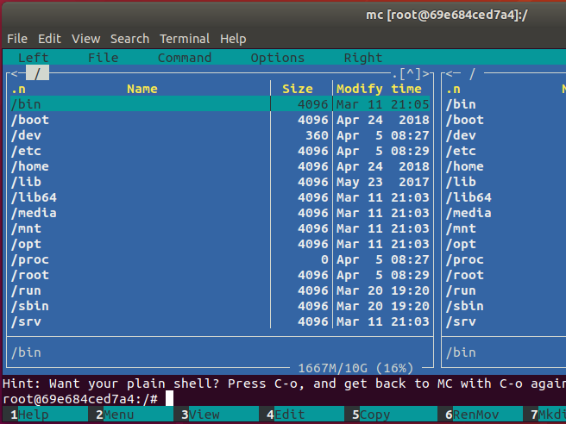

1. Загрузите в контейнер файл и скачайте с контейнера другой файл.

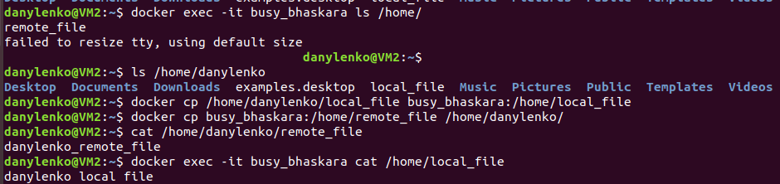

1. Прочитать документацию и кратко описать основные 7 команд Dockerfile

**FROM imageName AS name** - sets starting image from which build process will start, also additional images, can divide build process on stages and use resulting build of some stage as a parent of other stages.

**ENV name=value** – sets global variables for whole build process and all stages.

**ARG name=default value** – sets allowed arguments list that can be used with docker build command, after it. Scope is until after next FROM command – next stage start. ARG need to be used again, inside of each stage for variable value to be available.

**RUN**  - Executes commands in new layer on top of current image, and commits result to the image. Have Shell and Exec calls. Exec form can execute commands directly without shell, but also without Shell context and Shell variables.

**ENTRYPOINT и CMD** – Do not participate in build process, but are used to set command execution that will be called when built image will run. Have shell and Exec forms of calls. Exec form runs command without shell with PID 1 and allows this process to get commands sent to it though Docker from Host. CMD is replaced with commands\args from run comand line after image name. ENTRYPOINT sets not replaceable by default part of command and, with additional replaceable part from CMD, allows presenting the image as executable application. (Still can be replaced with --entrypoint)

**ONBUILD** sets instruction that will run upon use of this image as a base of next build in FROM command. Instructions will be triggered right after FROM command, before all following commands.

**HEALTHCHECK**  used to set specific instructions that to make checks of working state of processes in running image that can’t be connected directly to image state. Checks can be set to be done in intervals, with timeouts, and number of retries, after which image state in Docker will change to Unhealthy.

**COPY, ADD –** commands that are used to copy files from context sent by user with build command, to container. From best practices mostly COPY should be used. ADD should be only used for local .tar extraction. Also COPY can use files from previous stages of build.

Работа с Kubernetes в Ubuntu

<https://ubuntu.com/kubernetes/install> ; <https://microk8s.io/docs/>

1. Установить microk8s



1. Проверьте статус

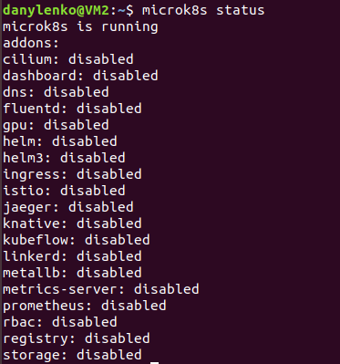

и команды менеджера кластера

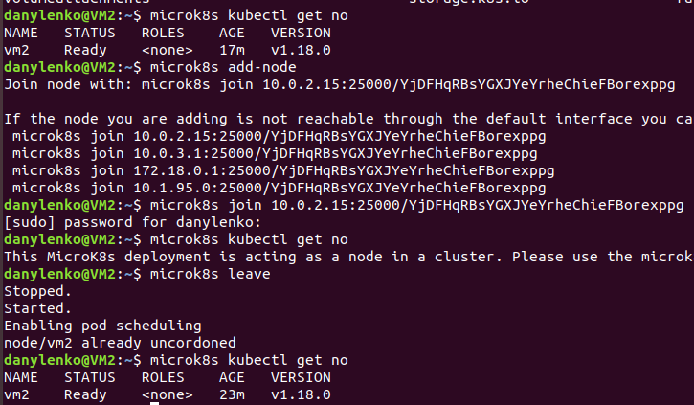

1. Просмотрите установленные в докере образы; заверните один из них в образ *.tar
2. Импортируйте образ в Kubernetes

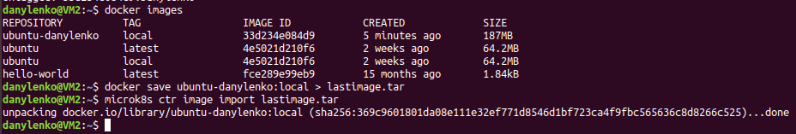

1. Запустите образ и убедитесь, что он работает.

