Module 4 Linux Essentials   
TASK 4.3

**Danylenko HOMEWORK**

After you have logged into the system, do the following.   
1.Invoke pwd to see your current working directory (there should be your home directory).

  
2. Collect output of these commands

Note differences between produced outputs. Describe (in few words) purposes of these commands.   
ls -l / -lists root directory, detailed listing format  
ls - lists current directoryls ~ - lists home directory  
ls -l - lists current directory in detailed listing format  
ls -a - lists current directory with addition of hidden entries (.*)  
ls -la - lists current directory with hidden entries, detailed listing format  
ls -lda ~ - lists only home directory entry in detailed format,

-a parameter here isn’t required to list even hidden directories

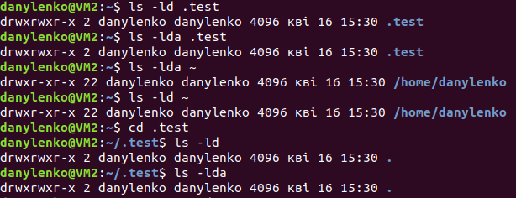

3. Execute and describe the following commands (store the output, if any):   
mkdir test make directory “test” in current directory  
cd test change directory to current/test.  
pwd print current working directory.touch test.txt update access&mod times of file test.txt in current dir,

create empty file because text.txt doesn’t exist  
ls -l test.txt detailed listing of test.txt entry  
mkdir test2 make directory “test2” in current test directory: test/test2  
mv test.txt test2 move file test.txt from current dir, to current/test2 dir  
cd test2 change directory to current/test2  
ls list current /test/test2 directory, it has test.txt file in itmv test.txt test2.txt move file test.txt to test2.txt, renamed file  
ls lists current /test/test2 dir, it has renamed test2.txt file in itcp test2.txt .. copy test2.txt to parent dir (test/test2>test) with same filename  
cd .. change directory to parent directory, to test  
ls list current directory test, there is copy of file test2.txt in itrm test2.txt remove test2.txt file  
rmdir test2 try to remove empty directory test2, but its impossible since we

didn’t remove test/test2/test2.txt file.

rmdir - only works on empty folder tree (rm –r to remove all)

Storing output of all commands

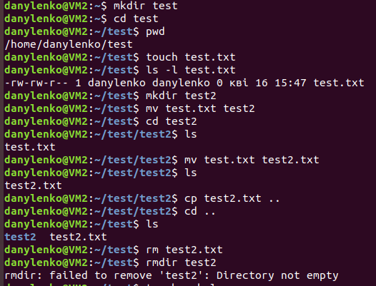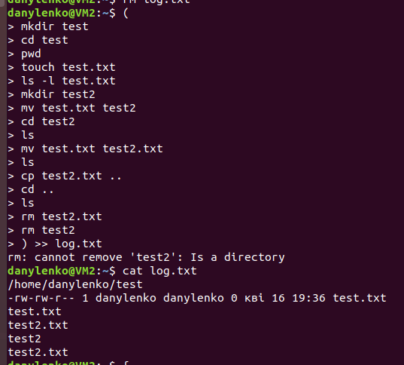

4. Execute and describe the difference   
cat /etc/fstab cat - concatenates file\or files to standard output.  
less /etc/fstab less - file reader that reads files 1 screen at a time,

allows to navigate both back and forward. Upgraded version of “more”

more /etc/fstab more – file reader that outputs files into screens or numbers of rows,

allows only forward navigation. Usually used to pipe long output of other commands. There is also “more” with almost same functionality

in other operating systems as example Windows\DOS

5. Add to archive all ‘test’ directories.

a. to the pure ‘tar’;

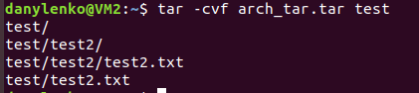

b. to the zipped ‘tar’ with only tar command;

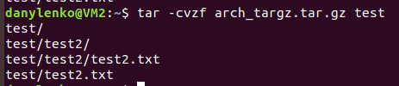

c. to the zipped ‘tar’ with gzip command;

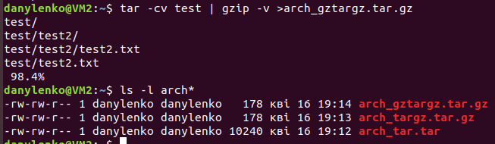

Extract from archives all above.

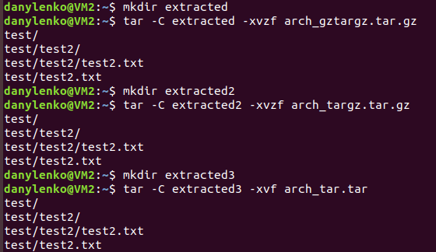

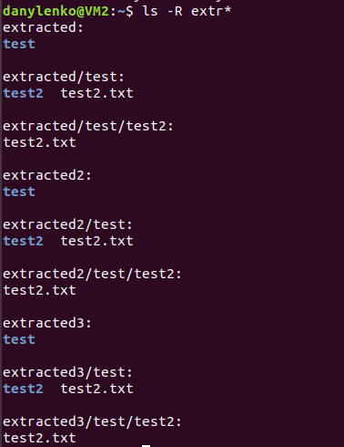

5. Look through man pages of the listed above commands.

Done it.