EPAM University Programs

DevOps external course

Module 4 Linux & Bash Essentials

TASK 4.6

1. User management. Here we suppose there are at least two users, namely, root and guest.   
(i) Create a new user user

groupadd user

useradd -g user -s /bin/bash -d /home/user -m user

passwd user

id user

ls -ld /home/user

(ii) Log in to the system as “user” (hint use su).

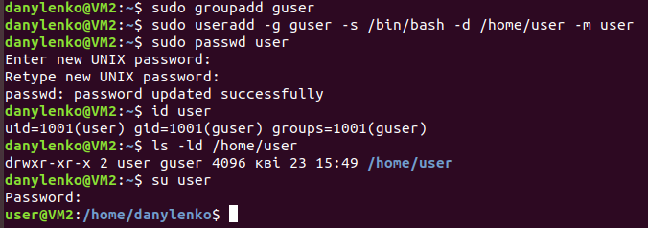

(ii) Edit /etc/passwd to prevent user user from logging in to the system.

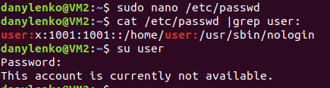

2. Content of /etc/passwd and /etc/group.

(i) Look through /etc/passwd and /etc/group (hint: use less or cat).

(ii) Get data from /etc/passwd and /etc/group about users: root, guest, user (hint: filter by grep).

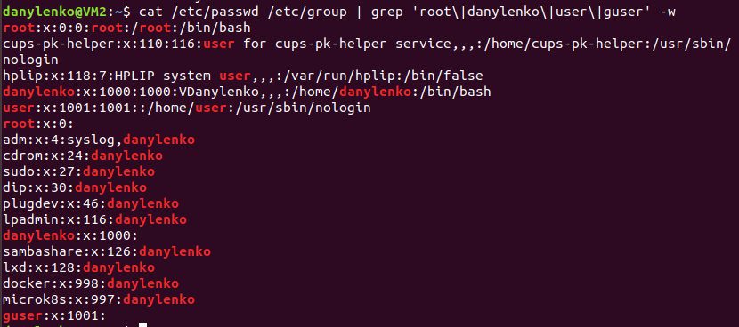

(iii)Parse /etc/passwd and /etc/group with cut.

cut -f1 -d: /etc/passwd list of users

cut -f1,2 -d: /etc/passwd list of user:x x –means shadowing enabled and encrypted passwords stored in /etc/shadow

cut -f1,7 -d: /etc/passwd list of user:shell

cut -f1 -d: /etc/group list of grops

cut -f1,2 -d: /etc/group list of grop:x

(iv) Try to call less on /etc/shadow and invoke

sudo less /etc/shadow

man -k shadow

man 5 shadow

Analyse content of /etc/shadow based on what you’ve found in man 5 shadow.

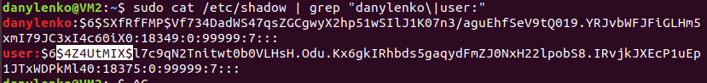

This file contains encrypted password info. Its stored in fields divided with “:”

1. Username
2. Hash of decrypted password in 3 parts separated with $ symbol

$ “hash_algorithm”$”hash_salt”$”hash_data”

$6 – means SHA-512 Hash Algoritm

1. Date of password change as example :18375 days after Jan 1, 1970 for «user:»
2. 0 –(days) minimum password age, when it’s possible to start changing password
3. 99999 (days) maximum password age
4. 7 (days) – length of user warning period before pwd expire date from field #5
5. Empty – number of days expired pwd will be still active. Empty means will be expired in 99999 days without inactivity period
6. Empty – account expiration date, also number of days after Jan 1, 1970

3. Dealing with chmod.

(i) An executable script. Open your favorite editor and put these lines into a file

#!/bin/bash

echo “Drugs are bad MKAY?”

Give name “script.sh” to the script and call to

chmod +x script.sh

Then you are ready to execute the script:

./script.sh

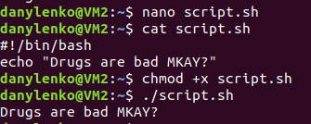

(ii) Suppose, you have logged in to the system as guest. Create directory “testDir” in the /tmp; put some file into testDir and prohibit user user from visiting this directory (i.e. “testDir”).

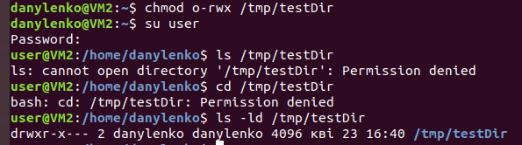

(iii) Test, if it possible to forbid an owner of some file to read to or write from this file.

