EPAM University Programs   
DevOps external course   
Module 4 DevOps Introduction   
TASK 4.2

**Danylenko - Homework**

1. Set up Linux Virtual Machine in VirtualBox.   
2. Familiarize yourself with the commands and utilities listed in the presentation (switching between virtual terminals (consoles); printenv; content of /etc/profile and ~/.bash_profile, $echo $HISTFILE $HISTSIZE $HISTFILESIZE, who, w, whoami, id). Make 5 screenshots.

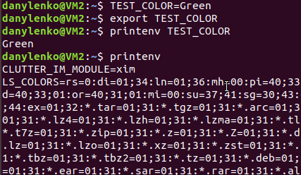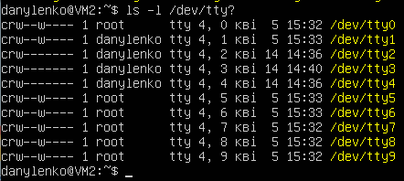

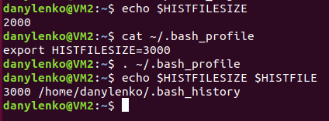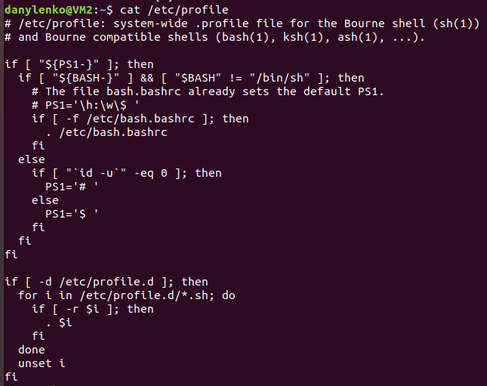

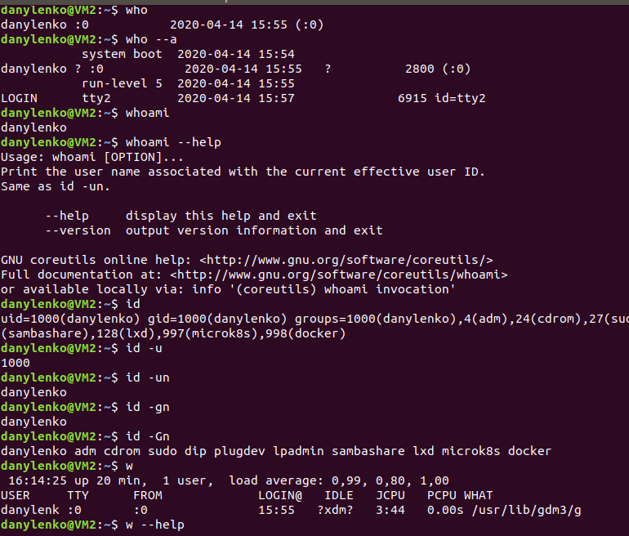

3. Familiarize yourself with the commands (***uname, hostname, uptime, shutdown, halt, reboot, init…***). Make 5 screenshots.

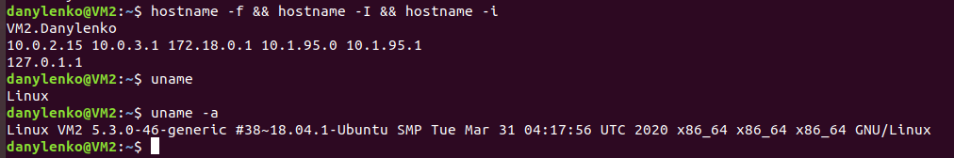

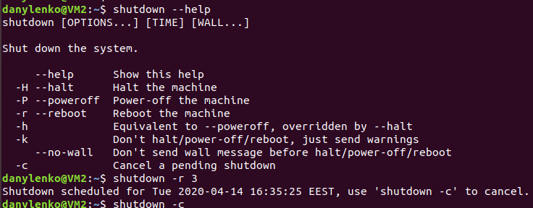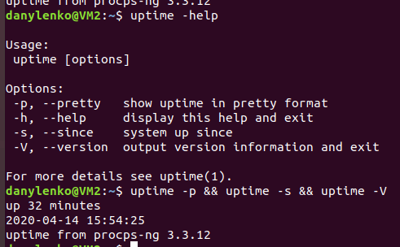

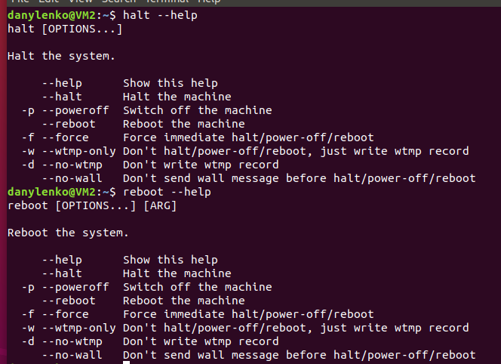

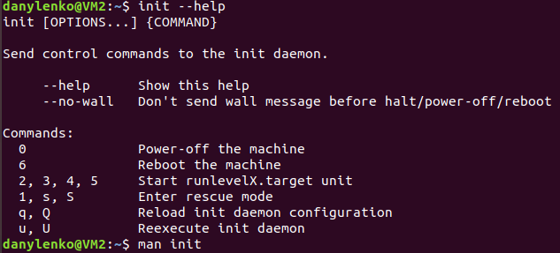

4. Familiarize yourself with the help commands (***man, info, find, locate, whereis, less|zless in /usr/share/doc***). Make 5 screenshots.

