Hybrid

<http://droidyue.com/blog/2014/09/20/interaction-between-java-and-javascript-in-android/index.html>

Demo：JavaJSInterActionDemo

<http://www.cnblogs.com/tony-yang-flutter/p/3566362.html>

Demo：JavaJSInterActionDemo2

<http://xiroid.com/post/android/androidzhong-javayu-javascriptjiao-hu-de-ji-chong-fang-shi>

Demo：jsbridgeDemo

1、@SuppressLint(“JavascriptInterface”)的用处

2、不会显示下面那个 button

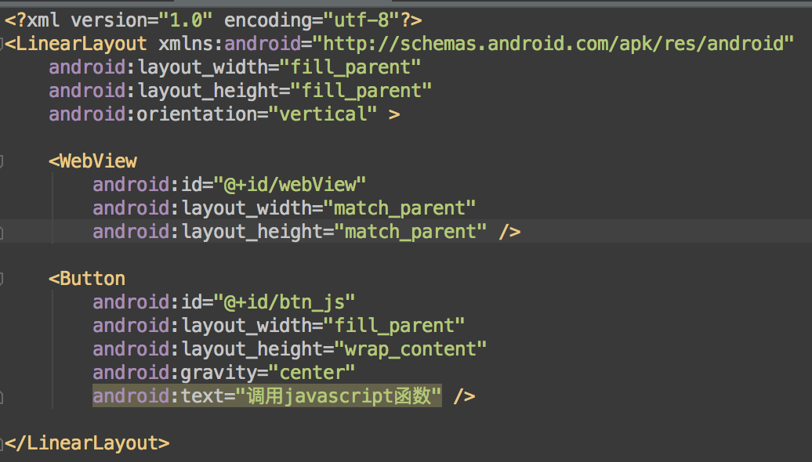

3、void（0）

4、CoordinatorLayout，AppBarLayout，androi:fitxSystemWindows，tools:context，app:popupTheme，app:layout_behavior

<meta name=”format-detection” content=”telephone=no” />

<meta name=”apple-mobile-web-app-capable” content=”yes” />