Java面试题

1. private、protected、public、default(friendly)

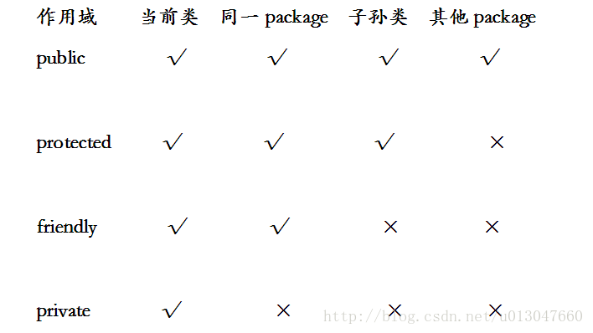

1. static、final

<http://lavasoft.blog.51cto.com/62575/18771>

静态内部类<http://book.51cto.com/art/201202/317517.htm>