Active Vocabulary Learning Support System

Based On Self-Directed-Learning

And Line Bot Platform

Gyumin Yeon  
Kyoto University  
Ogata labKyoto, Japan  
lourie@naver.com

Learning vocabulary is crucial part of acquisition of second-language. However, even though a lot of vocabulary learners are managed to memorize and understand words, using vocabulary they had memorized is totally different issue. In other words, the vocabularies that second-language learners memorize tends to easily become passive vocabulary. Currently a lot of vocabulary learning support applications only focus on acquisition of vocabulary not considering active vocabulary acquisition and learning management. In this article, proposed system is based on Self-Directed Learning which supports users' acquisition of active vocabulary on Goal-Setting, Executing, Monitoring, Reflecting Process. It also makes use of user's meta data such as user's motivation to learn second language to broaden active vocabulary and sustain motivation with web mining technology.

Keywords— Active vocabulary, Passive vocabulary, Ubiquitous learning, Self-Directed-Learning, Line-bot, Web mining, motivation

# introduction

## Importance of vocabulary learning on second english acquisition

For those who are not native English speakers, one of the most important factor to acquire English as a second language is vocabulary. Four factors of language skills, reading, writing, listening and speaking all largely depends on learner’s vocabulary capacity. Therefore, vocabulary learning is crucial part to master English for those who are non-native speakers.

## Problem of current vocabulary learning support applications

In the era of mobile, there are lots of applications and research which aims to support language learning. The most popular and most-used vocabulary support application is so called “flash card app”. However, these kinds of applications only provide tools for memorizing vocabulary, not personalized, not manageable and hugely relying on learner’s motivation. Also, these kinds of applications may increase learner’s passive vocabulary that learner understands the meaning but cannot use feely however, increasing passive vocabulary does not link to application of language for instance writing and speaking.

## Requirements for new vocabulary learning application

To effectively increase English learner’s active vocabulary, new vocabulary learning application should equip features below.

* Providing the place to apply the vocabulary which learner has memorized in order to sustain active vocabulary.
* Supporting self-directedness of learning vocabulary. It should help user set their goals and give feedbacks from their activity and finally make them retrospect their learning activities comparing other vocabulary learners.
* Supporting vocabulary learning motivation. Duolingo effectiveness study shows that the only key factor of the successful language learning is motivation[1] New vocabulary learning support application must consider learner's motivation and link it to learning process.

# Proposed system: hiyoko sensei

Hiyoko Sensei is Line bot designed to help learning English vocabulary for those who are non-native English speaker. This system mainly focuses on increasing user’s active vocabulary pool not just memorizing vocabulary.

To achieve this objective, Hiyoko Sensei is made up of four main phases which is based on Self-Directed-Learning framework.[2] Those four phases are “Goal Setting”, “Executing”, “Monitoring”, “Refelecting”

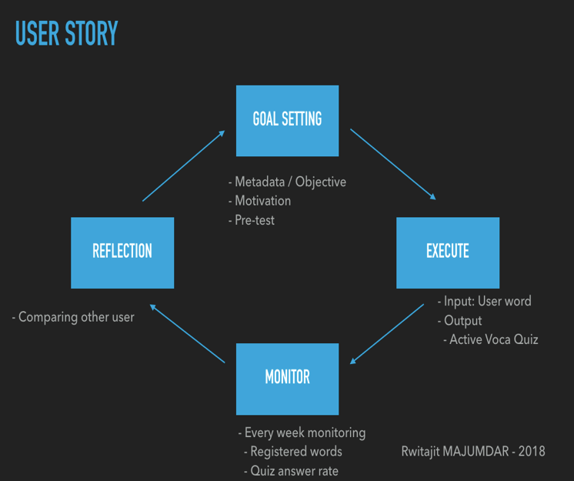

Fig. 1. User story with SDL of Hiyoko Sensei

## Goal Setting Phase

Hiyoko Sensei will register a regular based goal (i.e. memorize every day five vocabularies and get quiz). And It will monitor whether user followed that goal. And, it will register user’s motivation to utilize the information which will be treated at Executing phase. This phase also helps vocabulary learners to recognize and establish their own vocabulary learning strategy, which is expected to improve learning performance. It makes vocabulary learner become active learner.

## Executing Phase

For the executing phase, user input their vocabulary based on their own learning. And users also can get quiz with regular based timer registered time which was set at goal-setting phase or anytime they want.

This quiz system is hugely different from other flash-card based application. It automatically generates active vocabulary quiz[3] based on user’s registered words and their answer rates and motivation of learner. For example, if user registered his motivation as travel, our system searches travel related sentence from Wikipedia.

These features make vocabulary learners apply their memorized vocabularies and it triggers their vocabularies to be active for learners.

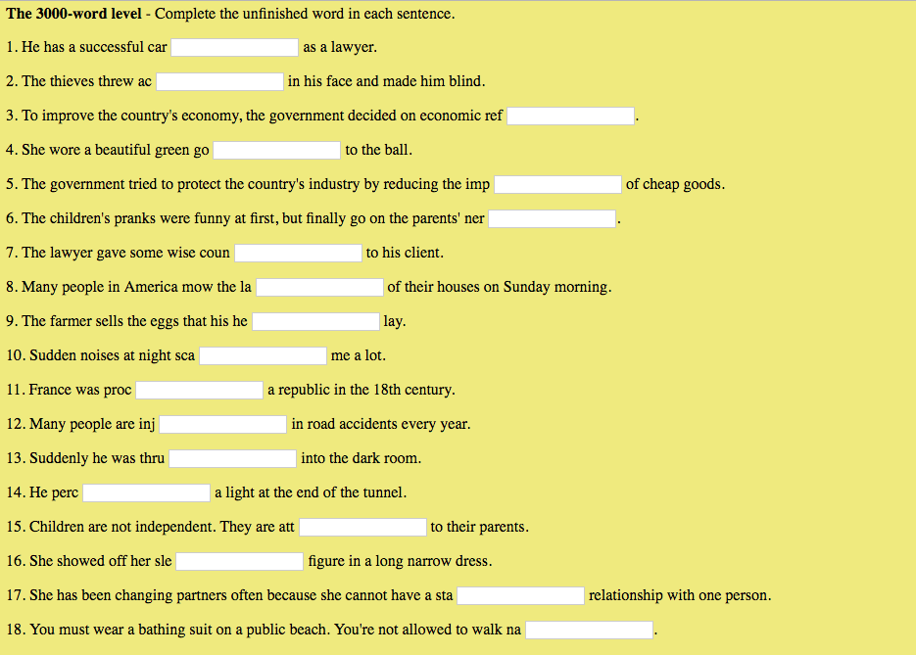

Fig. 2. Active vocabulary test(exmaple)

## Monitor phase

Hiyoko Sensei will notify results personal activities of the language learner once a week. It will show not only the answer rates of quizzes but also registered words in given periods.

By showing learner’s activity, the learner can see and judge his weak points and where to be improved.

## Reflection Phase

The language learner receives his relative activity results compared to others. For example, it includes average time usages of Hiyoko Sensei, answer rates, the number of registered vocabularies and quizzes.

Thanks to this phase, vocabulary learner can recognize his relative achievement and it will be the foundation to improve his learning strategy.

While using Hiyoko Sensei app, four phases mentioned above repeats once a week. In the cycle, vocabulary learner can decide his own learning phase and regular based goals and manage on his own. Not only that, learner can effectively increase active vocabularies by solving active vocabulary quizzes generated with his motivation. Furthermore, vocabulary learner can manage his process and change his vocabulary learning strategy anytime.

In terms of these features, Hiyoko Sensei satisfies the requirements for new vocabulary learning application that we mentioned above.

# Experiment

## Pretest and Posttest method

To verify Hiyoko Sensei works, firstly we can compare before and after of using Hiyoko Sensei. The pretest and posttest are made up of active vocabulary test which has format of Fig.2. We can compare those two scores and confirm the fact that it is valid score differences and vocabulary learner’s active vocabulary capacity improved.

## Comparison with Hiyoko Sensei, without Hiyoko Sensei

The other method is making two groups, one group uses Hiyoko Sensei as vocabulary study and another group does not use Hiyoko Sensei. This method also make use of active vocabulary test before and after using Hiyoko Sensei confirming advantages of using Hiyoko Sensei for vocabulary learning.

1. ROUMEN'VESSELINOV, PhD, “Duolingo Effectiveness Study Final Report pp. 16–17, December 2012.
2. Rwitajit MAJUMDAR, “GOAL: A System to Support Learner’s Acquisition of Self Direction Skills” Yang, J.C. et al. (Eds.) (2018). Proceedings of the 26thInternational Conference on Computers in Education. Philippines: Asia-Pacific Society for Computers in Education, pp.3–4. 2018
3. Laufer, B. & Nation, P “A vocabulary size test of controlled productive ability.” Language Testing, 1999, pp. 33-51.