Introduction

Hello, dear reader!

This book is a sequel to the first book ‘Meet Dameo!’ That time we got to know the game, and now we are planning a deeper dive into it.

The idea of the second book is to show the beauty, inexhaustibility of this game, the intentions and plans of the sides, and the originality of the players' thinking through examples of whole games or long fragments of them. Consistency in carrying out the plans of the players and a vivid battle of minds constitute the beauty of any intellectual game.

As I have often mentioned before, it is very difficult to comment on Dameo games because of the huge number of moves and variants. Only a computer programme can handle such a massive amount, but we are not going to complain and will try to study and understand this little-explored game more deeply by means of ordinary human manual analysis.

We assume that the reader is already familiar with Dameo's rules, but we will still briefly describe them. Sufficiently experienced players can skip this description and proceed to the next chapter.

So, the rules of Dameo are to a certain extent the same as the rules of international draughts, but there are three major differences, namely:

a) a simple checker moves forwards in three directions; a king moves in 8 directions, like a queen in chess to any available number of cells.

b) a simple checker may jump over one or more other checkers of its own colour, provided that the field ahead is free; the king does not participate in a line jump (red arrows below on the diagram).

c) all captures in Dameo are straight only; a simple checkers may capture forwards, backwards and sideways by the short leap; a king may capture by the long leap.

All three differences are shown in diagrams 1a, 1b and 1c.

The rest of the rules (the rule of majority capture, the rule of Turkish strike) coincide with the rules of international draughts.

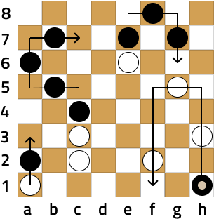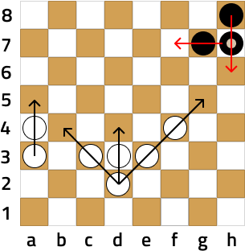**1a 1b 1c**

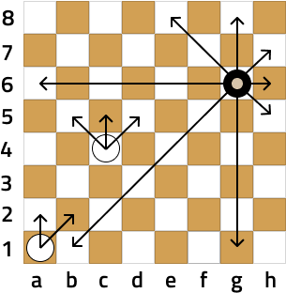

An important distinguishing feature of Dameo is the fact that two kings always defeat a lone king. Due to this, you will win with even a small advantage. This leads to a high percentage of won games. The construction of the winning position is shown in the first book in the chapter ‘Two kings against one’.

Well, that's the end of the introductory part and let's move on to the main content.