Advanced Python
Programming


Michael Foord
https://agileabstractions.com

- Python Trainer
- Core Python Developer
- Author of IronPython in Action
- Creator of unittest.mock
- Twitter: @voidspace
Advanced Python Programming

    - Text Processing
    - Understanding Assignment
    - Exception Handling
    - The Python Object Model
    - Writing Larger Programs
    - Advanced Language Features
    - Networking
    - Concurrency
    - Datascience Overview
    - More Python

Python 3.10 or more recent recommended.

Section 1

Text Processing

Strings, Unicode and bytes
Regular Expressions
The String Type

- Python strings are Unicode and the type is “str”
- Strings are immutable
- Strings are sequences – they can be iterated over, sliced and concatenated
- Many (many) useful methods
- String formatting with f-strings
- String templating with the format methods
- Binary data is supported through “bytes”
Strings

- Backslash is the escape character (\t, \n, \', \", \\, …)
- Newlines are always "\n" inside Python
- Single and double quotes are equivalent
- Triple quotes for multiline strings
- Use the 'r' prefix for 'raw' strings (regular expressions and Windows paths)

>>> """This is a
... multiline
... string"""
'This is a\nmultiline\nstring'

>>> r'c:\Users\fred'
'c:\\Users\\fred'

>>> print("\t means tab")
means tab
Strings as Sequences
'
'
'

- Lists, tuples and strings are all sequences
- Iteration over strings is by character (not so useful)
- Strings can be indexed into : s[n]

s = 'Hello world'
s[0] == 'H'
s[-1] == 'd'

- Slicing (for structured data) : s[start:end]

s[2:4] = 'll'
s[6:] = 'world'
s[:5] = 'Hello'

- Strings can be added (concatenated)

'Hello' + ' ' + 'world' == 'Hello world'

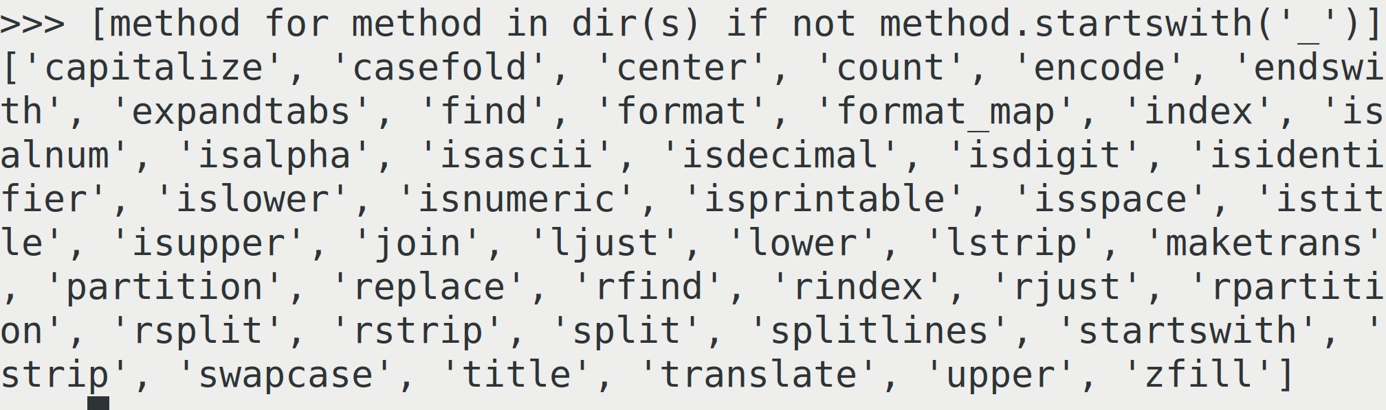
String Methods
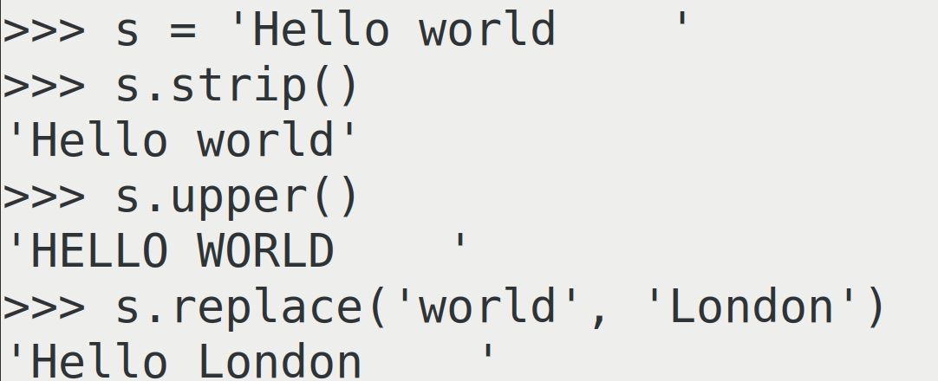

- Strings are immutable, cannot be changed

>>> s = 'Hello World'
>>> s[0] = 'F'
Traceback (most recent call last):
File "<stdin>", line 1, in <module>
TypeError: 'str' object does not support item assignment

- All operations on strings return a new string
- Any object can be converted into a string with "str"

>>> number = 1_000_000
>>> str(number)
'1000000'

- Substrings can be found with the in operator

>>> 'Hello' in 'Hello world'
True
>>> 'London' not in 'Hello world'
True
String Formatting

- f-strings are evaluated immediately

>>> name = 'Michael'
>>> job = 'Python trainer'
>>> f'My name is {name} and my job is {job}'
'My name is Michael and my job is Python trainer'

- Formatting is controlled with the fml (formatting mini language), also used by the format methods

>>> colour = 'red'
>>> weight = 334.5601
>>> size = 'large'
>>> f'{colour:>10s} {weight:>10.2f} {size:>10s}'
' red 334.56 large'
Format Methods

- The format methods provide reusable string templates

>>> template = '{colour:>10s} {weight:>10.2f} {size:>10s}'
>>> template.format(colour=colour, weight=weight, size=size)
' red 334.56 large'

>>> template = '{:>10s} {:>10.2f} {:>10s}'
>>> template.format(colour, weight, size)
' red 334.56 large'

>>> template = '{colour:>10s} {weight:>10.2f} {size:>10s}'
>>> data = {'colour': 'blue', 'weight': 478.998, 'size': 'huge'}
>>> template.format_map(data) # or template.format(**data)
' blue 479.00 huge'

Formatting Mini Language
{name: pad-char alignment pad-amount type}

- Alignment (defaults to right):
"<": left aligned
">": right aligned
"^": centred

- Padding is an optional pad character and an amount

>>> f'{name:*^20s}'
'******Michael*******'

- Type codes: s for string, d for integer, f for float (with number of decimal places), plus many more less useful

>>> number = 34.921345
>>> f'{number:.2f}'
'34.92'

See: https://learnpython.com/blog/python-string-formatting/
Unicode

Internally strings are a sequence of Unicode code points.

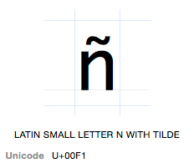
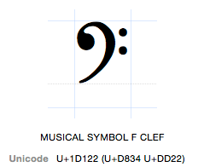

a = '\xf1' # a = 'ñ'
b = '\u2200' # b = '∀'
c = '\U0001D122' # c = ''
d = '\N{FOR ALL}' # d = '∀'

Binary Data with bytes

- The bytes type uses the 'b' string prefix
- The old 'str' type from Python 2
- Immutable, use bytearray for mutable data
- Only supports the old "%" style string formatting
- We can encode from text to bytes or decode from bytes to a Unicode string

>>> b'This is binary data \x00\x2f\x44'
b'This is binary data \x00/D'
>>> "This costs £456".encode('utf-8')
b'This costs \xc2\xa3456'
>>> type(b'some data')
<class 'bytes'>
Strings in the Standard Library

- There are several standard library modules for working with strings and text
  - string
  - textwrap
  - difflib
  - etc...

For more advanced use-cases use a proper
templating engine (e.g. Jinja2) or a proper parser
(e.g. PLY).

Exercise 1.1
Regular Expressions

- A powerful mini language
- Used by most programming languages and many tools
- Originating in Perl, Python has its own dialect
- Useful for processing semi-structured text (or bytes)
- Provided by the re module
- Always use raw strings (r'..') for regular expressions!

- We'll look at:
  - Features
  - Readability
  - Common pitfalls
Anchors and Selection

- Character classes select characters to match

[abc] any one character from list (a OR b OR c)
[a-m] any one character from range (a OR b OR ... OR m)
[^abc] any one character not in list (NOT a NOR b NOR c)
. any one character
\s any white space character
\S any NON white space character
\d any digit
\D any NON digit
\w any alphanumeric
\W any NON alphanumeric

- Anchors indicate context

^ start of string
$ end of string
\b on a word boundary
\B NOT on a word boundary
Repeat Counts

repeat counts apply to the previous expression

* 0 or more repeats
+ 1 or more repeats
? 0 or 1 repeats
{n,m} n to m repeats
{n,} at least n repeats
{n} exactly n repeats

Examples

[aeiou]* 0 more vowels
[0-9]+ 1 or more digits (\d+)
[0-9]{3,5} 3-5 digits
\.? 0 or 1 periods

\. matches a literal period. The backslash escapes the special meaning of the "." (or any other special character) that follows

Pattern Matching Functions

- match : matches from the start of the text
- search : match anywhere in the text

>>> import re
>>> test = '--------ABC---------'
>>> pattern = r"\w+"
>>> print(re.match(pattern, test))
None
>>> re.search(pattern, test)
<re.Match object; span=(8, 11), match='ABC'>
>>> match = _
>>> match.group()
'ABC'

None is returned when there is no match.
The Walrus Operator

- New in Python 3.8, := is assignment as an expression
- Called "the walrus operator" it allows us to do an assignment and test in one operation
- Ideal for checking if a regular expression returns a match

>>> test = '--------ABC---------'
>>> pattern = r"\w+"
>>> if match := re.search(pattern, test):
... print(f'We found a match {match!r}')
...
We found a match <re.Match object; span=(8, 11), match='ABC'>

Pattern Matching Functions

Note: in the re functions the regex pattern is always the first argument followed by the text to match on (for the two argument functions).

There's also an optional, but obsolete, compile step. Internally compiled regular expressions are cached by the re module so compilation is no longer needed.

>>> test = '--------ABC---------'
>>> pattern = re.compile(r"\w+")
>>> pattern
re.compile('\\w+')
>>> pattern.search(test)
<re.Match object; span=(8, 11), match='ABC'>
>>> match = pattern.search(test)
>>> match.group()
'ABC'
Splitting Strings

Strings have a useful split method, but what if the divider is not always the same, extraneous whitespace for example? We can split on a regular expression.

>>> text = "aaa ; bbb ;ccc; ddd ; eee"
>>> pattern = r"\s*;\s*"
>>> re.split(pattern, text)
['aaa', 'bbb', 'ccc', 'ddd', 'eee']

Combining and Substitutions

- The syntax for matching alternatives is "|"
- The "sub" function does substitutions

>>> text = "red or blue or green"
>>> pattern = r"red|blue|green"
>>> re.sub(pattern, 'colour', text)
'colour or colour or colour'

Note: the "sub" function can take a replacer function instead of a string for more advanced substitution. See the documentation.

Flags

- Matching behaviour can be customised with flags
- Flags can be combined with "|"
- The most useful flags are:

re.IGNORECASE, re.I ignore case when matching
re.MULTILINE, re.M match across newlines
re.DOTALL, re.S "." will match newlines
re.VERBOSE, re.X allow comments in regular expressions

e.g. re.match(pattern, text, re.VERBOSE | re.IGNORECASE)
Comments

Making regular expressions more readable with comments and the re.VERBOSE flag.

>>> text = "AAAAAA1111BBB2222CCC33DDDDDD"
>>> pattern = r"""
... ^ # start of line
... (.*?) # 0 or more characters
... # non-greedy
... (\d+) # 1 or more digits
... (.*) # 0 or more characters
... $ # end of line"""
>>> match = re.match(pattern, text, re.VERBOSE | re.IGNORECASE)
>>> match.group()
'AAAAAA1111BBB2222CCC33DDDDDD'
Repeating Patterns

For finding multiple matches use findall and finditer. finditer can be more memory efficient.

- findall : "greedy", returns a list
- finditer : "lazy", returns an iterator

>>> text = 'AB12CD34EF56GH'
>>> pattern = r"(\d+)"
>>> re.findall(pattern, text)
['12', '34', '56']
>>> re.finditer(pattern, text)
<callable_iterator object at 0x7fce06532a60>
>>> for match in re.finditer(pattern, text):
... print(match.group(), end =', ')
...
12, 34, 56
Advanced Searches: Groups

Groups, with (), allow you to capture and extract parts of the text. Much of the power of regexes are in groups.

>>> text = '----111122333344445567777----'
>>> pattern = r'2+(3+)4+(5+)6+'
>>> match = re.search(pattern, text)
>>> match.groups()
('3333', '55')
>>> match.group(0) # whole match, same as match.group()
'2233334444556'
>>> match.group(1)
'3333'
>>> match.group(2)
'55'

Note: you can use (?: ) to use parentheses for clarity without creating a group.
Modifying Data with Groups

We can use groups and the "sub" function to modify and rewrite our text data. We refer to groups by number (or name which is more verbose).

>>> text = "This course is attended by Sarah and Aisha"
>>> pattern = r"^This course is attended by (.+) and (.+)$"
>>> replace = r"This course is attended by \2 and \1."
>>> re.sub(pattern, replace, text)
'This course is attended by Aisha and Sarah.'

Named groups allow dictionary access to groups:

>>> text = "This course is attended by Sarah and Aisha"
>>> pattern = r"^.* (?P<name1>\w+) and (?P<name2>\w+)$"
>>> match = re.match(pattern, text)
>>> match.groupdict()
{'name1': 'Sarah', 'name2': 'Aisha'}
Greedy versus non-Greedy

Here be dragons!

- Regular expressions work by "backtracking" and are "greedy", capturing as much as possible
- Adding a "?" to a pattern makes it non-greedy and here gets the match we want

>>> text = "AAAA1111BBBB2222CCCC3333DDDD"
>>> greedy = r"^(.+)(\d+)(.+)$"
>>> re.match(greedy, text).groups()
('AAAA1111BBBB2222CCCC333', '3', 'DDDD')

>>> non_greedy = r"^(.+?)(\d+)(.+)$"
>>> re.match(non_greedy, text).groups()
('AAAA', '1111', 'BBBB2222CCCC3333DDDD')

Exercise 1.2

Section 2

Understanding Assignment
References and Mutable Objects
References and Assignment

- Names (variables) are one way to take a reference to an object
- Python uses reference counting for garbage collection
- There are many ways to take a reference to (store) an object

a = value # Assignment to a variable
s.append(value) # Appending to a list
thing.attribute = value # Setting as an object attribute
d['foo'] = value # Putting in a dictionary

Assignment never copies, it's a reference copy (or pointer copy).
Reference Example

- Here's some interesting code, how many different list objects are there here?

>>> a = [1, 2, 3]
[1, 2, 3]
ref = 4
"a"
"b"
[ ●, ● ]
"c"
>>> b = a
>>> c = [a, b]

- Here are the references:

Mutable Objects and References

- Modifying a mutable object by any reference shows up everywhere you have a reference

>>> a = [1, 2, 3]
>>> b = a
>>> c = [a, b]
>>> a.append(999)
>>> c
[[1, 2, 3, 999], [1, 2, 3, 999]]

This is because no copies were made, all the references point to the same object. This is by design and is not limited to Python.
Call by Object

- Functions receive a reference to objects, not a copy

>>> def function(thing):
... thing['new data'] = 33
...
>>> data = {'data': 99}
>>> function(data)
>>> data
{'data': 99, 'new data': 33}

- This is useful, not a bug!
- The primitive types (int, float, bool, str) are immutable
- Containers and class instances are usually mutable (not tuple or frozenset)
Reassignment

- Reassigning a name (a "rebind" operation) creates a new value rather than modifying the original.

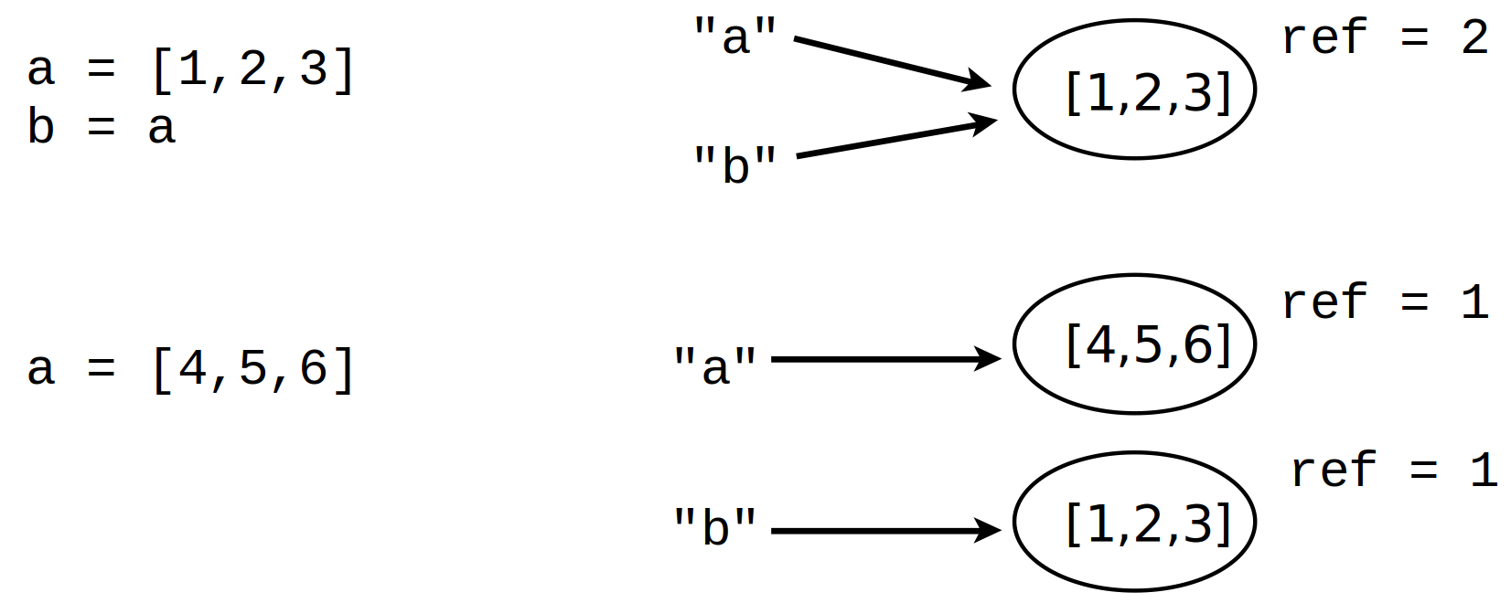

- The name "a" points to a new object, "b" is unchanged
Identity versus Equality

- Two objects are equal if they have the same value, but they can be different objects
- We can use the "is" operator to check if two references point to the same object

>>> a = [1, 2, 3]
>>> id(a)
140522824988032
>>> id(b)
140522825033216
>>> id(c)
140522824988032

Note: id is an integer unique for the lifetime of the object.

>>> b = [1, 2, 3]
>>> c = a
>>> a == b
True
>>> a is c
True
>>> a is not b
True
>>> b.append(999)
>>> a == b
False
Shallow Copies

- To avoid problems with mutable objects we can copy them
a
b
101
100
999
1
2
1
3

>>> a = [1, 2, [100, 101], 3]
>>> b = list(a)
>>> a is b
False

- But notice this:

>>> b[2].append(999)
>>> a
[1, 2, [100, 101, 999], 3]
- We took a shallow copy, copying references
Deep Copying

- For nested data structures, or objects with shared references, you need to take a "deep copy"
- For this we use the "copy" module

>>> import copy
>>> a = [1, 2, [100, 101], 3]
>>> b = copy.deepcopy(a)
>>> b[2].append(999)
>>> a
[1, 2, [100, 101], 3]
>>> a[2] is b[2]
False

- There is also copy.copy for shallow copies, but making shallow copies of objects is usually easy
Everything is an Object

- Everything is an object
- Every object has a type
- No special objects, everything is an object:
  - Numbers and strings
  - Containers
  - Exceptions
  - None and the bools
  - Even classes are objects (so what is the type of a class?)

In Python we call all objects "first class" objects.
Example: Functions as Objects

- We can use the fact that functions are objects to simplify the code on the left

from operator import add, sub, mul, truediv as div
if op == '+':
r = add(x, y)
elif op == '-':
r = sub(x, y)
elif op == '*':
r = mul(x, y)
elif op == '/':
r = div(x, y)
ops = {
"+": add,
"-": sub,
"*": mul,
"/": div
}
r = ops[op](x, y)

Exercise 2.1

Section 3

Exception Handling
Exception Handling

- Errors are reported as exceptions
- Unhandled exceptions terminate the program

>>> value = int('invalid')
Traceback (most recent call last):
File "<stdin>", line 1, in <module>
ValueError: invalid literal for int() with base 10: 'invalid'

- The exception has a type, a message, and a traceback telling you where in the code it occurred
- If the exception happens deep in a program the traceback will show you the whole call stack leading to the error - vital for debugging
The try...except Construct

- Some errors we know how to deal with and can handle
- For this we use the "try-except" statement

for line in f:
fields = line.split()
try:
shares = int(fields[1])
except ValueError:
print("Couldn't parse", line)

- The exception type must match (exact type or subclass) for it to be handled
- If a matching error occurs inside the try block the code in the except block runs
Raising Exceptions

- Sometimes we need to signal an error, for this we use the raise statement

raise ValueError("All your data is bad")

- If the exception is unhandled the program terminates with message and traceback

$ python explode.py
Traceback (most recent call last):
File "explode.py", line 21, in baz
bam()
File "explode.py", line 27, in bam
raise ValueError("All your data is bad")
ValueError: All your data is bad
The Exception Variable

- As well as a message the exception object may have important information
- The except statement can assign the exception object to a variable, using the as syntax

try:
value = int(line[1])
except ValueError as e:
print("The exception message is:", e)

Note: The exception variable ("e" by convention) is cleared after the except finishes. This is to avoid leaking memory, but it's unusual in Python.
Handling Multiple Error Types

- Handling multiple exception types the same way

try:
...
except (ValueError, TypeError, RuntimeError) as e:
...
- Handling multiple exception types differently

try:
...
except ValueError as e:
...
except TypeError as e:
...
except RuntimeError as e:
...

- On error the except blocks are checked in order
The else Section

- If there is code you only want to run if there isn't an exception you can put it in an else block
- This can help minimise the code inside the try block

try:
value = int(line[1])
except (ValueError, IndexError) as e:
logger.error('Error parsing "%s" because %s', line, e)
else:
data.append(value) # only runs if there is no error

- To avoid overbroad exception handling follow two important rules
  - Minimise code protected in the try block
  - Be as specific as possible about the error types

The finally Statement

- The finally block runs whether or not there is an error
- Typically used for resource management, like releasing locks and closing connections
- Largely, but not entirely, made obsolete by the with statement
lock = Lock()
with lock:
...
lock = Lock()
lock.acquire()
try:
...
finally:
lock.release()
What Exceptions to Handle?

- Exception handling is for when you are able to deal with the error
- Only handle exceptions you can recover from
- This error here is the right exception to signal the problem – leave the caller to handle it if they can

>>> read_data('missing.xml')
Traceback (most recent call last):
File "<stdin>", line 1, in <module>
File "data.py", line 7, in read_data
h = open(filename)
FileNotFoundError: [Errno 2] No such file or directory: 'missing.xml'

Re-raising Exceptions

- Sometimes you need to catch an exception, do some processing (close connections or free resources) and then re-raise the exception to let it propagate

allocate_resources()
try:
# Complex operations
...
except LookupError as e:
logger.error("Operation failed: %s", e)
free_resources()
raise
- A bare raise inside an except re-raises the current exception
Exceptions and the Stack

- Exceptions propagate up the stack
- They can be handled at any level
- Execution continues from the except
- Or Python terminates with a non-zero error code and a traceback
- Running code with "python -i script.py" drops you into an interpreter even on error
- "import pdb;pdb.pm()" launches the debugger into the stack frame where the error occurred

Demo with "explode.py"
The Debugger

- pdb is the Python debugger
- pdb.pm() for "postmortem" investigation of errors
- breakpoint() in code or test drops you into the debugger - equivalent of pdb.set_trace()
- Investigate local variables, execute code, step through code or set new breakpoints and continue

pdb commands
help | Get help | c(ontinue) | Continue execution
w(here) | Print stack trace | s(tep) | Execute a single line
d(own) | Move down a stack level | n(ext) | Execute a single line (**)
u(p) | Up a stack level | l(ist) | List the source code
b(reak) loc | Set breakpoint at loc (*) | !statement | Execute statement

(*) e.g. "b 45" set a breakpoint at line 45. "b file.py 45" line 45 in file.py
(**) Step through code in the current function, don't step into functions calls.
Exception Wrapping

- Sometimes we need to signal an error that comes from some underlying different exception
- Using exception wrapping we can raise an exception without losing the original error or traceback

try:
execute_task(task)
except Exception as e:
raise TaskError("Task failed") from e

- The exception chain can be unwrapped by the caller

try:
send_task(task)
except TaskError as e:
original_error = e.__cause__
Custom Exception Types

- All exception types derive from Exception
- Common for libraries and applications to define custom exceptions (often in a hierarchy)
- Usually all that is required is inheriting from Exception

class NetworkError(Exception):
pass
class HTTPError(NetworkError):
pass
class FTPError(NetworkError):
pass

The Logging Module

- Logging is easy to use, thread-safe and highly configurable
- Log messages at different levels and filter the output by level
  - DEBUG
  - INFO
  - WARNING
  - ERROR
- Log to the console (not so useful for code on a server) or to a file (much more useful)
- Loggers are named, usually the module name
- Logging still uses "%s" style message formatting

Logging Example

import logging
logger = logging.getLogger(__name__)
def read_portfolio(filename):
...
for row in rows:
logger.info("Processing %s", row)
try:
amount = int(row[1])
price = float(row[2])
except ValueError as e:
logger.error("Bad row %s : because %s", row, e)
continue

Logging Configuration

- Call logging.basicConfig(…) on script/program start
- Configure the level of logging to output and where output goes
- Logging goes to the console by default
- Many (many) options for configuration including individual loggers by name

logging.basicConfig(filename='example.log',
encoding='utf-8',
level=logging.INFO)

logging.debug('This message should not go to the log file')
logging.info('But this should')

Exercise 3.1

Section 4

The Python Object Model
Objects

- Python is an object oriented language
- Everything is an object: lists, None, exceptions, classes, numbers, etc…
- Objects combine data with functions for operating on the data – their "methods"

a = 'Hello World' # A string object
b = a.upper() # A method applied to the string
items = [1,2,3] # A list object
items.append(4) # A method applied to the list
Methods as Functions

A helpful way to think about methods is as a function that takes the object as the first argument.

>>> string = 'Hello world'
>>> str.upper(string)
'HELLO WORLD'
>>> a = [1, 2, 3]
>>> list.append(a, 4)
>>> a
[1, 2, 3, 4]

And as we'll find out, this is in fact what is happening under the hood. Objects combine data and functions for working on the data (and some interesting rules about how they operate).
The Class Statement

- We can define custom classes
- Type and class are synonyms

class Frobulator:
def __init__(self, data):
self.data = data
self.version = 1.0
def update(self, version):
self.version = version
def frobulate(self):
return self.data
- The body of the class is the collection of methods
Methods and Explicit Self

- The class definition/class object is the type
- Individual objects are "instances" of the type
- When we call a method the instance is passed in (automatically) as the first argument – called "self"
- Methods are functions that operate on instances

>>> frob = Frobulator(data)
>>> frob.update(2.0)

def update(self, version):
self.version = version

- In other languages self is called "this" and isn't declared explicitly in the method definition
Instantiation

- Instances are created by calling the class
- Every instance can be created with its own data
- Everything that lives on the class (like methods) are shared by all the instances

>>> frob1 = Frobulator(79)
>>> frob2 = Frobulator(130)
>>> frob1.data
79
>>> frob2.data
130
>>> frob2.update(2.0)
>>> frob1.version
1.0
>>> frob2.version
2.0
The Initialiser

- __init__ is the initialiser, it initialises the instance
- One of Python's protocol (magic/dunder) methods
- Part of the "two phase object creation protocol"
- Similar to a "constructor" in other languages
- __init__ is called automatically on instantiation
- Typically they set attributes, the instance data

>>> frob1 = Frobulator(108)

def __init__(self, data):
self.data = data
self.version = 1.0

>>> frob1.data
108

Exercise 4.1
Attributes

- Data and methods are all object attributes
- There are three attribute operations on objects

x = obj.attr # Get an attribute
obj.attr = value # Set an attribute
del obj.attr # Delete an attribute

- Objects are "open by default" – new attributes can be created and existing ones modified/deleted

>>> del frob1.version
>>> frob1.supersonic = True

Note: attribute deletion is rare
Attribute Access Functions

- Four functions give us access to object attributes

getattr(obj, 'attribute') # Fetch an attribute
setattr(obj, 'attribute', value) # Set an attribute
delattr(obj, 'attribute') # Delete an attribute
hasattr(obj, 'attribute') # Test if an attribute exists

attributes = [ 'name', 'shares', 'price']
for attr in attributes:
print(attr, '=', getattr(stock, attr))

- getattr has an optional third argument – a default value for non-existent attributes (useful for duck typing)
getattr(stock, date, 'today')
Bound Methods

- Calling a method is two step, first the lookup and then the call
- Looking up a method returns a "bound method" – self is already bound in as the first argument

>>> frob
<__main__.Frobulator object at 0xc7c40>
>>> method = frob.frobulate
>>> method
<bound method Frobulator.frobulate of <__main__.Frobulator object at 0xc7c40>>
>>> method()
79

The instance is bound into the method

Exercise 4.2
More on Classes

- Everything that lives on the class is shared by all instances
- For example the update method on Frobulator
- A function defined on the class becomes a method on all instances
- Defined once, used in many places
- So far we've only looked at methods but there are other things we can put in the class definition

Class Level Attributes

- As well as methods classes can have attributes
- Class level attributes or variables
class DataConnection:
active = True
def __init__(self, address, port):
self.socket_address = address, port
...

- Class attributes are shared by all instances
- Accessible via the class and via the instances

Class Level Attributes

>>> conn1 = DataConnection(addr1, port1)
>>> conn2 = DataConnection(addr2, port2)
>>> DataConnection.active
True
>>> conn1.active
True
>>> conn2.active
True
>>> DataConnection.active = False
>>> conn1.active
False
>>> conn2.active = True
>>> conn1.active
False
>>> DataConnection.active
False
>>> conn2.active
True
- Setting the attribute on an instance shadows (does not change) the class level attribute
Using Class Attributes

- Class attributes are useful for anything shared by all instances
  - Default settings
  - Configuration
  - Caches
  - With inheritance for customisation

Note: Class attributes for default settings can be a performance optimisation – the initialiser doesn't need to set default values for attributes as the defaults live on the class. Instances are free to override (shadow) the class level default.
Class Attributes and Inheritance

- An example for customisation via inheritance

class Date:
datefmt = '{year}-{month}-{day}'
def __init__(self, year, month, day):
self.year = year
self.month = month
self.day = day
def __str__(self):
return self.datefmt.format(year=self.year,
month=self.month,
day=self.day)

class USDate(Date):
datefmt = '{month}/{day}/{year}'
Class Methods

- Class methods can be called from the class
- They take the class (cls) instead of self as the first argument

class DataConnection:
active = True
@classmethod
def toggle(cls):
cls.active = not cls.active
...
>>> DataConnection.active
True
>>> DataConnection.toggle()
>>> DataConnection.active
False
Alternative Constructors

- Providing alternative constructors is the most common use case for class methods

class Date:
def __init__(self, year, month, day):
self.year = year
self.month = month
self.day = day
@classmethod
def today(cls):
tm = time.localtime()
return cls(tm.tm_year, tm.tm_mon, tm.tm_mday)
d = Date.today()
The Perils of Not Using cls

- The previous example used cls(…) to create the Date instance
- See what happens if we hardcode Date(…) and then subclass
...
@classmethod
def today(cls):
tm = time.localtime()
return Date(tm.tm_year, tm.tm_mon, tm.tm_mday)

class NewDate(Date):
pass

>>> NewDate.today()
<__main__.Date object at 0x7f0206844670>

- Calling NewDate.today() returns a Date instance!

Exercise 4.3
Problem: Simple Attributes

- Objects, classes and instances are open by default
- We can create new attributes and set any value
- This is powerful and useful, but what if we want to prevent users setting the wrong type

>>> stock = Stock('IBM', 300, 479.25)
>>> stock.shares
300
>>> stock.shares = '450'

Setting shares to a string is going to cause a crash later in our code!

Private Attributes

- Some languages solve this by using getter and setter methods and private attributes
- In Python a private attribute is signalled with a leading underscore (see next slide)
- This is a convention only, but widely understood, and really useful for testing (etc)

Note: Languages that have data privacy tend to also provide reflection (or have pointers) that can circumvent privacy – privacy is also a convention in those languages.
Getters and Setters

class Stock:
def __init__(self, name, shares, price):
self.name = name
self.set_shares(shares)
self.price = price
def get_shares(self):
return self._shares
def set_shares(self, value):
if not isinstance(value, int):
raise TypeError('Expected an int')
self._shares = value

Unfortunately this change is backwards incompatible and existing code would break.

stock.shares = 50 stock.set_shares(50)
Properties

- Properties wrap getter [and optionally] setter methods but are used just like attributes

class Stock:
def __init__(self, name, shares, price):
self.name = name
self.shares = shares
self.price = price
@property # A "get only" property
def cost(self):
return self.shares * self.price
>>> stock = Stock('GOOG', 100, 490.10)
>>> stock.cost
49010.0
Properties

Wrapping a setter as well to make shares a property:

class Stock:
def __init__(self, name, shares, price):
self.name = name
self.shares = shares
self.price = price
@property
def shares(self):
return self._shares
@shares.setter
def shares(self, value):
if not isinstance(value, int):
raise TypeError('Expected an int')
self._shares = value
Note: we don't need to change any existing code, including this call in __init__.

Setting "shares" triggers the property setter and we now get type checking in the initialiser for free.
>>> stock = Stock('GOOG', 100, 490.10)
>>> stock.shares = '50' The property prevents this
TypeError: Expected an int
__slots__ Attribute

- __slots__ on a class limits the available attributes
- Attempting to set other attributes will error
- This is a memory optimisation!

class Stock:
__slots__ = ('name', 'shares', 'price')
...
>>> stock = Stock('GOOG', 100, 490.10)
>>> stock.foo = 33
Traceback (most recent call last):
File "<stdin>", line 1, in <module>
AttributeError: 'Stock' object has no attribute 'foo'

Warning: creates "non-standard" Python objects!

Exercise 4.4
Inheritance

- A tool for specialising existing objects
- A tool for code reuse!
- Without an explicit base class classes inherit from object

class Parent:
...
class Child(Parent):
...

- The parent – also superclass or base class
- The child – also subclass or derived type
- Inheritance can modify and extend the parent
Adding New Methods

- Extend an existing class by adding new methods
- The child has all the behaviour/features of the parent plus the new method

class MyStock(Stock):
def panic(self):
self.sell(self.shares)

>>> stock = MyStock('GOOG', 100, 490.10)
>>> stock.shares
100
>>>
>>> stock.panic()
>>> stock.shares
0

Overriding Methods

- Modify classes by replacing (overriding or shadowing) existing methods
- Everything else behaves as the parent

class MyStock(Stock):
def cost(self):
return 1.25 * self.shares * self.price

>>> stock = MyStock('GOOG', 100, 490.10)
>>> stock.cost()
61262.5

Calling the Parent

- It's common for a child class to modify the parent behaviour without replacing it altogether
- Use super() to call up to the parent

class Stock:
...
def cost(self):
return self.shares * self.price
...
class MyStock(Stock):
def cost(self):
real_cost = super().cost()
return real_cost * 1.25
Inheritance and __init__

- With inheritance you must initialise your parents
class Stock:
def __init__(self, name, shares, price):
self.name = name
self.shares = shares
self.price = price
class MyStock(Stock):
def __init__(self, name, shares, price, factor):
super().__init__(name, shares, price)
self.factor = factor
def cost(self):
return self.factor * super().cost()
Inheritance

- Inheritance establishes an "is a" relationship
- Both Object Oriented theory and in the type system

class MyStock(Stock):
...

>>> stock = MyStock('GOOG', 100, 490.10)
>>> type(stock)
<class '__main__.MyStock'>
>>> isinstance(stock, Stock)
True
>>> isinstance(stock, object)
True
>>> issubclass(Stock, object)
True
Composition Over Inheritance

- Inheritance exposes all the features of the parent
- Object composition limits what is exposed – more control at the cost of more work
- Composition is a "has a" relationship
- The composed object is exposed by explicit "delegation"

class Holding:
def __init__(self, name, shares, price):
self._stock = Stock(name, shares, price)
def cost(self):
return self._stock.cost()
@property
def name(self):
return self._stock.name
Note: If we used "dependency injection" as well as composition the Stock would be created outside the Holding and passed into the initialiser.
Multiple Inheritance

- Classes can have multiple parents

class D(B,C):
...

class B(A):
...

class A:
...

class C:
...
The practical details can be somewhat tricky!
Cooperative Inheritance

- Python has "cooperative multiple inheritance"
- Child classes can arrange their parents to cooperate
- So the order of the parents is significant
- Attribute lookup can jump from parent to parent

class Child(Parent1, Parent2, Parent3):
...
Cooperative Inheritance

class Parent:
def method(self):
print('Parent')

class A(Parent):
def method(self):
print('A')
super().method()
class B(Parent):
def method(self):
print('B')
super().method()

- See what happens when we use it:
class C(A, B): >>> c = C()
pass >>> c.method()
A
B
It's gone sideways!
Parent

Cooperative Inheritance


- Using cooperative inheritance
we can create and combine
classes as components
to build things
An Interesting Code Reuse
class Bike:
def noise(self):
return 'Ding!'
def pedal(self):
return 'Pedaling!'
class LoudBike(Bike):
def noise(self):
return super()\
.noise().upper()
class Dog:
def noise(self):
return 'Woof'
def chase(self):
return 'Chasing!'
class LoudDog(Dog):
def noise(self):
return super()\
.noise().upper()

- Two unrelated pieces of code
- Yet there is code duplicated between them
- But nowhere obvious to put the common code
Mixin Classes

- Mixin classes add new behavior to existing classes
- We "mix-in" a slice of functionality, like aspect oriented programming
- This is a great tool for reducing code duplication
- Individual bits of functionality can be provided as reusable components in the form of mixin classes

# An example from Flask
from flask_login import UserMixin
class User(UserMixin, db.Model):
id = db.Column(db.Integer, primary_key=True)
username = db.Column(db.String(64), unique=True)
...
Mixin Classes

- To add a loud() method to unrelated classes like Dog and Bike we can write a mixin class that looks like this:

class Loud:
def noise(self):
return super().noise().upper()

- Note that it can't be used by itself!
- We use it by mixing it into other classes
- The mixin class always goes first

class LoudDog(Loud, Dog):
pass
class LoudBike(Loud, Bike):
pass
How it Works

- Example:

class LoudDog(Loud, Dog):
pass
super()

>>> dog = LoudDog()
>>> dog.noise()
'WOOF'
- super moves from one class to the next
- This allows us to use our mixin class with any compatible class!
- Details to be explained shortly
Inside Python Objects

- A dictionary with string keys can be seen as a collection of "named" objects

stock = {
"name": 'GOOG',
"shares": 100,
"price": 490.10
}

- Dictionaries are one of the basic data structures
- They are used internally everywhere in Python
- "Names" (dictionary keys) mapping to objects provides a "namespace", a fundamental idea in Python
Dicts and Objects

- Dictionaries are used inside classes we create for:
  - Instance data
  - Class members
- In fact the entire object system is mostly just an extra layer that's put on top of dictionaries
- Let's take a look...

Dicts and Instances

- A dictionary holds the instance data (__dict__)

>>> stock = Stock('GOOG', 100, 490.10)
>>> stock.__dict__
{'name': 'GOOG', 'shares': 100, 'price': 490.1}

- When we assign to self we populate this dictionary

class Stock:
def __init__(self, name, shares, price):
self.name = name
self.shares = shares
self.price = price
{
"name": 'GOOG',
"shares": 100,
"price": 490.10
}

self.__dict__

Dicts and Instances

- Because every instance has its own dictionary they can each store separate data
{
"name": 'GOOG',
"shares": 100,
"price": 490.10
}
s = Stock('GOOG',100,490.10)
t = Stock('AAPL',50,123.45)

{
"name": 'AAPL',
"shares": 50,
"price": 123.45
}
Dicts and Classes

- The class members are also stored in a dictionary

class Stock:
def __init__(self, name, shares, price):
self.name = name
self.shares = shares
self.price = price
def cost(self):
return self.shares * self.price
def sell(self, nshares):
self.shares -= nshares
{
"__init__": <function>,
"cost": <function>,
"sell": <function>
}
methods

Stock.__dict__

Instances and Classes

- Instances and classes are linked together
- The __class__ attribute links instances back to the class

>>> stock = Stock('GOOG', 100, 490.10)
>>> stock.__dict__
{'name': 'GOOG', 'shares': 100, 'price': 490.1}
>>> stock.__class__
<class '__main__.Stock'>

- The instance dictionary holds the data which is separate for each instance whereas the class dictionary holds the data which is shared by all the instances

Instances and Classes
.__dict__
.__class__
{attrs}
.__dict__
.__class__
.__dict__
.__class__
{attrs}

instances
{attrs}

class
.__dict__

{methods}
Attribute Access

- When we work with objects we access their methods and data using the dot operator (.), the attribute lookup operator

x = obj.name # Getting
obj.name = value # Setting
del obj.name # Deleting

- Attribute operations correspond directly to operations on the underlying dictionary
- This can potentially be customised by the attribute lookup protocol
Modifying Instances

- Operations that modify an object update the underlying dictionary

>>> stock = Stock('GOOG', 100, 490.10)
>>> stock.__dict__
{'name': 'GOOG', 'shares': 100, 'price': 490.1}
>>> stock.shares = 50
>>> stock.date = '2023-03-23'
>>> stock.__dict__
{'name': 'GOOG', 'shares': 50, 'price': 490.1, 'date': '2023-03-23'}
>>> del stock.shares
>>> stock.__dict__
{'name': 'GOOG', 'price': 490.1, 'date': '2023-03-23'}
Fetching Attributes

- Suppose you want to fetch an attribute from the object

x = obj.name

- The attribute may exist in two places
  - The local instance attribute dictionary
  - The class member dictionary
- So both dictionaries have to be checked
Fetching Attributes

- First check in __dict__ of the instance
- If the attribute isn't found look in __dict__ of the class
s
>>> s = Stock(...)
.__dict__
.__class__
{"name": 'GOOG', "shares": 100, ...}
>>> s.name
'GOOG'
1
>>> s.cost()
49010.0
Stock
{"__init__": <func>, "cost": <func>, ...}
.__dict__

2
- This lookup scheme is how class members are shared by all instances of the class

Exercise 4.5
How Inheritance Works

- Classes may inherit from other classes

class A(B, C):
...

- The bases of the class are stored as a tuple on the class

>>> C.__bases__
(<class '__main__.A'>, <class '__main__.B'>)

- This provides a link from the class to the parents
- This link is used to extend the search for attribute lookups
Fetching Attributes

- First check in __dict__ of the instance
- If the attribute isn't found look in __dict__ of the class
s
>>> s = Stock(...)
.__dict__
.__class__
{"name": 'GOOG', "shares": 100, ...}
>>> s.name
'GOOG'
1
>>> s.cost()
49010.0
Stock
{"__init__": <func>, "cost": <func>, ...}
.__dict__
.__bases__
2
2
3
look in __bases__
Single Inheritance

- Where we have an inheritance hierarchy with several classes, attribute lookup walks up the inheritance tree
object
A
B
- With single inheritance, there
is a single path to the top
C
- Python stops when it finds the
first match
D
E
instance
e
MRO

- The inheritance chain is computed when the class is created and stored as an "MRO" attribute on the class

>>> E.__mro__
(<class '__main__.E'>, <class '__main__.D'>, <class '__main__.C'>, <class '__main__.A'>, <class 'object'>)

- The "method resolution order"
- To find an attribute Python walks the MRO
- First match wins

Multiple Inheritance

- Consider this inheritance hierarchy
object
class A: pass
class B: pass
class C(A, B): pass
class D(B): pass
class E(C, D): pass
A
A
B
A
C
D

- What happens here?
e = E()
e.attr
E

- A similar search process is carried out, but is more complex as there are several potential search paths
Multiple Inheritance

- Python uses "cooperative multiple inheritance"
- There are two rules to decide the order of the MRO:

Rule 1: Children go before parents
Rule 2: Parents go in order

- Inheritance goes in two directions (up the hierarchy and across the order of the parents)
Rule 1
Rule 2
class C(A, B):
...

Multiple Inheritance

- The multiple inheritance hierarchy is flattened, linearised
>>> E.__mro__
(<class '__main__.E'>, <class '__main__.C'>, <class '__main__.A'>, <class '__main__.D'>, <class '__main__.B'>, <class 'object'>)

- The order of the MRO is calculated using the C3 linearization algorithm
- A constrained merge sort of parents
- It produces an ordering based on "the rules"

Multiple Inheritance

- Consider classes with a common parent
class Base:
...

class A(Base):
...
class B(Base):
...
class C(Base):
...

- All children of a common base go first
class D(A, B, C):
...

MRO:
D
A
B
C
Base
Why super()?
- Always use super when overriding methods

class A(Base):
def method(self):
...
return super().method()

- super() jumps to the next class in the MRO
- The next class isn't always directly a parent
super()
D
A
B
C
Base
A
Base
super()
super Explained

- super() is one of Python's most poorly understood features
class A(Base):
def method(self):
...
return super().method()
VS.

class A(Base):
def method(self):
...
return Base.method()

- The classes above are not equivalent
- super() jumps to the next class is in the MRO, which is not always the direct parent
- So hardcoding the base will break if anyone uses that class with multiple inheritance
Designing for Inheritance

- Rule 1: Compatible method signatures
D
A
B
C
Base
method(args)
method(args)
method(args)
method(args)

- Overriden methods must have a compatible signature across the whole hierarchy
- Remember: super() might not go an immediate parent
- Tip: If there are varying signatures you can use keyword arguments (but must avoid passing them on)

Designing for Inheritance

- Rule 2: method chains must terminate
method(args)
method(args)
method(args)
AttributeError
D
A
B
object
Base

- If every class calls super at some point it will reach object and fail – some class has to terminate the chain

class Base:
def method(self):
pass

- Typically the role of a common base class
Designing for Inheritance

- Rule 3: use super() everywhere

method(args)
D
A
B
C
Base
method(args)

- Direct parent calls cause unexpected and broken behaviour with multiple inheritance

class A(Base):
def method(self):
...
return Base.method(self) # NO!

Exercise 4.6
Operator Overloading

- Classes can customise almost every aspect of their behaviour
- This is done through special methods, the protocol methods

class Point:
def __init__(self):
...
def __str__(self):
...

- There are dozens of protocols and hundreds of methods
- We'll look at some of the essential protocol methods
The String Conversion Protocol

- Objects have two string representations

>>> from datetime import date
>>> d = date(2023, 3, 23)
>>> print(d)
2023-03-23
>>> d
datetime.date(2023, 3, 23)

- str(x) – Printable output (for humans)

>>> str(d)
'2023-03-23'

- repr(x) – For programmers

>>> repr(d)
'datetime.date(2023, 3, 23)'

String Conversions

class Date:
def __init__(self, year, month, day):
self.year = year
self.month = month
self.day = day
def __str__(self):
return '{}-{}-{}'.format(self.year,
self.month, self.day)
def __repr__(self):
return 'Date({}, {}, {})'. format(self.year,
self.month, self.day)

Note: the convention is for __repr__() to return a string that if fed back to eval() recreates the original object. It's not always possible.
'{self.__class__.__name__}(...)' can be used to avoid hardcoding class names in the repr.
The Container Protocol
- Methods for implementing containers
len(x) | x.__len__()
x[a] | x.__getitem__(a)
x[a] = v | x.__setitem__(a)
del x[a] | x.__delitem__(a)
a in x | x.__contains(a)
- Definitions in a class
class Container:
def __len__(self):
...
def __getitem__(self, a):
...
def __setitem__(self, a, v):
...
def __delitem__(self, a):
...
def __contains__(self, a):
...
The Numeric Protocol

- Mathematical operations (see reference for the gory details including right hand variants)

a + b | a.__add__(b) | Addition
a - b | a.__sub__(b) | Subtraction
a * b | a.__mul__(b) | Multiplication
a / b | a.__div__(b) | Division
a // b | a.__floordiv__(b) | Floor division
a % b | a.__mod__(b) | Modulo
a << b | a.__lshift__(b) | Left shift
a >> b | a.__rshift__(b) | Right shift
a & b | a.__and__(b) | Bitwise and
a | b | a.__or__(b) | Bitwise or
a ^ b | a.__xor__(b) | Bitwise xor
a ** b | a.__pow__(b) | Power
-a | a.__neg__() | Unary negative
~a | a.__invert__() | Bitwise not
abs(a) | a.__abs__() | Absolute value
a @ b | a.__matmul__(b) | Matrix multiplication

Exercise 4.7

Section 5

Writing Larger Programs
Modules and Packages

- You've written some code
- Now you need to organise it
- Possibly give it to others
- How do you do it?

Modules

- Every Python source file is a module

# foo.py
def grok(a):
...
def spam(b):
...
- The import statement loads and executes a module

import foo
a = foo.grok(2)
b = foo.spam('Hello')
...

Module Objects

- Modules are objects
>>> import foo
>>> foo
<module 'foo' from 'foo.py'>
- A namespace for the definitions inside
>>> foo.grok(2)
- Actually a layer on top of dictionaries (module globals)
>>> foo.__dict__['grok']
<function grok at 0x7f733a914670>

Special Variables

- A few special variables defined automagically in a module

__file__ # Name of the source file
__name__ # Name of the module
__doc__ # Module docstring

- We can use __name__ to tell if we have been imported or are running as the main module (the main script or program)

Import Implementation

- Import in a nutshell (pseudocode)

import types
def import_module(name):
# locate the module and get source code
filename = find_module(name)
code = open(filename).read()
# Create the enclosing module object
mod = types.ModuleType(name)
# Run it
exec(code, mod.__dict__, mod.__dict__)
return mod

- Import finds and executes the module source file to create the module object
import Statement

- import executes the entire module

# bar.py
import foo

- After the import the module name is a reference to the module object inside the module that did the import

bar.__dict__
# bar.py
import foo
foo.grok(2)
{
...
"foo": <module 'foo'>,
...
}

Module Cache

- Each module is loaded only once
- Repeated imports return a reference to the same module object
- sys.modules is a dict of all loaded modules

>> import sys
>>> list(sys.modules)
['sys', 'builtins', '_frozen_importlib', '_imp', '_warnings', '_io', 'marshal', 'posix', '_frozen_importlib_external', '_thread', ... ]

Import Caching

- Import pseudocode with module caching
import types
import sys
def import_module(name):
# Check for cached module
if name in sys.modules:
return sys.modules[name]
filename = find_module(name)
code = open(filename).read()
mod = types.ModuleType(name)
sys.modules[name] = mod
exec(code, mod.__dict__, mod.__dict__)
return mod
- There are many more details but this is most of the work
- See the importlib module for more
from module import

- Import selected symbols with "from module import …"

# bar.py
from foo import grok
grok(2)

- Useful for frequently used names
- Slightly faster as it avoids the attribute lookup of "foo.grok"

Note: This doesn't change how import works, the entire source file is still executed and the module cached but you only have references to the specific objects imported
from module import *

- Imports all the symbols from a module

# bar.py
from foo import *
grok(2)
spam('Hello')
...

- "import *" doesn't import private names from a module, those that start with an underscore (_)
- Not recommended! Namespace pollution!
- Useful for the interactive interpreter and for namespace packages (__init__.py)
Module Reloading

- Modules can sometimes be reloaded

>>> import foo
...
>>> import importlib
>>> importlib.reload(foo)
<module 'foo' from 'foo.py'>

- Reloading re-executes the source code over the top of the existing module dictionary

# pseudocode
def reload(mod):
code = open(mod.__file__, 'r').read()
exec(code, mod.__dict__, mod.__dict__)
return mod
Module Reloading Dangers

- Problem: Existing instances of classes will still have a reference to the old class object
- Problem: Anything imported with "from module import name" will still use the old definition
- Problem: Anything that uses super or does type checks will fail
- Reloading is not for production code but very useful for development where modules change rapidly

Locating Modules

- When looking for modules Python first looks in the same directory as the source file that's executing the import
- If the module isn't found there sys.path contains a list of places that Python checks (in order)

>>> import sys
>>> sys.path
['', '/usr/lib/python310.zip', '/usr/lib/python3.10', '/usr/lib/python3.10/lib-dynload', '/home/michael/.local/lib/python3.10/site-packages', '/usr/local/lib/python3.10/dist-packages', '/usr/lib/python3/dist-packages']
Module Search Path

- sys.path contains the search paths for import
- You can manually adjust it if you need to

import sys
sys.path.append('/project/foo/pyfiles')

- Paths can also be added via environment variables

$ export PYTHONPATH=/home/user/code

- The directory added will now be at the start of sys.path when you run Python

Exercise 5.1
Organising Libraries

- It is standard practise for Python libraries to be organised as a hierarchical set of modules that sit under a top level package name

packagename
packagename.foo
packagename.bar
packagename.utils
packagename.utils.spam
packagename.utils.grok
packagename.parsers
packagename.parsers.xml
packagename.parsers.json
...

Creating a Package

- To create the module library hierarchy, organize files on the filesystem in a directory with the desired structure

packagename/
foo.py
bar.py
utils/
spam.py
grok.py
parsers/
xml.py
json.py
...
Creating a Package

- Optionally add __init__.py files to each directory

packagename/
__init__.py
foo.py
bar.py
utils/
__init__.py
spam.py
grok.py
parsers/
__init__.py
xml.py
json.py
...
Using a Package

- You can now import from your package

import packagename.foo
import packagename.parsers.xml
from packagename.parsers import xml

- Almost everything should work as it did before but your import statements can have multiple levels

Fixing Relative Imports

- Relative imports between submodules don't work
spam/
__init__.py
foo.py
# bar.py
import foo # import fails
bar.py

- The issue: resolving name clashes between submodules and top level packages
spam/
__init__.py
os.py
# bar.py
import os # ??? stdlib?
bar.py

- imports are always "absolute" (from the top level)
Absolute Imports

- One approach: always use absolute imports

spam/
__init__.py
foo.py
bar.py

- Example:

# bar.py
from spam import foo

- Notice the use of the top level package name

Package Relative Imports

- Consider a package
spam/
__init__.py
foo.py
bar.py
grok/
__init__.py
blah.py
- Package relative imports
# bar.py
from . import foo # Imports ./foo.py
from .foo import name # Load a specific name
from .grok import blah # Imports ./grok/blah.py
Package Environment

- Packages define a few useful variables
__package__ # Name of the enclosing package
__path__ # Search path for subcomponents

- Example:
>>> import xml
>>> xml.__package__
'xml'
>>> xml.__path__
['/usr/local/lib/python3.10/xml']

- Useful if code needs to know about its enclosing environment

__init__.py Usage

- What are you supposed to do in these files?
- __init__.py provides the top level namespace for the package/sub-package
- Main use: stitching together multiple files (the submodules) into a "unified" top-level import

Tip: Don't put lots of code in __init__.py, use it to create the namespace, use helpfully named modules for the actual code.
Module Assembly

- Consider two submodules in a package

# foo.py
class Foo:
...
...
spam/
foo.py

bar.py

# bar.py
class Bar:
...
...

- Suppose we wanted to combine them for import
Module Assembly

- Combine in __init__.py
# foo.py
spam/
foo.py

bar.py

__init__.py
class Foo:
...
...

# bar.py
class Bar:
...
...

# __init__.py
from .foo import Foo
from .bar import Bar
Module Assembly

- Users see a single unified top-level package

import spam
foo = spam.Foo()
bar = spam.Bar()
...

- The internal split across submodules, the implementation details, are hidden from the user
Case Study

- The "asyncio" module
- It's actually a package with many sub-components
- If we look in the __init__.py we can see all the submodules that provide the implementation

# This relies on each of the submodules having an __all__ variable.
from .base_events import *
from .coroutines import *
from .events import *
from .exceptions import *
from .futures import *
from .locks import *
from .protocols import *
from .runners import *
from .queues import *
...
Controlling Exports

- Submodules should define __all__

# bar.py
__all__ = ['Bar']
class Bar:
...
# foo.py
__all__ = ['Foo']
class Foo:
...

- This controls 'from module import *'
- Which makes it easier to create __init__.py

# __init__.py
from .foo import *
from .bar import *
__all__ = [ *foo.__all__, *bar.__all__ ]
Module Splitting

- Suppose you have a large module

# spam.py
class Foo:
...
...
class Bar:
...
...
- You want to refactor this into multiple files for sanity
- But you want to keep the external API the same as the single file for backwards compatibility

Module Splitting

- Step 1: turn it into a directory with multiple files
spam/
foo.py

bar.py
# foo.py
class Foo:
...
...

# bar.py
class Bar:
...
...

- Split the code across the submodules as you wish
- Fix any dependencies between submodules with appropriate imports (not relative imports!)
Module Splitting

- Step 2: stitch back together in __init__.py
spam/
foo.py

bar.py

__init__.py
# foo.py
class Foo:
...
...
# bar.py
class Bar:
...
...
# __init__.py
from .foo import Foo
from .bar import Bar

Exercise 5.2
Circular Imports

- Circular imports are a common problem within submodules, modules that depend on each other
# spam/base.py
from . import child
class Base:
...
# spam/child.py
from .base import Base
class Child(Base):
...

- Follow the control-flow
- Definition order matters!

Circular Imports

- Moving the import can fix the problem
# spam/base.py
class Base:
...
from . import child
# spam/child.py
from .base import Base
class Child(Base):
...

- Alternative fixes:
  - An "inner import" inside a function/method
  - Refactoring the shared code into a third module
- Better yet, avoid circular imports!
Main Modules

- python -m module
- Runs the specified module as a script

spam/
__init__.py
foo.py
bar.py

$ python -m spam.foo # runs spam/foo.py

- Can be used to ship tools and applications as part of a package
- Many standard library modules can be run this way (e.g. unittest, gzip, idlelib, timeit, asyncio, antigravity, etc)
Main Entry Point

- __main__.py designates an entry point
- Makes the package itself executable

spam/
__init__.py
__main__.py # starting module
foo.py
bar.py

$ python -m spam # runs spam/__main__.py

- Can also be done with subpackages, ship multiple tools within a package!

Section 6

Advanced Language Features

Advanced Language Features

- Functional Programming
  - Higher order functions
  - Closures
- Decorators
  - Decorator factories
  - Class decorators
- The iteration protocol
- Generators

Functional Programming

- Programming style characterized by
  - Functions
  - No side-effects/mutable-state
  - Higher order functions

Higher Order Functions

- Functions as objects
- Essential features
  - Functions can take functions as inputs
  - Functions can return functions
- Python supports both

Functions as Input

- Consider these two functions:

def sum_of_squares(nums):
total = 0.0
for num in nums:
total += num ** 2
return total
def sum_of_cubes(nums):
total = 0.0
for num in nums:
total += num ** 3
return total
only difference
- There's a lot of duplicated code (one line differs)

Functions as Input

- Recognizing commonality is part of abstraction

def sum_map(func, nums):
total = 0.0
for num in nums:
total += func(num)
return total
def square(x):
return x * x
nums = [1, 2, 3, 4]
r = sum_map(square, nums)

- This version allows any operation to be applied by passing a function
- Mapping an operation across a sequence and reducing to a single value is an example of "map-reduce"
Lambda Functions

- Single expression functions can be written as a lambda

def sum_map(func, nums):
total = 0.0
for num in nums:
total += func(num)
return total
nums = [1, 2, 3, 4]
r = sum_map(lambda x: x * x, nums)

- lambda creates an anonymous function
- Can only contain a single expression
- So no control flow or exception handling, etc.
- Commonly used for callback functions/event handlers
Partial Application

- lambda can be used to alter function arguments

def distance(x, y):
return abs(x – y)

>>> dist_from10 = lambda y: distance(10, y)
>>> dist_from10(3)
7
>>> dist_from10(14)
4

- functools.partial

from functools import partial
dist_from10 = partial(distance, 10)

Returning Functions

- Consider the following function

def greet(name):
def do_greet():
print(f'Hello {name}')
return do_greet

>>> greeter = greet('Sally')
>>> greeter
<function greet.<locals>.do_greet at 0x7fe99b6c18b0>
>>> greeter()
Hello Sally

- A function that returns a function!
- Notice that it works, but ponder it...
Nested Scopes

- Observe how the inner function refers to a variable defined by the outer function

def greet(name):
def do_greet():
print(f'Hello {name}')
return do_greet

- Even after greet has completed, and the function returned, the name variable is kept alive

>>> greeter = greet('Sally')
>>> greeter()
Where does the name variable come from?
Hello Sally

Closures

- If a function returns an inner function the result is called a "closure"

def greet(name):
def do_greet():
print(f'Hello {name}')
return do_greet

- Essential feature: A "closure" retains the values of all variables needed for the function to run properly later on
- The closure "closes over" any variables it uses from the enclosing scope

Closures

- To make it work references to variables from the outer scope (bound variables) are carried along with the function

def greet(name):
def do_greet():
print(f'Hello {name}')
return do_greet

>>> greeter = greet('James')
>>> greeter.__closure__
(<cell at 0x7fe99c4556d0: str object at 0x7fe99b675770>,)
>>> greeter.__closure__[0].cell_contents
'James'

Note: these are implementation details you'll rarely need to use, but useful for understanding Python.
Closures

- Closures only capture (keep-alive) variables they use

def add(x, y):
result = x + y
def get_result():
return result
return get_result

- The function add has three local variables: x, y, result
- The inner function only uses result

>>> a = add(3, 10)
>>> a.__closure__
(<cell at 0x7fe99b6cc8b0: int object at 0x956fc0>,)
>>> a.__closure__[0].cell_contents
13
Closures and Mutability

- Assignment inside a function creates a local variable
- But inner functions can change the value of a variable from an enclosing scope with nonlocal

def counter(n):
def incr():
nonlocal n
n += 1
return n
return incr
Note: functions can be nested to any level; you can have functions within functions within functions. Functions can also return multiple closures.

>>> c = counter(10)
>>> c()
11
>>> c()
12

- Can be used to hold mutable internal state, like a class, or communicate between closures with shared state
Using Closures

- Closures are an essential feature of Python
- Closures encapsulate state
- Create utility functions/tools specialised on the input to the closure
- Common applications:
  - Delayed evaluation
  - Callback functions
  - Partial application
  - Code creation (metaprogramming)

Exercise 6.1
Decorators

- A decorator is (typically) a function that wraps another function
- With some special Python syntax to enable them
- The wrapper is a new function that works the same way as the old one (same arguments, same return value) except that some kind of extra processing is carried out
- Decorators are built on closures with an inner function
- Let's see a simple example first
Wrapper Functions

- Here is a simple function:

def add(x, y):
return x + y

- Here is an example of a wrapper function:

def logged_add(x, y):
print(f'Adding {x} + {y}')
return add(x, y)

- Example use:

>>> add(3, 4)
7
The extra output is caused by the wrapper, but the original function is still called to get the result.
>>> logged_add(3, 4)
Adding 3 + 4
7
Creating Wrappers

- Insight: You can write a function that makes a wrapper around any function

def logged(func):
# Define a wrapper function around func
def wrapper(*args, **kwargs):
print('Calling', func.__name__)
return func(*args, **kwargs)
return wrapper

- Usage:

>>> logged_add = logged(add)
>>> logged_add
<function logged.<locals>.wrapper at 0x7fe99b6c18b0>
>>> logged_add(7, 2)
Calling add
9
Wrappers as Replacements

- When you create a wrapper, you often want to replace the original function with it

def add(x, y):
return x + y
# Replace add with a wrapped version
add = logged(add)

- Other code continues to use the original function name, but can be unaware that it has been replaced by a wrapped version

>>> add(3, 4)
Calling add
7
Decorator Concept

- When you replace a function with a wrapper you usually giving the function extra functionality
- This process is known as decoration
- You are "decorating" a function with extra features
- The extra features can be before calling the original or after calling the original, they can process the arguments to the function or work with the return value or even do function registration and return the function unchanged or tagged

Decorator Syntax

- The definition of a function and wrapping almost always occur together

def add(x, y):
return x + y
add = logged(add)

- However it looks a little weird (defining something and replacing it immediately) and can be error prone
- The @ syntax simplifies it

@logged
def add(x, y):
return x + y
Decorator Syntax

- Whenever you see a decorator, a function is being wrapped. That's it
- Example in classes with the builtin decorators:
class Foo:
@staticmethod
def bar():
...
@classmethod
def spam(cls):
...
@property
def name(self):
...
class Foo:
def bar():
...
bar = staticmethod(bar)
def spam(cls):
...
spam = classmethod(spam)
def name(self):
...
name = property(name)

Using Decorators

- Use a decorator every time you want to define a kind of "macro" involving function definitions
- There are many kinds of applications
  - Avoiding code duplication
  - Enabling and disabling optional features
  - Debugging and diagnostics
  - Optimization
  - Function registration

Timing Measurements

- A decorator that reports execution time

import time
def timethis(func):
def wrapper(*args, **kwargs):
start = time.time()
r = func(*args, **kwargs)
end = time.time()
print(func.__name__, end - start)
return r
return wrapper

- Usage:

@timethis
def bigcalculation():
statements
statements

Exercise 6.2
Advanced Decorators

- There are a few additional tricky details
  - Multiple decorators
  - Decorator metadata
  - Decorators with arguments

Multiple Decorators

- You can apply as many decorators as you want

@foo
@bar
@spam
def add(x,y):
return x + y

- This is the same as this:

add = foo(bar(spam(add)))

- The decorators are applied "bottom up" (innermost wrapper first)
- Particularly important for the builtin decorators (property, classmethod, etc) which are "descriptors" not functions and must be last (at the top)
Function Metadata
- When you define a function there is metadata (information) attached to the function (the name, the docstring, function signature, function attributes, etc)

def add(x,y):
"Adds x and y"
return x + y

>>> import inspect
>>> add.__name__
'add'
>>> add.__doc__
'Adds x and y'
>>> inspect.signature(add)
<Signature (x, y)>

- This metadata is used by help, IDEs and documentation building tools like Sphinx

The Metadata Problem

- The way we've written decorators so far loses this metadata

@logged
def add(x,y):
"Adds x and y"
return x + y

>>> add.__name__
'wrapper'
>>> print(add.__doc__)
None
>>> inspect.signature(add)
<Signature (*args, **kwargs)>

- This is a problem

Copying Metadata

- Decorators should copy metadata to the new function

def logged(func):
def wrapper(*args, **kwargs):
print('Calling', func.__name__)
return func(*args, **kwargs)
wrapper.__name__ = func.__name__
wrapper.__doc__ = func.__doc__
return wrapper
Manually copying metadata

- A better solution: use functools.wraps:
from functools import wraps
def logged(func):
@wraps(func)
def wrapper(*args, **kwargs):
print('Calling', func.__name__)
return func(*args, **kwargs)
return wrapper
Copies metadata for you
Decorators with Args

- Decorators can take arguments

@decorator(x, y, z)
def func():
...

- These are "decorator factories"
- The decorator factory is called, with arguments, to create the actual decorator
- Its the equivalent of each of these two pieces of code:

actual_decorator = decorator(x, y, z)
@actual_decorator
def func():
...

def func():
...
func = decorator(x, y, z)(func)
Decorators with Args

- Example: logging with a custom message

def logmsg(message):
def logged(func):
@wraps(func)
def wrapper(*args, **kwargs):
print(message.format(name=func.__name__))
return func(*args, **kwargs)
return wrapper
return logged
- Example use:

@logmsg('You called {name}')
def add(x, y):
return x + y

Decorators with Args

- Example: logging with a custom message
Arguments can be used by the code inside

def logmsg(message):
def logged(func):
@wraps(func)
def wrapper(*args, **kwargs):
print(message.format(name=func.__name__))
return func(*args, **kwargs)
return wrapper
return logged
Outer function takes the arguments
- The outer function is like an enclosing environment that gets added to the decorator to accept the extra arguments
- Two levels of nested scopes!

Decorators with Args

- Example: logging with a custom message

def logmsg(message):
def logged(func):
@wraps(func)
def wrapper(*args, **kwargs):
print(message.format(name=func.__name__))
return func(*args, **kwargs)
return wrapper
return logged
The same decorator as before
- The inner function is a standard decorator
- It uses the message argument from the enclosing scope, the decorator factory

Decorators with Args

- Decorator factories are more general
- You can call them to create decorators which can be used as normal

logged = logmsg('Calling {name}')
@logged
def add(x, y):
return x + y
- This is subtle but can simplify code where you have several similar decorators

Exercise 6.3
Class Decorators

- Decorators can also be applied to class definitions

@decorator
class Foo:
def bar(self):
...
def spam(self):
...

- Exactly the same as doing:
class Foo:
def bar(self):
...
def spam(self):
...
Foo = decorator(Foo)

- Manipulates or wraps the class definition
Class Decorators

- Unlike function decorators most class decorators don't wrap the class but inspect or modify it
- Typical prototype:

def decorator(cls):
# Do something with cls
...
# Return the original class back
return cls

- Notice that here the class is not replaced but the original class is returned
Example

- Recording all attribute lookups

def logged_getattr(cls):
# Get the original implementation
orig_getattribute = cls.__getattribute__
# Replacement method
def __getattribute__(self, name):
print('Getting:', name)
return orig_getattribute(self, name)
# Attach to the class
cls.__getattribute__ = __getattribute__
return cls
- This is replacing a method on a class

Example

@logged_getattr
class Spam:
def foo(self):
pass
def bar(self):
pass
>>> s = Spam()
>>> s.x = 23
>>> s.x
Getting: x
Notice that all attribute lookups are now logged
>>> s.foo()
Getting: foo
>>> s.bar()
Getting: bar

Decoration via Inheritance

- Base classes can customise subclasses with the __init_subclass__ method
- Can also be used for class registration, a framework tool

class Parent:
def __init_subclass__(cls, **kwargs):
# Do something with cls (the subclass)
...
class Child1(Parent):
pass
class Child2(Parent, a=1, b=2):
pass
The parent receives the child class as the first argument, cls, along with any keyword arguments in the child definition

- Like an implicit/inherited class decorator
- Class decorators and __init_subclass__ replace most use-cases for metaclasses
Iteration

- Iteration defined: Looping over items

a = [2, 4, 10, 37, 62]
# Iterate over a
for x in a:
...
- A very common pattern, fundamental to computer science
- Loops, list comprehensions, tuple unpacking, equality comparisons with sequences, etc
- Most programs do a huge amount of iteration

Iteration: Protocol

- Iteration

for x in obj:
# statements
...

- Underneath the covers

_iter = obj.__iter__() # Get iterator object
while True:
try:
x = _iter.__next__() # Get next item
except StopIteration: # No more items
break
# statements
...

- Objects that work with the for-loop all implement this low level protocol
Iteration: Protocol

- Example: Manual iteration over a list

>>> x = [1, 2, 3]
>>> it = iter(x) # equivalent of x.__iter__()
>>> next(it) # equivalent of it.__next__()
1
>>> next(it)
2
>>> next(it)
3
>>> next(it)
Traceback (most recent call last):
File "<stdin>", line 1, in <module>
StopIteration

Delegating Iteration

- Iteration is part of the container protocol
- The easiest way to make a custom container iterable is to delegate to a builtin iterator

class Portfolio:
def __init__(self):
self._holdings = []
def __iter__(self):
return iter(self._holdings)

- An example of object composition with delegation

Generators

- Generators provide "stateful iteration"
- Generators simplify custom iteration, using the yield keyword

def countdown(n):
print('Counting down from', n)
while n > 0:
yield n
n -= 1

>>> for i in countdown(5):
... print('T-minus', i)
...
Counting down from 5
T-minus 5
T-minus 4
T-minus 3
T-minus 2
T-minus 1
Generator Functions

- Generators are full coroutines, this is a subset of their functionality
- Behaviour is very different from normal functions
- Calling a generator function creates a generator object (an iterator), it does not start running the function

def countdown(n):
print('Counting down from', n)
while n > 0:
yield n
n -= 1
Notice that no output was produced!

>>> x = countdown(10)
>>> x
<generator object at 0x58490>

Generator Functions

- Execution only begins on next (when iteration starts)

>>> x = countdown(10)
>>> x
<generator object at 0x58490>
>>> next(x) # invokes x.__next__()
Counting down from 10
Function execution starts here
10

- yield produces a value and pauses execution
- Control flow is yielded along with the value
- When next is called again execution resumes, until we hit yield again

>>> next(x)
9
>>> next(x)
8

Generator Functions

- When the generator returns, iteration stops

>>> next(x)
1
>>> next(x)
Traceback (most recent call last):
File "<stdin>", line 1, in <module>
StopIteration

- Observation: A generator function implements the same low level iteration protocol that the for-loop uses on all iterables; lists, tuples, dicts, files, etc
- Any function that contains the "yield" keyword is a generator function

Reusing Generators

- Generators are "one shot", single use

>>> c = countdown(5)
>>> for x in c:
... print('T-minus', x)
...
Counting down from 5
T-minus 5
T-minus 4
T-minus 3
T-minus 2
T-minus 1
>>> for x in c:
... print('T-minus', x)
...
>>>

- To reuse, recreate the generator

>>> c = countdown(5)

Reusable Generators

- Subtle trick: Making iterable objects with __iter__

class Countdown:
def __init__(self, n):
self.n = n
def __iter__(self):
n = self.n
while n > 0:
yield n
n -= 1

- The object can be iterated over many times, because every call to __iter__ produces a new generator

Exercise 6.4

Section 7

Networking
Networking

- HTTP request response cycle
- The requests module
- HTTP clients for REST APIs
- pip and venv for project management
- Sockets
- TCP server
- TCP Client

Web Requests

- HTTP request → response cycle
- Used by browsers, REST APIs and other clients
- Built on lower level protocols
  - DNS (addresses)
  - TCP/IP (transport)
  - Sockets, packets, etc
- Several types of request
  - GET
  - POST
  - HEAD, PUT, PATCH, DELETE, etc
Web Requests
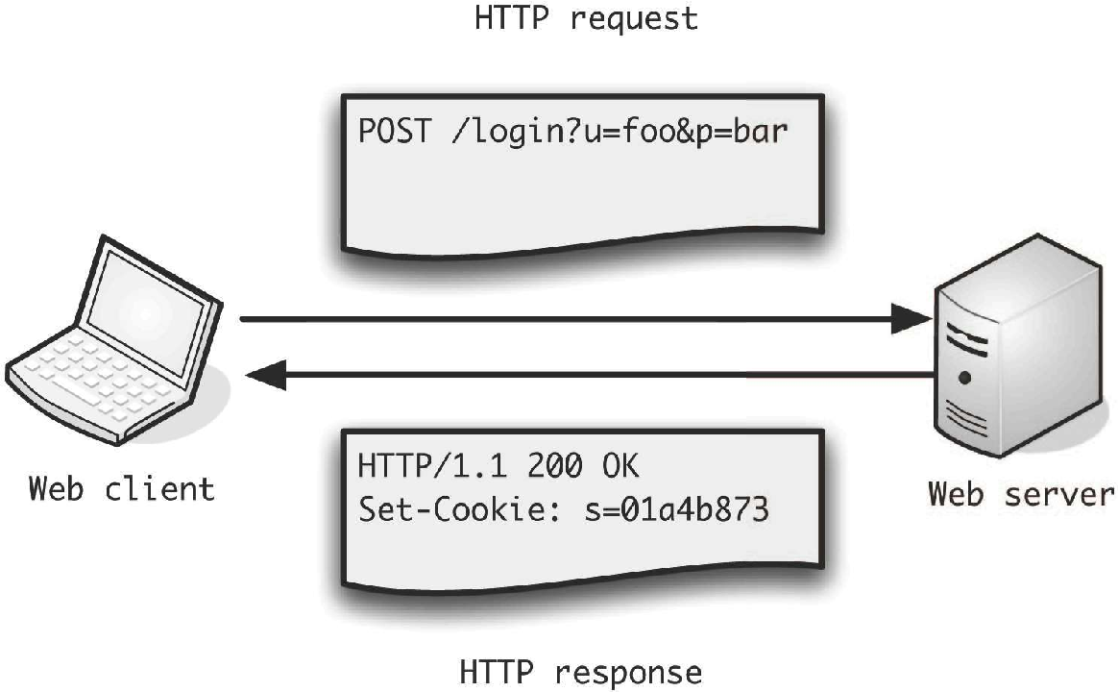
Web Requests

- The client makes a request to a server
- DNS turns the address into an IPv4 or IPv6 number
- A request is sent as text consisting of:
  - A request type
  - A location on the server (a path)
  - Headers
  - Optionally data (message body or parameters)
GET /hello.html HTTP/1.1
User-Agent: Mozilla/4.0 (compatible; MSIE5.01; Windows NT)
Host: www.agileabstractions.com
Accept-Language: en-us
Accept-Encoding: gzip, deflate
Connection: Keep-Alive

Request Types

- Used by browsers, REST APIs and other clients
- For browsers, and simple APIs, GET and POST are the most common
- The five request types of REST APIs (roughly corresponding to CRUD):
  - POST – create a resource
  - GET – fetch a resource
  - PATCH – update a resource
  - DELETE – delete a resource
  - PUT – update by replacing
The Response

- If the request reaches a server we get a response
- The response consists of:
  - A status code
  - Headers
  - The message body (data)

HTTP/1.1 200 OK
Cache-Control: no-cache
Server: libnhttpd
Date: Wed Jul 4 15:32:03 2022
Connection: Keep-Alive:
Content-Type: application/json;charset=UTF-8
Content-Length: 5964

{"rowset": {"osname": "NCOMS", "dbname": alerts", ...}}}
Status Codes

- Status codes range (in theory) from 100-599
  - 100-199 Informational (rare)
  - 200-299 Success
  - 300-399 Redirect
  - 400-499 Client error
  - 500-599 Server error
- Common status codes:
  - 200 – Success, OK
  - 301 – Temporary redirect
  - 302 – Permanent redirect
  - 404 – Resource missing
  - 500 – Internal server error
Installing the requests Module

- requests is a third party library
- Much better than stdlib "urllib.request.urlopen"
- We can install it from PyPI with pip
- We'll use a "virtual environment", the venv module
- A venv is just a directory and can be deleted
Create and activate a new Python virtual environment.
On windows use:
".env\Scripts\activate.bat" to activate.
$ python -m venv .env
$ source .env/bin/activate
(.env) $ which pip
.../.env/bin/pip
(.env) $ which python
.../.env/bin/python
Installing requests, and all its dependencies into our venv
(.env) $ pip install requests
Collecting requests
...
pip and venv for Project Management

- Keep your dependencies in "requirements.txt"
- Preferably with pinned version numbers
- Install with "pip install -r requirements.txt"
- Get a list of all your currently installed dependencies with "pip freeze"

(.env) $ pip install -r requirements.txt
...
(.env) $ pip freeze
certifi==2022.12.7
charset-normalizer==3.1.0
idna==3.4
requests==2.28.2
urllib3==1.26.15
Making Requests with requests

>>> import requests
>>> r = requests.get('https://agileabstractions.com/')
>>> r
<Response [200]>
>>> r.status_code
200
>>> r.headers['content-type']
'text/html; charset=utf-8'
>>> r.text
'<!DOCTYPE html>\n<html>\n <head>\n <title>Agile Abstractions

>>> r = requests.get('https://agileabstractions.com/not-here')
>>> r
<Response [404]>
>>> r.status_code
404
>>> r.text
'<!DOCTYPE html>\n<html>\n <head>\n <title>404 - Page not found

Exercise 7.1

Sockets

- Sit below the http protocol
- Low level protocol for communication
- Can act as server or client
- We'll use the socket module to work with them
- Stream and datagram sockets
  - SOCK_STREAM for tcp
  - SOCK_DGRAM for udp
  - AF_INET for IPv4
  - AF_INET6 for IPv6
- As well as network communication they're commonly used for inter-process communication (IPC)
The socket Module

- Low level functionality provided by the socket module
- Used by all other http client/server libraries
- Includes generally useful functions like:
  - getaddrinfo
  - getfqdn
  - gethostbyname
  - inet_ntoa
  - etc…
- Plus some constants and exceptions useful outside directly working with low level sockets
A TCP Socket Server

- Let's create a simple socket echo server and client
- Create a socket and start it listening

import socket
# Create a TCP/IP socket (SOCK_STREAM) using IPv4 (AF_INET)
sock = socket.socket(socket.AF_INET, socket.SOCK_STREAM)
# Bind the socket to the port
server_address = ('localhost', 10000)
print('starting up on {} port {}'.format(*server_address))
sock.bind(server_address)
# Listen for incoming connections
sock.listen(1)

Note: see also the socketserver module for more practical socket servers. This is a nuts and bolts tutorial.
An Echo Server

- Listen and echo back the data
while True:
print('waiting for a connection')
# this blocks until a connection is made
# connection is a socket object
connection, client_address = sock.accept()
with connection: with closes the socket for us
print('connection from', client_address)
# Receive the data in small chunks and retransmit it
while True:
data = connection.recv(16)
print('received {!r}'.format(data))
if data:
print('sending data back to the client')
connection.sendall(data)
else:
print('no data from', client_address)
break
TCP Socket Client

- Use connect instead of bind

import socket
# Create a TCP/IP socket
sock = socket.socket(socket.AF_INET, socket.SOCK_STREAM)
# Connect the socket to the port where the server is listening
server_address = ('localhost', 10000)
print('connecting to {} port {}'.format(*server_address))
sock.connect(server_address)
The Echo Client

- Send data and retrieve response

with sock:
# Send data
message = b'This is the message. It will be repeated.'
print('sending {!r}'.format(message))
sock.sendall(message)
# Look for the response
amount_received = 0
amount_expected = len(message)
while amount_received < amount_expected:
data = sock.recv(16)
amount_received += len(data)
print('received {!r}'.format(data))

Exercise 7.2

Section 8

Concurrency

Concurreny

- Basic principles
- The Global Interpreter Lock
- Threading
- Multiprocessing
Multitasking

- Multitasking with a single CPU means task switching
Task 1:
run
run
run
switch
Task 2:
run
switch
run
run

- The cost of task switching means running tasks concurrently is slower than running them consecutively

True Concurrency

With multiple cores and multiple CPUs, modern computers can do "parallel processing" and run multiple tasks simultaneously without the overhead of task switching.
Task Execution

- Tasks tend to be "I/O bound" (Input/Output) or "CPU bound"
- I/O means a network request, or accessing a file or a database which is much slower than the CPU, so the task spends a lot of time waiting
- CPU bound tasks do a lot of processing and will use as much processing power as you can give them
I/O
I/O
I/O
I/O
I/O
I/O
I/O
I/O
I/O
An I/O bound task

I/O
I/O
A CPU bound task

Task Execution

- A web crawler is an example of an I/O bound task
- Image processing is an example of a CPU bound task
- A single processor can run many I/O bound tasks concurrently as they spend most of their time waiting
- The basic unit for concurrent task execution is the "thread", an OS level unit of execution
- Multiple threads can run within a process
- Threads in Python are real system threads, the OS does the scheduling/thread switching
  - POSIX threads (pthreads) for Linux/Mac
  - Windows threads
- An alternative model for running multiple tasks concurrently is to use multiple processes
Processes

- Every program runs as a separate process
- Processes have "memory isolation"
- A process inherits an environment from the OS
- With multiple CPUs multiple processes can run concurrently
- Programs may launch "sub-processes", which inherit the same (or a modified) environment
- Sharing information between processes means "inter-process communication" of some kind (or shared memory)
- Both the subprocess and multiprocessing modules enable you to work with processes
- "Use processes not threads" is a common Python mantra
The Global Interpreter Lock

- Python has a Global Interpreter Lock, the GIL
- Only one thread of Python code executes at a time
- The GIL simplifies the interpreter and means fewer locks internally (faster single threaded code, the common case)
- The GIL makes threads suitable for I/O bound tasks only
- CPU bound tasks will run slower!
- C extensions may release the GIL and run concurrently
- For parallel processing use processes
- For I/O bound tasks, event loops and coroutines (green threading) are another alternative (asyncio)
Threads

- With threads we have multiple tasks running together within a program, each thread is independent but with access to shared resources
$ python program.py
statements
statements
...
create thread(foo)
statements
statements
...
Program launch. Python starts and runs code on the "main thread".
Starting a new thread launches a function, which runs concurrently.
def foo():
statements
statements
...
"main thread"
...
Threads

- Threads run independently until they terminate on return or program exit
- Many "thread primitives" (locks, events, queues, etc) allow them to communicate and synchronise
- No shared resources (the "actor model"/CSP) is a way to minimise locking and maximise sanity
- The GIL ensures only one thread is actually running Python code at any time
- The GIL is released/acquired every hundred interpreter "ticks" or so (around bytecode boundaries)
- We use the threading module to access threads

Functions as Threads

- How to launch a function in a thread

import threading
import time
def countdown(count):
while count > 0:
print("Counting down", count)
count -= 1
time.sleep(5)
>>> t1 = threading.Thread(target=countdown, args=(10,))
>>> t1.start()
Counting down 10
>>> Counting down 9
Counting down 8
Counting down 7

- countdown runs in a thread. We can still execute code in the interactive interpreter ("main thread") whilst it runs
Joining a Thread

- Once you start a thread it runs independently until it returns or the program exits
- Threads don't return a value, use a queue
- Use t.join() to wait for a thread to exit

t.start() # Launch a thread
...
# Do other work
...
# Wait for thread to finish
t.join() # blocks until t exits
- This only works from another thread
- A thread can't join itself!

Exercise 8.1
Thread Termination

- Python has no built in support for thread cancellation
- Sometimes programs with threads can only be force killed! (kill -9)
- The normal solution is periodic polling and a terminate flag
- You can cancel threads at the OS level using the ctypes library and this solution (but it isn't recommended):

https://stackoverflow.com/questions/323972/is-there-
any-way-to-kill-a-thread-in-python

Race Conditions

- Threads can introduce great complexity
- Race conditions deadlocks, livelocks, resource contention, etc…
- You will need locks to access shared resources to avoid race conditions
Executing concurrently
Thread 1

x is 9

...

x is 9
+=1
x is 10
Thread 2

x is 9

...

x is 9
+=1
x is 10
x = 9

statements
statements
...
race condition
x += 1

- If two threads read x as 9 at the same time and both add 1 then x will be 10 when it should be 11
Mutex Locks

- Thread safe concurrent access to resources with locks

import threading
m = threading.Lock()
with m: # Acquires the lock (or blocks)
statements
statements
...
# Lock is released
statements
- Only one thread can acquire the lock at a time
- Others will block waiting for it to be released
- with automatically acquires and releases the lock
- All access to shared resources must be protected with locks
Coordinating Threads

- Synchronising threads or communicating between them can be done with an Event
  - Events have an internal flag that can be set/clear and other threads can wait on it being set
- Other useful thread specific primitives:
  - Re-entrant locks
  - Queues (useful for implementing the actor model)
  - Conditions
  - Semaphores
  - Thread local variables

See also: concurrent.futures.ThreadPoolExecutor is a high level interface to push tasks to a background thread.

Exercise 8.2
Processes

- For concurrent task execution with processes we use the multiprocessing module
- Provides a similar API and primitives to the threading module
- Uses fork on Linux
- On Windows tasks and their environment are pickled and sent to the new process (so higher startup cost)
- Using processes bypasses the problem of the GIL (one GIL per process)
Multiprocessing

- Creating a process and sending it a task is easy
- The task must be "importable" by the new process
- Processes have useful methods like join/kill/is_alive, etc

import multiprocessing
def worker(i):
print(f'Worker {i}')
if __name__ == '__main__':
for i in range(3):
p = multiprocessing.Process(target=worker, args=(i,))
p.start()
$ python workerprocesses.py
Worker 0
Worker 1
Worker 2

Higher Level API: ProcessPool

- A process based worker pool
p = multiprocessing.Pool([num_processes])
- It executes functions in a subprocess
- It maintains a pool of workers to divide tasks between
- A high level API, no need to worry about the details
- Core pool operations:
p.apply(func [, args [, kwargs]])
p.apply_async(func [, args [, kwargs [,callback]]])

- apply blocks and waits for a result
- apply_async returns a result object you can poll for the result or wait on
Pool: apply()

- Running a function in another process

import multiprocessing
def add(x, y):
return x + y
if __name__ == '__main__':
p = multiprocessing.Pool()
r = p.apply(add, (3, 4))
print(r)

$ python processingpool.py
7

- apply() runs the function in one of the subprocesses and waits for the result
Pool: apply_async()

- Running a function in another process without blocking
- Provides a handle (an ApplyResult) to fetch the result

import multiprocessing
import time
def add(x, y):
return x + y
if __name__ == '__main__':
p = multiprocessing.Pool()
r = p.apply_async(add, (3, 4)) # r is an ApplyResult object
# We could call r.wait([timeout])
while not r.ready():
time.sleep(0.1)
print(r.ready())
print(r.successful())
print(r.get()) # get has an optional timeout param

Exercise 8.3

Section 9

Data Science

Data Science

- No strict definition
- Associated with "big data"
- Anything to do with data!
- Data cleaning and preparation (not covered here!)
- Statistics (not covered here!)
- Machine learning and AI (not covered here!)
- The science is the exploratory understanding of domain specific data – the search for meaning
- We'll take a brief tour of the common tools for data science in Python
Data Science

- Modern tools of data science
  - OpenPyXL
  - Pandas
  - numpy
  - matplotlib
Excel

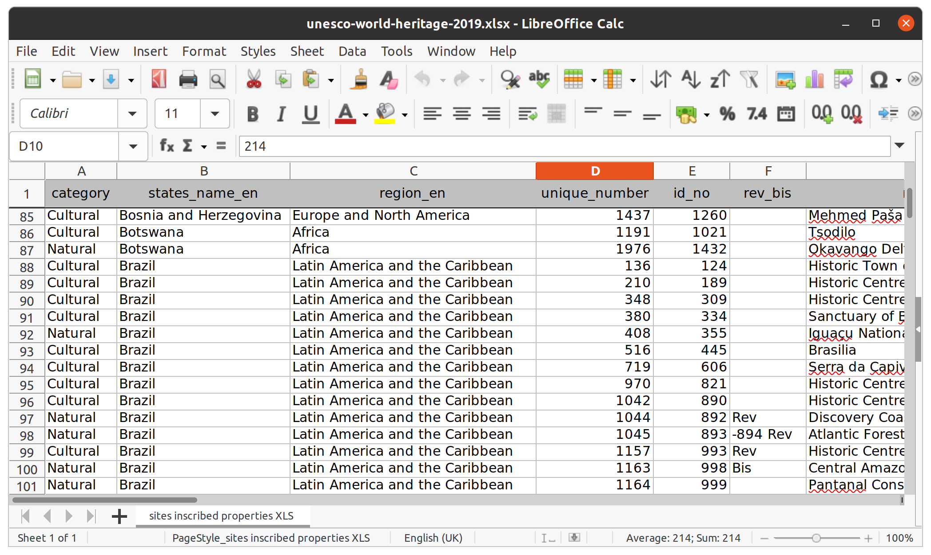
- Excel is the most common data tool and programming interface

OpenPyXL Reading Data

- Use openpyxl for modern Excel files, xlrd for '.xsl' files
- An object oriented interface for reading and writing Excel files
- pip install openpyxl
- Will use lxml if installed
- Needs pillow for working with images

>>> from openpyxl import load_workbook
>>> wb = load_workbook('Data/unesco-world-heritage-2019.xlsx')
>>> wb
<openpyxl.workbook.workbook.Workbook object at 0x8eb0>
>>> wb.sheetnames
['sites properties']
>>> sheet = wb['site properties']
>>> sheet
<Worksheet "site properties">
OpenPyXL Reading Data

- We can index a sheet to get cells, or use the cell method
- The first row is the column titles which we get from '.value'

>>> sheet.dimensions
'A1:V1122'
>>> sheet['A1']
<Cell 'site properties'.A1>
>>> sheet['A1'].value
'category'
>>> sheet.cell(row=1, column=1).value
'category'
>>> for col in 'ABCDEFGHIJKLMNOPQRSTUV':
... print(sheet[f'{col}1'].value)
...
category
states_name_en
region_en
unique_number
...
OpenPyXL Reading Data

- sheet.rows gives us a generator for the rows
- sheet.columns gives us a generator for the columns
- Spreadsheets are row oriented data, so generally we want rows
- Indexing by number gives us row, by letter column
- Each of these return a tuple of cell objects
- Many more methods and attributes on workbooks, sheets and cells for accessing data, including:
  - Fonts and properties of cells/worksheets
  - Ranges
  - Pivot tables
  - Images
  - etc...

Exercise 9.1
OpenPyXL Writing Data

- Creating spreadsheets and writing them is also simple
- Create a new spreadsheet with Workbook()
- This will have one worksheet: wb.active
- Let's create a new worksheet

>>> from openpyxl import Workbook
>>> wb = Workbook()
>>> sheet = wb.active
>>> sheet.title = 'A Worksheet'
>>> sheet2 = wb.create_sheet('Sheet2') # the default name
>>> wb.sheetnames
['A Worksheet', 'Sheet2']
>>> for sheet in wb:
... print(sheet.title)
...
A Worksheet
Sheet2

OpenPyXL Writing Data

  - Now let's populate our spreadsheet with data
  - Saving the spreadsheet is done with the save method

>>> digimon_columns = ['Digimon', 'Stage', 'Type', 'Attribute']
>>> data = [['Kuramon', 'Baby', 'Free', 'Neutral'],
... ['Tanemon', 'In-Training', 'Free', 'Plant'],
... ['Agumon', 'Rookie', 'Vaccine', 'Fire'],
... ['IceDevimon', 'Champion', 'Virus', 'Water']]
...
>>> for col, title in zip('ABCD', digimon_columns):
... sheet[f'{col}1'].value = title
...
>>> for i, row in enumerate(data, start=2):
... for j, value in enumerate(row, start=1):
... sheet.cell(row=i, column=j).value = value
...
>>> wb.save('example.xlsx')

Exercise 9.2
Pandas

- Pandas is the standard tool for data science in Python
- Provides a powerful and easy to use DataFrame object, a 2D typed array (each column has a type)
- Partially built on numpy (but less than it used to be)
  - numpy provides n-dimensional arrays
- For working with row oriented data
- Functionality includes:
  - Load data from different files types and online sources
  - Filtering, sorting, editing and processing of data
  - Joining and aggregation of datasets
  - Tools for time series and statistical analysis
  - Display of data in tables and charts
Pandas

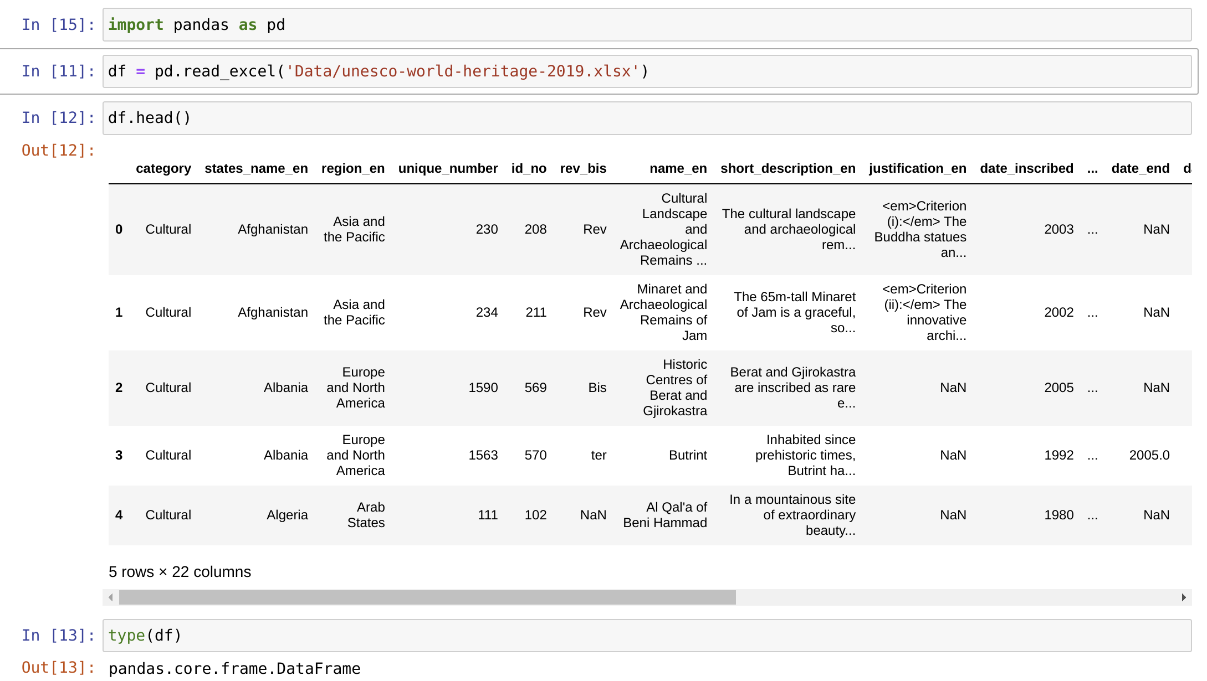
DataFrame

- Both columns and rows have indexes which can be labels
- head(), tail() and sample() methods show us part of the data
- info(), describe() and shape tell us about the data
- iloc allows us to index into the data by integer index
- DataFrame common types:
  - object - used for strings, arbitrary objects, or if the column contains a mix of data types
  - int64 – integers
  - float64 - floats, or where a column has integers and NaN values
  - datetime64 / timedelta - time-based values
  - bool - booleans, i.e. True or False
  - Plus NaN and NaT (Not a Number and Not a Time)
Pandas

- Reading from a csv file

>>> import pandas as pd
>>> df = pd.read_csv('Data/portfolio.csv')
>>> df.head(2)
name shares price
0 AA 100 32.20
1 IBM 50 91.10
>>> df.info()
<class 'pandas.core.frame.DataFrame'>
RangeIndex: 7 entries, 0 to 6
Data columns (total 3 columns):
# Column Non-Null Count Dtype
--- ------ -------------- -----
0 name 7 non-null object
1 shares 7 non-null int64
2 price 7 non-null float64
dtypes: float64(1), int64(1), object(1)
memory usage: 296.0+ bytes
DataFrame

>>> df.shape # the dimensions (rows, columns)
(7, 3)
>>> df.columns
Index(['name', 'shares', 'price'], dtype='object')
>>> df.index
RangeIndex(start=0, stop=7, step=1)
>>> df.dtypes
name object
shares int64
price float64
dtype: object
>>> df.iloc[6, 2] # gets a single value
70.44
>>> df.iloc[1] # gets the whole row
name IBM
shares 50
price 91.1
Name: 1, dtype: object
111
>>> df['name'] # gets the whole column
0 AA
1 IBM

Exercise 9.3
matplotlib

- More than 25% of all images in the scientific Archive are generated with matplotlib (and the Python/SciPy stack)
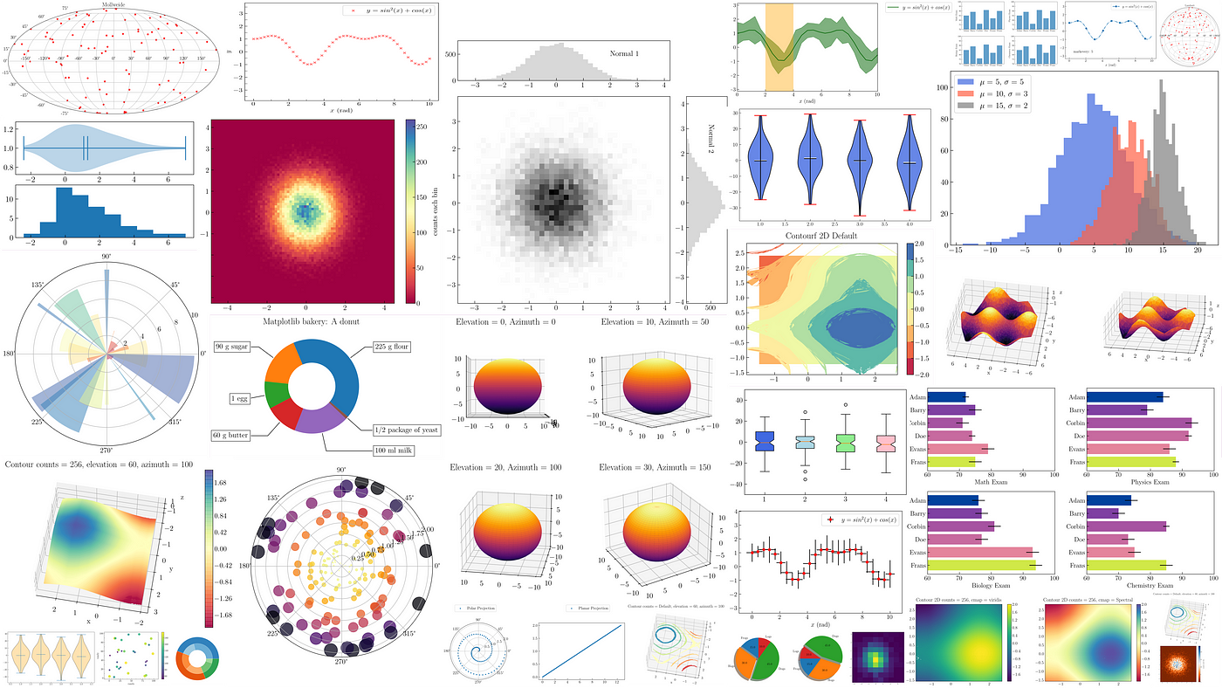

matplotlib

- A very powerful library with simple interface
- Basic integration with Pandas
- Supports many kinds of plots and charts (including interactive)
  - Bar charts
  - Line graphs
  - Scatter plots
  - Heat maps
  - Pie charts
  - etc…
- Can produce high quality charts but can be tricky to configure
A Simple Plot

- matplotlib plots numpy arrays
- Use the .to_numpy() method to convert a Pandas DataFrame (or column, row or series) to a numpy array

>>> import matplotlib.pyplot as plt
>>> import numpy as np
>>> fig, ax = plt.subplots()
>>> x = np.linspace(0, 10, 300)
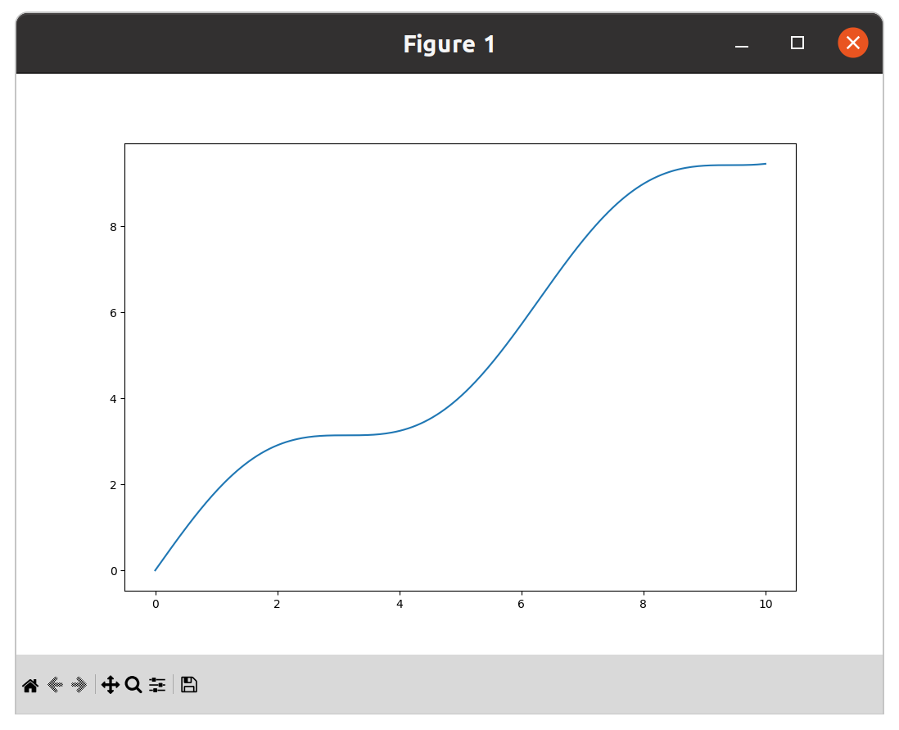
>>> y = np.sin(x) + x
>>> ax.plot(x, y)
>>> fig.show()

Pandas Integration

- Plotting a time series

>>> from numpy.random import randn
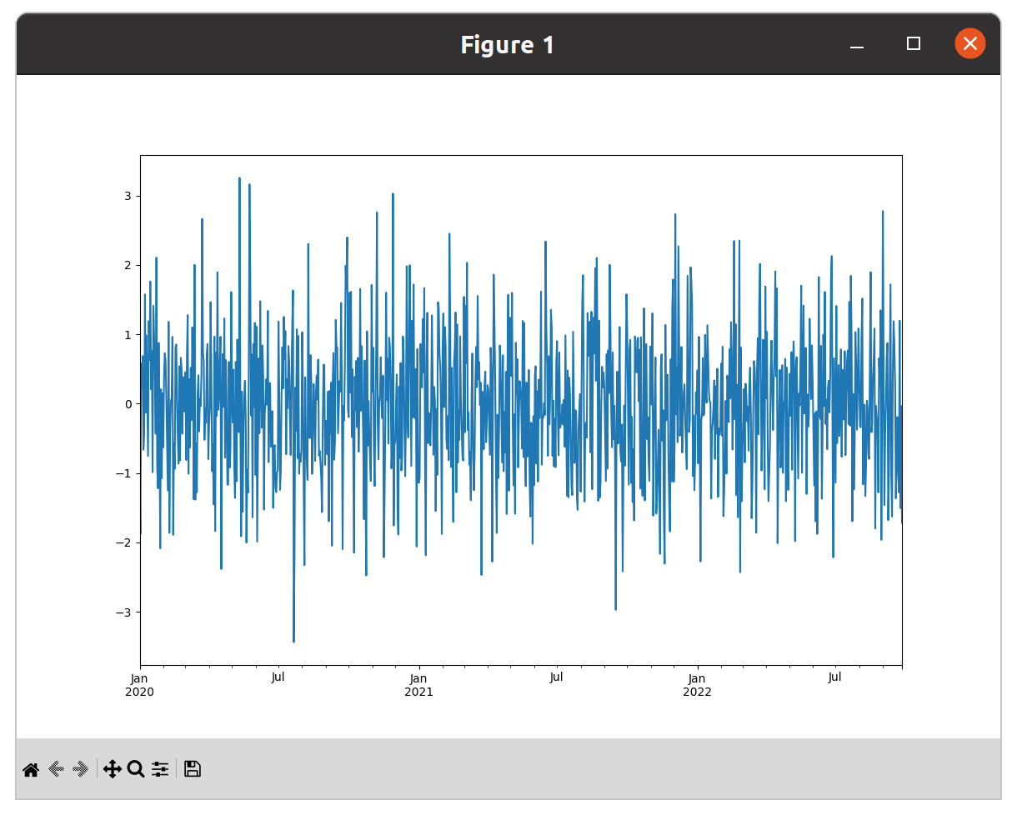
>>> ts = pd.Series(randn(1000), pd.date_range('1/1/2022', periods=1000))
>>> ts.cumsum()
...
Freq: D, Length: 1000, dtype: float64
>>> ts.plot()
<Axes: >
>>> plt.show()

Bar Charts

>>> import pandas as pd
>>> from numpy.random import rand
>>> import matplotlib.pyplot as plt
>>> df = pd.DataFrame(rand(10, 4), columns=['a', 'b', 'c', 'd'])
>>> df.plot(kind='bar', stacked=True) >>> df.plot(kind='bar')
<Axes: >
>>> plt.show()

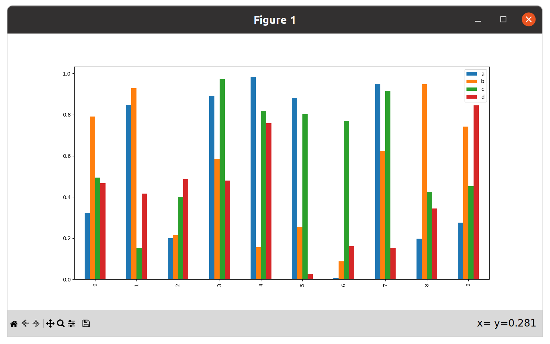
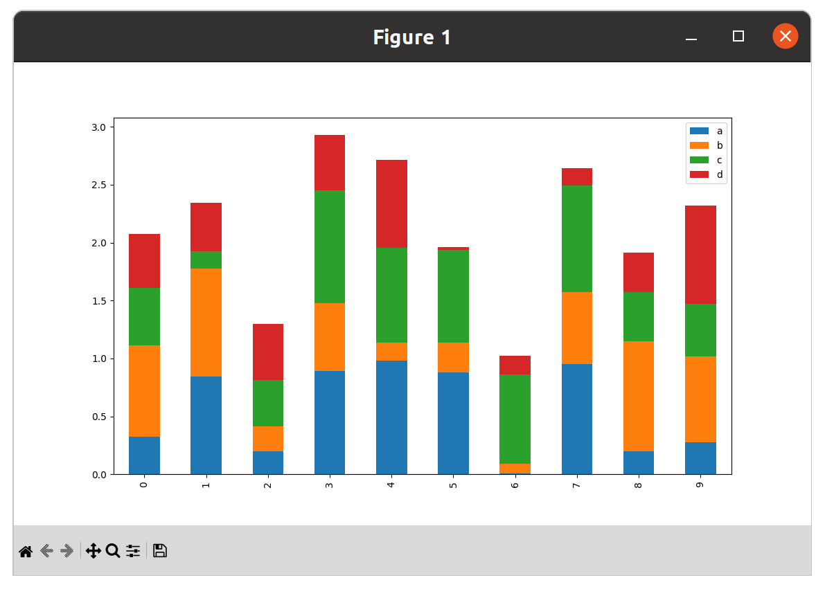
Chart Customization

>>> x = np.linspace(0, 10, 300)
>>> y = np.sin(x) + x
>>> fig, ax = plt.subplots(figsize=(15,10))
>>> fig.suptitle('A Customised Plot', fontsize=40)
>>> ax.plot(x, y, c='r', linestyle='dashed', linewidth=4)
>>> ax.grid()
>>> ax.set_xlabel("The x axis", fontsize=30)
>>> ax.set_ylabel("The y axis", fontsize=30)
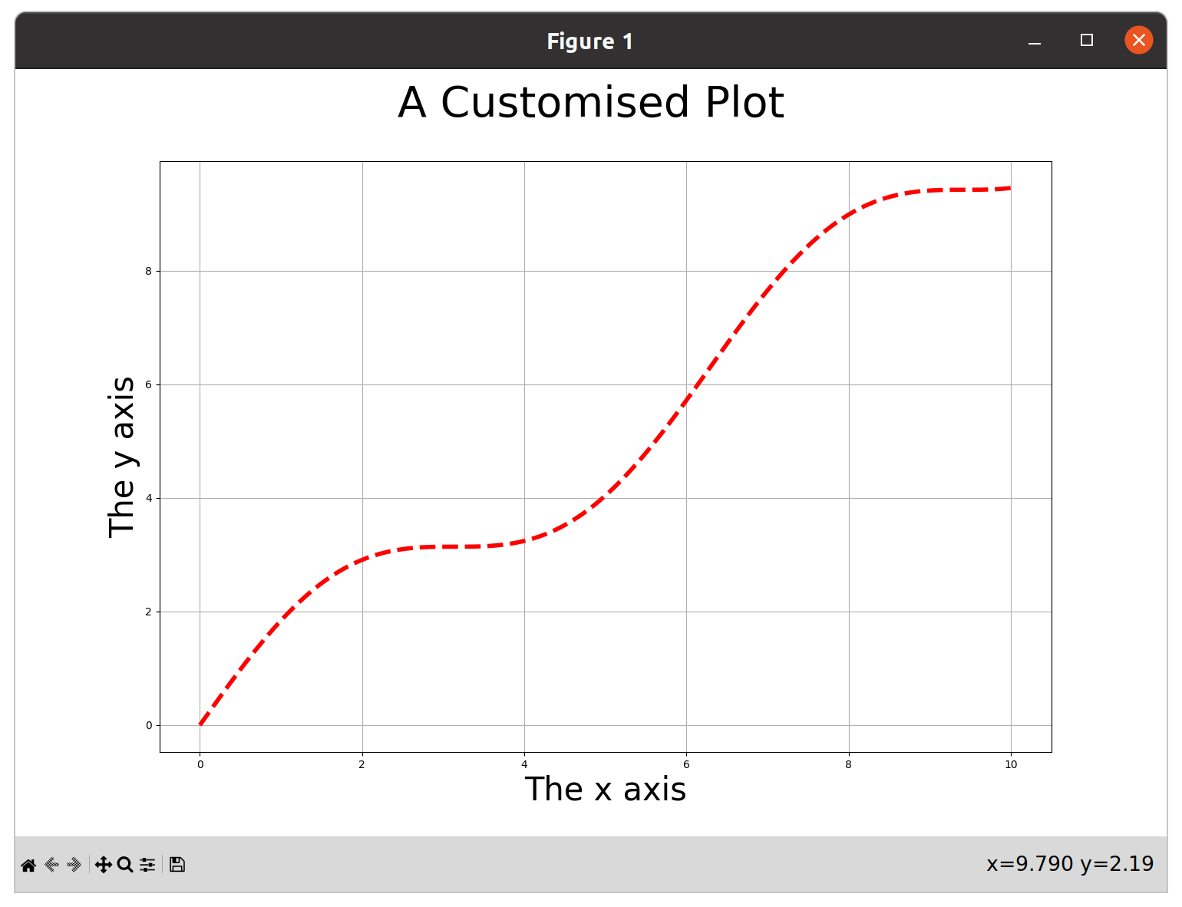
>>> plt.show()

Exercise 9.4

Section 10

More Python

More Python

- A few very useful bits of Python syntax we haven't already covered
- Some of them from more recent versions of Python
    - Generator expressions
    - Ordered dictionaries
    - Ternary expressions
    - The walrus operator
    - Positional and keyword only arguments

Generator Expressions

- List comprehensions are "eager", they consume their input and produce a list
- Many of the builtin functions in Python are "lazy", they produce iterable objects instead of executing immediately

>>> range(100)
range(0, 100)
>>> zip(['name', 'shares', 'prices'], ['GOOG', 100, 490.10])
<zip object at 0x7f503b5d80c0>
>>> enumerate(nums)
<enumerate object at 0x7f503b6a8840>

- Generator expressions are a lazy version of list comprehensions

Generator Expressions

- Generator expressions produce "one shot" generators
- The syntax is very similar to list comprehensions

>>> a = [2, 4, 6, 8, 10]
>>> b = (x**2 for x in a)
>>> b
<generator object <genexpr> at 0x7f503b78f760>
>>> for result in b:
... print(result)
...
4
16
36
64
100

- They don't produce a list, so the whole result set doesn't need to be in memory
- They can't be reused

Generator Expressions

- General syntax (very similar to list comprehensions)

(expression for names in iterable if conditional)

- They look better than list comprehensions in function calls

sum(x*x for x in a)

- Can be applied to any iterable and even chained together

>>> a = [1,2,3,4]
>>> b = (x*x for x in a)
>>> c = (-x for x in b)
>>> for i in c:
... print(i, end=' ')
...
-1 -4 -9 -16

Ordered Dictionaries

- Since Python 3.7 Python dictionaries are now ordered by insertion order
- Originally a memory (layout) optimisation originating in pypy and ported to CPython
- Iteration over dictionaries, the keys and values and items, all preserve order

>>> d = {}
>>> d['first'] = 1
>>> d['second'] = 2
>>> d['third'] = 3
>>> list(d)
['first', 'second', 'third']
>>> d.keys()
dict_keys(['first', 'second', 'third'])
>>> d.items()
dict_items([('first', 1), ('second', 2), ('third', 3)])
>>> d.values()
dict_values([1, 2, 3])
Ternary Expressions

- Also known as "conditional expressions"
- A concise way of having an expression evaluate to a value based on a condition

>>> email_address = None
>>> send_email = True if email_address is not None else False
>>> send_email
False
>>> email_address = 'michael@python.org'
>>> send_email = True if email_address is not None else False
>>> send_email
True

- Very terse syntax, it maybe clearer to use if/else
- Like list comprehensions it can be helpful to start reading them in the middle (the true condition is on the left, the false is on the right and the if is in the middle)
The Walrus Operator

- Assignment as an expression: x := 3
- New in Python 3.8
- Useful where you need to test a value immediately after setting it
- Can be used to write inscrutable code!

- Old code (regular expressions):

>>> match = re.match(r'\w+@(\w+\.\w+)', email_address)
>>> if match is not None:
... domain = match.groups(1)
...

- With the walrus operator:

>>> if match := re.match(r'\w+@(\w+\.\w+)', email_address):
... domain = match.groups(1)
...

Positional and Keyword Only Arguments

- Python function signatures are now very rich
- We can now express positional and keyword only arguments
- Positional only arguments (mostly for compatibility with C functions) added in Python 3.8
- Keyword only arguments were new in Python 3.0

>>> def foo(data, /, *, debug=False):
... pass
...
>>> foo(1, debug=True)
>>> foo(data=2)
Traceback (most recent call last):
File "<stdin>", line 1, in <module>
TypeError: foo() got some positional-only arguments passed as keyword arguments: 'data'
>>> foo(3, False)
Traceback (most recent call last):
File "<stdin>", line 1, in <module>
TypeError: foo() takes 1 positional argument but 2 were given

