Introduction to pytest


pytest

- Defacto standard testing tool for Python
- unittest is in the standard library, pytest is better
- pytest is a command line tool for collecting and running tests
- Also a framework for writing tests
- Extendable by plugins (not very hard to write), for example pytest-asyncio for async testing
- Very widely used, lots of documentation and videos
- The purpose of testing is to verify behaviour
- https://pytest.org/

Installing pytest

- Install pytest into a virtual environment
- pipenv is commonly used to manage environments and dependencies
- Pipfile and Pipfile.lock specify dependencies
- Install and create the virtual environment with "pipenv install"
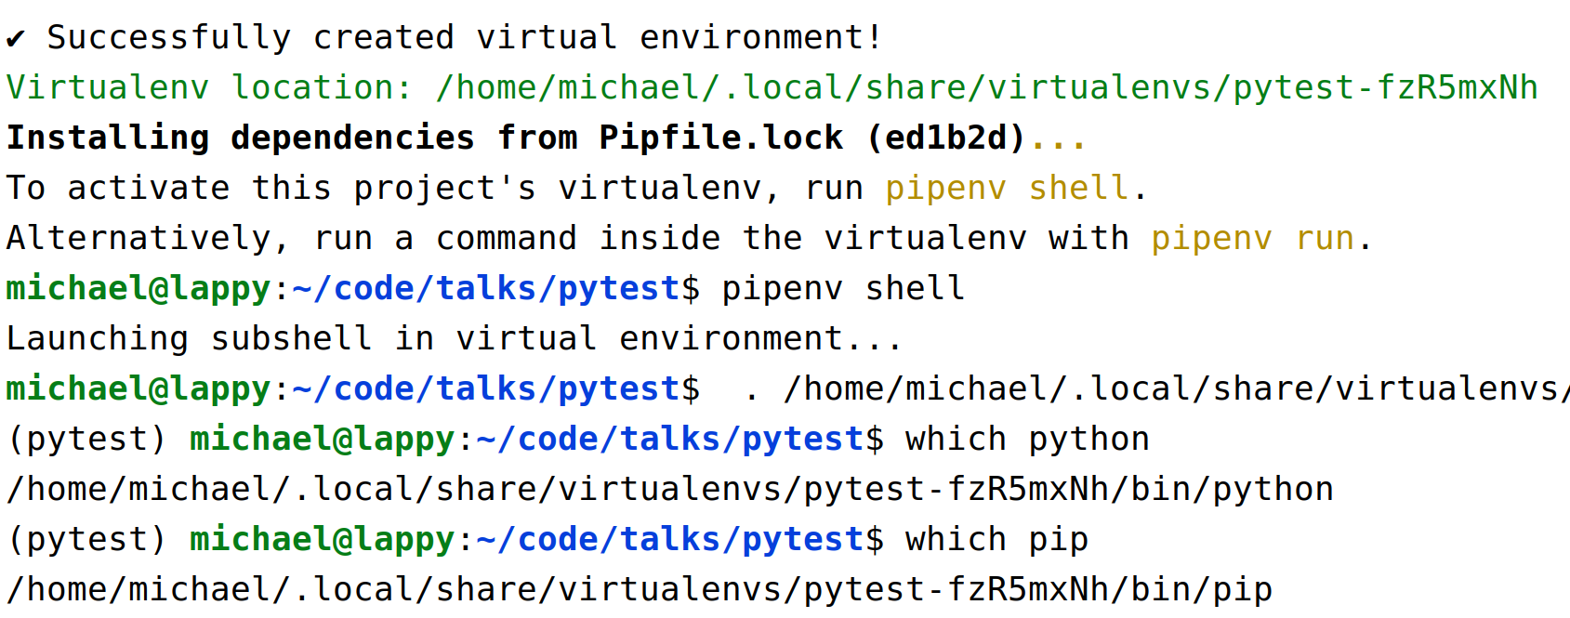
- Activate the virtual environment with "pipenv shell"
Creating a Test Suite

- Test collection is done with a naming convention:
- Write tests as functions* in files called "test_something.py" (etc)
- They probably live in a project directory called "tests"
- Run the tests with pytest
- A "test suite" is a collection of tests found from test files

(*) Tests can be collected in classes or generated. Test functions are most common though.
Test Functions

- Functions should be named "test_something" as well
- Use the assert statement to verify something
  - assert actual_value == expected_value
- The test fails with a useful error message if an assert fails or something goes wrong (an exception raised)
def test_function():
result = 1 + 2
assert result == 3
def test_failing_test():
result = 1 + 2
assert result == 4
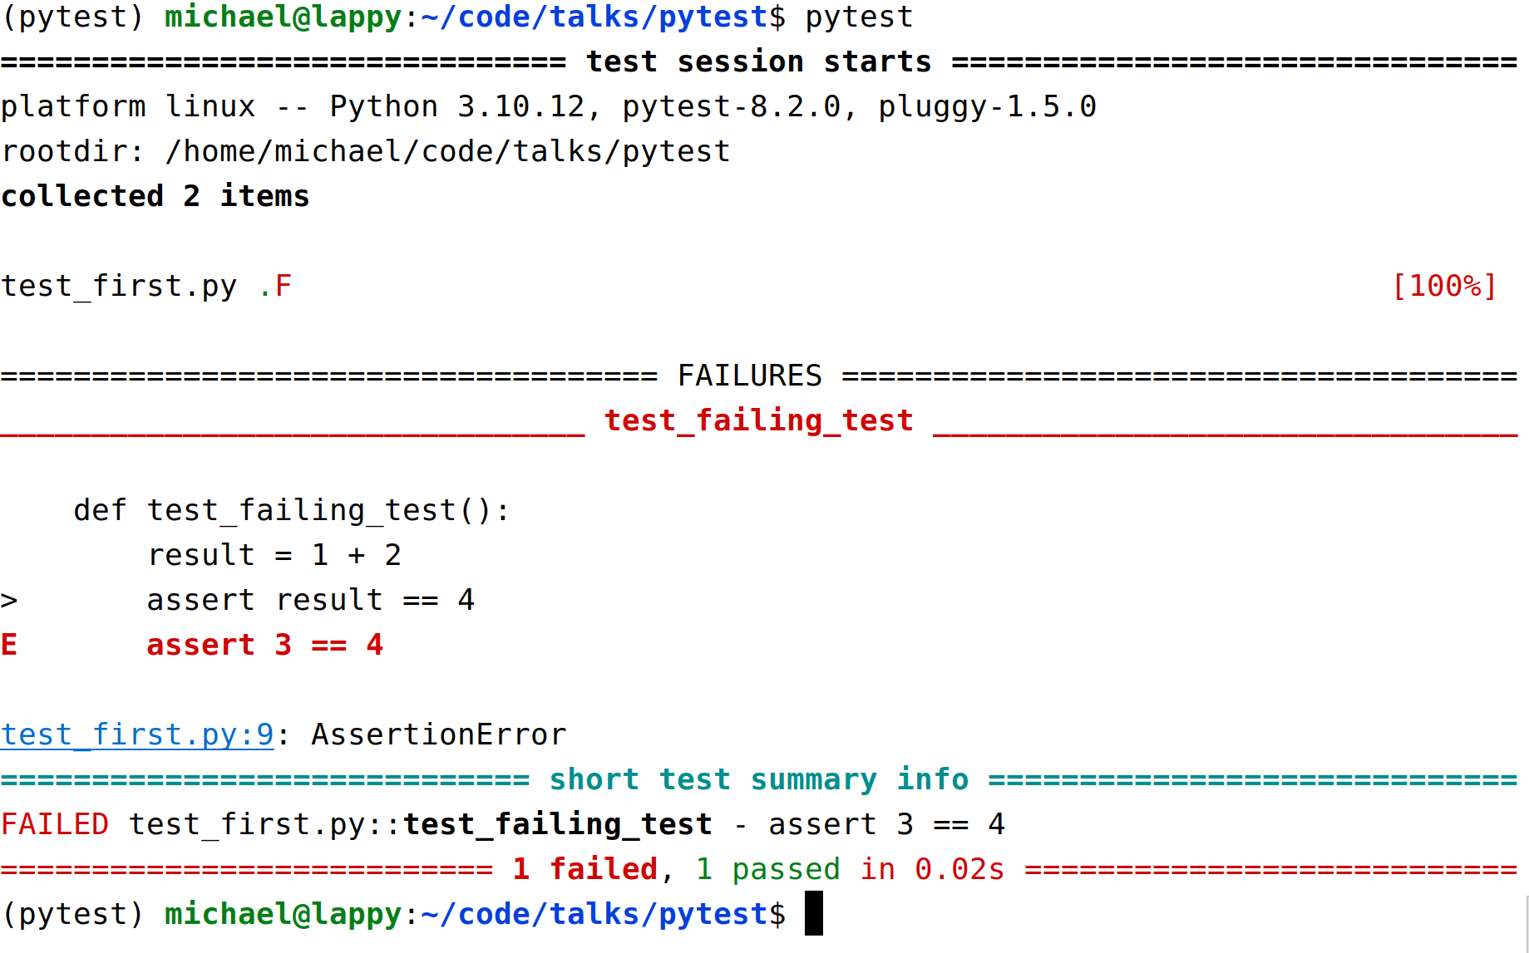
Test Run
Different Types of Test

- Types of test (jargon and usage can vary):
  - Unit tests
    - Short tests to verify behaviour of individual components, written by devs
    - Test the unit of behaviour not implementation
    - Should be fast and ideally not use external resources
    - Often depend on mocking
  - Functional tests
    - QA tests are usually functional tests
    - Also called end to end tests
    - The most useful tests (for CI/CD and refactoring)
    - Verify behaviour from the point of view of the user
    - Do as little mocking as possible
  - Integration tests
    - Verify connection between components
    - Sometimes a synonym for functional tests
    - Avoid over testing and skip this layer...
Setting up the System Under Test

- The code you're testing is the "System under test"
- It usually needs setting up before you can test it
  - You might need to run a server
  - You might need to provide or populate test data
  - You might need to mock out some external services for the tests to work
- We can setup the system under test using pytest fixtures

Fixtures

- Test functions specify test fixtures as parameters
- Fixtures are made available once they've been imported
- When a test is run the fixture is called by pytest and passed into the function for you
- A common place to put them is conftest.py which pytest always checks
  - But fixtures and other test helpers may live in separate modules
- Mark the function as fixture a with the pytest.fixture decorator
- Fixtures can also take fixtures, so you can build them on top of each other
- Fixtures can be hard to trace in code, don't go overboard! Avoid "fixture hell" (fixtures that take fixtures that take fixtures that take …)
A test_client Fixture

- These fixtures starts a web app running (using connexion 3 and Flask 3) and return a client for testing
- The fixtures in conftest.py are automatically called and the result passed to the "test_app" function

from app import create_app
import pytest
@pytest.fixture
def app(event_loop):
return create_app()
@pytest.fixture
def test_client(app):
return app.test_client()
conftest.py
def test_app(test_client):
response = test_client.get('/healthz/live')
assert response.json() == {'response': 'Healthy'}
test_second.py
Parameterise Tests

- Running tests with combinations of inputs (and expected outputs) can be done with parameterize decorator

import pytest
from operator import add
sample_test_cases = [
# (x, y, result)
(1, 2, 3),
(0, 0, 0),
(-1, 2, 1),
]
@pytest.mark.parametrize("x,y,result", sample_test_cases)
def test_add(x, y, result):
assert add(x, y) == result

Note: similar to subTest in unittest
Parameterise Tests

- pytest creates a test case for every input
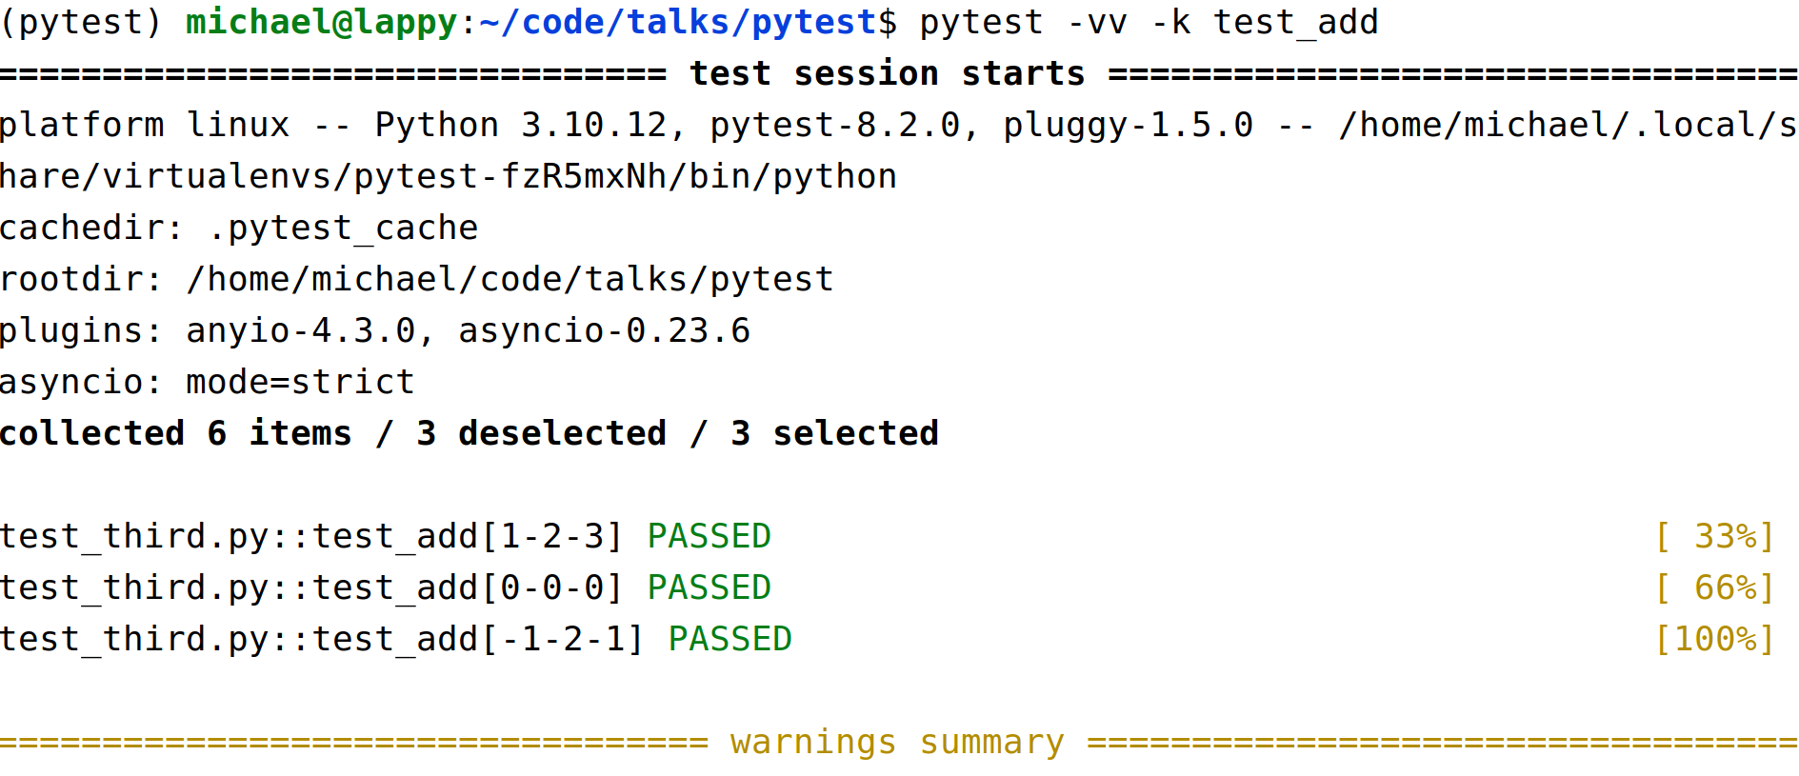

Marking Tests

- We can mark tests to group them and only run a subset, like smoke tests or slow tests (etc)
- Check the documentation for some useful standard marks:
  - skip – always skip the test
  - skipIf – skip on a condition
  - xfail – mark a test that is expected to fail (it will raise an error if the test passes)
- We can also use custom marks like "slow" or "smoke_test"

Marking Tests

import pytest
import sys
import time
@pytest.mark.skipif(sys.platform=='win32', reason="Skipped on windoze")
def test_not_windows():
assert sys.platform != 'win32'
@pytest.mark.smoke_test
def test_core_functionality(test_client):
def test_app(test_client):
response = test_client.get('/healthz/live')
assert response.status == 200
@pytest.mark.slow
def test_slow():
time.sleep(10)
assert True
Command Line Arguments

- pytest -k test_name
  - Select test functions or file by [partial] name

- pytest -v/-vv
  - Verbose (and more verbose) test run output

- pytest -m smoke_test
  - Run a subset of tests with marks

- pytest --runslow
  - Custom command line options
  - Setup in conftest.py (see example code)

- pytest --help/-h
Testing Exceptions

- Test error handling/exceptions with pytest.raises
- If no exception is raised, or a different type of exception, the test fails

import pytest
expected_message = 'can only concatenate str (not "int") to str'
def test_exception():
with pytest.raises(TypeError) as exc_info:
"3" + 4
assert str(exc_info.value) == expected_message

