**5110VEMU (Version 2)**

**voidstar’s Wintel Compatible IBM 5110 Emulator**

## Introduction

Christian Corti’s original emulator used X11 GUI interfaces, which is typically available on Unix-like operation system (or under Windows with the Cygwin package). This included an excellent reproduction of the IBM screen font by Thomas A. Fine (of Harvard). Around 2015, Norbert Kehrer wrapped this emulator into a web-based emulator, which makes the emulator very easy to use (by having a full virtual keyboard to type with and replicates the overall look-and-feel of the IBM 5110 system). However, the online IBM 5110 currently lacks features to “fast load” binary sequences (nor BASIC or APL sequences), so they have to be re-keyed in each time the emulator is started.

To address this, 5110VEMU was built. 5110VEMU is a 2022 updated build of Christian’s original emulator code, to function under the Wintel (Windows/Intel x86 or x64) platform. X11 is replaced by pdcurses, where multiple information windows are presented to provide runtime-state context of the emulator. The intent is to help study runtime behavior between the Executive and Non-Executive portions of the system, in a more observable and controllable fashion.

## What’s new in VERSION2

* Revised screen layout, to better display upcoming instructions
* Ability to load in Macro Assembler binaries directly into RAM (this effectively emulates using the DCP to do so, but without having to create a file or to re-key in the machine code sequence)

## Setup

This emulator uses the ROS binaries of the IBM 5110. This includes:

execros.bin Main Executive ROS (handles keyboard input translation and display output updates)  
basicros.bin BASIC ROS (manages execution of the Non-Executive BASIC)  
aplros.bin APL ROS (manages execution of the Non-Executive APL)  
comros.bin Common ROS  
basicnx.bin BASIC Non-Executive (System/3 code)  
aplnx.bin APL Non-Executive (System/370 code)

These files are required (using the name specified above) or the emulator will not continue to load.

Optional files are:

csf.dsk Disk version of the Customer Support Functions (auto-attached on startup)  
csf.tap Tape version of the Customer Support Functions (auto-attached on startup)  
(command input) A text file to script various inputs into the emulator (auto-parsed on startup)

Run the emulator from the bin\ folder, which should also have all the files listed above in that same folder. The current working folder should also be the bin\ (typically this is the case when running programs locally, but this might not be the case if running the emulator from a UNC path like \\fileserver\foo -- use a mapped driver letter or copy the emulator files locally to work around that).

Your overall runtime folder should look like the following:

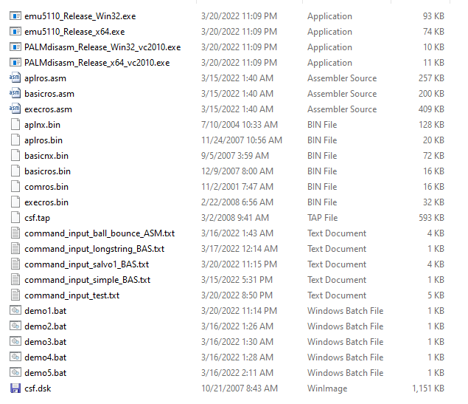

HINT: After running the DEMOx.BAT or emu5110_Release_XXX.exe files, a text-console window will appear. If not running full-screen, then use the System Menu (ALT-SPACE) to adjust the Properties to a larger font-size (I use Size 18) to make the console window context easier to read.

# Command Line Arguments

You can double-click the emu5110_Release_x64.exe file and the emulator will launch with default settings: BASIC language, no instruction stop, no scripted inputs.

From the command line, you can specify a few behaviors:

EMU5110.EXE <a|b> <stop_at> <input_script> [binary]

<a|b> A APL   
B BASIC

<stop_at> Enter STEP-MODE when reach instruction count N (use 0 for no-stop)

<input_script> ASCII text filename to be used as scripted inputs

[binary] A .bin output from ASW (Arnold Arnold Macro Assembler) that is converted to a .bin using p2bin  
NOTE: If specified, binaries are currently hard coded to load at 0x0B00.

See the “go3.bat” script for an example of using the binary load (which includes a script to pause the startup sequence just before handoff from the BR command in the DCP).

# Screen Layout

Here is an overview of the layout of the multiple screen-portions used by 5110VEMU:

The memory map at the bottom is better presented to make it easier to navigate offsets.

Past/present/future disassembled code added to the top right.

Registers better labeled and alternating colors to help identify them.

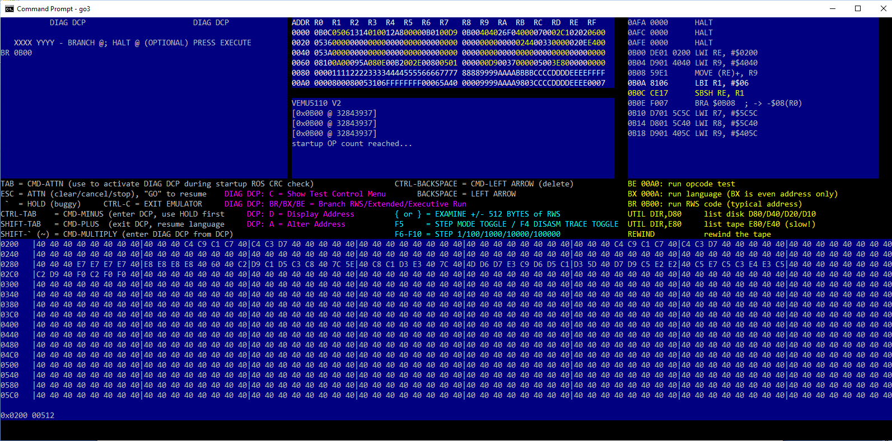

The “disasm” and “CPU states” update only during TRACE and STEP modes.

# Things to Know About the IBM 5110

## Main PC Key Mappings

**PC KEY (IBM USA) IBM 5110 Corresponding Scan Code**

ENTER/RETURN EXECUTE   
ESCAPE ATTN (use this to cancel an error, pause runtime, etc.)  
` (LEFT-APOSTROPHE) HOLD (use this first in order to enter DCP mode)  
TAB CMD-ATTN (during ROS initialization at startup, this enters DCP mode)  
! ‘ then LEFT-ARROW then . (some characters entered by a composed sequence)  
CTRL-TAB CMD-KEYPAD-MINUS (use this to enter the DCP when on HOLD)  
SHIFT-TAB CMD-KEYPAD-PLUS (use this to exit the DCP back to your language)  
SHIFT-` (or ~ TILDE) CMD-KEYPAD-MULTIPLY (use this to enter DIAG DCP)  
CTRL-BACKSPACE CMD-LEFT ARROW (like pressing DEL to delete current character)  
BACKSPACE LEFT ARROW  
? SHIFT-Q  
“ SHIFT-1  
& SHIFT-$  
< SHIFT-3  
> SHIFT-7  
: SHIFT-.  
\ SHIFT-/  
@ SHIFT-#  
( SHIFT-[  
) SHIFT-]  
ARROW KEYS Mapped to left/right up/down arrow keys  
A-Z A-Z  
0-9 0-9  
SPACE SPACE  
  
Emulator Control Keys  
F4 Toggle Disassembler Trace  
F5 Toggle Step Mode  
F6 Step one instruction  
F7 Step 100 instructions  
F8 Step 1,000 instructions  
F9 Step 10,000 instructions  
F10 Step 100,000 instructions  
{ or } Step down/up 512 bytes in RWS monitor window  
CTRL-C Exit the emulator

Presently, there is not much support for mapping PC keyboard inputs into APL symbols and functions. However, APL inputs can be specified using the scripted inputs feature.

## Clearing Errors (use ATTN key = press ESCAPE)

The IBM 5110 does not have an ESCAPE key. But it did have an early version of this concept, which it called the ATTN (attention) key. It was located near the number-pad.

After entering a BASIC or APL line of code, it is sent to the “non-executive” to essentially verify that line of code (by parsing it and ensuring it is compatible with the corresponding emulation). Your line of code may be slightly altered during this process (e.g. to fill in defaults). But if the non-executive encounters a parsing error of your line of code, an error code is returned (with a little arrow below the column where the start of the error occurred).

## Supported Keyboards

The emulator is doing an IBM PC to IBM 5110 keyboard conversion. Currently the emulator was coded with an English US standard laptop keyboard (i.e. no keypad). You may need to experiment with which keys translate to what on your system/keyboard (i.e. especially for non-US or international keyboards). Unfortunately adapting to a new keyboard style requires a re-compile, no external mapping file has yet been defined.

## Registers

The first 128 bytes of RWS is reserved as the system registers for the various execution-levels. These execution-levels are as follows:

LEVEL 0 Normal system execution  
LEVEL 1 BSCA and asynchronous communication (not supported in this emulator, no async ROS)  
LEVEL 2 Tape, Disk, Printer, Serial I/O (during tape/disk operations, you’ll see this level used)  
LEVEL 3 Keyboard (you’ll see this level used while typing)

Each “level” has 32 registers, which includes the Program Counter as the first register in each level.

## Modes

Each “level’ also has an operating mode. Conceptually, if you write an interrupt handler, inside that interrupt you could call ROS code (and different types of ROS). You can also run code that is in RWS.

Level 0 has a special startup mode called BUP (basically boot-up processing, or “bring up” mode). This mode is about the first 160,000 instruction cycles of startup. After this startup, then the ROS CRC and startup test are issued (the ABCDEFGHIJKLMNPQ things you see during the startup), which take about another 6,000,000 instructions to complete (where it then examines which programming mode is selected, and proceeds to that corresponding Language ROS).

The system can also be commanded into “RWS mode” where it is executing instructions directly from RWS memory instead of any ROS.

## DCP vs DIAG DCP Modes

DCP is Diagnostic Control Program. When in this mode, you will see “DCP” at the top of the screen. This mode has two main features: “A” (ALTER RWS memory) and “D” (display RWS memory). This program is contained in the ROS/ROM of the system.

DIAG DCP is an extended version of DCP that has two additional features: “B” (BRANCH) and “C” (TEST mode). When using any of these commands (A, B, C, D), use ESCAPE (ATTN) to cancel.

# Scripted Inputs

Scripted inputs let you emulate pressing a repeatable sequence of keys at startup of the emulator. This is a convenient way to exercise aspects of the system, and return back to specific state-conditions for study.

These inputs are expressed in ASCII text files. The format is as follows:

<command> <parameters> <comments | sequence>

<command> can be

“Q” Sequence <parameter is ignored, use 0> [asm]  
 “A” ASCII sequence <parameter is ignored, use 0> [basic]  
  
 “C” CMD-<parameter is index>  
 “S” SHIFT-<parameter is index>  
 “N” Normal key press, <parameter is index>  
  
 “D” Delay <parameter is number of screen refreshes to wait>

The difference between “Q” and “A” is that for “A”, the newline at the end will be interpreted as to press ENTER (EXECUTE). Therefore, “Q” is generally used for machine-language/assembly inputs, and “A” is generally used for text/BASIC program inputs.

“S”, “C”, and “N” are single key presses. The specified index is an index into the IBM PC keyboard codes. This means it can be some trial and error to determine which index corresponds to which intended keystroke on the IBM 5110 system. An Excel worksheet is included in the DOCS folder to help maintain this mapping (at least for the laptop keyboard that I am using). While tedious, this input mechanism does technically support non-US keyboards and is also a way to force APL key inputs. This is also a way to do function keys, like CMD-ATTN to enter DCP mode.

Certain inputs may need a pause before the next input, and the “D” Delay command is used to do that. One of the most typical uses is to stall performing inputs during the BUP (“bring up”) sequence near the startup of the system. Each screen refresh is approximately 50 instructions, and so a command “D 2” would wait about 100 instructions before proceeding with the next input entry.

See the .TXT files included in the BIN\ folder as examples of input scripts. These scripts are used by the third argument on the command line.

Note that scripted inputs must be parsed to completion before using any other aspect of the emulator. PC keyboard inputs are not enabled during the script input processing. This also means you cannot enter STEP-MODE during the scripted input. Specifying a STOP-AT count on the command line while using a scripted input can lead to some confusion or contradiction, so make sure the STOP-AT count is well beyond however many instructions the scripted input requires.

# STEP-MODE and TRACE-MODE

STOP-MODE is where the CPU automatically halts before executing an instruction. The instruction (OPCODE or Operational Code) will be read, but it won’t yet be executed. In the physical hardware, there are “cycles” (I and E) to how an opcode is parsed and performed – the emulator does not go exactly to that level of detail.

At the very startup, the STEP-MODE will appear to linger at 0x00A0 twice – which is not exactly accurate. The PC (program counter) has been set during BUP (bring up), but the OPCODE hasn’t actually been processed yet. After this is initial STEP, from thereafter the PC address will appear at the “next address” while the OPCODE shown is what is about to be executed (from the previous address).

STEP-MODE is activated in two ways: specifying a non-zero stop-on index in the command line arguments, or pressing F5 during runtime operation of the emulator.

Once in STEP-MODE (toggled by pressing F5), time is given to update the CPU state and disassemble the current opcode. Doing so during normal emulation runtime would slow things down too much, even on modern 3GHz processors (however, this is what the TRACE-MODE does, it enabled updating those two displays during normal runtime of the emulator).

When in STEP-MODE, then use F6 to step one instruction, F7 for 100 instructions, F8 for 1000 instructions, F9 for 10,000 instructions, and F10 for 100,000 instructions – depending on what you are trying to observe. For example, to see individual register changes, you may use F6 to step one instruction at a time. But to “fast forward” to a portion you are more interested in, you might use F7/F8/F9/F10 to do so (in small or larger steps).

TRACE-MODE is toggled by using F4. When activated, this mode forces the update of the CPU state and disassembly window after each instruction. This slows down the emulator significantly, so type slowly as the emulator is technically still interactive while in this mode.

# Demos

In the bin\ folder of the emulator are a set of DEMOx.BAT files, to help quickly kick off the emulator in a variety of configurations. This is intended to help “train” on how to use the emulator, and give some ideas on what you can do with it.

**DEMO1.BAT** – Introduction orientation

This demo replicates the “famous” ball-bounce demo, which is entered in machine language. The emulator does not have an on-the-fly assembler, so while it may be referred to as an “ASM” input, it is really just hard-coded machine instructions. This main point of this demo is to show how to enter the DCP, use the Alter command, enter a sequence of machine instructions, and then execute those instructions.

This is done from a scripted input text file, which can be modified to experiment with various other PALM instructions (or copy to a new text file). Once the script is finished parsing, you can then use F5 to pause (by entering STEP-MODE), then use F6/F7/F8/F9/F10 to step through the instructions (F6 being a single instruction at a time, F10 being 1,000,000 instructions at a time).

Use CTRL-C to exit the emulator. This demo just gets you familiar with a few aspect about the emulator.

**DEMO2.BAT** – Getting familiar with BASIC inputs

DEMO2 is similar to DEMO1, but inputs a sequence of BASIC code. This does not use the built in DCP of the ROS/ROM. It simulates hand-typing a set of BASIC code directly into the system. It highlights a few important limitations about the IBM 5110 BASIC:

* No double quotes, use single quote (on 5110 keyboard this was SHIFT-K, just use [ ‘ ] on the IBM PC keyboard)
* No compound statements using colon ( : ) – you can do compound outputs in a PRINT statement using comma ( , ) or semicolon ( ; ) but cannot compound-mix PRINT with other statements
  + e.g. PRINT A,B;C is OK
  + e.g. PRINT A:PRINT B:C=A+B:PRINT C is INVALID
* The LET keyword is not supported
* When you LIST, only 16 lines of your program are listed at a time.
  + e.g. if you do “LIST 1000” then the lines 16 prior to line 1000 are listed (including line 1000 itself).
* You can use UP and DOWN arrow to scroll through lines of the program, then edit the line as desired, and press ENTER to commit the changes
  + To erase everything from the current column to the end of the current row, use ESCAPE (which the ATTN key on the original IBM 5110)
* There is no NEW, CLEAR, ERASE (just reset the emulator to clear the current program)
* Use “RUN” to run the current program from the beginning
* While running, you can press ESCAPE (ATTN) to pause the program.
  + Enter the command “GO” to resume the program.

**DEMO3.BAT** – Small BASIC sample to focus on STEP-MODE usage

This demo enters in a very small BASIC program, that does a calculation, shows (PRINT) a result, then repeats.

Run this program (type “RUN” then press ENTER), then use this “infinite” program to experiment with using F5 to pause/STEP through the program (F6 steps by one instruction, up to F10 to step by 1,000,000 instructions).

Press F5 to exit STEP-MODE and resume the emulation like normal.

**DEMO4.BAT** – Demonstrate how to use the STOP ON INSTRUCTION command-line feature

For this DEMO4, observe what is in the batch script. The second command line argument lets you automatically enter STEP-MODE at a specific instruction count. Once you’ve found a situation you’re interested, you can script the input and narrow down approximately what instruction count that situation is at. Then from the command line, you can quickly get back to that state, and then proceed with STEP-MODE to examine state behavior.

**DEMO5.BAT** – Demonstrates how you can enter STEP-MODE right at the first instruction

Similar to DEMO4, this exercises the ENTER-STEP-MODE-ON-INSTRUCTION-N feature of the command line arguments. However, it stops on the very first instruction, the very beginning of the startup sequence of the system.

One special thing to notice here is that LEVEL 0 is in BUP (“bring up”) mode. The system is hard coded to boot from the Executive ROS using address 0x000A. The very first instruction is 1FFF (a CTRL instruction to device $F).

**GO3.BAT** – Demonstrates executing the STAR sample binary.