How the Astronaut Absconds - by Patrick Jacobs

The problem: An astronaut’s rocket has landed on the middle of a circular lake on the planet Zorkon. Unfortunately, there is an angry Zorkoid at the shore who is eager to capture and eat the astronaut. The Zorkoid can’t swim, but it can run along the shore at a speed faster than the astronaut can propel the rocket through the water. This can be modeled as one point, the astronaut, circumscribed by a unit circle, and another point on the edge of the circle.

Method A:
The astronaut needs to get to the shore to launch the rocket and escape for the planet Zorkon. To do this, the astronaut adopts a strategy that says “swim directly away from wherever the Zorkoid is.” The zorkoid’s strategy is to run along the shore towards the side of the lake where the astronaut is. Can be defined by a truth table.

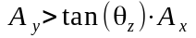 | 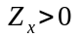 | 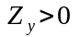 | clockwise-move
0 | 0 | 0 | 1
1 | 0 | 0 | 0
0 | 1 | 0 | 1
1 | 1 | 0 | 0
0 | 0 | 1 | 0
1 | 0 | 1 | 1
0 | 1 | 1 | 0
1 | 1 | 1 | 1

Here, it can be observed that there are four cases which yield a clockwise direction, and four which yield the opposite. The astronaut moves at a speed of 0.01 units per step, and the zorkoid moves 0.04 units per step. This can be visualized:
Astronaut Zorkoid:
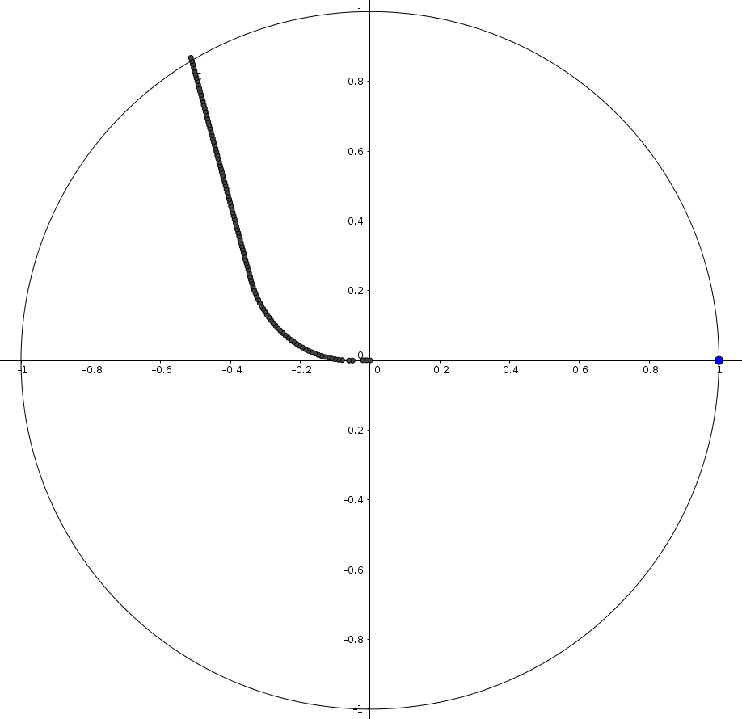
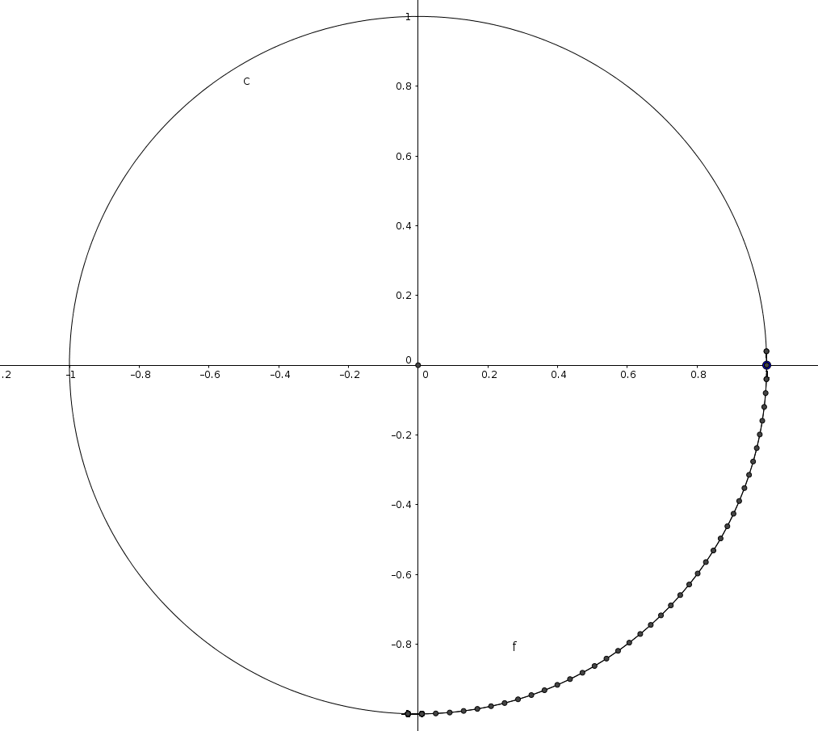

Using this method, the astronaut escapes in 111 steps. The zorkoid largely remains in the third quadrant, because this method does not account for the astronaut being on the line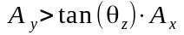.

Method B:
Seeing that clockwise cases in the zorkoid’s movement comprise half of all cases, this method will use a random function that will move the zorkoid clockwise with a 50% chance and counterclockwise with a 50% chance. This can be visualized:
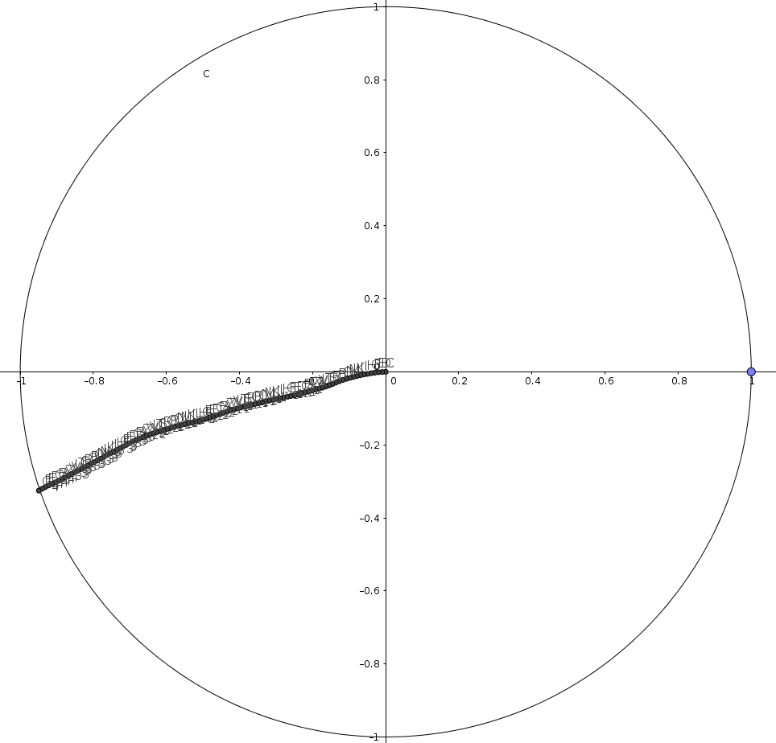
Astronaut Zorkoid
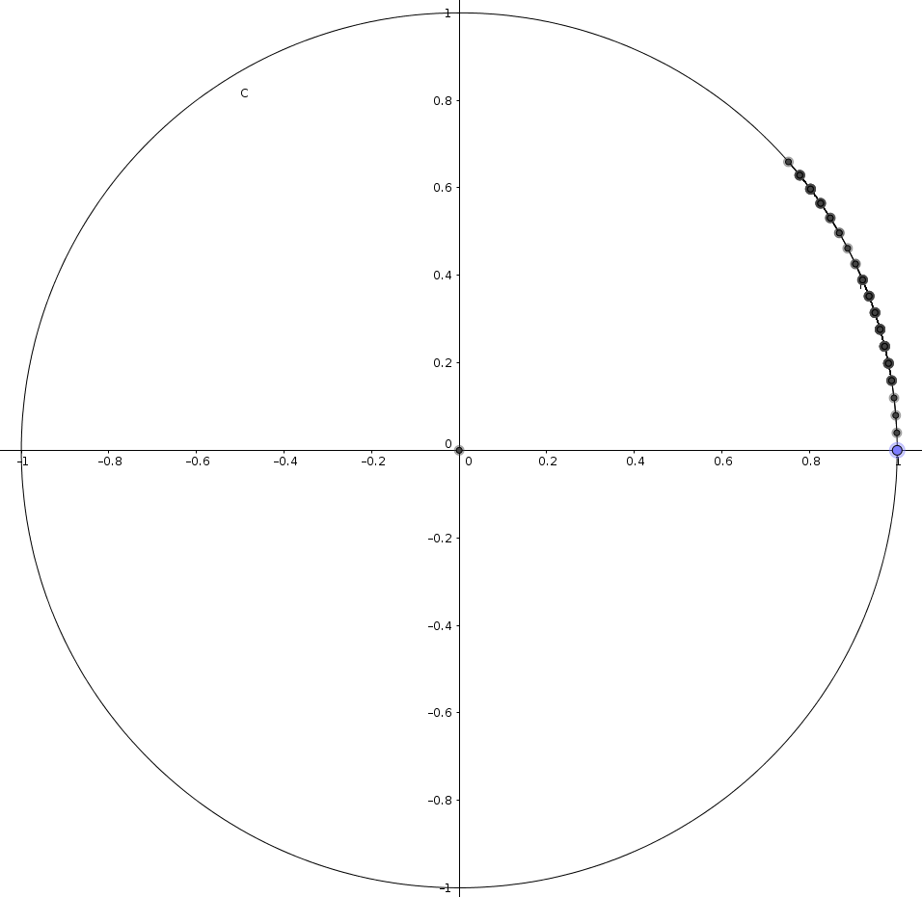

Throwing logic to the wind, and putting the zorkoid’s dinner in the hands of a coin toss has not proven fruitful. The zorkoid paces back and forth in the first quadrant, while the astronaut escapes handily.

Method C1:
Adding to the original method, a case will be added to move the zorkoid clockwise when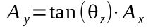is satisfied. This can be visualized:
Astronaut Zorkoid
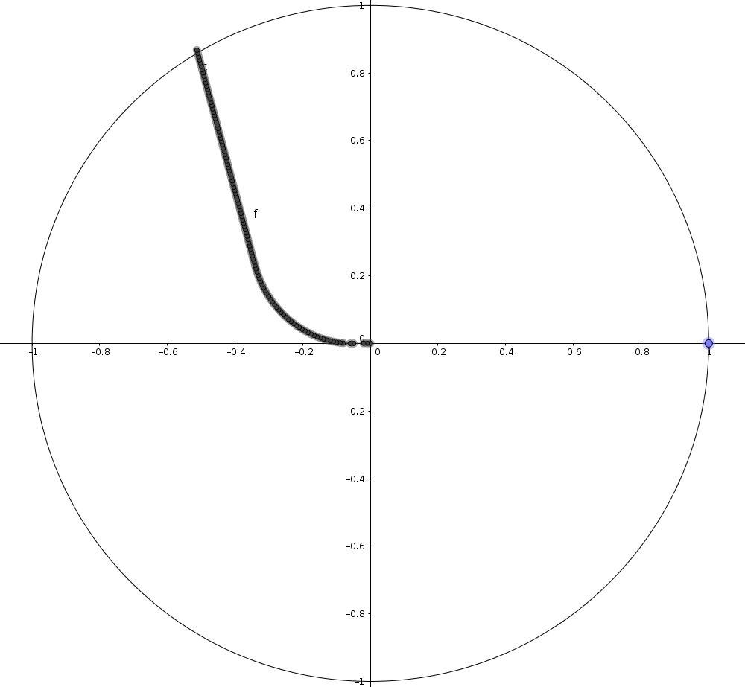
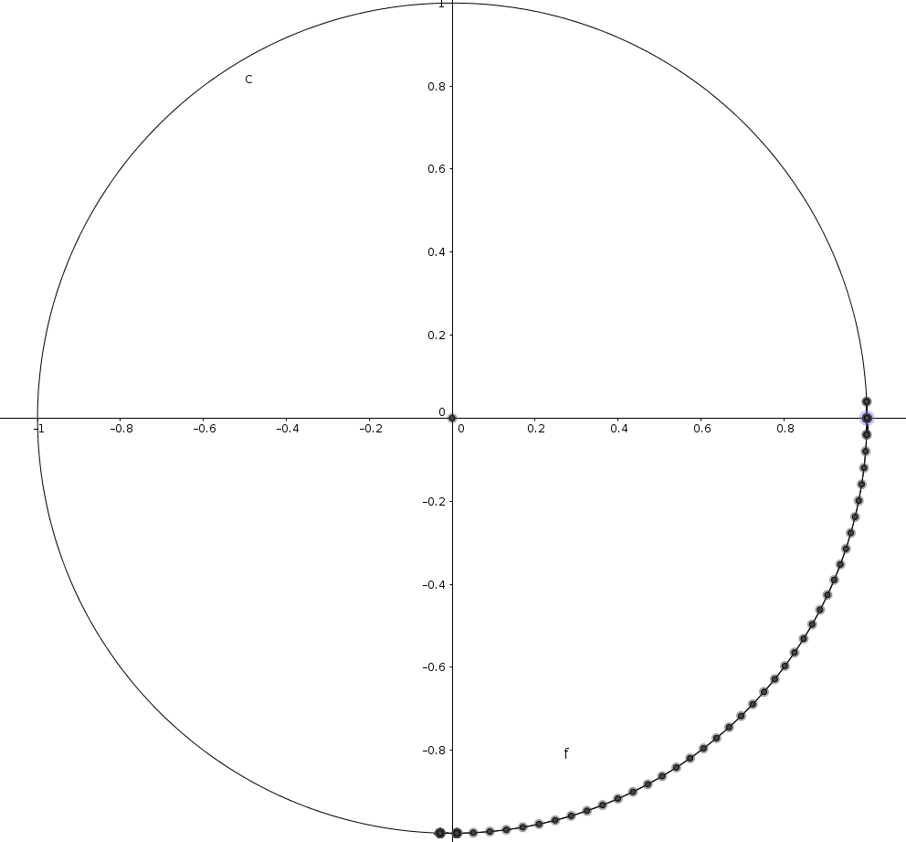
These results are nearly identical to method A’s results.

Method C2:
Similar to method C1, we will use the same logic, but the zorkoid will now move counterclockwise whenis satisfied. This can be visualized:
Astronaut Zorkoid
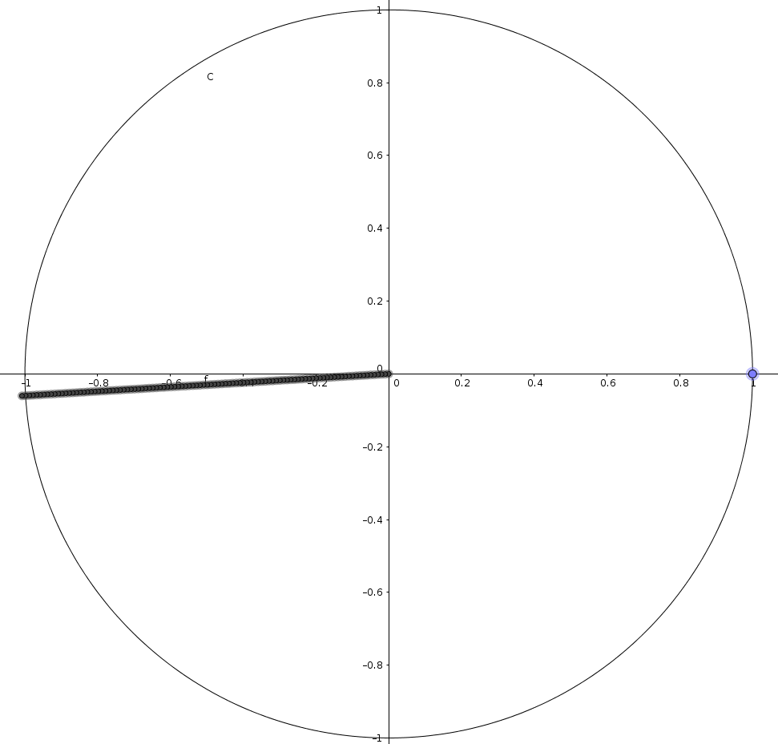
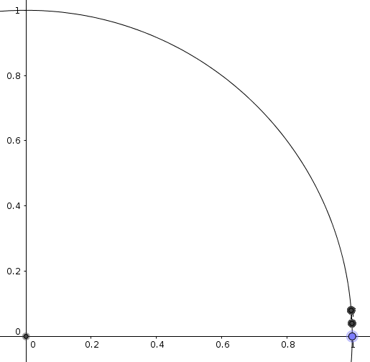

The zorkoid waivers between two points, (1, 0.04) and (1, 0.08). This is not a viable strategy to obtain dinner, because with each step taken by the zorkoid, the astronaut moves directly away which puts it above or below the line causing zorkoid to waiver.

In conclusion, the zorkoid, goes hungry another night. Moving forward, other methods the zorkoid may employ include using polar coordinate logic, which would stay crossing near the intersections of the circle and the axes repeatedly.

