How it looks like?

- Go to the test page: https://46.20.71.234/inline-booking/carrot-cars-home
- Enter/select the date and time of the booking:

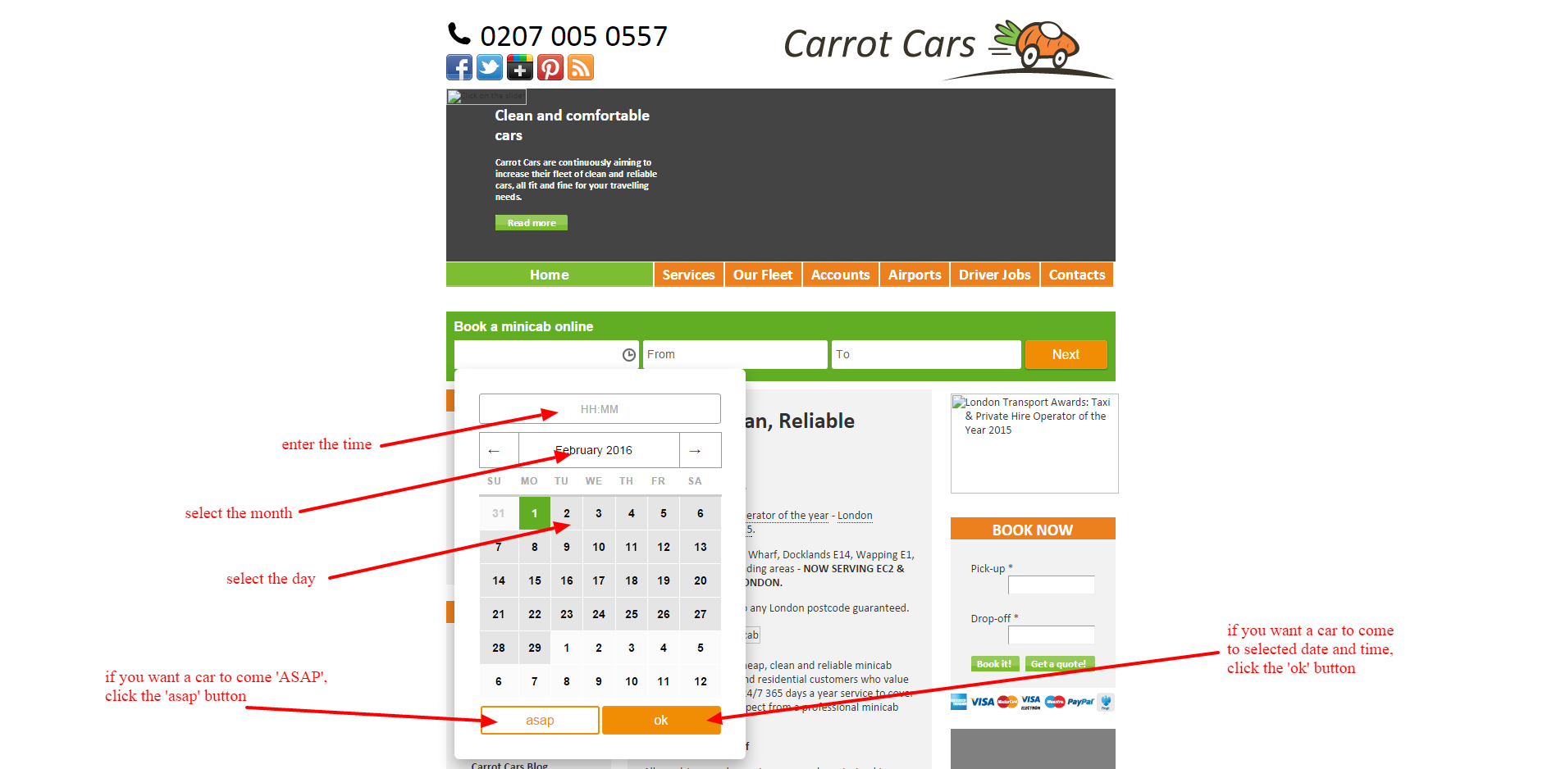

- Select the 'from' (pickup) address and 'to' (drop off) addresses:

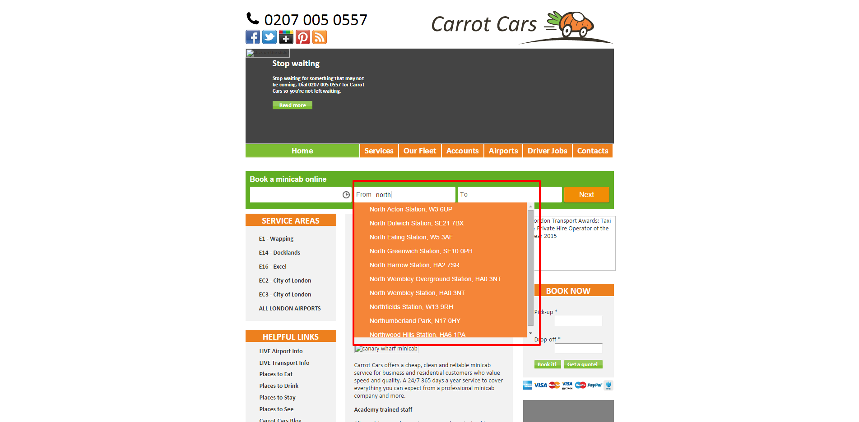

- Click the 'Next' button:

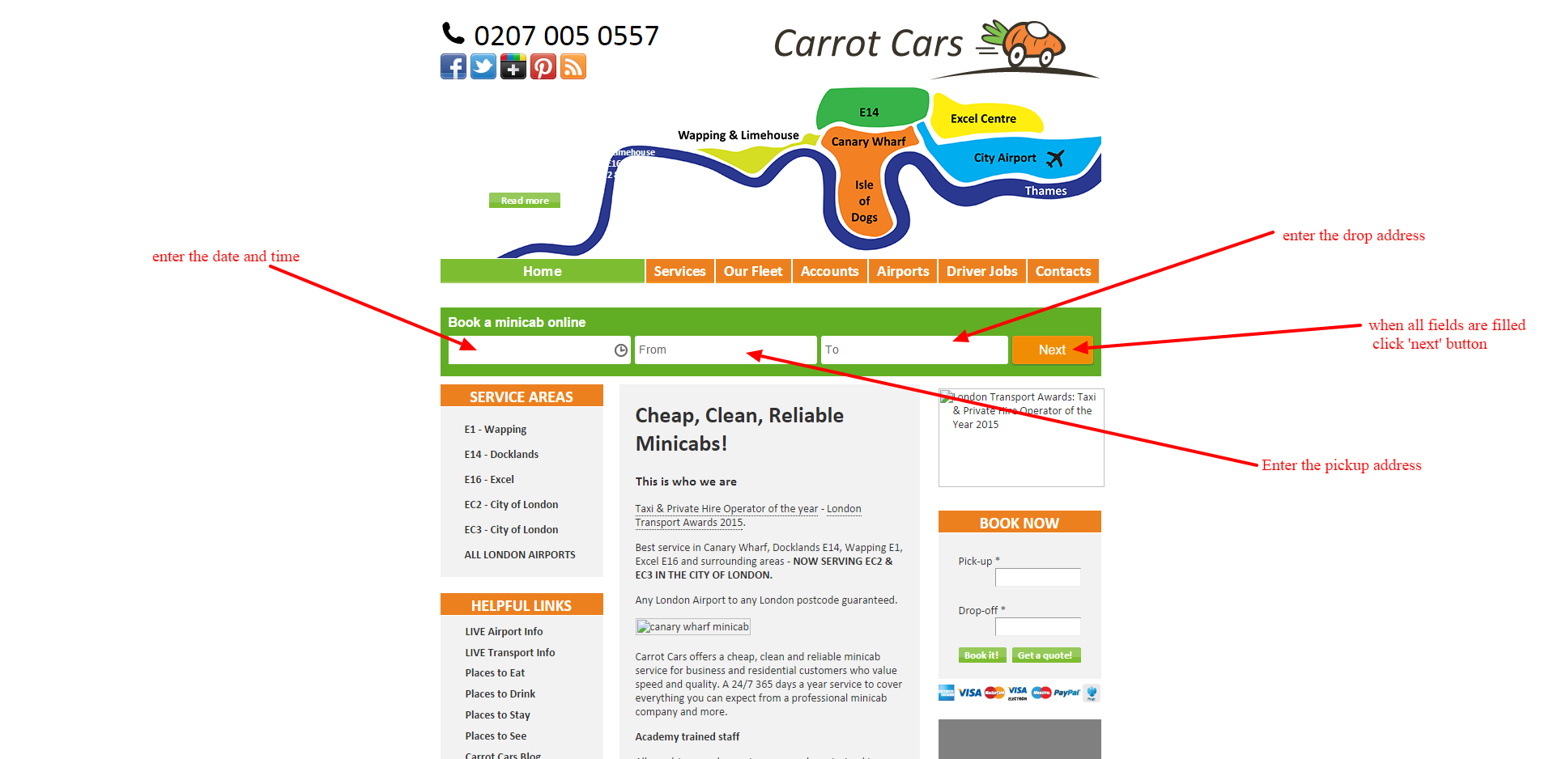

- The 'Log in' screen will be shown. It has 3 buttons:
  - 'Sign in' button. Enter your Customer Portal personal account user`s credentials : email (login) and password and click 'Sign in'. The details of the user (contact and credit card) will be obtained from the server side.
  - 'Skip' button. Click this button if you want to create a booking without signing in.
  - 'Cancel' button. Click 'cancel' if you want to close the form.

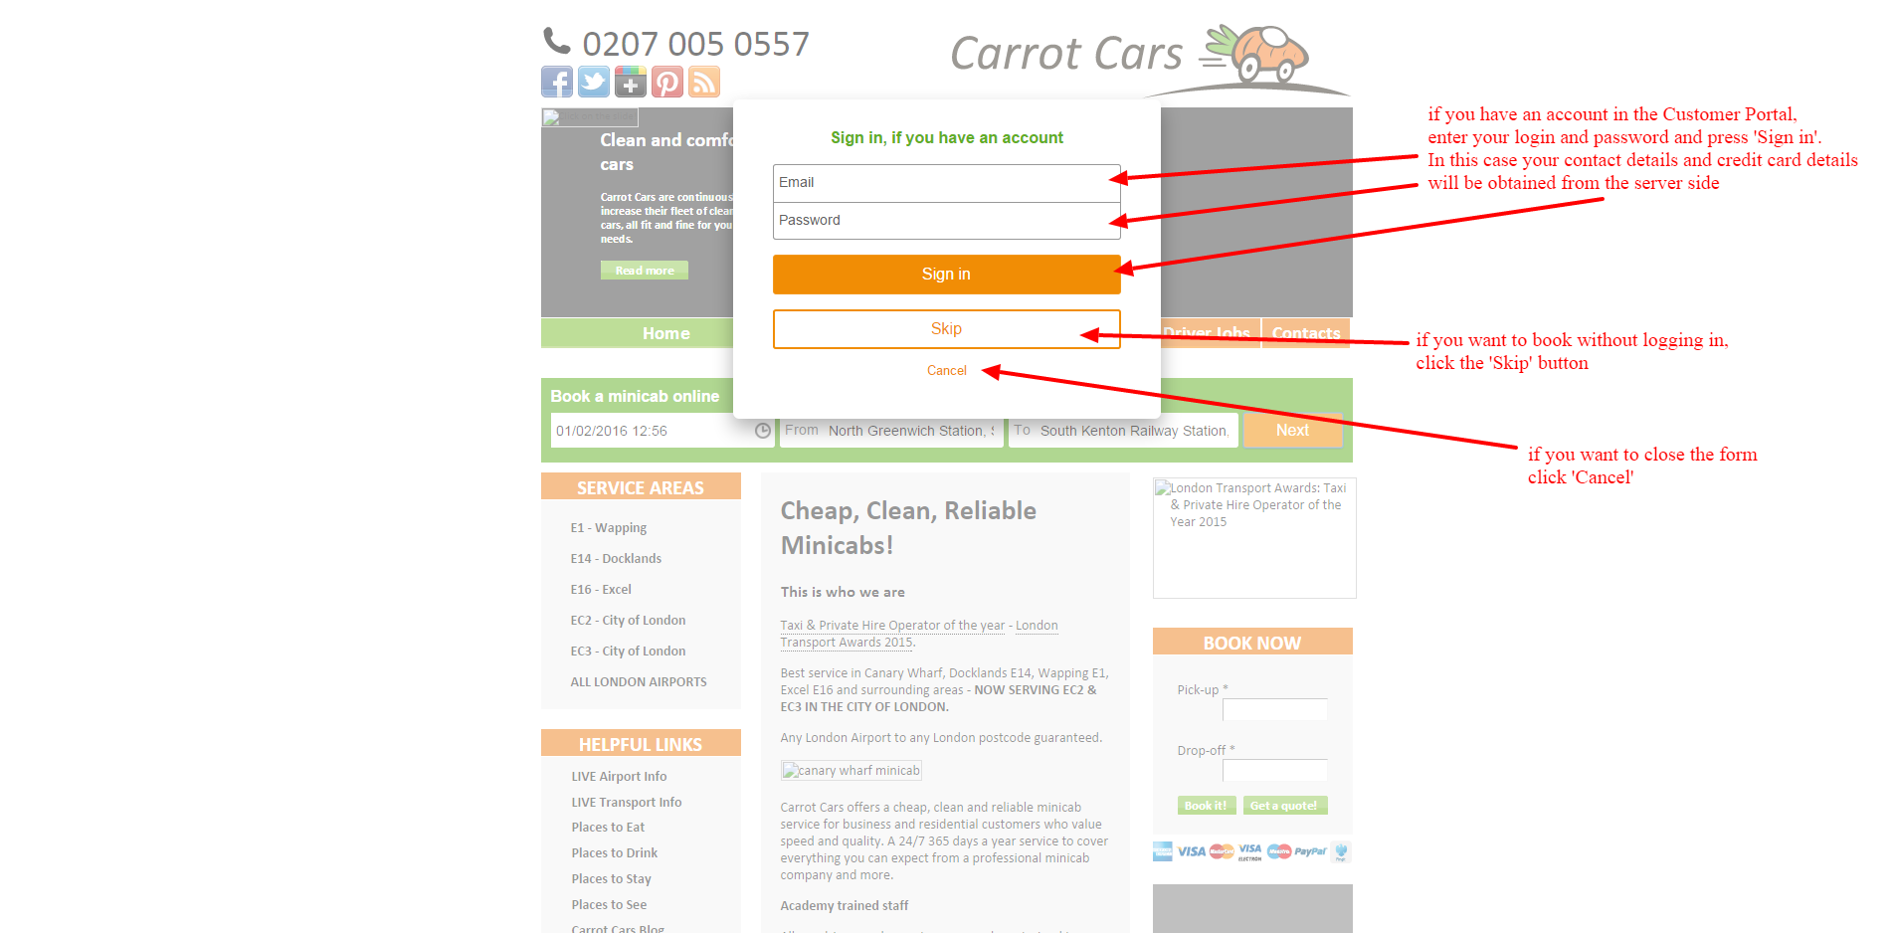

- Let`s enter the user`s credentials and press the 'Sign in' button. We will see the full booking screen where:
  - 'date/time', 'from' (pickup), 'to' (drop off) fields are filled from the first step
  - 'name', 'phone', 'email' fields are filled from the logged in user`s details
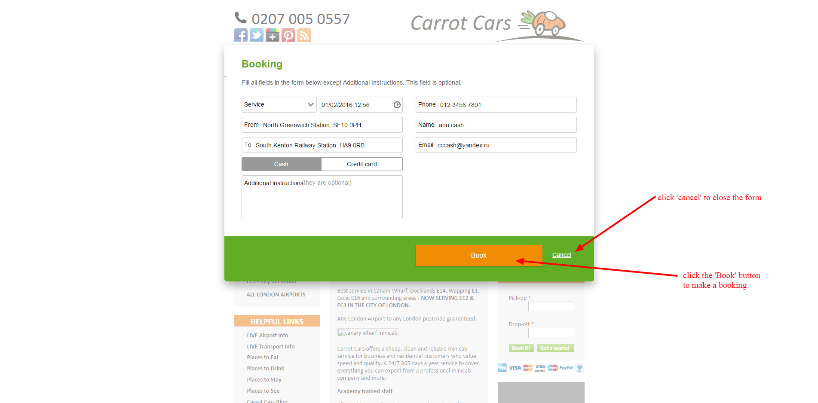

Select the 'Service' and the price will be calculated ('service', 'date/time', 'from' (pickup), 'to' (drop off) fields are necessary for the price calculation. When you select/change any of them the price will be recalculated):
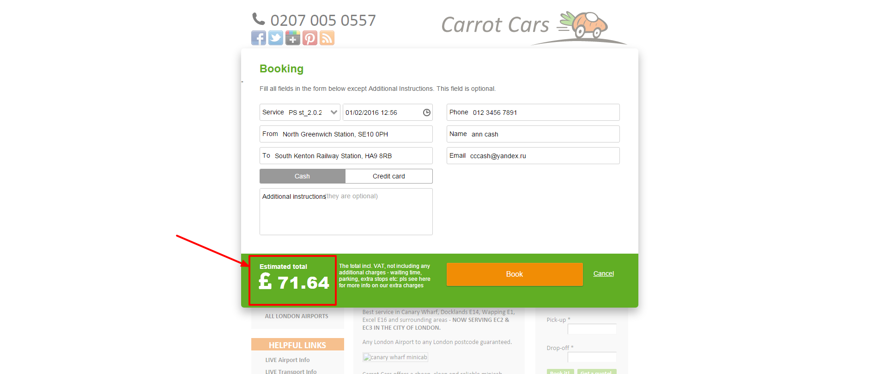

Press the 'Book' button:
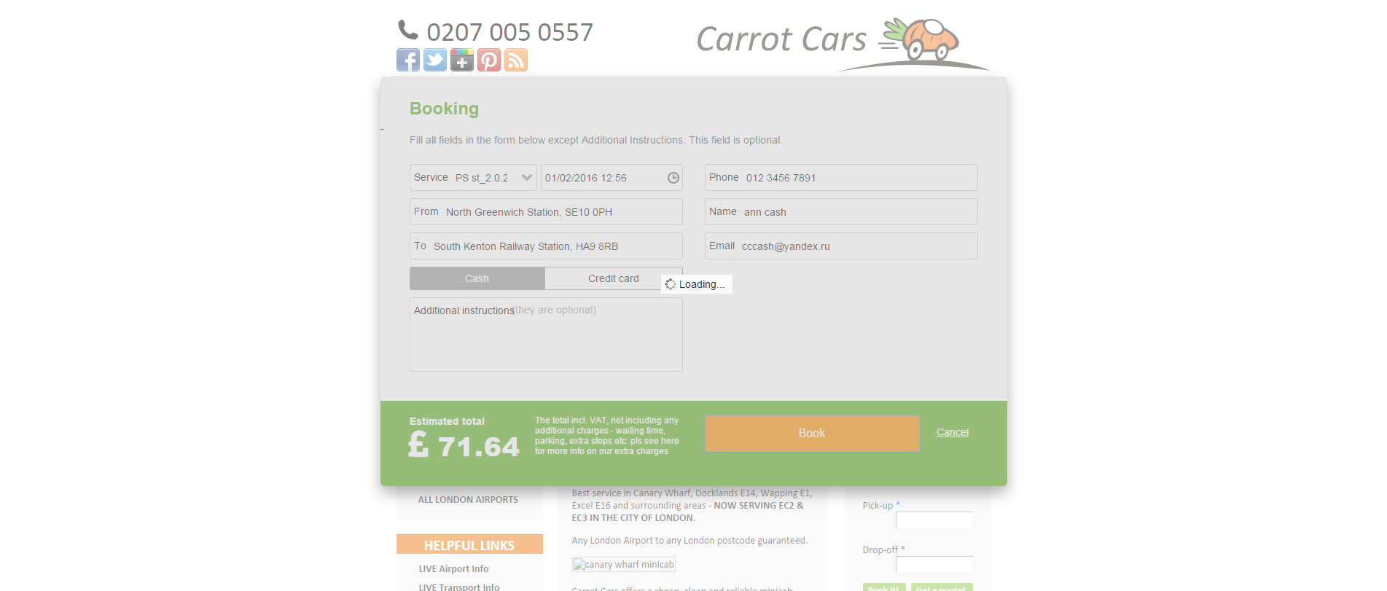

Finally, the booking will be created, the full booking screen will be closed and you will see it`s reference number above the first form fields line:
