Inline Booking

The test page

https://46.20.71.234/inline-booking/carrot-cars-home

Requirements

The Inline Booking is not supported in IE Compatibility View. Thus you should disable it by adding:

<meta http-equiv="X-UA-Compatible" content="IE=edge">

to the <head> tag of the page into which the Inline Booking is integrated.

Sources description

There are two folders in the 'inline-booking-scriplets' folder: the 'head' and the 'body'.

The 'head' folder contains scripts that should be placed in the <head> tag of the page:
- Developer scriplets:
  - properties-dev.jsp
Global properties for a developer (test) version. The content of this file should be placed in the <head> tag of the page of your web site before the content of the resources-dev.jsp
  - resources-dev.jsp
js/css resources loading scripts for a developer (test) version. The content of this file should be placed in the <head> tag of the page of your web site after the content of the properties-dev.jsp
- Production scriplets:
  - properties-prod.jsp
Global properties for a production version. The content of this file should be placed in the <head> tag of the page of your web site before the resources-prod.jsp
  - resources-prod.jsp
js/css resources loading scripts for a production version. The content of this file should be placed in the <head> tag of the page of your web site after the content of the properties-prod.jsp

The 'body' folder contains scripts that should be placed in the <body> tag of the page
- visible.jsp
The html code snippet presenting the Inline Booking form that will be visible on your site page at first:
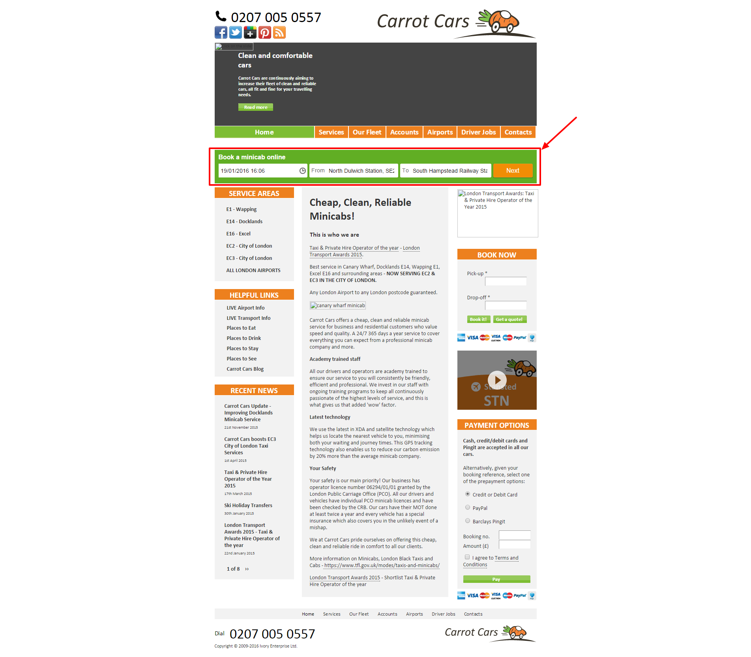
You should place the code from the visible.jsp in your page`s <body> where you actually want to embed the inline booking form.

- hidden.jsp
the html code snippet presenting the Login form
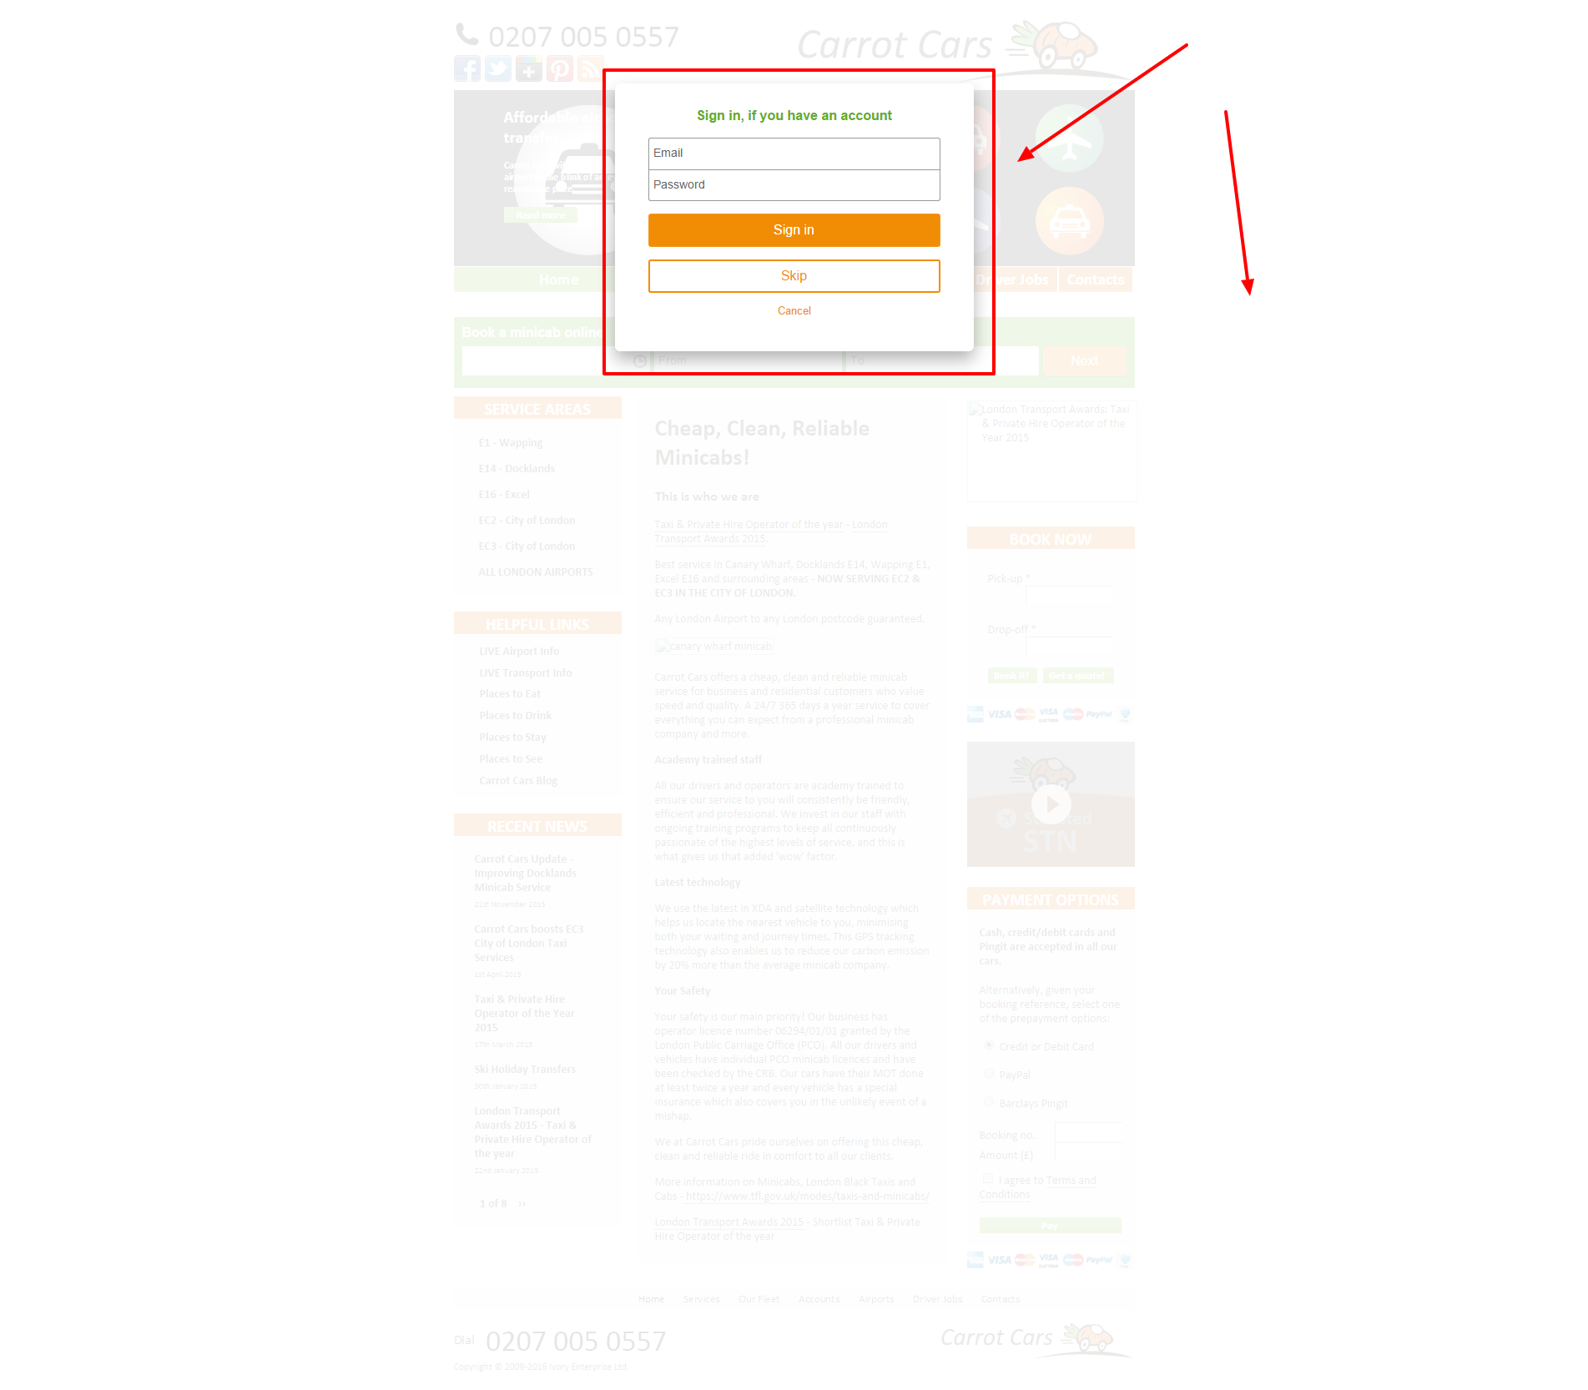

and the Full Inline Booking Form
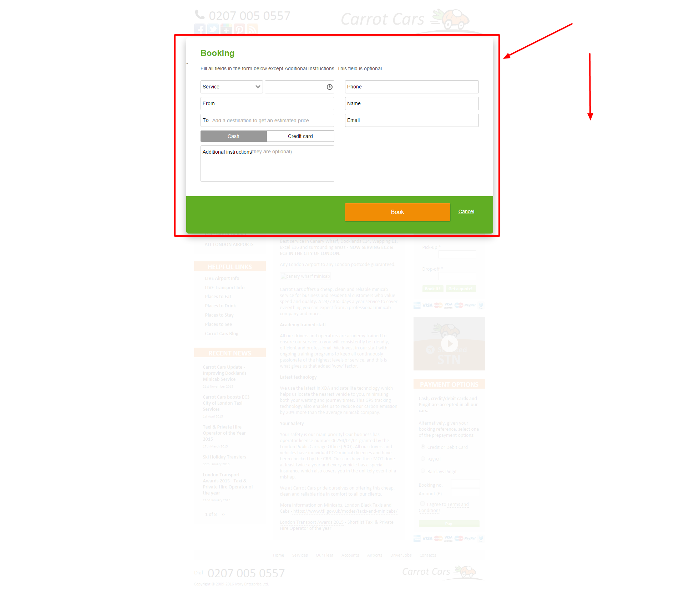

that are both initially hidden. You should place the code from the hidden.jsp in the end of the <body> tag of the page in which you want to embed the Inline Booking form.

