voitta-gateway
Messaging and voice connectivity layer: approach, architecture and POC status
Version 2 · 10 November 2026 · working name; the repository is voitta-sip, but SIP is only one of the transports.

1. Summary
One module connects Voitta agents to the outside world: Signal, Slack, ordinary phone calls, and later WhatsApp, SMS or Telegram. It runs on a Linux server, holds all platform accounts and keys, and exposes one API to the rest of the system.
- The proof of concept works on real calls. On .212 the gateway placed Signal calls from the 212 number; a first voice agent, voitta-ask, read a text to the callee and returned their spoken answer as text, end to end in 17 to 28 seconds.
- Two layers, not one. Messaging (text, media, reactions; asynchronous) and voice (real-time audio) have different shapes. They share config, identity and the API, but not the abstraction.
- Three API channels, now specified formally. REST commands (OpenAPI 3.1), one replayable event stream and a WebSocket per call for audio (AsyncAPI 3.1). Every test checks the traffic against these specs.
- Thin gateway, separate agents. The gateway translates platforms and enforces policy; agents such as voitta-ask decide what to say and talk to it only through the API.
- Slack in both layers. Messaging hardened with shmobster's lessons, voice clips arrive with transcripts, and outbound voice calls run through a browser join page (Slack bots cannot join huddles). Built and tested end to end against a simulated Slack and in headless Chrome; not yet on a live workspace (section 7).
- Scope for now: outbound calls on the 212 number. Incoming calls and other numbers are out of scope. The bot (manhattan-logic) and the gateway cannot hold the account at the same time, so they switch by hand (section 9).

2. Status (8 November 2026)
Every component in this document carries one of four tags:
Tag | Meaning
LIVE | Built; tested end to end on real Signal calls on .212.
TESTED | Built; tested end to end in the automated suite against simulated platforms (a JSON-RPC server standing in for signal-cli, signed Telnyx webhooks and media, a stubbed Slack client), over real sockets. Not yet run against the real service.
PARTIAL | Built in part; what is missing is stated next to it.
PLANNED | Designed in this document, not built.

2.1 Components
Component | Status | Evidence / what is missing
Signal calls: outbound, audio both ways | LIVE | 3 answered calls on .212 (echo, voitta-ask to Roman, voitta-ask to Nadya)
Signal calls: inbound | TESTED | simulated only; no live inbound call yet
Signal messaging (send, receive, receipts, reactions, edits, groups) | TESTED | simulated signal-cli; one message sent live via manhattan-logic's daemon
Slack messaging: Socket Mode, watchdog, safe downloads, bots, @here, blocks, buttons, history | TESTED | simulated Slack Web API; needs the Voitta Slack app installed (manifest in deploy/)
Slack voice clips -> transcripts (Slack's own, else voitta-speech) | TESTED | simulated Slack; real AAC/Opus clips transcribed on .212 by the real models
Slack calls: DM card + browser join page | TESTED | page run in headless Chrome with a fake microphone; needs a public HTTPS URL for live use
voitta-speech API (transcribe, synthesize) | LIVE | running in voitta-ask on .212; 0.1-0.3 s per clip
Phone via Telnyx (signed webhooks, L16 media, DTMF, dial-out) | TESTED | simulated Telnyx incl. big-endian audio; needs a Telnyx account
Event log, SSE + long-poll, replay, cursor reset | LIVE | SQLite (WAL); used by voitta-ask live
Policy: allowlist + held queue, STOP opt-out, emergency block | TESTED | live: only the caller allowlist
Durable outbox, pacing, retries, idempotency | TESTED | survives restarts (persisted first)
Media protocol voitta-media/1 | LIVE | start, media, mark, clear, stop, hangup used on live calls
CallSession | PARTIAL | single leg; no warm transfer, conference, recording or AMD
voitta-ask (text -> call -> transcript) | LIVE | Piper TTS (CPU) + faster-whisper small (GPU); over Slack calls: tested
Pipecat serializer + example bot | TESTED | echo mode in a real Pipecat pipeline; LLM mode needs keys
Formal specs (OpenAPI 3.1 x2, AsyncAPI 3.1) | LIVE | validated by official tools; all test traffic checked against them
Docker image + Compose + Caddy | PLANNED | files written; image never built
signal-call-tunnel with RingRTC >= 2.72 | PARTIAL | built only at 2.65.1 (CVE-2026-113380); patches need porting
manhattan-logic as a gateway consumer | PLANNED | phase 3

2.2 POC results
Call | Rings | Picked up | Listening | Answer ends | Transcript ready | Result
Roman | 0.3 s | 5.0 s | 9.9 s | 16.7 s | 17.0 s | "Hello, one, two, three, four, five."
Nadya | 0.5 s | 8.5 s | 19.3 s | 27.2 s | 27.5 s | "Search Google for Asian pairs prices." (pears: homophone)

- Times are seconds from the client's request. Almost all of it is the call itself: picking up, hearing the text, answering, and 1.5 s of silence that marks the end of the answer.
- Machine time is small: Piper synthesizes a sentence in about 0.15 s; Whisper small transcribes an 8-second answer in about 0.3 s on the RTX 3090.
- Automated suite: 46 tests pass in about 40 s (unit, end to end, spec conformance, the join page in headless Chrome); four more run the real models on .212 and pass.

3. How this is usually solved
Messaging
- One adapter per platform, translating to a common message model, with per-platform capabilities declared (threads, edits, reactions, calls).
- Off-the-shelf options: Matrix + mautrix bridges, Matterbridge, Bot Framework, Rasa channels; hosted: Twilio Conversations, Infobip. For two platforms, running a Matrix homeserver is more operational weight than it saves.
Voice
- The common AI voice stack: a phone number from a carrier (Telnyx, Twilio), a media server (LiveKit SIP, FreeSWITCH, Asterisk, Jambonz) or the carrier's own media streaming, and a voice-agent framework (Pipecat, LiveKit Agents) running speech-to-text, an LLM and text-to-speech.
- The useful abstraction is a call session: call events plus a two-way audio stream. Twilio Media Streams, Telnyx, Vonage and Jambonz all expose roughly this over WebSocket, which is what our media protocol follows.

4. Architecture
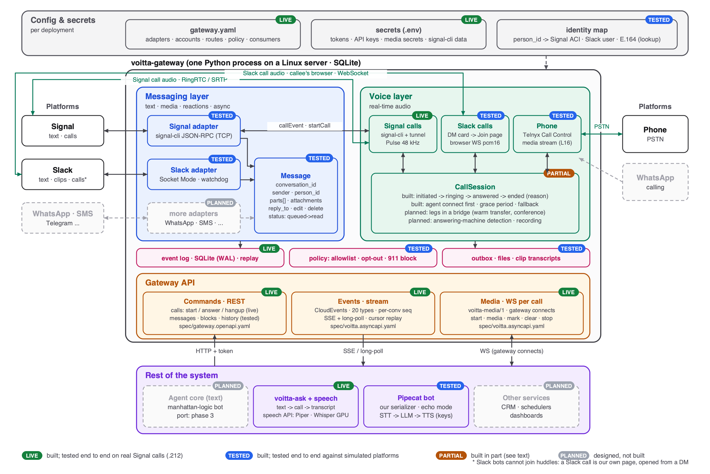
Figure: Architecture, with what is built and how it was tested (vector: out/architecture.svg)

4.1 Config and secrets
LIVE gateway.yaml, ask.yaml and .env run the POC on .212.
- gateway.yaml: which adapters run, the account each uses, routes (where a call's audio goes), policy, and the consumers with their scopes.
- Secrets: every *_secret field names an environment variable or a line in the env file; nothing secret is in the YAML. The signal-cli data directory holds the account's keys and is a secret too.
- Identity map: person_id to platform addresses: Signal ACI (UUID) or E.164, Slack team/user, phone E.164. A lookup only: sessions stay per conversation, so private context does not leak between channels.
adapters:
signal: {account: "+15551234567", calls: true, route: ask, groups: mention}
slack: {bot_token_secret: SLACK_BOT_TOKEN, app_token_secret: SLACK_APP_TOKEN}
phone: {api_key_secret: TELNYX_API_KEY, public_key_secret: TELNYX_PUBLIC_KEY,
numbers: ["+15550002222"], public_base_url: "https://gw.example.com", codec: L16}
routes:
ask: {media_url: "ws://127.0.0.1:8791/media", media_secret_secret: ASK_MEDIA_SECRET,
connect_timeout_s: 3, grace_s: 5, fallback: hangup}
consumers:
ask-service: {token_secret: TOKEN_ASK, scopes: [events:read, calls:control],
events: ["call.*"]}
persons:
p_roman: {signal: ["+15551112222"]}
policy: {inbound_allowlist: [p_roman], block_emergency_numbers: true}

4.2 Messaging layer
TESTED built; tested against simulated signal-cli and Slack, not yet on live accounts.
- Signal adapter: signal-cli daemon over JSON-RPC on a TCP socket, started with --receive-mode=manual; the gateway calls subscribeReceive so nothing is received before it listens, and writes each notification to the database before processing it. Message ids are author ACI + sent timestamp. In groups the agent sees only messages that mention it (configurable).
- Slack adapter: Socket Mode (outbound WebSocket only, no public ingress). DMs open on demand; a reply to a channel message goes into its thread; about one message per second per channel. Section 7 covers what it took from shmobster and the voice side.
- Common Message: conversation_id, sender (with kind: human or bot) and person_id, parts (text, file, sticker; outbound also blocks), reply_to, edits and deletes, and an outbound status that only moves forward: queued, sent, delivered, read or failed.
- Capabilities: each adapter declares what it supports (GET /v1/channels); unsupported operations are refused up front with 422 unsupported.

4.3 Voice layer
LIVE Signal outbound calls live; inbound and phone tested with simulators.
- Signal calls: signal-cli (0.14.2 and later) starts one signal-call-tunnel process per call, built on Signal's RingRTC. The gateway must call subscribeCallEvents, or incoming calls are ignored. Audio never passes through signal-cli: the tunnel creates per-call PulseAudio devices (signal_input_<id>, signal_output_<id>) and the gateway reads and writes them at 48 kHz with parec and pacat. So the gateway, signal-cli and the tunnels share one host and one audio server.
- Phone (Telnyx): Call Control webhooks (Ed25519-signed) and a bidirectional media WebSocket carrying L16 at 16 kHz, so no media server of our own is needed. L16 is big-endian on the wire; the gateway converts, and detects and corrects a wrong byte-order setting from the first speech.
- CallSession: one state machine for all channels: initiated, ringing, answered, ended with a reason. The agent's media socket is opened while the call still rings; if it cannot be reached the call is rejected or handed to a fallback before anyone hears anything. If it drops mid-call the gateway reconnects for a grace period, then hangs up or transfers. Planned: calls as legs in a bridge (warm transfer, conferences), answering-machine detection, recording.
- Audio format: announced, not assumed: the gateway resamples once at its edge (Signal 48 kHz, phone 8 or 16 kHz) to the format stated in the media start message, 16 kHz pcm16 by default.

4.4 Gateway core
TESTED event log live; policy and outbox tested.
- Policy: unknown senders are held without content until approved; STOP opts a contact out on that channel; calls to emergency numbers are refused; unknown callers are rejected unless allowed. This lives in the gateway because it is the only place that sees every channel.
- Event log and outbox: SQLite in WAL mode, enough for one host; Redis or Postgres is the scale-out path. Every event is written before anyone is told about it; outbound operations are written before they are sent and retried with backoff.
- Attachments: stored by content hash; uploaded with POST /v1/attachments and referenced by id.

5. API for the rest of the system
LIVE specified in spec/; validated with openapi-spec-validator and the AsyncAPI CLI.
File | Describes
spec/gateway.openapi.yaml | 26 REST operations of the gateway: messages, attachments, calls, events polling, admin (held messages, opt-outs); scopes per operation
spec/voitta.asyncapi.yaml | the event stream (19 CloudEvents types, each with a payload schema) and voitta-media/1 (11 messages, both directions)
spec/ask.openapi.yaml | voitta-ask: create an ask, read it (optionally waiting for the result)

The specs are part of the tests. A test fails if the routes the code serves differ from the spec, if an emitted event type has no schema, or if any JSON response, event or media message seen in an end-to-end test does not validate. Malformed requests return the same error shape as every other error.

5.1 Commands (REST)
POST /v1/messages {to, parts[], reply_to?, idempotency_key?}
-> 202 {message_id, status: queued}
POST /v1/messages/{id}/edit | delete | reactions
POST /v1/calls {to, via: signal|phone, route?} -> 202 {call_id, state: initiated}
GET /v1/calls/{id} state, reason, answered
POST /v1/calls/{id}/answer | reject | hangup | dtmf | transfer
GET /v1/events SSE stream (resume with Last-Event-ID)
GET /v1/events/poll ?after=evt_N&types=call.*&wait=20
GET /v1/channels · /v1/identities/{person_id} · /v1/held · /v1/optouts

- Replies go back where the message came from: to: {conversation_id}. A person_id target is only for conversations the agent starts; the gateway then picks a channel.
- Idempotency keys come from the event being answered (reply:evt_42): events are delivered at least once, so a repeated event produces one reply, not two.
- Scoped tokens: one per consumer: events:read, messages:send, calls:control, admin.

5.2 Events
{"specversion": "1.0", "id": "evt_42", "source": "/gateway/signal",
"type": "ai.voitta.call.ended.v1", "subject": "call_01a1bddd...",
"time": "2026-11-08T21:14:03.120Z", // when it happened on the platform
"ingesttime": "2026-11-08T21:14:03.131Z", // when the gateway got it
"data": {"call_id": "call_01a1bddd...", "channel": "signal", "direction": "outbound",
"from": "+15551234567", "to": "+15551230000", "person_id": null,
"reason": "ask_done", "duration_s": 19.0, "answered": true}}

- Conversation events also carry seq, a per-conversation counter, so consumers can see gaps.
- Read them as SSE (resume with Last-Event-ID) or by long-polling with a cursor. A cursor beyond the end of the log, left over from a previous database, replays the log from the start and says reset: true. That case caused the first hung ask in the POC (section 7).

5.3 Media (WebSocket per call)
The gateway connects to the agent (the agent is the WebSocket server), as Twilio and Telnyx do, so existing agent frameworks fit. The URL carries call_id, a timestamp and an HMAC signature. Messages are JSON text with base64 audio.
# while the call rings
g->a {"event":"connected","protocol":"voitta-media/1","call_id":"call_..."}
# once it is answered
g->a {"event":"start","frame_ms":20,"channel":"signal","direction":"outbound",
"media_format":{"encoding":"pcm16le","sample_rate":16000,"channels":1},
"capabilities":{"dtmf":false,"transfer":[]}, "from":..., "to":...}
g->a {"event":"media","seq":17,"ts_ms":340,"payload":"<20 ms>"}
a->g {"event":"media","payload":"<any length>"} # queued, played in real time
a->g {"event":"mark","name":"prompt"}
g->a {"event":"mark","name":"prompt","cleared":false}
a->g {"event":"clear"} # barge-in; pending marks: cleared
a->g {"event":"hangup","reason":"ask_done"}
g->a {"event":"stop","reason":"ask_done"}

5.4 Flows
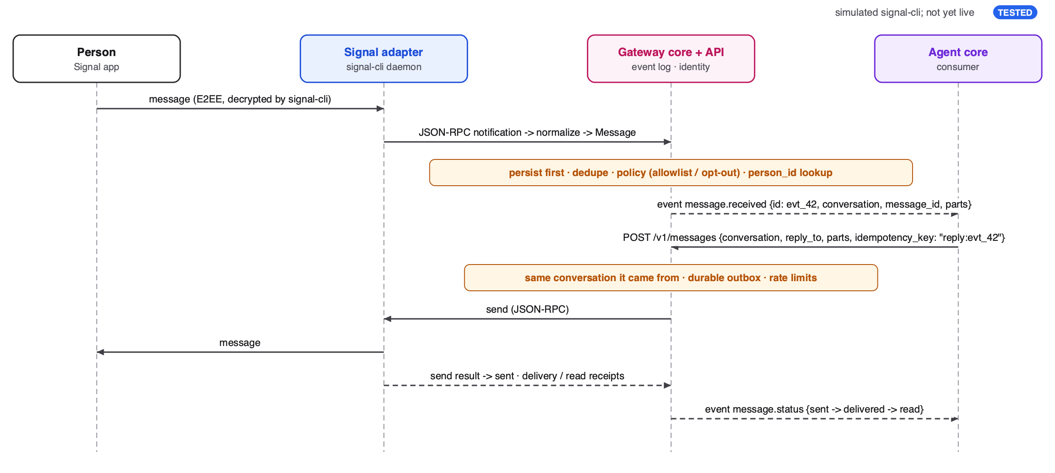
Figure: Inbound message and reply (vector: out/seq-message.svg)
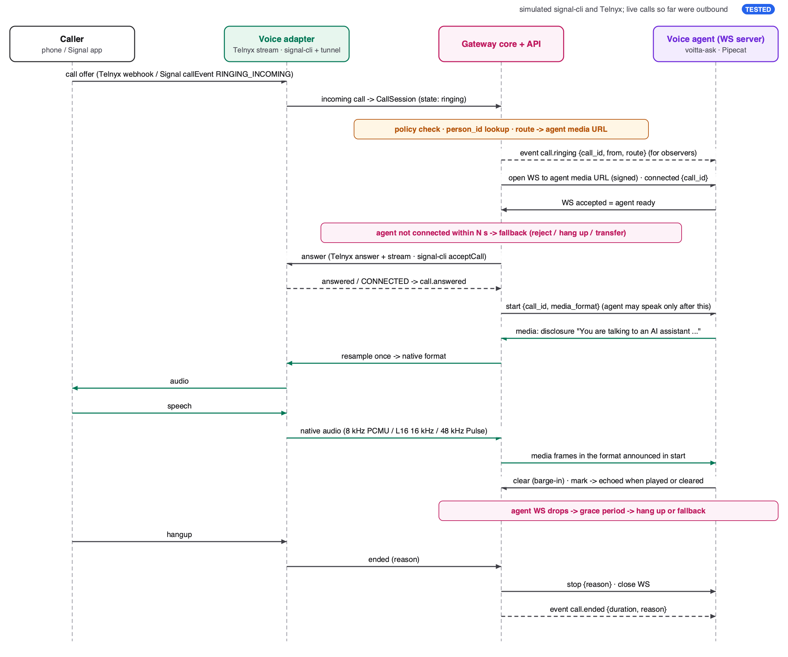
Figure: Inbound call (same flow for phone and Signal) (vector: out/seq-call.svg)

6. First agent: voitta-ask
LIVE two answered calls on .212 with real models.
A client sends a text and a recipient; voitta-ask calls them, reads the text, records the spoken answer, transcribes it and returns the text. It is a separate service that uses the gateway only through its public API and media protocol; the gateway did not change to support it beyond generic features (after=now, cursor reset, the answered flag on calls).
- States: calling, ringing, speaking, listening, transcribing, then done, no_answer or failed.
- End of the answer: energy-based detection with an adaptive noise floor: 1.5 s of silence after speech, 10 s without any speech, or 30 s in total; a hang-up also ends it.
- Never hangs: besides call events, a watchdog checks the call's state every 5 s, and a ring deadline (90 s) hangs up an unanswered call.
- Models: Piper en_US-lessac-medium on the CPU; faster-whisper small on the GPU (int8_float16). Both are behind a small interface; tests use deterministic stand-ins.
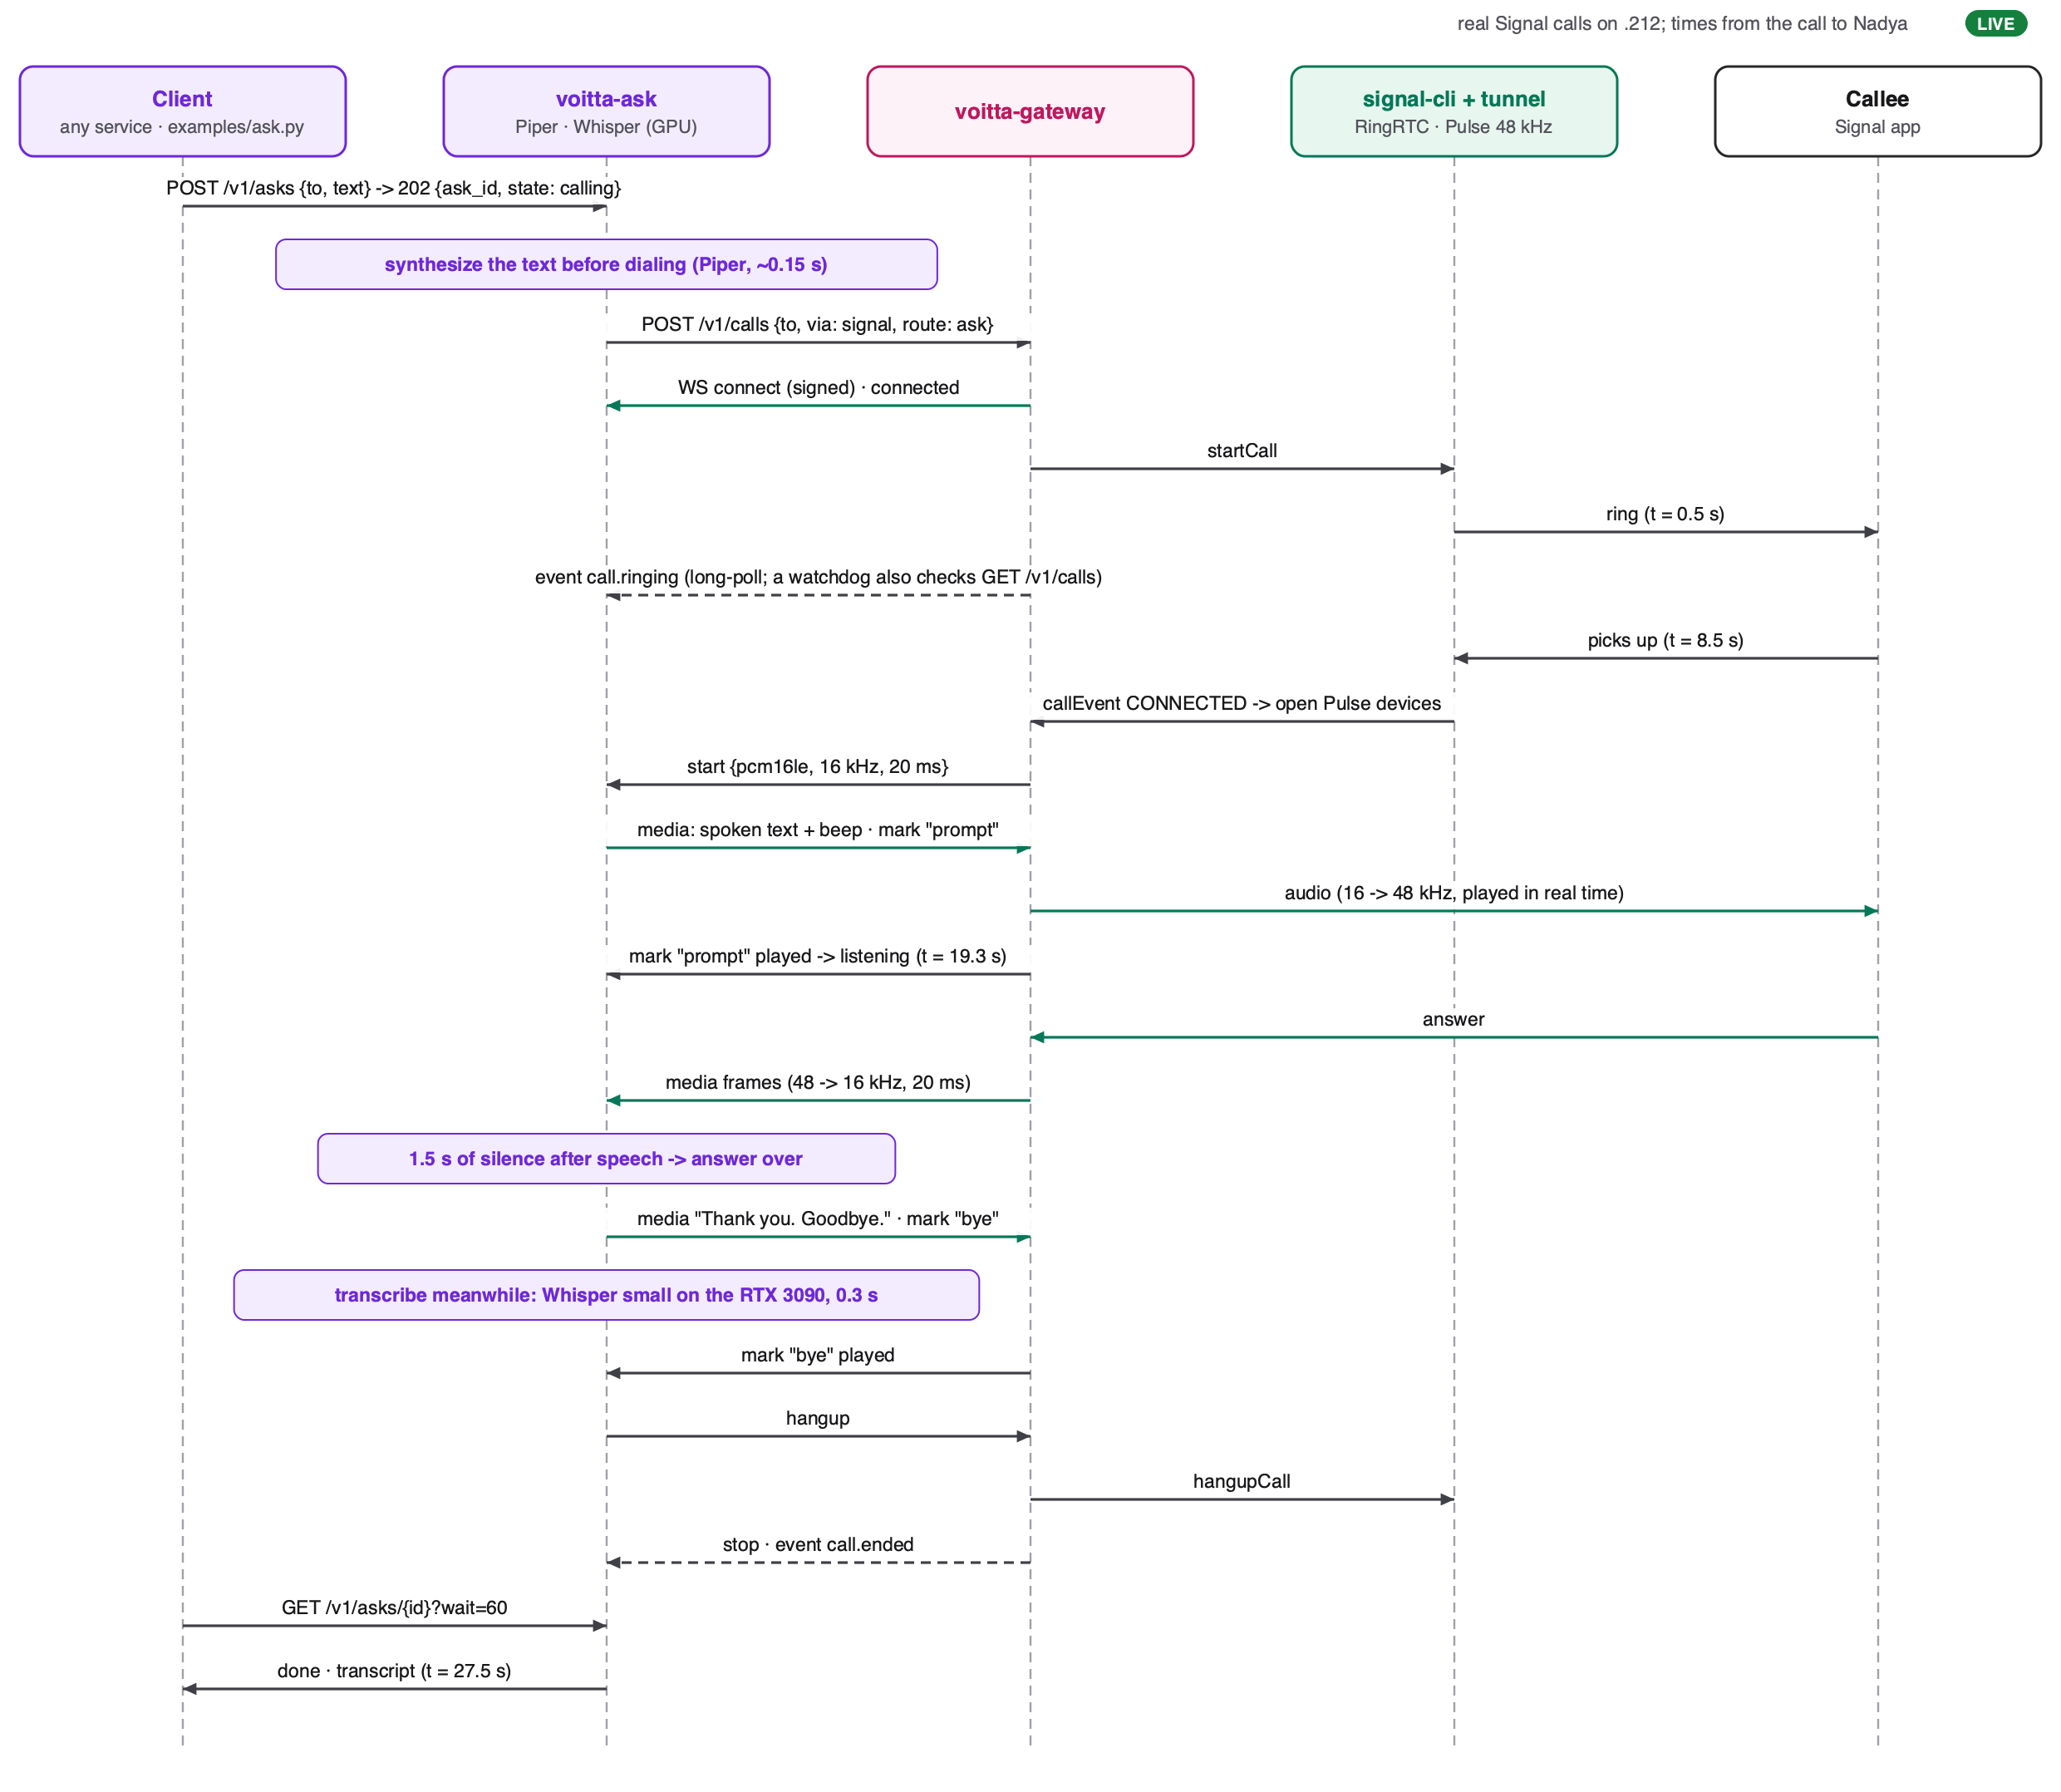
Figure: voitta-ask: text spoken on a call, answer transcribed (live) (vector: out/seq-ask.svg)

7. Slack: messaging and voice
TESTED built and tested against a simulated Slack and in headless Chrome; not yet live.
Slack gives bots no audio: apps cannot join huddles (they only see who is in one), and the Calls API is a directory of third-party calls, not a media path. So Slack voice is built from what the platform does allow: voice clips as files, and calls on our own page, announced in Slack.

7.1 Messaging, hardened with shmobster's lessons
shmobster (voitta-ai/shmobster) has run on Slack for months with Bolt and Socket Mode. What it learned, and what the adapter now does:
shmobster lesson | In the gateway
A Socket Mode session can reconnect forever without delivering anything (13 days, 52,707 sessions). | Watchdog on two signals: no pong for 60 s, or 6 sessions in 5 minutes. It rebuilds the client with backoff and reports channel.down / up.
The bot token must not leave Slack; an unauthorised download is a 200 with the sign-in page. | Downloads follow redirects by hand, send the token only to https *.slack.com, and refuse text/html.
Agents share workspaces; a voice listener posts as a bot. | Other bots' posts arrive only when they mention us, marked sender.kind = bot (configurable).
@here and @channel address everyone in the room, the agent included. | They count as addressed.
Approval cards with buttons; a click is acknowledged within 3 s. | blocks message parts out; interaction.received events in (acknowledged on receipt).
Replies need the thread so far. | GET /v1/conversations/{id}/history, with sender kind self / bot / human.
Two programs on one app's tokens both answer every event. | A separate Voitta app; manifest in deploy/slack-app-manifest.yaml with only the scopes used.

7.2 Voice clips
- A clip (subtype slack_audio) arrives as an audio file part with clip: true, its duration and a transcript.
- Slack's own transcript is used when it is complete; otherwise the gateway sends the audio to voitta-speech (the speech API now mounted in voitta-ask, same models) and records transcript_source. The gateway runs no models itself, and the same path transcribes Signal voice notes.
- Only senders that pass policy are transcribed: a stranger's clip is held untouched.
- Verified on .212 with the real models: AAC in m4a and Opus in webm both transcribed word for word, in about 0.1 to 0.3 s per clip.

7.3 Calls through a browser join page
- POST /v1/calls with via: slack DMs the callee a card with a Join button. The link opens a page served on the gateway's ingress, protected by a per-call token.
- The page captures the microphone with an AudioWorklet (echo cancellation and noise suppression on), sends 20 ms pcm16 frames over a WebSocket, and plays the agent's audio from a small jitter buffer that clear empties at once (barge-in).
- It plugs into the same media protocol as Signal and phone calls: voitta-ask asks over Slack unchanged.
- Not joined within the ring timeout: missed. Page reloaded: the call resumes (10 s grace). Tab closed: remote_hangup. The card in the DM follows the call: ringing, on a call, ended with its length, missed.
- card: calls_api posts Slack's native call card instead (calls.add); if Slack refuses it, the call is ended there and the Join button is used.
- Needs a public HTTPS address for live use: browsers only give microphone access on https or localhost. No TURN server is needed, because the page talks plain WebSocket to the gateway.
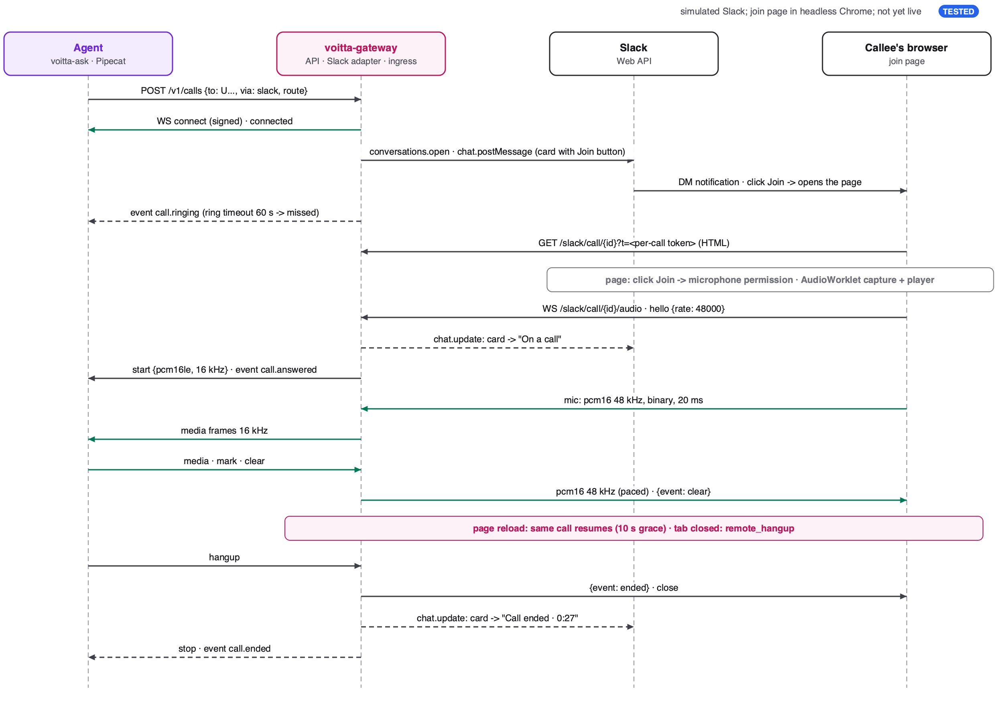
Figure: Outbound Slack call through the browser join page (vector: out/seq-slack-call.svg)

8. What the POC taught us
Finding | Consequence
Signal does not ring for calls from unknown numbers; the call times out silently. | Callees must know the number first (a message exchange or a contact). Send a short heads-up message before the first call.
The native signal-cli 0.14.9 build cannot place calls (TURN lookup fails, issue #2144). 0.14.10 fixes it but migrates the account database one way (version 31 to 32), after which 0.14.9 refuses to start. | The gateway runs the JVM build of 0.14.9 with a bundled Java 25; manhattan-logic keeps the native build on the same data. Upgrade both together later.
The tunnel's patches do not apply to RingRTC 2.72 or later (Signal rewrote the audio code they touch). | The POC runs on RingRTC 2.65.1, which has CVE-2026-113380; kept off PATH and limited to allowlisted callers. Porting the patches is a prerequisite for production.
Only one signal-cli daemon can hold an account. | The bot and the gateway switch by hand (about a minute). Decide: a separate voice number, or manhattan-logic as a gateway consumer (section 9).
A gateway that exits uncleanly left its signal-cli running beside the bot's. | signal-cli now dies with the gateway (Linux parent-death signal); SIGHUP shuts the gateway down cleanly.
After a database reset an agent's event cursor pointed past the end of the log; it missed call.ended and waited forever. | The gateway replays from the start and flags reset; voitta-ask also polls the call state and has a ring deadline. Regression tests cover both.
Whisper small heard "Asian pairs" for "Asian pears". | Try a larger Whisper model (the GPU has room) or pass expected vocabulary as a prompt.
faster-whisper 1.2.1 cannot decode files with PyAV 19 (it passes an argument PyAV removed). | voitta-speech decodes with PyAV directly; caught by the real-model test of clip formats.
Chrome's sandboxed audio service cannot read a fake-microphone file; the page then records silence. | The browser test disables that sandbox feature; the page itself is unaffected.
Shared host: ports 8765 and 8790 were already taken. | All ports are configurable; .212 uses 8700 (gateway), 7583 (signal-cli) and 8791 (voitta-ask).

9. Deployment

9.1 The POC on .212
LIVE as run for the calls in section 2.2.
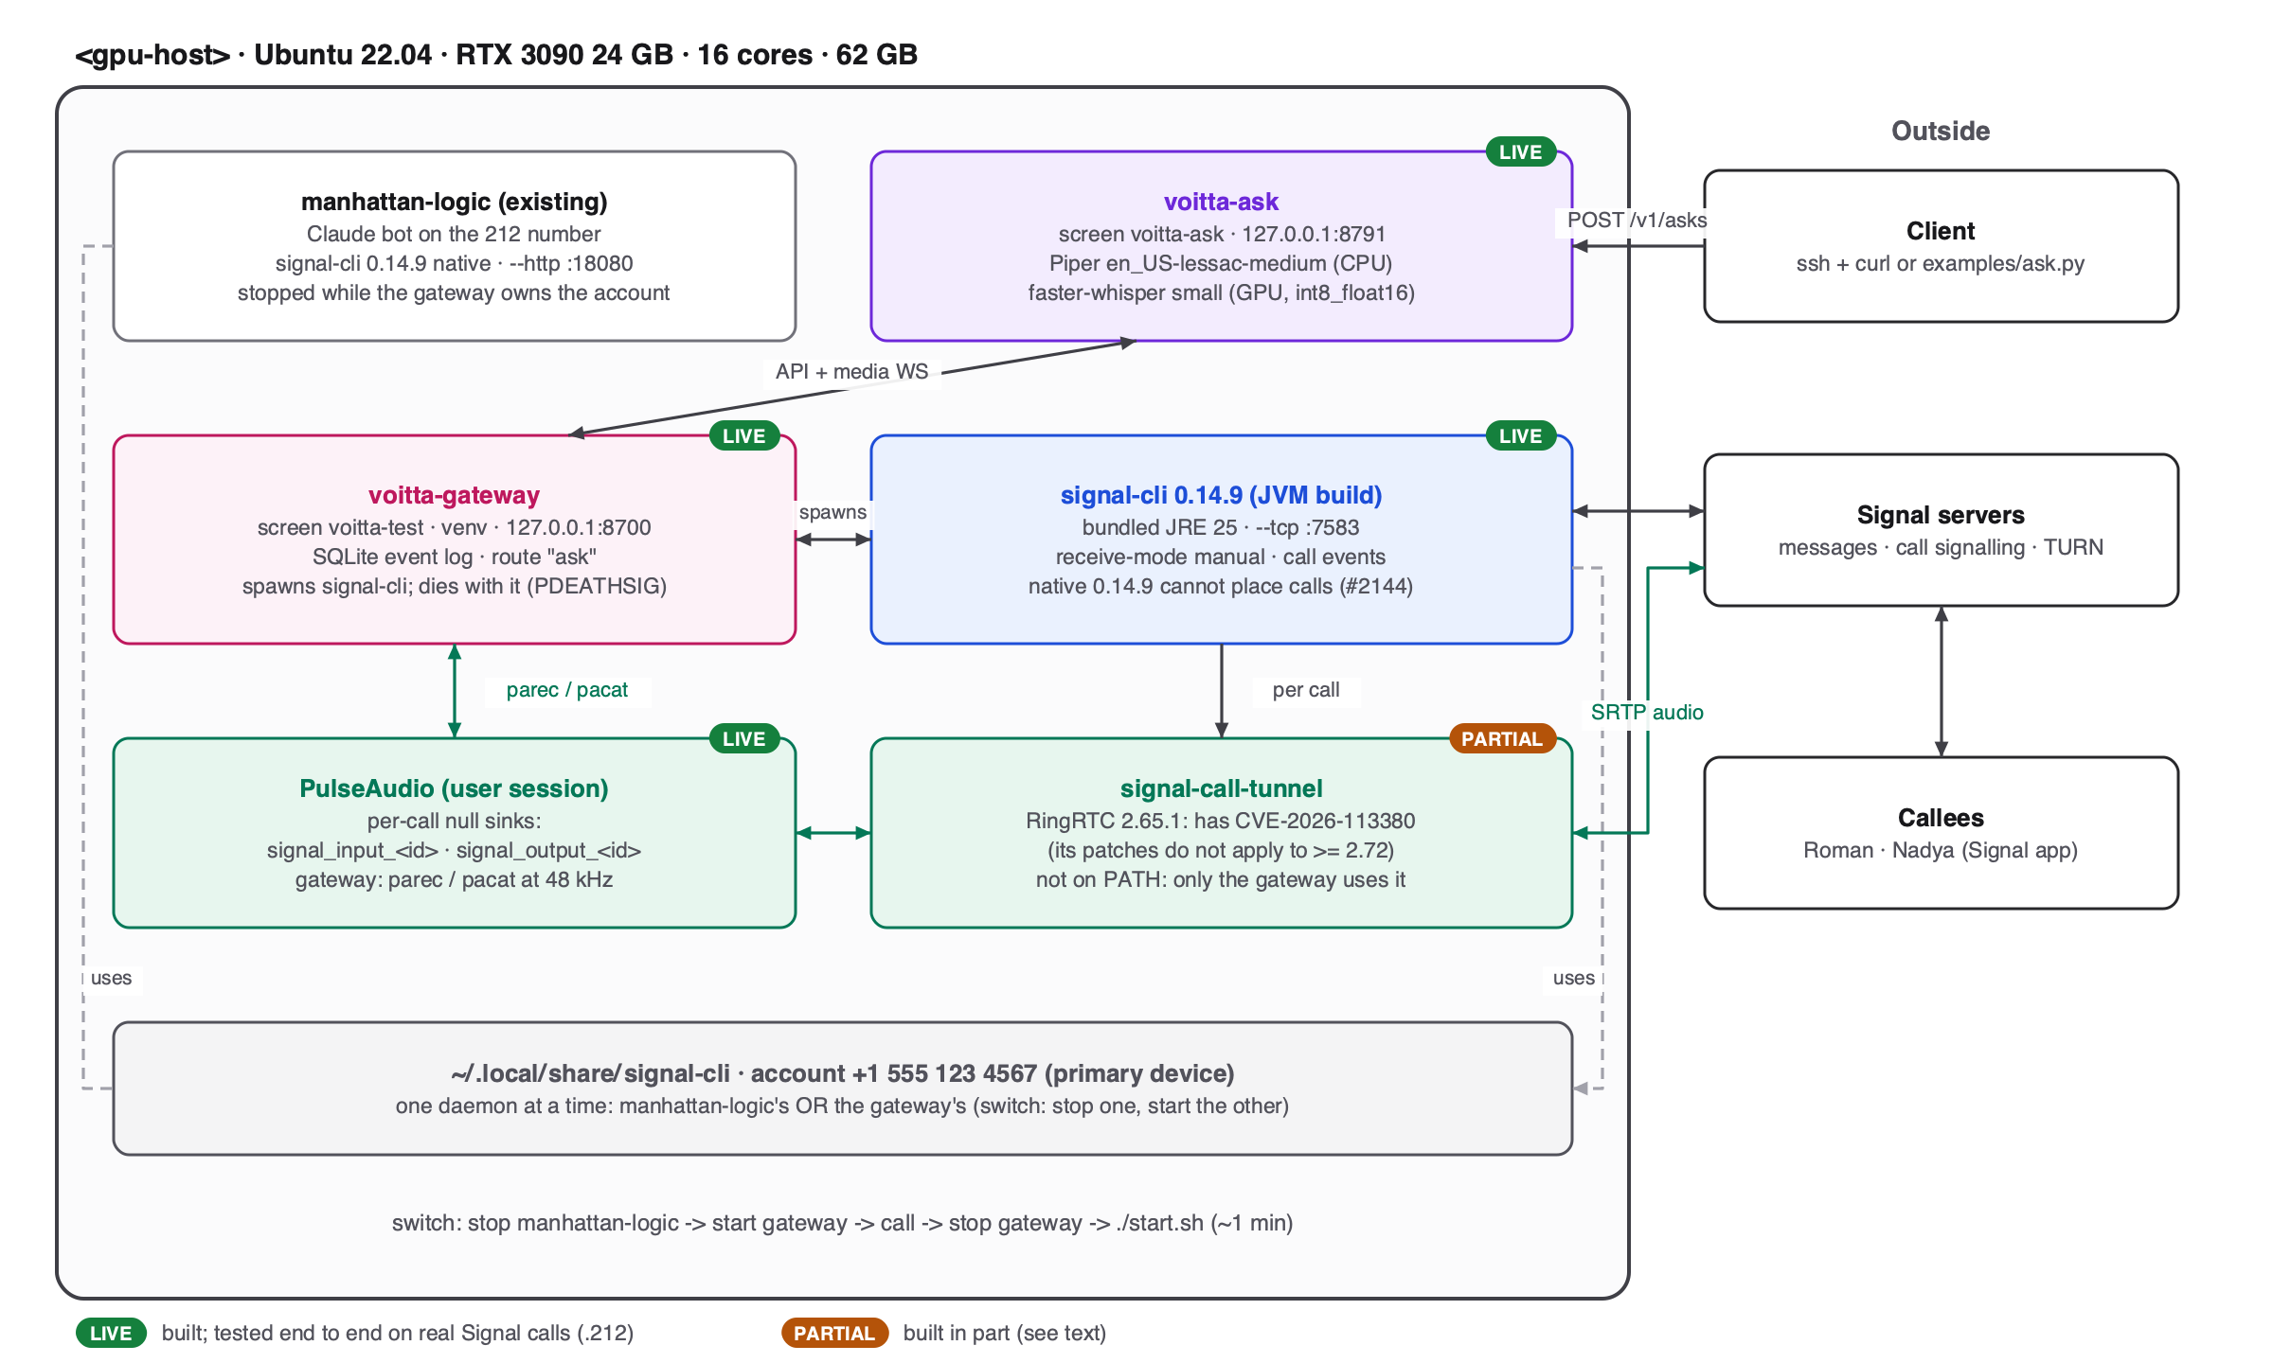
Figure: The POC as it runs on .212 (vector: out/deployment-poc.svg)
- Everything runs as the user in screen sessions; nothing is exposed beyond localhost.
- Switching the 212 account: stop manhattan-logic, start the gateway, call, stop the gateway, start manhattan-logic with its start.sh. Messages that arrive meanwhile go to the gateway.

9.2 Target deployment
PLANNED Dockerfile, Compose file and Caddy config are written; the image has not been built.
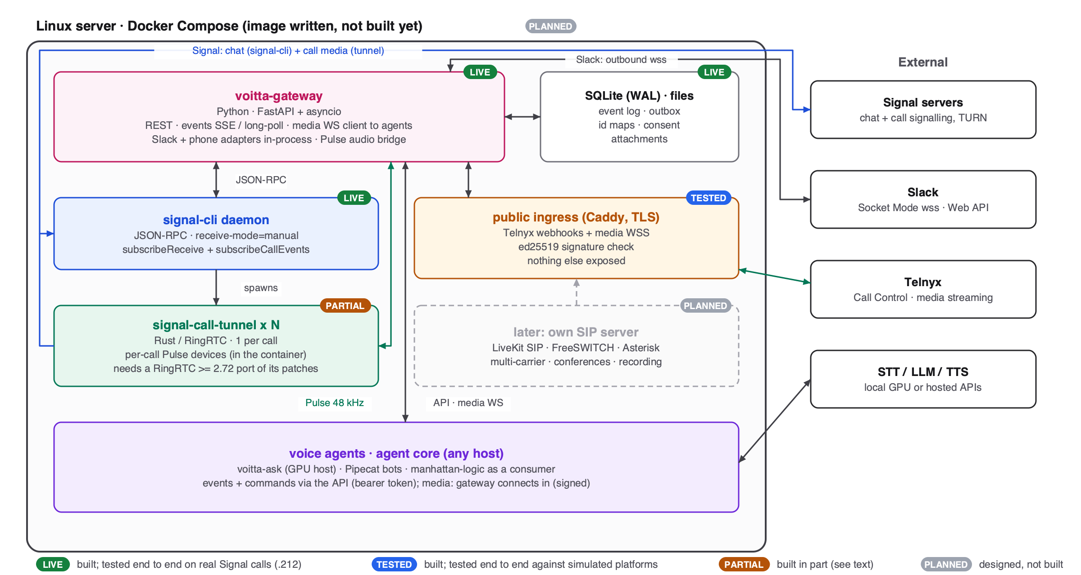
Figure: Target deployment on one Linux server (vector: out/deployment.svg)
- One Linux host per Signal number: gateway, signal-cli, the tunnels and PulseAudio in one container, because the call audio goes through a shared audio server.
- Public exposure only for the phone adapter: one TLS endpoint for Telnyx webhooks and media, with signature checks. Signal and Slack connect outward only.
- Agents run anywhere (voitta-ask on a GPU host); they reach the gateway through its API, and the gateway connects to their media endpoints.

10. Review against current practice (November 2026)
Before building, the design was checked against published practice and platform documentation. These changes were made then and are now in the code:
Area | Original idea | Changed to | Why
Audio format | Fixed PCM16 16 kHz | Announced per stream; resample once | Phone is 8 kHz, Signal 48 kHz; wrong-rate audio fails silently
Media protocol | Agent connects; binary frames | Gateway connects; JSON; start only after answer; mark reports cleared | Reuses agent frameworks; no audio into an unanswered call
Phone path | SIP trunk + own media server | Telnyx Call Control + media streaming | No media server to run; L16 16 kHz both ways
Replies | To person_id; gateway picks channel | To the source conversation | A Slack question must not be answered on Signal
Idempotency | Client-chosen key | Derived from the triggering event | At-least-once delivery would otherwise double-reply
Business logic | None in gateway | Policy, opt-out, consent in gateway | Must apply before any model sees content
Identity | Merge person across channels | Lookup only | Merging leaks private context
Event envelope | Custom; time = ingest | CloudEvents; time = platform time; seq | Standard; exposes gaps and reordering
Signal calls | acceptCall is enough | subscribeCallEvents; gateway owns the audio | Without it calls are ignored; audio bypasses signal-cli
Spec | OpenAPI | OpenAPI + AsyncAPI | OpenAPI does not describe WebSockets

10.1 Platform status
Platform | Messaging | Voice for a bot | Notes
Signal | signal-cli JSON-RPC | Experimental (0.14.2+); works | Tunnel built by us; 1:1 only; unknown callers do not ring; latest signal-cli 0.14.10
Slack | Socket Mode | No media API | Apps cannot join huddles; voice = clips (files) and our own join page
Phone (PSTN) | SMS via carrier | Mature | Telnyx Call Control + media streaming
WhatsApp | Cloud API | Calling API (GA Jul 2025) | Business-initiated calls not available for US/Canada numbers
Telegram | Bot API | User account only | py-tgcalls / NTgCalls
Discord | Bot API | Yes, DAVE E2EE required | Since March 2026
Teams | Bot Framework | Windows/.NET only | Application-hosted media; preview
Google Meet | - | Media API shutting down | Endpoints off 15 Jan 2027

10.2 Compliance
- Signal terms: no bulk messaging, auto-messaging or auto-dialing. Use a dedicated number; call only people who expect it.
- AI disclosure: EU AI Act Article 50 (since 2 August 2026) and US TCPA rules for AI voices (FCC 24-17). The voitta-ask demo introduced itself as an assistant; make it a fixed opening.
- Recording consent: voitta-ask records the answer to transcribe it. About 11 to 13 US states require all-party consent; say so in the opening.
- Emergency numbers: outbound calls and transfers to them are refused (built).

11. Roadmap
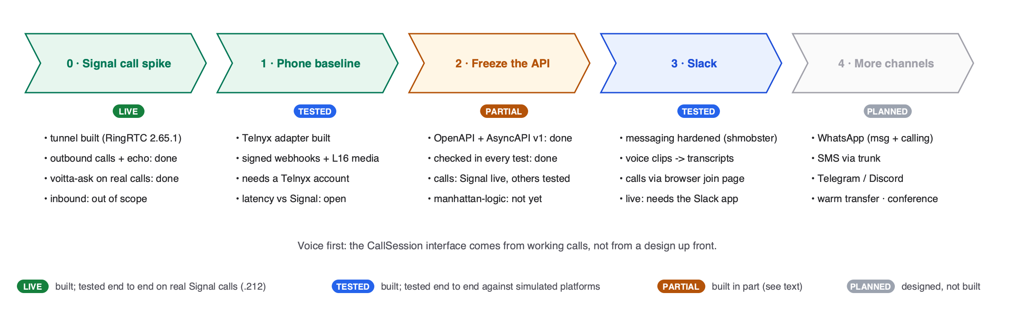
Figure: Roadmap and progress (vector: out/roadmap.svg)
Phase | Status | Done when
0 · Signal call spike | LIVE | Done: outbound calls, echo and voitta-ask on real calls. Inbound calls: out of scope for now.
1 · Phone baseline | TESTED | Adapter built and simulated. Left: a Telnyx account and number, a live call, latency compared with Signal.
2 · Freeze the API | PARTIAL | Specs v1 written and enforced in tests. Left: the phone path live, a generated client library.
3 · Slack | TESTED | Messaging, voice clips and calls built and simulated; join page tested in headless Chrome. Left: install the Voitta app, a public HTTPS address for the join page, a live call.
4 · More channels | PLANNED | WhatsApp, SMS, Telegram; warm transfer and conferences.

12. Next steps and open questions
- Scope decision (8 Nov 2026): outbound calls only, on the 212 number. Incoming calls and additional numbers are out of scope for now; the hand switch between manhattan-logic and the gateway stays until manhattan-logic becomes a gateway consumer (phase 3).
- Port the tunnel patches to RingRTC 2.72 or later before any use beyond the allowlisted test contacts (CVE-2026-113380).
- Upgrade signal-cli to 0.14.10 everywhere at once (database migration is one way); then the native build can place calls too.
- Slack, to go live: create the Voitta app from deploy/slack-app-manifest.yaml, put its two tokens in .env, and give the ingress a public HTTPS name (a reverse proxy or tunnel to .212) for the join page.
- Telnyx: open an account and buy a number to run phase 1.
- Transcription quality: try Whisper medium or large-v3 on the RTX 3090, and a vocabulary prompt.
- Make the disclosure and recording notice a fixed part of every outbound call.
- Production host and packaging: build the Docker image, or run as systemd units on .212.

Sources
- signal-cli releases, PR #1932 (calls): github.com/AsamK/signal-cli
- signal-cli issue #2144 (native build cannot fetch TURN servers): github.com/AsamK/signal-cli/issues/2144
- signal-cli issue #2155 (tunnel packaging): github.com/AsamK/signal-cli/issues/2155
- signal-cli call tunnel protocol: github.com/AsamK/signal-cli/blob/master/docs/CALL_TUNNEL.md
- signal-call-tunnel (patched RingRTC): github.com/hara-seihun/signal-call-tunnel
- RingRTC CVE-2026-113380: helpnetsecurity.com/2026/10/22/signal-ringrtc-vulnerability-cve-2026-113380/
- Signal terms: signal.org/legal/
- Slack Socket Mode vs HTTP: docs.slack.dev/apis/events-api/comparing-http-socket-mode/
- Slack Calls API: docs.slack.dev/apis/web-api/using-the-calls-api/
- Slack files and clips: docs.slack.dev/messaging/working-with-files/
- shmobster (Slack lessons): github.com/voitta-ai/shmobster
- Telnyx media streaming: developers.telnyx.com/docs/voice/programmable-voice/media-streaming
- Twilio Media Streams messages: twilio.com/docs/voice/media-streams/websocket-messages
- Pipecat transports: docs.pipecat.ai/pipecat/learn/transports
- Piper TTS: github.com/OHF-Voice/piper1-gpl · faster-whisper: github.com/SYSTRAN/faster-whisper
- CloudEvents 1.0: github.com/cloudevents/spec · AsyncAPI 3.1: asyncapi.com/docs · OpenAPI 3.1: spec.openapis.org
- WhatsApp Calling API: developers.facebook.com/docs/whatsapp/cloud-api/calling/
- FCC 24-17 (AI voices under TCPA): fcc.gov/document/fcc-makes-ai-generated-voices-robocalls-illegal
- EU AI Act Article 50 timing: joneswalker.com (Aug 2026 AI law blog)

