Function Approximation and Feature Selection Tool

# Version: 1.0

The current version provides facility for adaptive feature selection and prediction using flexible neural tree.

# Developers:

Varun Kumar Ojha

Supervision(s): Ajith Abraham and Vaclav Snasel

# Affiliation:

ESR 9, IPROCOM,

IT4Innovarion,

VŠB - Technical University of Ostrava

Contact:

17. listopadu 2172/15, 708 33 Ostrava, Czech Republic.

Email: varun.kumar.ojha@vsb.cz

Ph. No. +420 777880431.

### Realease:

Version 1.0 @ 09/2015

Please write your suggetions to the developers to enhance the current version. We shall accomodate all your amendements in our upgraded version.

    

Copyright: IPROCOM, http://www.surrey.ac.uk/iprocom/

Contant

Definitions

Function Approximation

Feature Selection

Flexible Neural Tree

Multi-Objective

Managing Dataset

ARFF Format

Benchmark Dataset

Managing Tool

Start Page

Loading Dataset

Setting Training Parameter

Testing a model

Output Features

Execution History

Tree Model

Plotting Result

Result and Statistics

# Definitions

## Function Approximation

Function Approximation finds underlying relation between a dependent (output) variable and one or more independent (input) variables. [V.K. Ojha, K. Jackowski, A. Abraham and V. Snasel, Dimensionality reduction, and function approximation of poly(lactic-co-glycolic acid) micro- and nanoparticle dissolution rate. International Journal of Nanomedicine. 2015; default: 0-0. 2015:10. (In Press)]

The most common tool for function approximation is Artificial Neural Network (ANN) or simply Neural Network [http://www.doc.ic.ac.uk/~nd/surprise_96/journal/vol4/cs11/report.html]. The present tool uses as flexible neural tree representation that offer adaptive feature selection and function approximation.

## Feature Selection

Feature selection, also known as variable selection, attribute selection or variable subset selection, is the process of selecting a subset of relevant features for use in model construction. Feature selection selects features based on their merits and significance to the problem. [V.K. VK Ojha, K. Jackowski, A. Abraham and V. Snasel, Feature Selection and Ensemble of Regression models for Predicting the Protein Macromolecule Dissolution Profile, Sixth World Congress on Nature and Biologically Inspired Computing (NaBIC), Page 121 -126 978-1-4799-5937-2/14 2014 IEEE.]

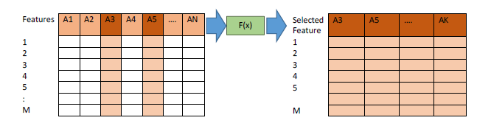

**Figure:** N - Number of Features, M - Number of Samples, K - Number of Selected Features (K _ N). Selection of best features (from the available N features) in terms of their prediction ability.

## Flexible Neural Tree

An adaptive data structure performs automatic feature selection and function approximation. A detail description of flexible neural network can be found in [Yuehui Chen, Bo Yang, Jiwen Dong, Ajith Abraham, Time-series forecasting using flexible neural tree model, Information Sciences, Volume 174, Issues 3–4, 11 August 2005, Pages 219-235, ISSN 0020-0255, <http://dx.doi.org/10.1016/j.ins.2004.10.005>.]

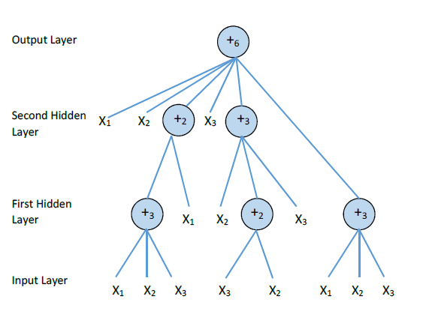

**Figure:** A typical representation of neural tree with function instruction set F = {+2; +3; +4; +5; +6}, and terminal instruction set T = {x1; x2; x3}. Tree depth 3 and max arity 6.

Using pre-defined instruction/operator sets, a flexible neural tree model is created and evolved.

This framework allows input variables selection, overlayer connections and different activation functions for different nodes.

The hierarchical structure is evolved using probabilistic incremental program evolution algorithm (PIPE). The fine tuning of the parameters encoded in the structure is accomplished using some optimization algorithm.

**Function node:** The root node of the flexible neural tree is a function node. The nodes that can have children’s are also function node.

**Leaf Node:** The leaf nodes are the terminal nodes that do receive input for the model. Terminal node act as operands to the function node.

**Fitness Function:** The root node of the flexible neural tree provides the predicted result. The function used to measure the performance of the flexible neural tree using the Root Mean Square Error (RMSE). The RMSE is given as:

$$Fit\left(i\right)=\frac{1}{P}\sum_{j=1}^{P}{{\left(t_{j}-y_{j}\right)}^{2}},$$

where 𝑃 is total number of training pattern in a dataset, 𝑡 is target output and 𝑦 is predicted output.

**Structural Training:** Finding an optimal or near-optimal neural tree is formulated as a product of evolution. For that purpose a Genetic Programming [http://www.genetic-programming.org/] may be used. Genetic programming (GP) is an [evolutionary algorithm](http://en.wikipedia.org/wiki/Evolutionary_algorithm)-based methodology [inspired](http://en.wikipedia.org/wiki/Bio-inspired_computing) by [biological evolution](http://en.wikipedia.org/wiki/Biological_evolution) to find [computer programs](http://en.wikipedia.org/wiki/Computer_program) that perform a user-defined task. Essentially GP is a set of instructions and a fitness function to measure how well a computer has performed a task. It is a specialization of [genetic algorithms](http://en.wikipedia.org/wiki/Genetic_algorithms) (GA) where each individual is a computer program. It is a [machine learning](http://en.wikipedia.org/wiki/Machine_learning) technique used to optimize a population of computer programs according to a [fitness landscape](http://en.wikipedia.org/wiki/Fitness_landscape) determined by a program's ability to perform a given computational task [http://en.wikipedia.org/wiki/Genetic_programming].

**Parameter Optimization of FNT:** Particle Swarm Optimization (PSO) [http://www.swarmintelligence.org/] is used for the parameter optimization Particle swarm optimization (PSO) is a computational method that [optimizes](http://en.wikipedia.org/wiki/Mathematical_optimization) a problem by [iteratively](http://en.wikipedia.org/wiki/Iterative_method) trying to improve a [candidate solution](http://en.wikipedia.org/wiki/Candidate_solution) with regard to a given measure of quality. PSO optimizes a problem by having a population of candidate solutions, here dubbed [particles](http://en.wikipedia.org/wiki/Point_particle), and moving these particles around in the [search-space](http://en.wikipedia.org/wiki/Optimization_(mathematics)#Concepts_and_notation) according to simple [mathematical formulae](http://en.wikipedia.org/wiki/Formula) over the particle's [position](http://en.wikipedia.org/wiki/Position_(vector)) and [velocity](http://en.wikipedia.org/wiki/Velocity). Each particle's movement is influenced by its local best known position but, is also guided toward the best known positions in the search-space, which are updated as better positions are found by other particles. This is expected to move the swarm toward the best solutions [http://en.wikipedia.org/wiki/Particle_swarm_optimization].

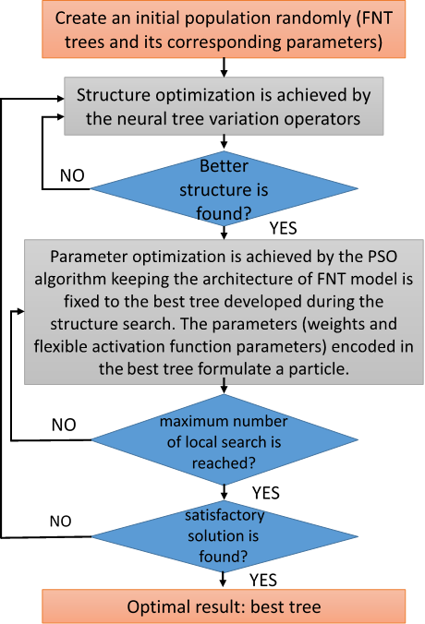

**Figure:** Flexible Neural Tree Training General Procedure

## Multi-Objective

Usually, learning algorithms owns single objective (approximation error minimization) that is often achieved by minimizing root mean squared error (RMSE) on the learning data. A multi-objective optimization procedure optimized two or more objectives simultaneously. An adaptive data structure

**Data:** Problem and Objectives

**Result:** A bag M of solutions selected from Pareto-fronts

*Initialization:* FNT population P;

*Evaluation*: nondominated soring of P;

**while** termination criteria satisfied do

*Selection*: binary tournament selection;

*Generation*: a new population Q;

*Recombination*: R = P + Q;

*Evaluation*: nondominated soring of R;

*Elitism*: P = |P| best individuals from R;

**end**

**Algorithm 1**: NSGA-II based Multi-objective Genetic Programming

# Managing Dataset

## ARFF Format

Please follow **ARFF** file format to load and processed data using this tool. A detail description of the ARFF file format can be found in <http://www.cs.waikato.ac.nz/ml/weka/arff.html>

ARFF files have two distinct sections. The first section is the **Header** information, which is followed by the **Data** information.

The **Header** of the ARFF file contains the name of the relation, a list of the attributes (the columns in the data), and their types. An example header on the standard IRIS dataset looks like this:

% 1. Title: Iris Plants Database

%

% 2. Sources:

% (a) Creator: R.A. Fisher

% (b) Donor: Michael Marshall (MARSHALL%PLU@io.arc.nasa.gov)

% (c) Date: July, 1988

%

@RELATION iris

@ATTRIBUTE sepallength NUMERIC [min, max]

@ATTRIBUTE sepalwidth NUMERIC [min, max]

@ATTRIBUTE petallength NUMERIC [min, max]

@ATTRIBUTE petalwidth NUMERIC [min, max]

@ATTRIBUTE class {Iris-setosa,Iris-versicolor,Iris-virginica}

@inputs sepallength, sepalwidth, petallength, petalwidth

@output class

The **Data** of the ARFF file looks like the following:

@DATA

5.1, 3.5, 1.4, 0.2, Iris-setosa

4.9, 3.0, 1.4, 0.2, Iris-setosa

4.7, 3.2, 1.3, 0.2, Iris-setosa

4.6, 3.1, 1.5, 0.2, Iris-setosa

5.0, 3.6, 1.4, 0.2, Iris-setosa

5.4, 3.9, 1.7, 0.4, Iris-setosa

4.6, 3.4, 1.4, 0.3, Iris-setosa

5.0, 3.4, 1.5, 0.2, Iris-setosa

4.4, 2.9, 1.4, 0.2, Iris-setosa

4.9, 3.1, 1.5, 0.1, Iris-setosa

Lines that begin with a % are comments. The **@RELATION**, **@ATTRIBUTE** and **@DATA** declarations are case insensitive.

## Benchmark Dataset

The tool offers few benchmark dataset for initial experiment. The dataset given in the tool are taken from <http://sci2s.ugr.es/keel/datasets.php> and <http://archive.ics.uci.edu/ml/datasets.html> (need to be converted into ARFF format).

The tool can robustly manage the dataset for **Regression** and **Classification** problems. Several dataset mentioned in the given links can be tested and a model for prediction can be drawn out of this.

# Managing Tool

## Start Page

The start page is a simple initiator page. It is meant for the information regarding the developers, tools.



## Loading Dataset

The benchmark dataset given tool can be chosen easily by selecting the file name. The selected file is needs to be scaled before the training the model.

Feature Scaling: Data values are re-scaling or normalized between certain ranges of values. Re-Scaling of data values is a crucial because of the fact that a dataset may dealing with parameters of different units and scales. The simplest method is rescaling the range of features to make the features independent of each other and aims to scale the range in [0, 1] or [−1, 1]. Selecting the target range depends on the nature of the data. The general formula is given as:

x' = \frac{x - \text{min}(x)}{\text{max}(x)-\text{min}(x)},

where x is an original value, x' is the normalized value. For example, suppose that we have the students' weight data, and the students' weights span [160 pounds, 200 pounds]. To rescale this data, we first subtract 160 from each student's weight and divide the result by 40 (the difference between the maximum and minimum weights). More detail can be found in <http://en.wikipedia.org/wiki/Feature_scaling> and <http://arxiv.org/ftp/arxiv/papers/1209/1209.1048.pdf>

## Setting Training Parameter

**Data Set Loading** 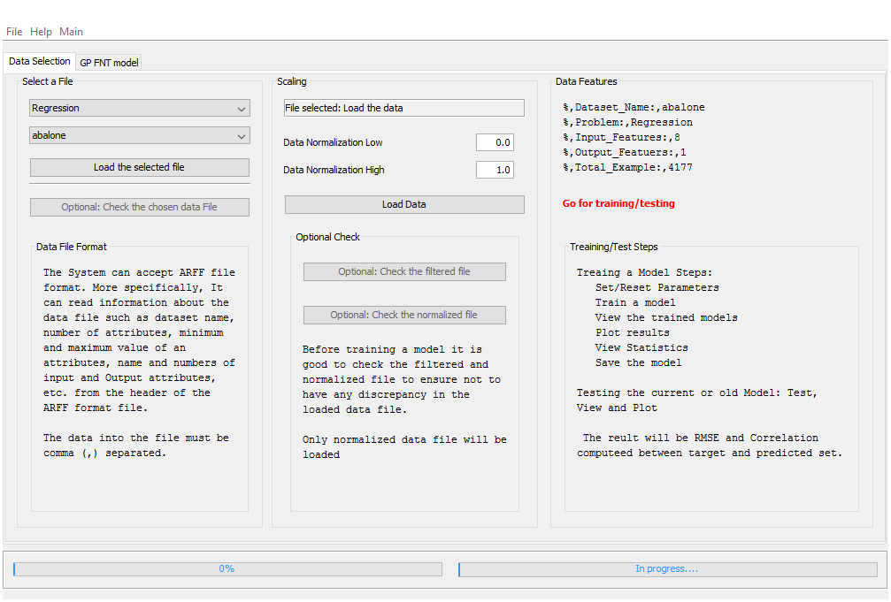

**Figure.** Window of the tool.

**Features:**

1. Select a sample benchmark data file name for loading data. User can select “Choose another file” to choose a data file from the desktop.
2. Scaling and Loading dataset.
3. [Optional] to open the selected data file to check if file is loaded correctly (Please close excel file after checking).

**Model Bulling**

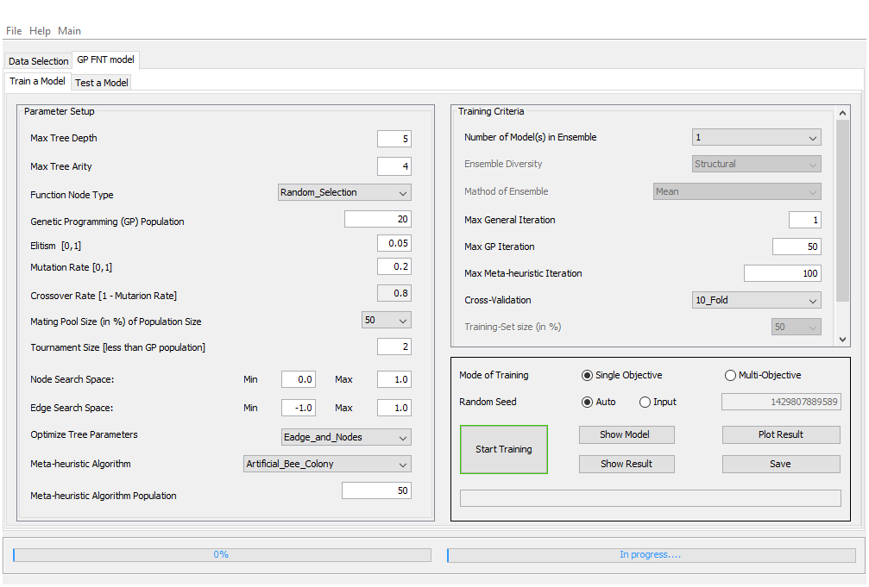

**Figure. Training Window of Tool**

**Features:**

1. Parameter Setting
2. Max Tree arity indicates is the number of arguments or operands the function or operation accepts. In the case of tree, the arity indicated number of child a node can have.
3. Max Tree Depth indicated the height of a tree.
4. Indicated number of individual trees/models that will take part in the process of the training.
5. Tournament size indicated the number of individuals take part in formation of next generation into genetic operation. The tournament size must be smaller than the GP population size.
6. Keep it as small as possible. It indicated the number of times the whole process will be repeated.
7. Indicated the number of times GP training will be repeated.
8. Indicated the number of times Metaheuristic training will be repeated.
9. Select Cross validation mode.
10. Select Mode of Training
11. Select a Random Seed.
12. Click to see the plot the fitting of the data.
13. Click to see the results.
14. Click to save the results and the model.

**Training objectives:**

1. As small as possible Root Mean Square Error
2. A high correlation (close to 1) value
3. A small tree model. Smaller the model, fewer the free parameters in the model.
4. Appropriate fitting of data (See the plots fitting and scatter plot)
5. Less complex model

**Max Tree Arity:** Tree Arity indicates the children’s of a tree node. In other words, as a node in flexible neural tree represents a function, hence the children are the operands of the function.

**Max Tree Depth**: The tree height from the root to a leaf. A default value is given as in the tool itself. However user can Input typical a number close to default value in order to obtain a simple model.

**Genetic Programming (GP) Population:** Population of individuals/agent used in the optimization of flexible neural tree structure.

**Tournament Size:** Tournament size indicated that the number of individuals take part in the creation of new generation.

**Particle Swarm Optimization (PSO) Population:** Population of individuals/agent used in the optimization of the parameters of the flexible neural tree.

**Max General Iteration:** A default value is given in the tool itself. The general iteration indicate the repetition of the whole process of the GP and PSO optimization. Therefore, the speed of the training depends on the general iteration. It should be increased only if the satisfactory result obtained.

**Max GP Iteration:** Indicated the number of generation of the genetic programming (GP) evolution.

**Max PSO Iteration:** Indicated the number of iteration of the PSO optimization iterations.

**Train Model:** Click to train the model.

**Show Model Structure:** Click to see the model structure.

**Plot Result:** The plot will show the fitting of predicted and target outputs. There is two types of plot can be seen.

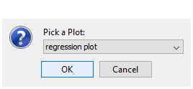 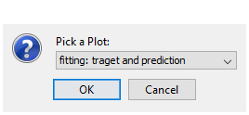

**Figure:** Select the type of plot

## Testing a model

User may test an existing model (already saved old model) or the current model. To test the current model select the current model and click the test.

**Test an old model:**

1. If the old saved model was developed on the existing loaded dataset, click and test the model.
2. If the old model was developed for another dataset. Load the dataset and click to test the model.

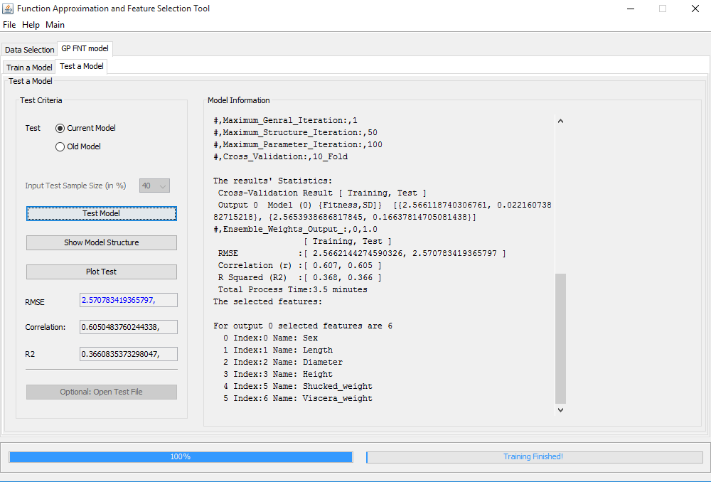

Figure: Test Window of Tool

# Output Features

## Execution History

The execution history indicates the iteration of the GP and PSO optimization process. This will indicate the progress of the program in search of **better structure** (in terms of the performance) **and better parameters** (in terms of the performance).

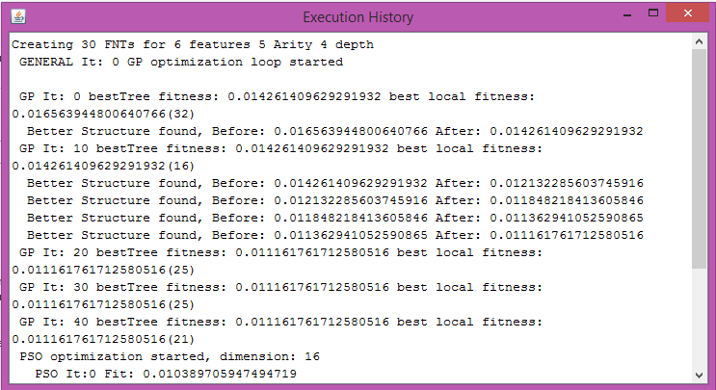

## Tree Model

**Terminologies used in Trees**

**Root** – The top node in a tree.

**Parent** – The converse notion of child.

**Siblings** – Nodes with the same parent.

**Descendant** – a node reachable by repeated proceeding from parent to child.

**Ancestor** – a node reachable by repeated proceeding from child to parent.

**Leaf** – a node with no children.

**Internal node** – a node with at least one child.

**External node** – a node with no children.

**Degree** – number of sub trees of a node.

**Edge** – connection between one node to another.

**Path** – a sequence of nodes and edges connecting a node with a descendant.

**Level** – The level of a node is defined by 1 + the number of connections between the node and the root.

**Height of tree** –The height of a tree is the number of edges on the longest downward path between the root and a leaf.

**Height of node** –The height of a node is the number of edges on the longest downward path between that node and a leaf.

**Depth** –The depth of a node is the number of edges from the node to the tree's root node.

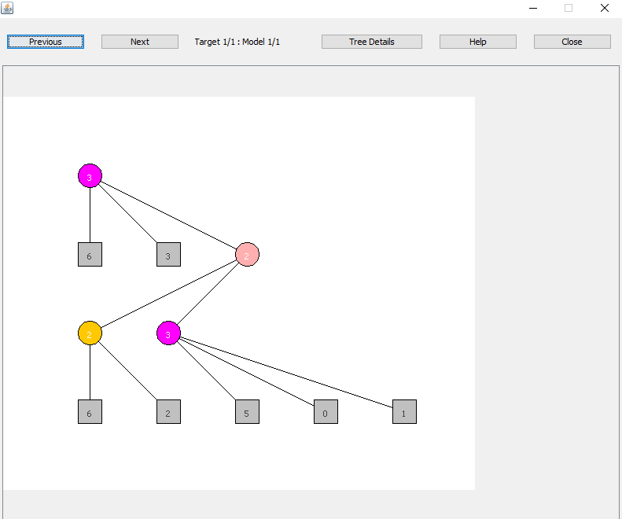

## Plotting Result

**Scattered plot:** Scatter plots are similar to line graphs in that they use horizontal and vertical axes to plot data points. However, they have a very specific purpose. Scatter plots show how much one variable is affected by another. The relationship between two variables is called their **correlation**. [http://mste.illinois.edu/courses/ci330ms/youtsey/scatterinfo.html]

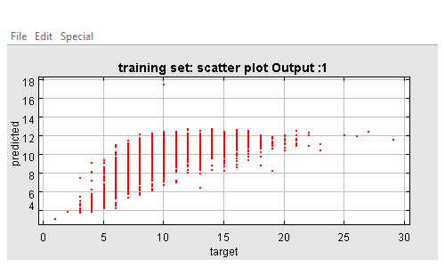

**Fitting:** Data fitting display the target vs perdicted value.

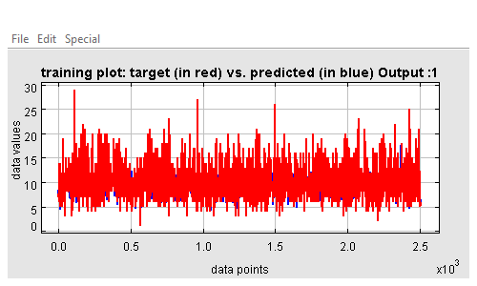

## Result and Statistics

